Summary of research and findings from the Pacific Salmon Strategy Initiative

Pacific Salmon Strategy Initiative

Cory Lagasse

Joe Enns

Nicholas Brown

Isobel Pearsall

Ann-Marie Huang

Diana Dobson

2025-12-31

Table of contents

# Preface

## Abstract

Brief overview of the report’s purpose and findings.

## Citation

Lagasse, C., Enns, J., Brown, N., Pearsall, I., Huang, A.-M., and Dobson, D. 2026. Summary of research and findings from the Pacific Salmon Strategy Initiative. Canadian Technical Report of Fisheries and Aquatic Sciences nnn.

## Report Information

**Report Number:** nnn  
**Year:** 2026  
**Region:** Pacific Region  
**DOI:** TBD  
**ISBN:** TBD  
**Catalog Number:** TBD

**Contact Information:**  
Pacific Biological Station  
Fisheries and Oceans Canada  
3190 Hammond Bay Road  
Nanaimo, British Columbia, V9T 6N7, Canada

## Acknowledgments

This report summarizes research and findings from 224 projects conducted under the Pacific Salmon Strategy Initiative.

# Introduction

## Pacific Salmon Strategy Initiative Overview

The Pacific Salmon Strategy Initiative (PSSI) was a generational investment of over $500 million in habitat restoration, hatchery enhancement, fisheries management, scientific research, and other activities related to Pacific salmon. Over its five year span beginning in 2021, the multi-faceted initiative sought to restore vulnerable populations of Pacific salmon and their habitats, support sustainable fishing opportunities while reducing impacts on at‑risk stocks, and build capacity among partners to achieve better outcomes for Pacific salmon. In doing so, the initiative sought to respond to long‑standing concerns about declines in many salmon populations, increasing pressures from climate change, and the need for more integrated approaches to management and recovery.

PSSI brought significant new capacity and resources to Fisheries and Oceans Canada (DFO), the lead federal agency for the initiative, enabling expanded scientific research, enhanced stewardship and restoration activities, additional capacity for enhancement and monitoring, and new collaborative approaches with Indigenous and non-Indigenous partners. The initiative was initially designed and managed across four pillars—Conservation and Stewardship, Salmon Enhancement, Harvest Transformation, and Integration and Collaboration—each of which involved multiple sectors within DFO and included several initiatives (**?@tbl-pssi-initiatives**). The pillars were intended to provide a framework for aligning actions across habitat, hatcheries, fisheries, and governance in support of the long‑term persistence and resilience of Pacific salmon.

The conservation and stewardship pillar focused on new activities and investments supporting the long-term persistence and rebuilding of Pacific salmon populations. Key components included a doubling of the British Columbia Salmon Restoration and Innovation Fund (BCSRIF), investing in research to improve our understanding of salmon and their ecosystems, advancing integrated planning for salmon ecosystems to mitigate pressures on freshwater habitats, developing integrated rebuilding plans for vulnerable salmon populations, improving supports for salmon stewardship activities through engagement, and capacity-building with First Nations and community partners.

The salmon enhancement pillar aimed to modernize hatchery programs to more effectively support the conservation, recovery, and sustainable use of Pacific salmon. A key objective under this pillar was to invest in new hatchery infrastructure and capacity, including retrofitting existing facilities and building new facilities in the Upper Fraser area. The pillar also aimed to strengthen collaboration and enhancement partnerships, including with First Nations and other stakeholders, while investing in hatchery science related to genetics, fish health, salmon ecosystems, and operational monitoring. In addition, this pillar supported development of a modernized enhancement policy intended to guide decision-making in a way that better supports the overall enhancement vision, including the targeted use of conservation-based hatchery production to help recover, stabilize, and restore vulnerable salmon stocks.

The harvest transformation pillar was intended to change how Pacific salmon fisheries were managed in response to long-term stock declines and ongoing conservation concerns. Its key objectives included adopting more precautionary and selective fishing approaches, including exploring mark-selective fisheries, and developing new tools to better manage harvest capacity across sectors. The pillar also included commitments to update the Salmon Allocation Policy and to update licensing, regulatory, and management frameworks, including measures such as licence buyback programs and long-term commercial fishery closures in areas with significant conservation concerns. In addition, it aimed to improve the timeliness and accuracy of fishery monitoring and catch reporting programs to strengthen the information base used for harvest decision-making.

The integration and collaboration pillar focused on strengthening collective capacity to address Pacific salmon declines by improving how DFO worked both internally and with external partners. Key objectives under this pillar were to provide capacity support to various internal and external groups involved in salmon conservation and management, to improve collaboration among federal, provincial, territorial, Indigenous, and other governments, and to prioritize salmon stocks for recovery through coordinated, cross-jurisdictional planning and decision-making processes.

| **Pillar** | **#** | **Initiative Name** |
| --- | --- | --- |
| **Conservation and Stewarship** | **1** | **Improved Understanding Of Salmon Ecosystems** |
| **2** | **High Seas Monitoring And Enforcement** |
| 3 | Integrated Salmon Ecosystem Planning |
| **4** | **Salmon Stewardship And Restoration** |
| 5 | BC Salmon Restoration And Innovation Fund Phase Two |
| **Salmon Enhancement** | 6 | New Upper Fraser DFO Hatcheries |
| 7 | Retrofitting DFO Hatcheries |
| 8 | New And Retrofitted Community-Based Hatcheries |
| **9** | **Modernized Hatchery Management (Harvest)** |
| **10** | **Expansion Of Mass Marking** |
| **Harvest Transformation** | 11 | Pacific Salmon Allocation Policy Review Process |
| 12 | Transition To Selective Harvesting Methods For FSC |
| 13 | New And Innovative Harvest Opportunities (First Nations) |
| 14 | Modernized Management Approach For First Nations Fisheries |
| 15 | Long Term Conservation Closures On Non-Selective Fishing, And Mitigation Measures |
| 16 | Modernized Licensing And Management Approach (Commercial) |
| 17 | New Recreational Harvest Opportunities (Mark Selective Fisheries) |
| **18** | **Modernized Licensing And Management Approaches (Recreational)** |
| **Integration and Collaboration** | 19 | PSSI Implementation Secretariat |
| 20 | Integrated Salmon Workplanning |
| **21** | **Strategic Data Policy And Analytics Team** |
| 22 | Inter-Jurisdictional Salmon Collaboration |
| 23 | BC First Nations Salmon Stewardship Governance |
| 24 | International Salmon Collaboration |

## Scientific Research Components of PSSI

The PSSI pillars were underpinned by a dual-track investment in scientific research, combining internal DFO expertise with external grants and partnerships. This new scientific capacity supported a diverse range of projects intended to inform rebuilding plans, identify factors driving population declines, better understand the impacts of climate change, and pilot new approaches for monitoring, enhancement, fisheries harvest, and restoration. By supporting research within DFO and externally, the initiative aimed to leverage and build on existing capacity within the federal government and across academic institutions, Indigenous organizations, non-governmental organizations, and industry.

While the first phase of BCSRIF was already underway with over X projects, PSSI significantly expanded this reach by funding a second phase. This resulted in 72 new collaborative agreements (Appendix @ref(app:BCSRIF)), with many focused on scientific research in areas such as climate change modelling, habitat restoration effectiveness, and monitoring innovation. These investments enabled First Nations, academic researchers, industry, and community organizations to work alongside DFO scientists, strengthening the evidence base for management decisions while incorporating Indigenous knowledge, local observations, and novel technologies into the broader PSSI research portfolio.

Within DFO Science, PSSI resources were primarily concentrated into two initiatives: Improved Understanding of Salmon Ecosystems and Science to Support Hatchery Modernization. Targeted funding also bolstered research in support of the Habitat Restoration Centre of Expertise, improving the management and accessibility of salmon-related data, increasing the capacity of the molecular genetics lab, and expanding monitoring of recreational fisheries. This work was implemented across the Pacific Region’s four Science divisions—Stock Assessment, Ecosystem Science, Ocean Science, and Aquatic Diagnostics—enabling multi-disciplinary approaches to research and monitoring.

The largest PSSI initiative led by DFO Science was Improved Understanding of Salmon Ecosystems. The overarching aim of this initiative was to enable the development of effective conservation strategies and management actions for wild salmon and their ecosystems by developing a comprehensive understanding of habitat, ecosystem, and climate change impacts on salmon productivity. Research planning and prioritization began in 2022 with a DFO workshop that identified knowledge gaps and research themes (Lagasse et al. In press). Subsequently, research proposals underwent a peer-review process and steering committee evaluation. Beginning in 2023, dozens of multi-year projects were funded, including the establishment of new research programs and the expansion or continuation of existing long-term programs.

The second major DFO Science initiative, Science to Support Hatchery Modernization, was a part of the PSSI Salmon Enhancement pillar. This initiative was designed to provide scientific advice and information to inform planning and program implementation, advance the use of molecular genetics and other tools for assessment, and expand fishery and escapement sampling programs. These research activities were intended to support the expansion of hatchery programs under PSSI, informing effective enhancement for population rebuilding and providing harvest opportunities while reducing risks for wild salmon populations. Research priorities were co-developed by a steering committee representing the Salmonid Enhancement Program and DFO Science.

In this report, we summarize the outcomes and findings of research projects funded through the PSSI, with a focus on work led by DFO Science in the Pacific Region. We synthesize results across several research themes aligned with the major PSSI initiatives(Figure 1), providing an overview of findings from a diverse set of multi-disciplinary projects. For the Improved Understanding of Salmon Ecosystems initiative, we review research within five thematic areas: salmon population monitoring, life-cycle approaches, freshwater ecosystems, marine ecosystems, and climate change vulnerability. For the Science to Support Hatchery Modernization sub-initiative, we outline research conducted under the Genetics, Fish Health, and Hatchery Practices themes. In addition, we describe broader research and monitoring activities supported by PSSI, including work related to fisheries monitoring and new harvest techniques, stock assessment advice, and new tools for data mobilization and management. We provide project summaries for n_projects DFO-led research projects, offering a snapshot of the current state of Pacific salmon science under PSSI. Although the synthesis is not comprehensive of all research conducted under PSSI, it highlights the insights, knowledge gaps and future priorities identified during the five years of the initiative as they relate to thematic areas.

# Understanding Salmon and Their Ecosystems

Context for this section

### A. Salmon population monitoring

| **ID** | **Project title** |
| --- | --- |
|  | |
| BCSRIF_2022_329 | Meziadin River Up-looking Hydroacoustic Sockeye Smolt Enumeration Project |
| BCSRIF_2022_345 | Digital Imaging of Wild Coho Returns to the Lillooet River Conservation Unit |
| BCSRIF_2022_346 | Genetic monitoring of Kokanee-sockeye salmon (Oncorhynchus nerka) hybrid fitness and long term outcomes associated with an experimental re-introduction program |
| BCSRIF_2022_351 | Estimating aggregate Coho salmon escapement to the Lower Fraser Management Unit |
| BCSRIF_2022_451 | Boundary Bay Chinook salmon restoration in the TA’TALU watershed |
|  | |
| 2403 | San Juan River Adult and Juvenile Assessment Program |
| 2426 | Sakinaw Sockeye Juvenile Research on Measures to Increase Marine Survival |
| 2430 | Feasibility of Estimating Chilko River Smolt Abundance Using Upward- and Side-Looking SONAR Methods |
| 2442 | Graduate Research into 1) habitat use by juvenile Chinook Salmon in the Canadian Okanagan River and Lake system and 2) predation on juvenile salmon in the Canadian Okanagan River and Lake system |
| 2444 | Assessment of the distribution and abundance of juvenile Chinook salmon in the lower Thompson River basin. |

### B. Life cycle approaches

#### Follow the Fish (IP)

Provide an overview of the follow the fish program, how risk assessments and limiting factors (RAMS) were used to guide research priorities, key insights, and next steps to support rebuilding of WCVI Chinook salmon.

| **ID** | **Project title** |
| --- | --- |
|  | |
| BCSRIF_2022_332 | Research in support of Sarita Chinook as an Ecological Indicator and WCVI Chinook Salmon Rebuilding |
| BCSRIF_2022_337 | Chinook Salmon Assessments and WCVI Chinook Salmon Rebuilding in the Kaouk and Artlish Watersheds |
| BCSRIF_2022_442 | Identifying factors that influence early marine survival of WCVI Chinook salmon |
| BCSRIF_2022_442 | Identifying factors that influence early marine survival of WCVI Chinook salmon |
|  | |
| 2397 | Identifying good practices for considering Indigenous Knowledge in Rebuilding Plan targets and stock assessment reference poi |
| 2398 | WCVI Sediment Transport and Redd Scour Assessment |
| 2407 | Follow the Fish: An integrated Chinook salmon assessment and monitoring program for the West Coast of Vancouver Island |
| 2422 | Development and application of laser ablation-inductively coupled plasma-mass spectrometry (LA-ICP-MS) to determine saltwater entry size of juvenile salmonids and track habitat usage. |
| 2432 | Barkley Sound and Clayoquot Sound acoustic monitoring of salmon and salmon prey |
| 2447 | Innovative Ecosystem Based Approaches to identify cumulative stressors: Salmon Fit-Chips and eDNA |

#### Bottlenecks to survival (IP)

| **ID** | **Project title** |
| --- | --- |
|  | |
| BCSRIF_2019_040 | Determination of Bottlenecks Limiting Wild and Enhanced Juvenile Salmon and Steelhead Production in BC using PIT tags and Spatially Comprehensive Arrays |
| BCSRIF_2022_456 | Informed Approaches to Determine Bottlenecks to Survival for Chinook and Coho Salmon and Steelhead |

### C. Freshwater ecosystems (JE)

| **ID** | **Project title** |
| --- | --- |
|  | |
| BCSRIF_2022_334 | First Nations led salmon habitat and population monitoring, research and cumulative effects assessment in the Lower Fraser River and Boundary Bay |
| BCSRIF_2022_361 | Identifying and mitigating hot spots of salmon exposure to toxic road runoff |
| BCSRIF_2022_368 | Thompson-Shuswap Salmon Habitat Assessment, Monitoring & Restoration Program (2023-26) |
| BCSRIF_2022_389 | Mitigating Inputs of Tire Wear Toxins to Protect Salmonid Habitat on Vancouver Island |
| BCSRIF_2022_426 | Investigation of water acidification and habitat on imprinting and homing in Pacific salmon |
| BCSRIF_2022_435 | Colquitz River Salmonid Restoration and Monitoring Project |
| BCSRIF_2022_449 | Analysis of forestry effects on Pacific salmon in Musgamagw Dzawada’enuxw territory and across coastal BC. |
|  | |
| 2414 | South Coast freshwater ecological indicator pilot |
| 2424 | Mechanistic modelling to link hydrology to juvenile salmon habitat quality and productivity |
| 2425 | Development of geospatial tools for large-scale freshwater salmon habitat assessment by the Freshwater Spatial Ecology Program |
| 2443 | Quantitative assessment of the impact of Smallmouth Bass suppression efforts in Cultus Lake and SMB emigration from Cultus Lake |
| 2493 | Improved understanding of cumulative impacts on salmon survival across freshwater life-stages; tools and approaches for mechanistic assessments |
| 2504 | Identifying and characterizing tire-related chemical (6PPD-quinone) toxic hotspots in salmon habitat |

Summarize research undertaken and key findings focused on freshwater ecosystems. Projects and themes include:

* Risk assessment and mitigation of aquatic invasive species
  + Understanding threats of freshwater AIS (Thomas Therriault)
  + Survival and predation on Okanagan Chinook (Tommy Pontbriand)
  + Monitoring of Smallmouth bass in Cultus Lake (Daniel Doutaz)
* Research on freshwater toxins and their effects on salmon, particulalrly 6PPD-Q
  + Identifying tire-related toxic hotspots (Lisa Loseto)
* Physiological and mechanistic studies to link environmental conditions with survival and productivity
  + Mechanistic modelling linking hydrology to habitat quality (Sean Naman)
  + Physiological studies to understand cumulative impacts on salmon survival (David Patterson)
  + Effects of redd scour on WCVI Chinook (Diana McHugh)
* Broad-scale spatial and statistical modelling to characterize cumulative threats to freshwater habitat
  + Geospatial indicators of cumulative threats to stream habitat (Josie Iacarella)
  + Effects of forest harvest of salmon productivity (BCSRIF, Maria Kuruvilla)
  + The CEMPRA cumulative effects modelling framework (BCSRIF, Jordan Rosenfeld)

### D. Marine ecosystems (IP/NB)

| **ID** | **Project title** |
| --- | --- |
|  | |
| BCSRIF_2022_341 | ʔaayaaqa (Herring) Herring Spawn Dynamics |
| BCSRIF_2022_358 | Determining the mechanisms of impacts of a changing climate on zooplankton in the Salish Sea using models and observations |
| BCSRIF_2022_379 | Strait of Georgia Herring: Restoring the Salmon Food Web |
| BCSRIF_2022_397 | Mapping, monitoring and restoring important forage fish habitats in Coastal British Columbia to support salmon conservation efforts. |
| BCSRIF_2022_404 | Oolichan From Estuary to Offshore: Assessment of Early Marine Populations and Limiting Factors of Central Coast Oolichan (Eulachon: Thaleichthys pacificus) in Douglas Channel and Gardner Canal |
| BCSRIF_2022_425 | Empirically resolving interspecific competition experienced by North Pacific salmon in the open ocean |
| BCSRIF_2022_430 | Resilient Estuaries in the Salish Sea: Phase Two (Baseline Assessments and Ground-truthing) |
| BCSRIF_2022_436 | Establishing baselines, risks, and mechanisms of thiamine deficiency in British Columbia Chinook salmon |
| BCSRIF_2022_444 | Enhancing Estuary Resilience: A Collaborative Approach to the Monitoring and Restoration of Estuaries with Coastal First Nations |
|  | |
| 2404 | Improving baseline knowledge of environmental conditions in Vancouver Islands fjords through observations and modelling, with a focus on hypoxia dynamics, climate change, and the potential implications for Pacific salmon |
| 2406 | Changing coastal productivity: Using sediment cores, water properties and archived plankton data to identify changes at the bottom of the food web in BC’s coastal waters |
| 2409 | Convergent tracks: a tagging study to quantify salmon predation by sea lions |
| 2412 | Investigation of the impacts of singular and coinciding acute climate stressors on the nutritional quality of the pteropod Limacina helicina, a juvenile Pacific salmon dietary species |
| 2413 | Barkley Sound and Clayoquot Sound Krill Monitoring |
| 2416 | Monitoring and predicting the exposure of Pacific salmon to harmful algal biotoxins |
| 2427 | Salish Sea plankton and oceanography |
| 2433 | Integrated Salish Sea acoustic monitoring of salmon and salmon prey |
| 2513 | Characterizing and monitoring priority contaminants of concern in WCVI juvenile salmon |

Summarize research and key findings related to building understanding of marine ecosystems and key stressors. Projects and themes include:

* Oceanographic studies monitoring marine conditions to understand their influence on salmon productivity
  + Zooplankton and krill monitoring (Akash Sastri)
  + Hypoxia and temperature within Vancouver Island fjords (Laura Bianucci)
  + Acoustic monitoring of salmon and salmon prey (Stephane Gauthier)
  + Monitoring harmful algal biotoxins (Andrew Ross)
  + Contaminants monitoring (Lisa Loseto)
* Research and monitoring on marine ecosystems and predators
  + eDNA monitoring in WCVI (Christoph Deeg)
  + Quantifying salmon predation by sea lions (Cameron Freshwater)

### E. Climate change vulnerability (CL)

| **ID** | **Project title** |
| --- | --- |
|  | |

**Highlights**

* Newly developed marine and freshwater climate models allow us to assess environmental changes that will be experience by Pacific salmon within British Columbia
* Vulnerability assessments reveal differences in risk for the 50 conservation units of Pacific salmon within the Fraser basin, with Pink and Chum salmon the least vulnerable to climate changes while ….
* Life stage models….
* Genetic adaptation….
* Greenhouse gas emissions matter. Vulnerability, as represented by conditions beyond optimal thresholds, was more severe in high emissions scenarios compared to scenarios with mitigation.
* These new assessments can be applied in planning and decision-making to contextualize risks and benefits….

**Research Goals**

The significance of climate change for Pacific salmon, and biodiversity in general, cannot be overstated. Studies across their range have highlighted the vulnerability of Pacific salmon to recent and future climate changes for freshwater and marine life stages (Crozier et al. In press; Grant et al. In press; Mantua et al. In press; McClure et al. In press). Climate change emerged as a key theme during the PSSI Science planning workshop (Lagasse et al. In press) and was a central element of the Improved Understanding of Salmon Ecosystems sub-initiative. Discussion papers, minister mandate letters, funding initiatives, and national adaptation plans have recognized the need to make climate change considerations central to decision-making and planning (Macdonald and Grant In press). This need follows from the understanding that climate change introduces additional risk and uncertainty into plans and decisions because expectations based on past climate relationships may not hold true.

Yet there is still much that is uncertain about how climate changes will unfold for Pacific salmon, such as which species and stocks will be most affected, when physiological thresholds or ecological tipping points will be reached, the relative influence of various environmental changes on productivity, and the degree to which populations will be able to evolve and adapt to changing conditions and increasing temperatures (Chittenden et al. In press; Crozier and Siegel In press; Schoen et al. In press). Research within this theme sought to better understand and resolve these uncertainties through a variety of approaches including downscaled climate modelling, modern genotyping, life-cycle modelling, and vulnerability risk assessments. Collectively, these studies reveal important details about the implications of climate change for Pacific salmon that can allow us to understand and anticipate current and future changes.

**Downscaled climate modelling**

Global climate modelling – the simulation of earth systems into the future under different greenhouse gas emission scenarios – is the basis for much of our understanding about future climate change as reported on by the intergovernmental panel on climate change (IPCC). However, these global models lack the necessary detail to tease out fine-scale environmental changes to aquatic habitats that will be significant to understanding responses of Pacific salmon over the coming decades. Recent work, including many projects supported by PSSI, is addressing these gaps through downscaling of global climate models to marine and freshwater environments across the Pacific region.

Within freshwater habitats, the Pacific Climate Impacts Consortium (PCIC) has developed high resolution stream temperature and flow models that project future conditions throughout British Columbia. Statistically downscaled models of August stream temperature have also recently been developed providing an alternative method for projecting future temperatures.  These models reveal a gradient of temperature changes throughout British Columbia influenced not only by global climate patterns, but by elevation, glacial coverage, latitude…..

Within marine areas, regional oceanographic models developed by the Ocean Science division project changes in salinity, temperature, and biogeochemistry for waters across the continental shelf of British Columbia. While these models have recently been applied to understand how climate change will affect habitat availability for groundfish and other marine species, applying them towards the assessment of climate change vulnerability for Pacific salmon is more challenging…  Given the importance of marine survival to the productivity of Pacific salmon, this is an important area for further research….

**Vulnerability assessments**

For the purposes of Pacific salmon management, projecting future environmental conditions is only helpful if we can predict how Pacific salmon will respond to those changes. Climate change vulnerability assessments apply a diverse range of methods to consider how the combined exposure and sensitivity of a species or population determines the risks they face from climate change. While such assessments have been applied to thousands of different species at regional and global scales, including to Pacific salmon in the continental US, it is only recently and with support from PSSI that these studies have been applied to Pacific salmon in Canada.

Two of these studies have been focused on the Fraser Basin, the largest and most diverse river basin for Pacific salmon in Canada with over 50 conservation units. The Pacific Salmon Foundation developed a model to quantify life-stage specific exposure of Pacific salmon conservation units to environmental conditions above optimal thresholds, including high temperature and low flow thresholds. DFO Science has developed a climate vulnerability indicators framework that incorporates several downscaled climate models, demographic information such as conservation status, and genetic diversity information to characterize key mechanisms of vulnerability.

Together, these studies reveal …..

Life stage modelling can also be used for evaluating and disentangling the influence of environmental conditions on salmon productivity retroactively and into the future. Models of sockeye salmon, covering populations from the southern to northern ends of their range, reveal important similarities and differences in responses….

**Genetic adaptation**

**Knowledge gaps and future priorities**

Expanding vulnerability assessments to populations beyond the Fraser basin

Further understanding thresholds and tipping points, and how these differ among species of Pacific salmon

Changes in the frequency of extreme events, such as flooding, marine heat-waves, and droughts, are difficult to accurately model and assess but are important determinants of salmon survival

Incorporating climate vulnerability information into decision-making and planning frameworks, prioritizing actions that can mitigate vulnerability

# Science to support hatchery modernization (CL/SEP)

Describe the enhancement pillar of PSSI, DFO Science sub-initiatives, and the priority research areas. Include a description of the SEP-SCI steering committee and process used to prioritize and develop research projects (adapt elements from the SEP hatchery science booklet).

### A. Genetics

| **ID** | **Project title** |
| --- | --- |
|  | |
| 2434 | SHERLOCK assay for rapid genotyping applications |
| 2435 | Intergenerational transfer and parental origins of DNA methylation variation in Coho and Chinook Salmon |
| 2436 | Chum whole genome sequencing for improved stock delineation |
| 2451 | Relative reproductive success of hatchery- versus natural-origin salmon in Canadian integrated populations |
| 2452 | Genetic associations with age of return in male Canadian Chinook Salmon |
| 2453 | Epigenetic variation between hatchery- and natural-origin Canadian Chinook Salmon |
| 3103 | Drivers and functional consequences of hatchery epigenetic variation |

Summarize research and key findings from genetics projects. Research questions (from SEP):

* What are the differences between hatchery and natural origin fish?
* Why do these differences occur and what are the mechanisms behind them?
* What factors affect long-term population fitness?

Projects and themes include:

* Developing and operationalizing modern genetic methods for stock identification and assessment
  + Continuation/expansion of PBT programs (Eric Rondeau)
  + Improving stock delineation in Chum salmon by characterizing genome-wide genetic variation (Anna Tigano)
  + Rapid broodstock screening for improved genetic management of Pacific salmon (Kyle Wellband)
* Evaluating genetic differences among hatchery and wild populations, and their implications for fitness
  + Fitness effects of hatchery enhancement and relative reproductive success (Tim Healy)
  + Epigenetic variation and inheritance in hatchery and natural origin Chinook and Coho salmon (Tim Healy, Kyle Wellband)
  + Genetic variation linked to early maturation in male Chinook salmon

### B. Fish health and hatchery practices

| **ID** | **Project title** |
| --- | --- |
|  | |
| BCSRIF_2022_326 | Aeromonas salmonicida Genome Sequencing and qPCR Test Development |
| BCSRIF_2022_387 | Charting a Path for Coastal First Nations’ Community Salmon Enhancement Initiatives |
|  | |
| 2400 | Assessment of SEP Chinook and Coho broodstock ELISA screening data by modelling for explanatory variables, and yearling DFAT prevalence data by modelling for predictive variables. |
| 2401 | Epidemiological modeling of infectious hematopoietic necrosis virus in Sockeye salmon |
| 2408 | Improvement, Expansion and Modernization of Salmonid Health Diagnostic Services For Optimizing Salmonid Hatchery Health Management. |
| 2417 | Optimization of feeds used in the hatchery production of Pacific Salmon. |
| 2418 | Prediction of reproductive success of Chinook salmon based on Thiamine concentrations in returning adults. |
| 2421 | Measurement of stress hormones in scales and its application for the identification of conditions causing chronic stress in Pacific Salmon. |
| 2448 | Developing a proactive, modernized, holistic approach to ensure optimal health and condition of Hatchery Production |
| 2494 | Modeling interactions of environmental, biological and infectious factors with respect to production of Pacific salmon (Oncorhynchus spp.) at the Quinsam River hatchery |

Summarize research and key findings from fish health projects. Research questions (from SEP):

* How can we better assess and track fish condition and stress?
* How do we advance aFish health and hatchery best practicesnd modernize diagnostic and health-management practices?
* How can new molecular and technological tools help us detect issues early and inform decision-making?

Projects and themes include:

* New diagnostic and monitoring tools for fish health
  + Expanding and modernizing the finfish diagnostic lab (Amy Long)
  + Developing a proactive, modernized approach to ensure optimal health and condition (Karia Kaukinen, Kristi Miller)
  + Using scales to monitor chronic stress in Chinook and Coho salmon (Stewart Johnson)
  + Application of nanopore technology for detection and characterization of pathogens (BCSRIF, Ahmed Siah)
* Evaluating factors determining fish health and disease prevalence
  + Using broodstock data to understand factors that affect BKD rates (Amy Long)
  + Factors influencing IHNV in sockeye salmon (Kyle Garver)
  + Modeling interactions of environmental, biological, and infectious factors at the Quinsam river hatchery (Simon Jones)
* Effects of rearing practices and diet on hatchery fish survival
  + Optimizing feeds for hatchery production of Pacific salmon (Erika Eliason)
  + Predicting Chinook reproductive success based on adult thiamine levels (Erika Eliason)
  + Causes and consequences of vateritic otoliths in hatchery-reared Coho salmon (BCSRIF, Leigh Gaffney)

# Fishery monitoring and harvest techniques (NB/CL/FM)

| **ID** | **Project title** |
| --- | --- |
|  | |
| BCSRIF_2022_347 | Selective Fishing Using a Salmon Trap in the Campbell River Estuary |
| BCSRIF_2022_357 | TFN Fish Trap – Capacity Building, Communications and Operations 2023-26 |
| BCSRIF_2022_371 | Skeena River Fish Trap Project |
| BCSRIF_2022_453 | Establishing a Test Fishery for Chinook Salmon in key areas of the BC Coast |
| BCSRIF_2022_454 | FRIM – Short term mortality holding and respirometry studies |
|  | |
| 2394 | Enhanced salmon bycatch monitoring and sampling in the Pacific region groundfish trawl fishery |
| 2402 | Quantifying Yukon Chinook migration mortality and its implications for fisheries management and rebuilding under the Fish Stock Provisions of the Fisheries Act |
| PSSI | Enhanced Monitoring of Chinook Salmon Mark Selective Fishery (MSF) |

### Highlights

* New technologies and collaborative partnerships are improving efficiency and accuracy of salmon fishery monitoring programs
* Research has identified new methods, opportunities, and best practices for selective fishing that can mitigate impacts on non-target stocks and species

### Background and objectives

The PSSI harvest transformation pillar focused on how precautionary fishery management can help address persistent declines in numerous British Columbia and Yukon salmon stocks. Various efforts and management measures were embraced to improve selectivity of fisheries across all sectors, including advancement of selective harvest methods, reformed licensing and regulatory approaches, enhanced catch monitoring, and long-term closures of some commercial fisheries. Research projects conducted under the harvest transformation pillar focused on developing, testing, and applying improved catch monitoring and reporting frameworks to address longstanding information gaps, particularly with respect to mixed‑stock fisheries. Pilot projects were also conducted to evaluate selective and mark‑selective fishing methods to better understand their effectiveness in reducing impacts on stocks of concern while maintaining harvest opportunities. Collectively, these projects lay the foundation for a refined approach to managing and regulating Pacific salmon fisheries. Preliminary results and management implications from a selection of PSSI harvest transformation research projects are summarized thematically below.

### Enhancements to recreational monitoring

British Columbia is a renowned destination for salmon angling. Active recreational fisheries span the entire coastline alongside an extensive network of lodges and guiding operations. Likewise, recreational fishing is prevalent and popular in many of BC’s salmon-bearing watersheds. It is a considerable challenge to monitor and assess the impacts to salmon of such widespread, diffuse fisheries, and critical information gaps exist. As a result, several new recreational fishery restrictions have been introduced in recent years to protect declining stocks. PSSI sub-initiative 18.2 focuses on developing or improving recreational fishery monitoring to better inform management actions.

In one such effort, the Central Coast Indigenous Resource Alliance has developed and implemented a creel survey with expanded coverage across a large swathe of the Central Coast. Researchers designed an improved survey and analytical framework that fills gaps in existing DFO programs and is more robust against data limitations. The survey also includes expansive genetic sampling that will better inform the stock composition of salmon catches, particularly Coho, in the region. Finally, this work is strengthening First Nation leadership in fishery monitoring and paves the way for a more active role moving forward.

* MSF reference fishery (Erin Rechisky)
* Creel monitoring capacity improvements (Natalie Fuller)

### Research on release mortality and best practices for recreational fisheries

The Pacific Salmon Ecology and Conservation Laboratory at the University of British Columbia undertook a 5-year research program to study the mechanisms and impacts of injuries sustained by chinook and coho salmon when released by recreational anglers. The BC Sport Fishing Institute, Pacific Salmon Foundation, Canada’s Ocean Tracking Network, DFO, and Kintama Marine Research were key collaborators on this work.

Results arising from acoustic telemetry tracking, extended holding studies, and physiological assays demonstrate that post‑release mortality varies considerably among catch and release methods and that fish condition, species, size, and environmental conditions are also important factors. In broad terms, chinook salmon released in good physical condition generally exhibit low mortality, whereas individuals exhibiting injuries such as bleeding, scale or fin damage, or eye trauma experience substantially higher mortality. Coho salmon appear less resilient compared to chinook released under similar conditions. In addition, smaller fish suffer higher mortality than larger fish, and warm ocean temperatures during capture and release exacerbate losses. These findings indicate that release mortalities in marine recreational fisheries can be significant but that outcomes depend strongly on the circumstances under which fish are captured and released.

Based on these findings, the Pacific Salmon Ecology and Conservation Laboratory is developing practical, evidence‑based recommendations to minimize injury, physiological stress, and subsequent mortality when releasing salmon. Key recommendations emphasize reducing physical contact and air exposure, avoiding the use of landing nets and on‑board handling, releasing fish at the waterline, and minimizing fight times. Gear recommendations include eschewing in-line flashers as well as large or multiple hooks, especially treble hooks,  all of which increase injury risk and severity. Recommendations for fishery management include minimizing fishing in areas dominated by immature fish or salmon predators, winding down fisheries when surface water temperatures are exceptionally warm, and stopping fishing trips once daily retention limits have been achieved. These best practices provide new options to reduce recreational fishing impacts while maintaining opportunity. Researchers are also developing resources to help integrate release mortality considerations into monitoring and public education programs.

### Bycatch monitoring in commercial fisheries

* Salmon bycatch monitoring in the trawl fishery (Cory Lagasse)

### Selective harvest methods and monitoring to support adaptive management

Several research initiatives focused on improving the timeliness, accuracy, and operational relevance of fishery data to support measures aiming to reduce impacts on stocks of concern. A central theme across projects is the integration of emerging technologies with established fishing practices and community‑based monitoring programs. All projects recognized the need for innovation in both fishing practices and monitoring to better support precautionary management.

DFO fishery management indicated that expanded fishery observer coverage is required on the North Coast. This motivated efforts to advance electronic monitoring for commercial vessels as an alternative or offset to the costly at-sea observer program. A pilot study was conducted by the United Fishermen & Allied Workers Union, Teem Fish Monitoring, and Ecotrust Canada  during a Skeena River gillnet demonstration fishery. The electronic monitoring system accurately captured core information, including fishing effort, retained catch, released catch, and fish condition at release. Species identification, camera placement, and potential for crew members to block the view were important limitations, but these might be diminished through improved camera placement, lighting, and fisher cooperation. Future integration of automated image analysis and artificial intelligence could further improve data processing and cost efficiency, emphasizing the value of continuing to develop electronic monitoring systems for commercial salmon fisheries .

Complementary efforts are exploring selective harvest and monitoring tools in First Nation terminal fisheries. A pilot study led by the A‑Tlegay Fisheries Society is revitalizing traditional salmon trap technologies in the Campbell–Quinsam estuary to enable selective harvest of hatchery salmon while safely releasing wild salmon and steelhead. To support improved First Nation terminal fishery management and monitoring, the Pacific Salmon Foundation is developing deep‑learning approaches to automate salmon counting and species identification from video and sonar data, with the goal of linking these tools to escapement monitoring programs on the North and Central Coast. By enabling near‑real‑time data integration, this work supports more responsive management of terminal fisheries. Together, these projects illustrate how selective fishing methods, combined with modern monitoring technologies and Indigenous leadership, can yield more flexible and precautionary fisheries.

# Stock assessment - Fisheries Science Advisory Reports (AMH)

Summarize policy context and rationale for FSARs. Describe Salmon Sprint Weeks that occurred during PSSI and FSARs that were completed or are still underway. Describe emergent themes, trends, or challenges across FSARs and stocks that were assessed.

Include a table or figure with list of FSARs.

# Data management and tools

Describe the data-related PSSI sub-initiatives and key projects to improve management and availability of data for Pacific salmon.

### A. Improving data management and availability

| Tool | Description |
| --- | --- |
| FOS External Data Explorer Status: In Pilot Access: Publicly available | The Fishery Operations System (FOS) is a DFO Pacific Region centralized Oracle database. It stores salmon fishery catch, effort and biological data from commercial fisheries, test fisheries and Indigenous sale fisheries. This dashboard allows the public to view insights and retrieve up-to-date information about commercial salmon catch and commercial salmon openings. This data has been redacted according to privacy rules. |
| FOS Internal Data Explorer Status: Operational Access: Internal to Fisheries and Oceans only | The Fishery Operations System (FOS) is a DFO Pacific Region centralized Oracle database. It stores salmon fishery catch, effort and biological data from commercial fisheries, test fisheries and Indigenous sale fisheries. This dashboard allows internal staff to view insights and retrieve up-to-date information about commercial salmon catch and commercial salmon openings. |
| Salmon Space Status: Operational Access: Publicly available | Salmon Space is an interactive map that provides information about salmon data in British Columbia and Yukon. You can search by location or salmon species to see information such as salmon counts and stock status. Salmon Space shows all Stock Management Units (SMUs), Conservation Units (CUs), and Designatable Units (DUs) with spatial data. |
| STREAM Platform Status: Operational Access: Internal to Fisheries and Oceans only | The Salmon Tracking, Escapement, Assessment and Management (STREAM) Platform is your salmon escapement data toolbox - consisting of Salmon escapement databases, tools, and applications to improve data flow, confidence, and accessibility. |
| STAMP platform Status: In development Access: Internal to Fisheries and Oceans only | The Specimen Tracking and Analysis Management Platform (STAMP) is an integration and tracking system that supports field biologists, laboratories, and analysts by linking information about individual organism specimens across field sampling, tissue handling, and laboratory analysis. |
| SILScanner Status: In development Access: Internal to Fisheries and Oceans only | SILscanner is a cloud-based digitization and data recovery platform focused on converting paper Stream Inspection Logs (SILs) into machine-readable data. SILs remain a significant component of salmon monitoring and assessment operations, and SILscanner supports operational programs by transforming these paper records into accessible digital data. |
| DocFlow Status: In Pilot Access: Internal to Fisheries and Oceans only | DocFlow is an AI-assisted document processing platform designed to transform large collections of unstructured PDF documents into searchable, analyzable, and decision-ready data. It supports programs such as Fish and Fish Habitat Protection by unlocking information embedded in regulatory, monitoring, and authorization documents that are currently difficult and time-consuming to use. |
| Salmon Population Summary Repository Status: Operational Access: Internal to Fisheries and Oceans only | A regional Salmon Population Summary Repository (SPSR) that centralizes derived salmon population indices and supporting metadata without replacing source systems. It provides standardized, versioned index data with documented methods and assumptions, enabling faster, more transparent FSAR production and improved coordination across science programs. |
| Qualark Data System Status: In Pilot Access: Internal to Fisheries and Oceans only | A shared PSC�DFO data service for in-season Qualark sonar counts that standardizes data ingest, validation, and sharing. It enables faster, more reliable access to trusted counts to support forecasting workflows and reduce manual data transfers during the field season. |
| DFO Salmon Data Standards Status: Operational Access: Publicly available | A standardized semantic reference for salmon data, providing controlled vocabularies and an ontology that define common terms, code lists, and metadata fields. It enables consistent alignment of columns and codes across datasets, improving interoperability and reuse. All artifacts are versioned, openly maintained in GitHub, and published as a browsable HTML site. |
| Genetic Results Database Status: In Pilot Access: Internal to Fisheries and Oceans only | A centralized Genetic Results Database that standardizes and version-controls genetic stock ID and parentage-based tagging outputs with common structures, metadata, and terminology. It provides a single, traceable source for genetic results, enabling reuse, mixed-stock analyses, and interoperability with other salmon data systems. |
| Salmon Outlook Enhancements Status: Operational Access: Publicly available | A rapid reporting data service that collects Outlook inputs via Survey123 forms and transforms them into standardized tables, slides, and reports using automated R workflows. It reduces manual processing, supports tight timelines, and produces repeatable, versioned Outlook products ready for publication. |
| FADS Open Science Hub Status: Operational Access: Publicly available | A public documentation hub for DFO Pacific Region Science staff that provides guidance, tools, and best practices for data stewardship and management, with a focus on Pacific salmon data. It supports FAIR-aligned data practices, respects Indigenous data governance principles (OCAP), and complements internal FADS documentation by making key resources openly accessible. |
| Escapement Estimate Toolkit Status: Operational Access: Publicly available | An interactive Shiny-based data service that guides users through consistent escapement classification using reference visuals and examples. It supports transparent review and produces more consistent escapement inputs for stock assessment workflows. |
| metasalmon R Package Status: Operational Access: Publicly available | An R package that enables messy spreadsheets to be converted into standard salmon data packages with semantic alignment to the DFO Salmon Data Standards. Metasalmon standardizes semantic fields, streamlines code-list handling, and provides validated R and Salmon Data GPT supported workflows with clear schemas and documentation. It allows teams to rapidly produce consistent, shareable data packages aligned with the DFO Salmon Ontology, without re-inventing standard terms or guessing structure. |
| Salmon Data Package Specification Status: Operational Access: Publicly available | A lightweight, salmon data exchange specification for salmon datasets, designed for use with spreadsheets and CSVs works with the DFO Salmon Data Standards. The Salmon Data Package (SDP) links columns and codes to the DFO Salmon Ontology, enabling validation, interoperability, automation, and reproducible sharing across science, assessment, and stewardship workflows. |
| Salmon Data GPT Status: In Pilot Access: Publicly available | An AI assistant for salmon biologists and data stewards that converts messy spreadsheets into validated, ontology-aware Salmon Data Packages. It applies standardized schemas and controlled vocabularies, guides semantic decisions with user confirmation, and produces ready-to-use CSV metadata and code lists aligned with the DFO Salmon Ontology. |
| Salmon Data Wiki Status: Operational Access: Internal to Fisheries and Oceans only | A collaborative wiki that centralizes knowledge on salmon data sources, methods, and stewardship practices. It supports faster onboarding and more consistent use of data across DFO teams through searchable, linkable, and collaboratively maintained content. |

### B. Data and modelling to support decision making

| **ID** | **Project title** |
| --- | --- |
|  | |
| BCSRIF_2022_360 | Basin-scale Events to Coastal Impacts (BECI) |
| BCSRIF_2022_415 | Restoring freshwater connectivity for Pacific salmon |
| BCSRIF_2022_439 | Nanwakolas 50 Watersheds Project |
|  | |
| 2410 | Improved decision making for salmon by understanding the threats of freshwater Aquatic Invasive Species both now and in the future |
| 2449 | A decision-support tool that considers harvest, hatchery, and habitat management levers to support implementation of the Fisheries Act for Pacific salmon |

# Restoration and recovery

### A. Recovery and rebuilding Programs

| **ID** | **Project title** |
| --- | --- |
|  | |
| BCSRIF_2022_331 | Bute Inlet Salmon Viability Strategy |
| BCSRIF_2022_348 | Chemainus-Koksilah Twinned Watershed Salmon Sustainability Project- Phase 2 |
| BCSRIF_2022_349 | Clayoquot Pacific Salmon Recovery Initiative |
| BCSRIF_2022_356 | Campbell River Estuary Salt Marsh and Eelgrass Restoration |
| BCSRIF_2022_370 | 10,000 Wetlands Project |
| BCSRIF_2022_410 | Portage Creek Chinook Salmon Recovery Program |
| BCSRIF_2022_414 | Columbia River Salmon Reintroduction Initiative (CRSRI): Bringing the Salmon Home |
| BCSRIF_2022_433 | Towards food security: restoring salmon and their habitat |
| BCSRIF_2022_438 | Highway 16 and CN Corridor Stranding Remediation/Willow Creek Arch Culvert/Mid-Scully Creek Spawning Gravel Addition. |

### B. Restoration prioritization

| **ID** | **Project title** |
| --- | --- |
|  | |

### Template / Guiding Questions

Research Goals

* What were the key objectives of this research theme?
* How do these relate to original goals of PSSI/BCSRIF?
* What major gaps in our knowledge were being addressed?

Outcomes

* What have we learned and how have we moved the dial on our scientific understanding?
* What new tools/tech/techniques have been created?
* How can these projects inform management planning/actions/policy?

Engagement, Collaboration & Knowledge Transfer

* How did these projects engage with other groups? Was this effective?
* Have new ways to ensure knowledge transfer to different audiences been developed?
* What products have been created?

Next Steps

* Major conclusions
* How could/should the project findings be operationalized for salmon conservation and management?
* Remaining knowledge gaps and recommendations for future studies

# Summary

How have PSSI Research elements met its objectives? How has work completed moved the dial for salmon conservation and understanding factors driving salmon declines?

# References

Chittenden, C.M., Beamish, R.J., and McKinley, R.S. (In press). [A critical review of pacific salmon marine research relating to climate](https://doi.org/10.1093/icesjms/fsp174). ICES Journal of Marine Science 66(10): 2195–2204.

Crozier, L.G., and Siegel, J.E. (In press). [From threats to solutions: A literature review of climate adaptation in anadromous salmon and trout](https://doi.org/10.1002/ecs2.70054). Ecosphere 16(1): e70054.

Crozier, L.G., McClure, M.M., Beechie, T., Bograd, S.J., Boughton, D.A., Carr, M., Cooney, T.D., Dunham, J.B., Greene, C.M., Haltuch, M.A., Hazen, E.L., Holzer, D.M., Huff, D.D., Johnson, R.C., Jordan, C.E., Kaplan, I.C., Lindley, S.T., Mantua, N.J., Moyle, P.B., Myers, J.M., Nelson, M.W., Spence, B.C., Weitkamp, L.A., Williams, T.H., and Willis-Norton, E. (In press). [Climate vulnerability assessment for pacific salmon and steelhead in the california current large marine ecosystem](https://doi.org/10.1371/journal.pone.0217711). PLoS ONE 14(7).

Grant, S.C.H., MacDonald, B.L., and Winston, M.L. (In press). State of canadian pacific salmon: Responses to changing climate and habitats.

Lagasse, C.R., Czember, C.A., Huang, A.-M., and Dobson, D. (In press). DFO pacific salmon science workshop 2022: Addressing conservation and management challenges now and into the future. 3267. Nanaimo, BC.

Macdonald, B., and Grant, S.C.H. (In press). State of canadian pacific salmon: Considerations for pacific salmon management in a changing climate. : 27 p.

Mantua, N., Tohver, I., and Hamlet, A. (In press). [Climate change impacts on streamflow extremes and summertime stream temperature and their possible consequences for freshwater salmon habitat in washington state](https://doi.org/10.1007/s10584-010-9845-2). Climatic Change 102(1-2): 187–223.

McClure, M.M., Haltuch, M.A., Willis-Norton, E., Huff, D.D., Hazen, E.L., Crozier, L.G., Jacox, M.G., Nelson, M.W., Andrews, K.S., Barnett, L.A.K., Berger, A.M., Beyer, S., Bizzarro, J., Boughton, D., Cope, J.M., Carr, M., Dewar, H., Dick, E., Dorval, E., Dunham, J., Gertseva, V., Greene, C.M., Gustafson, R.G., Hamel, O.S., Harvey, C.J., Henderson, M.J., Jordan, C.E., Kaplan, I.C., Lindley, S.T., Mantua, N.J., Matson, S.E., Monk, M.H., Moyle, P., Nicol, C., Pohl, J., Rykaczewski, R.R., Samhouri, J.F., Sogard, S., Tolimieri, N., Wallace, J., Wetzel, C., and Bograd, S.J. (In press). [Vulnerability to climate change of managed stocks in the california current large marine ecosystem](https://doi.org/10.3389/fmars.2023.1103767). Frontiers in Marine Science 10(February): 1–21.

Schoen, E.R., Wipfli, M.S., Trammell, E.J., Rinella, D.J., Floyd, A.L., Grunblatt, J., McCarthy, M.D., Meyer, B.E., Morton, J.M., Powell, J.E., Prakash, A., Reimer, M.N., Stuefer, S.L., Toniolo, H., Wells, B.M., and Witmer, F.D.W. (In press). [Future of pacific salmon in the face of environmental change: Lessons from one of the world’s remaining productive salmon regions](https://doi.org/10.1080/03632415.2017.1374251). Fisheries 42(10): 538–553.

# Project Reports

This section provides detailed reports for each PSSI-funded research project. Reports are organized by project ID and include highlights, background, methods, findings, insights, and next steps.

### Project 1261: Salmon Marine Interactions - SMI - COE Section

### Project 2394: Enhanced salmon bycatch monitoring and sampling in the Pacific region groundfish trawl fishery

**Project Leads:** Cory Lagasse, Kathryn Fraser

**Collaborations:** Internal:

Nicholas Komick

Emily Braithwaite

Brenda Ridgway

Maria Cornthwaite

Maureen Finn

Lindsay Richardson-Deranger

Mike Hawkshaw

External:

Canadian Groundfish Research and Conservation Society

David Suzuki Foundation

Archipelago Marine Research Ltd.

JO Thomas and Associates Inc.

**Region:** Pacific region

**Species:** All Oncorhynchus

**Life History:** Marine

**Stock:** Population (if applicable)

#### Highlights

Bycatch of Pacific salmon in the groundfish trawl fishery has emerged as an important management issue due to the potential impacts on stocks of conservation concern, particularly for Chinook salmon, which constitute the majority of salmon bycatch. Beginning fall 2022, an enhanced monitoring program for salmon bycatch was implemented to provide accurate estimates of catch by species and to characterize the stock composition of Chinook salmon.

The monitoring program captured large fluctuations in Chinook salmon bycatch with total catches peaking at 26,273 individuals during the 2022/23 trawl fishery followed by a steep decrease to 7,040 individuals for the 2024/25 trawl fishery. This marked reduction coincided with the implementation of a salmon bycatch management plan in 2024, which included the introduction of a fleet-wide Chinook salmon bycatch cap of 9,500 individuals.

Representative sampling across three years of fishing improved our understanding of the stock composition of Chinook salmon bycatch, including stock-specific catches and catch of Chinook salmon coded-wire tag (CWT) indicator stocks. Across all years examined, the majority of Chinook salmon bycatch originated from stocks in the continental United States, whereas Canadian-origin bycatch was dominated by the Fraser River Fall 4(1) stock.

#### Background

The Pacific Region groundfish trawl fishery is one of the largest commercial fisheries in British Columbia by catch volume and value. Management of the fishery is informed by a comprehensive monitoring program that includes mandatory electronic monitoring and dockside validation of all catch. In recent years bycatch of Pacific salmon, particularly Chinook salmon, has emerged as a management issue due to the potential for impacts on stocks of conservation concern. In trawl fisheries, salmon are a prohibited species that cannot be targeted or sold, but until recently monitoring requirements for salmon bycatch were no different than those applicable to all catch species and representative information on catch by stock were not available.

In collaboration with the Groundfish Trawl Research and Conservation Society, the groundfish trawl industry, non-profit organizations, and monitoring service providers, DFO developed an enhanced monitoring and sampling program for salmon bycatch to address knowledge gaps and inform management of the fishery. The program was designed to provide accurate estimates of salmon bycatch by species and determine impacts on Chinook salmon stocks of concern by estimating stock composition and coded wire tag catches. Enhanced monitoring was initiated in September 2022 and has continued until February 2026, covering multiple fishery years and informing the development a salmon bycatch management plan for the trawl fishery.

#### Methods and Findings

Commercial groundfish trawl catch is monitored and reported using a combination of fisher logs, audits of independent at-sea electronic monitoring, and dockside observer validation of landed catch. Prior to enhanced monitoring, Pacific salmon were required to be released and catch estimates were based primarily on fisher logs and at-sea observer data, with limited, opportunistic biological sampling of catch. Retention and sampling requirements for Pacific salmon were revised to enable accurate estimation of the number of salmon caught by species, and accurate estimation of stock composition for Chinook salmon catch. The key changes implemented as part of the enhanced monitoring program were to: 1) require mandatory retention of salmon bycatch from all option A trawl vessels (covering all vessels that fish using mid-water trawl nets); 2) independently validate all salmon bycatch, either during trip offloads by dockside observers or by sampling of retained heads; and 3) sample CWT and DNA tissue samples representatively from a subset of Chinook salmon bycatch.

The enhanced monitoring program provided independently validated estimates of salmon bycatch over three years of the groundfish fishery, with data collection currently ongoing for a fourth year. Monitoring procedures, analysis methods, and annual results were published in technical reports (Lagasse et al 2024, Lagasse et al 2025), providing the first comprehensive, publicly available reporting on salmon bycatch in the trawl fishery. The new monitoring requirements were successfully implemented for all Option A trawl vessels (over 35 active vessels each year) and nearly 12,000 Chinook salmon were identified to stock-of-origin using genetic stock identification (GSI), parentage-based tagging (PBT), and CWT methods. These samples were used to determine Chinook salmon stock composition and catch of CWT indicator stocks in a statistically representative manner.

Monitoring results revealed large fluctuations in salmon bycatch across years, while stock composition of Chinook salmon remained relatively stable. Chinook salmon bycatch increased drastically in 2022 coinciding with the first year of the enhanced monitoring program, peaking at a historic high of 26,237 Chinook salmon (out of 28,183 Pacific salmon) that was more than double any previous years since 2008. Bycatch remained relatively high during the following year with 21,696 Chinook salmon caught during the 2023/24 trawl fishery. Following implementation of a salmon bycatch management plan, Chinook salmon bycatch plummeted to 7,040 Chinook salmon for the 2024/25 trawl fishery. Stock composition across the three years of monitoring data showed that the majority of these Chinook salmon originated from the continental United States. Among Canadian stocks, most bycatch originated from the Fraser Fall 4(1) stock, which includes the Harrison River and Chilliwack River CWT indicator stocks.

#### Tables and Figures

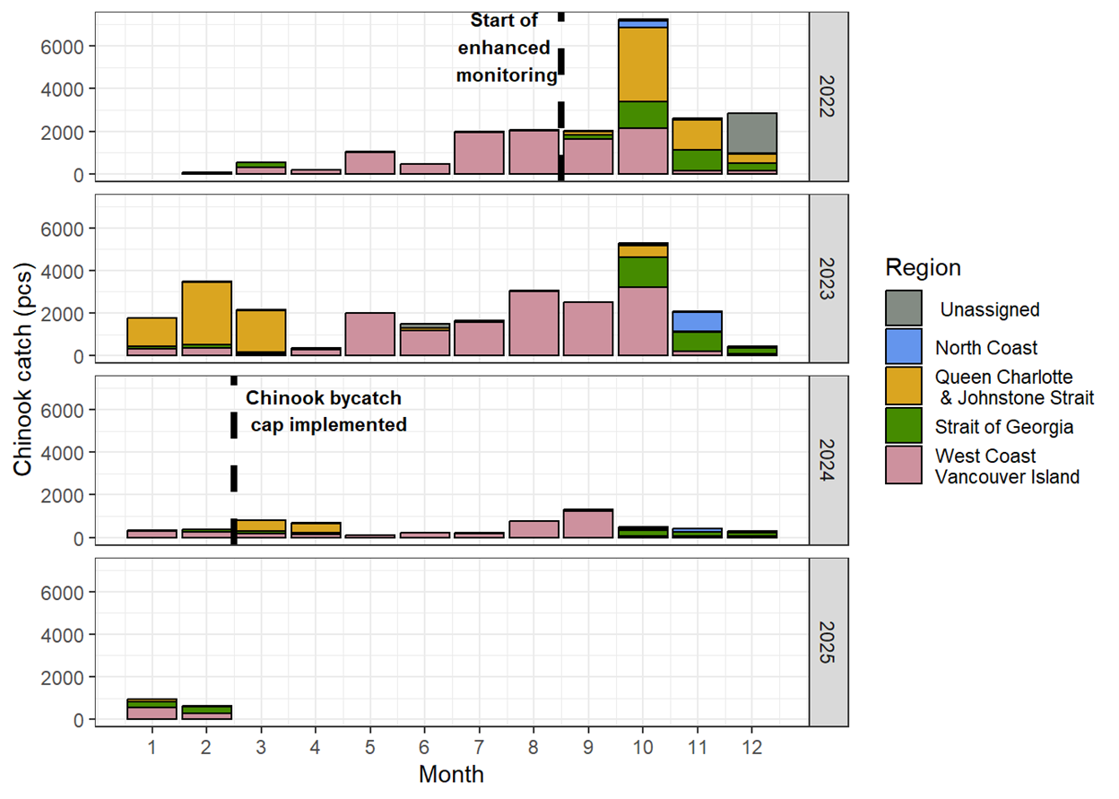

**Figure 1**

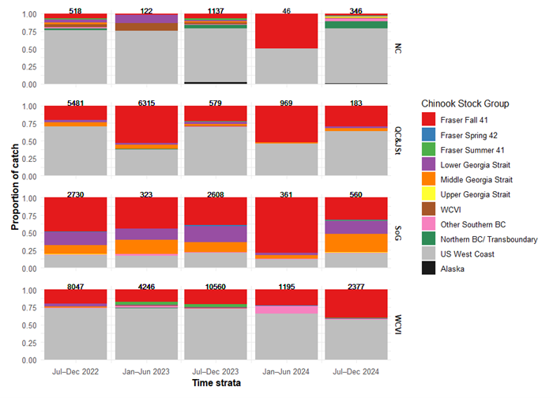

**Figure 2**

Figure 1. Chinook salmon bycatch by month and region in the groundfish trawl fishery from 2022 to the end of the 2024/25 fishery on February 21, 2025. The enhanced monitoring program and changes to retention requirements began on September 22, 2022. Chinook salmon bycatch since February 21, 2025 is not yet available or shown.

Figure 2. Chinook salmon stock composition by half-year time strata and catch region using CWT and GSI-PBT stock identification methods for bycatch occurring between September 2022 to December 2024. The numbers above each bar represent the catch of Chinook salmon within each time and region combination. The regions shown are as follows: NC = North Coast, QC&JSt = Queen Charlotte and Johnstone Strait, SoG = Strait of Georgia, and WCVI = West Coast Vancouver Island. The Other Southern BC stock group includes Fraser Spring 5(2), Fraser Summer 5(2), Boundary Bay Fall 4(1), Mainland Inlet Chinook stocks.

#### Insights

Information generated from the enhanced monitoring program has already been operationalized to develop a salmon bycatch management plan for the trawl fishery. The management plan includes a fleet-wide Chinook salmon bycatch cap of 9,500 fish along with individual vessel bycatch caps. In response to these new restrictions, the groundfish trawl industry has been investigating the use of exclusion devices – escape hatches that allow salmon to swim out of nets prior to hauling in – among other methods for reducing salmon bycatch. These regulations and changes in fishing practices have already mitigated impacts on Chinook salmon, decreasing catches by over two thirds from 2023/24 to 2024/25.

#### Next Steps

The enhanced monitoring program represented three and a half years of salmon bycatch in the groundfish trawl fishery, however, ongoing monitoring is needed to inform management of the fishery and evaluate potential impacts on stocks of concern. The groundfish trawl fishery is a year-round, multi-species fishery that may vary in the distribution of effort and catch over time in response to regulations, market incentives, fish stock abundances, and other factors. Therefore, stock composition and catch patterns observed during the enhanced monitoring program should not be considered representative of future years. There is currently uncertainty in future funding and capacity for representative sampling of DNA tissue and CWTs to estimate stock composition, which may lead to information gaps in the future. Continued monitoring, along with communication and collaboration among the trawl industry, advisory groups, First Nations, and DFO, is important for the adaptive management of salmon bycatch in the trawl fishery moving forward.

#### References

Lagasse, C.R., Fraser, K.A., Braithwaite, E., and Komick, N. 2025. Salmon bycatch monitoring and sampling results for the Pacific Region 2023/24 groundfish trawl fishery. *In* Canadian manuscript report of fisheries and aquatic sciences. Fisheries and Oceans Canada. doi:10.60825/D0E4-PP46.

Lagasse, C.R., Fraser, K.A., Houtman, R., Grundmann, E., Komick, N., Brien, M.O., Braithwaite, E., and Cornthwaite, A.M. 2024. Review of Salmon Bycatch in the Pacific Region 2022/23 Groundfish Trawl Fishery and Preliminary Results of an Enhanced Monitoring Program. Can. Manuscr. Rep. Fish. Aquat. Sci. 3273: 3273: v + 35 p.

### Project 2397: Identifying good practices for considering Indigenous Knowledge in Rebuilding Plan targets and stock assessment reference poi

### Project 2398: WCVI Sediment Transport and Redd Scour Assessment

**Location:** Tranquil Creek

### Project 2399: Risk Assessment Method for Salmon – Development for Regional Implementation

### Project 2400: Assessment of SEP Chinook and Coho broodstock ELISA screening data by modelling for explanatory variables, and yearling DFAT prevalence data by modelling for predictive variables.

**Project Leads:** Amy Long

**Collaborations:** Derek Price, DFO

Ian Keith, DFO

Cheryl Lynch, DFO

**Location:** Spius Creek;#Puntledge River;#Nitinat

**Region:** Pacific

**Species:** Chinook salmon (Fall, Spring, and Summer)

Coho salmon (Fall)

**Life History:** Juveniles, broodstock

**Stock:** Puntledge, Nitinat, Coldwater River, Spius Creek, Nicola River, Chilcotin River, Chilko Ricer, Salmon River, Eagle River

#### Highlights

The study explored the relationship between parental BKD levels on individual salmon results while controlling for the impact of environmental factors such as thermal regime using previously collected data including broodstock disease levels, environmental parameters, and progenitor disease status.

BKD levels in returning adults do not demonstrate a significant association with the OD levels of their progenitors. Instead, the relationship appears to be confounded by environmental and population-level factors, including water temperature, specific watershed characteristics, and the overall BKD prevalence within the returning population.

The findings reveal key knowledge gaps in understanding BKD dynamics, suggesting the need for further research to build a fuller picture of the factors influencing disease transmission and prevalence.

#### Background

*Renibacterium salmoninarum*, the causative agent of bacterial kidney disease (BKD), is endemic to the Pacific Northwest. Infection with this bacterial pathogen can result in significant morbidity and mortality in cultured juvenile Pacific salmon. Current BKD management relies on screening brood stock using an enzyme-linked immunosorbent assay (ELISA) and excluding eggs from females exceeding the defined optical density (OD) threshold. This approach has significantly reduced the incidence of disease in both hatchery-reared juveniles and returning adult fish. The Salmonid Enhancement Program (SEP) maintains an extensive dataset that includes 16 years of ELISA broodstock screening results for many Vancouver Island and mainland Coho and Chinook stocks.

These datasets have not been previously subjected to a comprehensive epidemiological analysis to identify potential explanatory variables for BKD prevalence in stocks of concern. This project sought to address that knowledge gap by integrating ELISA data and linking broodstock ELISA values to Parental Based Tagging (PBT) information enabling stock-specific analyses. The work was conducted through a collaborative partnership among the Science Branch, SEP, and Aquaculture Management.

#### Methods and Findings

Methods

The study explored the relationship between parental BKD levels on individual salmon results while controlling for the impact of environmental factors such as thermal regimes by incorporating various temperature metrics, such as average temperature, minimum and maximum temperatures, degree days, and the number of days within specific temperature thresholds (6°C to 10°C). While Nitinat’s temperature data was based on monthly or daily mean temperatures (depending on the year), Puntledge and Spius provided daily mean, maximum, and minimum temperatures. For each stock year, temperature data were filtered to include dates that a stock occupied the hatchery, e.g. the day of first broodstock captured to the day of last juvenile release. Juveniles of Chinook stocks were released less than a year of holding at the hatchery at Puntledge and after two years at Spius, while Coho stocks were released after 1 year and 2 year but temperature measurements were calculated based on the 2 year release for Coho stocks.

Data used in the analysis was from 2014 through 2023, and was dependent on data available in E-PRO and temperature data (Table 1). Only individuals with BKD value and maturity class information were included. Incomplete data points were filtrated out in each analysis. Dam’s BKD optical density (OD) value and BKD level were attached to E-PRO records for progenies by matching progenies’ dam DNA code to the dam’s data in the report. This step was only possible for progenies with dam’s DNA code and BKD OD value.

To guide the modelling of the vertical transmission path, we collaborated with an expert panel to develop a causal diagram (Figure 1). This exercise facilitated the identification and characterization of relationships across multiple scales, including the watershed, hatchery, and individual fish levels, while specifically assessing variables for their potential to confound the results. We evaluated these factors using a mixed-effects generalized linear model framework, designating the OD from the BKD ELISA as the outcome of interest and the OD of the progenitor (the dam) as the primary predictor. Temporal variation was integrated as a random effect to account for annual fluctuations. The final model incorporated several confounding factors, most notably the specific watershed of origin. We also included terms for interactions between mean temperature—which was scaled and centered by creek—and BKD prevalence at the stock level. For the purposes of this analysis, a stock was defined as a cohort of brood fish of the same species returning to the same creek during the same season, such as Nitinat Spring Coho. While species and season were initially tested, they were excluded from the final model as they were not statistically significant and did not meet the criteria for confounders; their observed effects were largely captured by spatial and temporal variables.

Research Findings

The primary analysis indicates that BKD levels in returning adults do not demonstrate a significant association with the OD levels of their progenitors. Instead, the relationship appears to be confounded by environmental and population-level factors, including water temperature, specific watershed characteristics, and the overall BKD prevalence within the returning population. For instance, while the watershed variable was not statistically significant in isolation, its inclusion in the model resulted in a measurable change in the coefficient of the primary predictor, suggesting a latent environmental influence. A more notable finding was the negative association between BKD levels and scaled temperature, which suggests that OD levels generally decrease as temperatures increase. However, a significant interaction between temperature and BKD prevalence indicates a modulating effect on this relationship (Figure 2). While lower temperatures appear to provide a more suitable environment for the transmission of BKD, a higher proportion of infected individuals within a population further intensifies this effect.

It is important to note, however, that the statistical model demonstrated a relatively low goodness-of-fit, indicating that a substantial portion of the variance in BKD levels remains unexplained by the variables currently under study. This suggests that the dynamics of BKD in these ecosystems are influenced by a complex array of factors—potentially including individual host immunity, varying hatchery practices, or additional environmental stressors—that were not fully captured in the present framework. Consequently, while the identified trends regarding temperature and prevalence offer valuable directional insights, they should be interpreted with caution and viewed as preliminary findings within a highly variable biological system.

#### Tables and Figures

| Stock Name | Cohort | BKD screening | Progenitor DNA | Temperature Data |
| --- | --- | --- | --- | --- |
| Puntledge Fall Coho | * | 2018, 2020 | None | 2014-2023 |
| Puntledge Summer Chinook | * | 2014-2023 | 2017-2023 | 2014-2023 |
| Nitinat Fall Coho | * | 2014-2022 | 2016-2020, 2022 | 2014-2023 |
| Coldwater River Spring Chinook | Spius 1 | 2014-2023 | 2019, 2022, 2023 | 2017-2022 |
| Spius Creek Spring Chinook | Spius 1 | 2014-2023 | 2019, 2022, 2023 | 2017-2022 |
| Nicola River Spring Chinook | Spius 1 | 2014-2023 | 2019-2022 | 2017-2022 |
| Chilcotin River Spring Chinook | Spius 3 | 2021, 2022 | None | None |
| Chilko River Summer Chinook | Spius 4 | 2014-2023 | 2021 | None |
| Coldwater River Fall Coho | Spius 1 | 2014-2023 | 2017, 2020-2022 | 2017-2022 |
| Spius Creek Fall Coho | Spius 1 | None | None | 2017-2022 |
| Salmon River Fall Coho | Spius 2 | 2014-2015, 2017-2023 | 2017-2018, 2020, 2022-2023 | None |
| Eagle River Fall Coho | Spius 5 | 2015-2023 | 2018-2020, 2022 | None |

**Table 1**

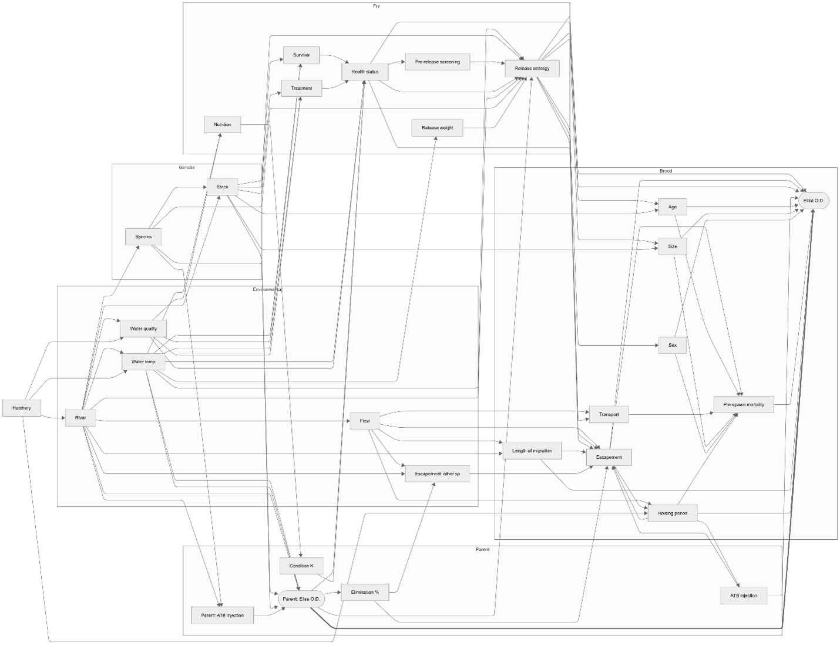

**Figure 1**

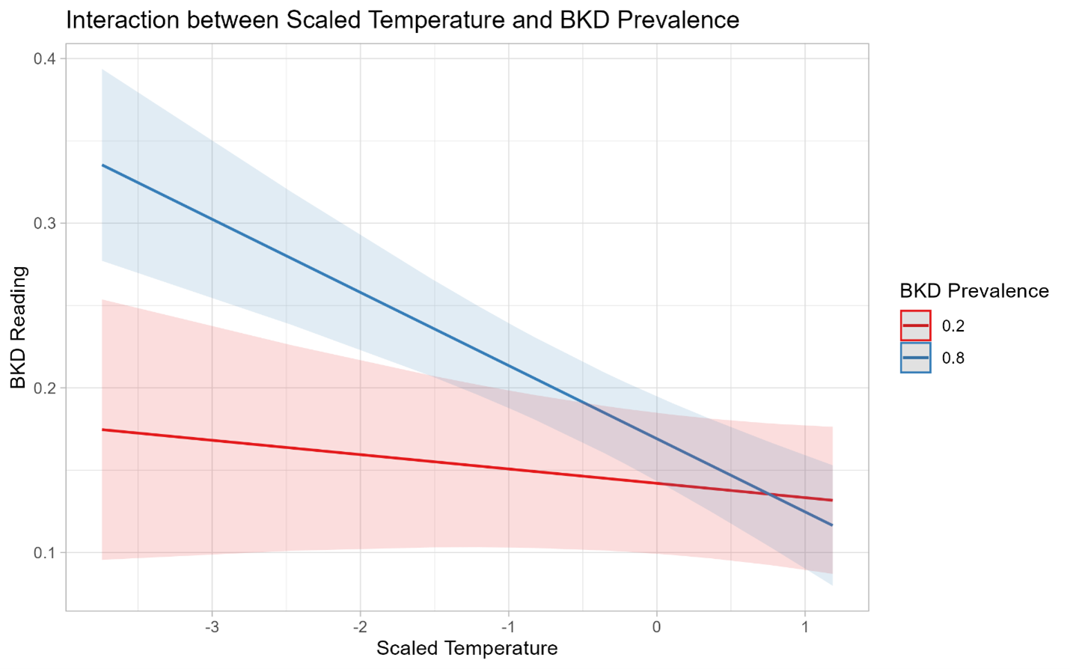

**Figure 2**

#### Insights

The findings reveal key knowledge gaps in understanding BKD dynamics, suggesting the need for further research to build a fuller picture of the factors influencing disease transmission and prevalence. The low goodness-of-fit of the current model indicates that additional variables, such as hatchery practices, genetic diversity, or other environmental and anthropogenic stressors, may play significant roles in shaping BKD dynamics. A promising avenue for research includes the use of simulation models to assess the impact of altering management practices, such as raising or lowering the positive-negative culling threshold OD value. This approach could help predict how adjustments to culling thresholds might influence disease prevalence and population outcomes under varying environmental conditions. Research should also focus on understanding potential thresholds or tipping points where environmental conditions, such as temperature extremes, significantly influence disease prevalence and outcomes.

The study’s findings can inform proactive strategies for salmon conservation and management, particularly concerning how environmental conditions affect BKD prevalence. Managers could prioritize monitoring in watersheds where conditions, including temperature and BKD prevalence, elevate disease transmission risks. Additionally, the insights from simulations examining the effect of changing the positive-negative culling threshold OD value could guide policy and operational decisions to strike a balance between limiting disease spread and optimizing population sustainability.

#### Next Steps

The findings reveal key knowledge gaps in understanding BKD dynamics, suggesting the need for further research to build a fuller picture of the factors influencing disease transmission and prevalence. The low goodness-of-fit of the current model indicates that additional variables, such as hatchery practices, genetic diversity, or other environmental and anthropogenic stressors, may play significant roles in shaping BKD dynamics. A promising avenue for research includes the use of simulation models to assess the impact of altering management practices, such as raising or lowering the positive-negative culling threshold OD value. This approach could help predict how adjustments to culling thresholds might influence disease prevalence and population outcomes under varying environmental conditions. Research should also focus on understanding potential thresholds or tipping points where environmental conditions, such as temperature extremes, significantly influence disease prevalence and outcomes.

The study’s findings can inform proactive strategies for salmon conservation and management, particularly concerning how environmental conditions affect BKD prevalence. Managers could prioritize monitoring in watersheds where conditions, including temperature and BKD prevalence, elevate disease transmission risks. Additionally, the insights from simulations examining the effect of changing the positive-negative culling threshold OD value could guide policy and operational decisions to strike a balance between limiting disease spread and optimizing population sustainability.

### Project 2401: Epidemiological modeling of infectious hematopoietic necrosis virus in Sockeye salmon

**Project Leads:** Kyle Garver

**Location:** Okanagan;#Nadina Hatchery;#Fulton Hatchery;#Pinkut Hatchery;#Weaver Creek Spawning Channels

**Species:** Sockeye salmon

**Waterbodies:** Weaver Creek, Nadina River, Fulton River, Pinkut Creek

**Life History:** Region

**Stock:** Population (if applicable)

#### Highlights

This study examined IHNV prevalence across different watersheds, Sockeye stocks, and environmental conditions to identify those factors responsible for driving IHNV prevalence and/or influencing disease within Sockeye salmon populations

#### Background

Infectious hematopoietic necrosis virus (IHNV) is a deadly virus of Sockeye salmon, causing catastrophic losses during the early lifestages. Long-term monitoring of IHNV infections across multiple stocks of Sockeye salmon has revealed the prevalence of IHNV infections can vary annually within and between stocks; however, the factor(s) responsible for such fluctuations in IHNV prevalence in sockeye salmon stocks in British Columbia remain unresolved. Understanding the drivers behind the occurrence and perpetuation of IHNV in Sockeye salmon is instrumental in managing and mitigating the risk of this endemic pathogen. Utilizing epidemiological analytical approaches to study the patterns of IHNV in Sockeye salmon we’ll identify the factors which influence the prevalence of the virus in BC Sockeye salmon stocks.

#### Methods and Findings

METHODS:

Adult and fry Sockeye salmon were each collected annually from 1987 to 2018, from each of four spawning channel populations, representing two stocks within the Fraser River watershed and two within the Skeena River watershed (Figure 1). Samples were screened for the presence of infectious hematopoiectic necrosis virus (IHNV) using cell culture methodologies. Characteristic cytopathic effects (CPE) observed in cells indicated the presence of viable replicating IHNV. Prevalence of IHNV was calculated by dividing the number of samples with CPE by the total number of samples screened.

We used statistical methods to understand how IHNV prevalence in adult fish relate to infection levels in fry, and how infection in fry affects infection in adults that return 3–4 years later.

To compare how infection levels changed over time, we looked at timeseries data for each project site (Fulton, Pinkut, Nadina, Weaver) and for each life stage (fry, adult males, adult females). We used a clustering method that can line up patterns even when the timing doesn’t match perfectly (a technique called dynamic time warping) to measure how similar the trends were.

To study how infection in returning adults affects IHNV prevalence in fry, we used a mixedeffects binomial model for proportions that accounted for differences between spawning years and project sites.

To study how fry infection affects infection in adults 3–4 years later, we used a similar model along with escapement data to calculate a weighted average of fry infection that matched the makeup of the returning adult population. Because the relationship wasn’t linear, we also added a quadratic term to better capture the pattern.

RESULTS:

From 1987 to 2018, a total of 56,692 Sockeye salmon were screened for IHNV. Over this 32 year timeframe, the prevalence of IHNV infections varied annually within and between the four stocks sampled (Figure 2). Across the entire dataset, there was a positive correlation between the detection of IHNV in male and female samples; with the prevalence being generally higher in females than in males (Figure 3). Nonetheless, this prevalence in spawned females was not demonstrative of what was observed in fry, as there were numerous years where IHNV was not detected in the fry despite high prevalence in the broodstock. However, it appears as though the IHNV prevalence in fry is a strong predictor of the population’s IHNV status upon returning adults 4 years later. For instance, fry with 50% IHNV prevalence are predicted to return as adults with a prevalence of 30 to 80% (Figure 4).

#### Tables and Figures

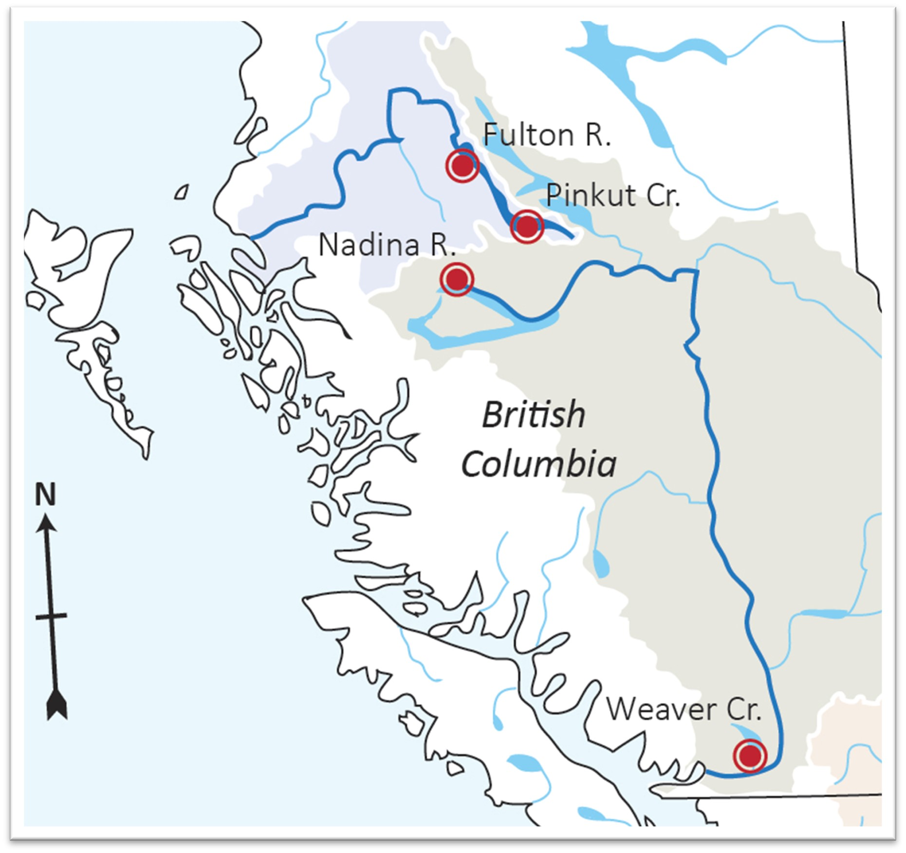

**Figure 1**

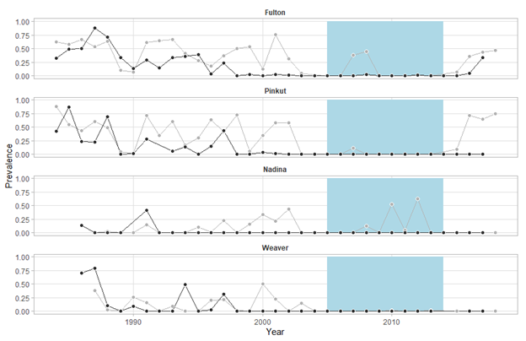

**Figure 2**

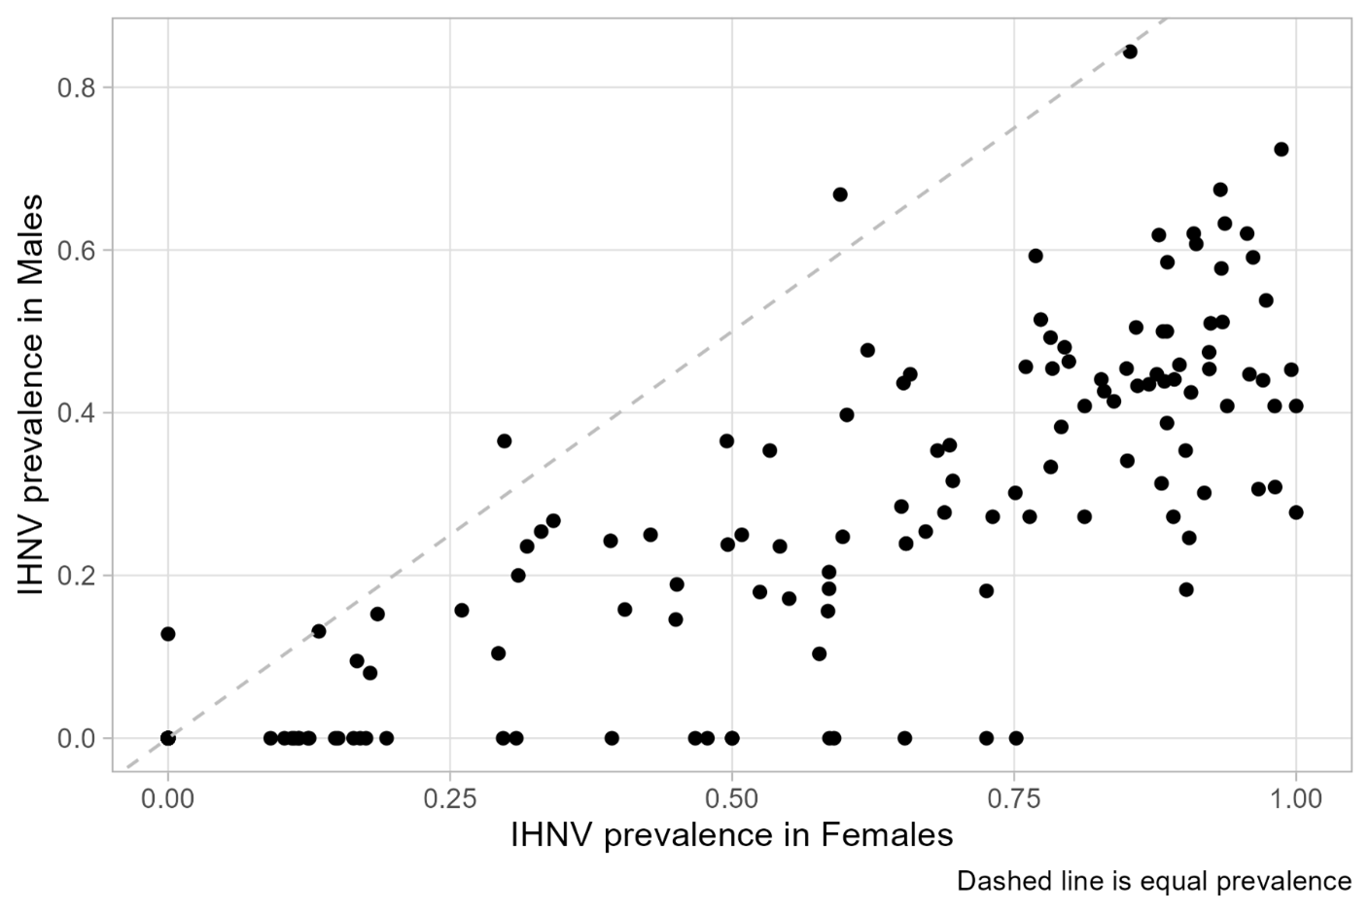

**Figure 3**

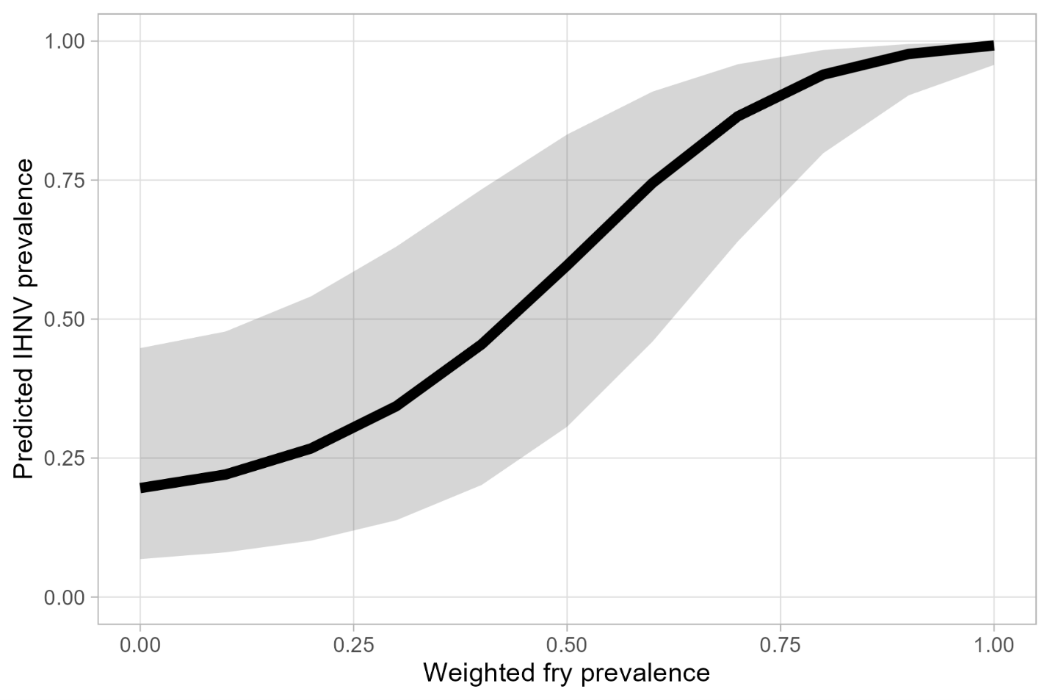

**Figure 4**

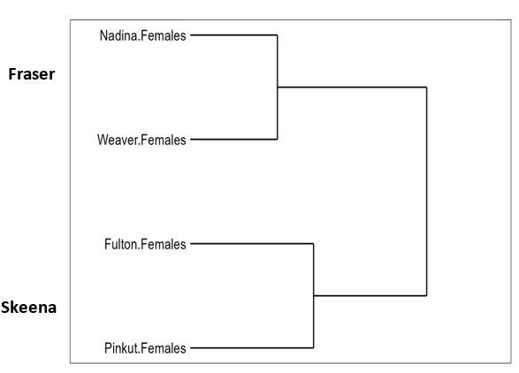

**Figure 5**

Figure 1. Map showing the locations of the Sockeye Salmon spawning channels (red circles) within the Skeena and Fraser River watersheds, revealed by blue and olive shading; respectively.

Figure 2. Annual prevalence of IHNV in adults (grey) and fry (black) Sockeye salmon collected over 32 years from spawning channels located at Fulton River, Pinkut Creek, Nadina River and Weaver Creek. Blue shading highlights years where IHNV prevalence was generally lower across all four collection sites.

Figure 3. Plot illustrating a positive relationship between IHNV prevalence in males (y-axis) and females (x-axis)

Figure 4. Plot illustrating the predicted IHNV prevalence in returning adult Sockeye salmon to Fulton River Spawning Channel based on IHNV prevalence in fry. Grey shading represents 95% confidence intervals.

Figure 5. Cluster diagram illustrating similarities in IHNV prevalence of adult female Sockeye salmon across spawning channels over a 32 year time period.

#### Insights

This work provides the first long-term dataset of infectious hematopoietic necrosis virus (IHNV) prevalence among various Sockeye salmon stocks in British Columbia and reveals a highly dynamic nature of this deadly virus. From this data, it was learned that when surveying adult fish, it is best to sample females as they have the highest prevalence. In naturally spawning populations of Sockeye salmon, it was found that the IHNV prevalence in broodstock offers little insight into the infection status of fry, as true parent to progeny transmission is unlikely. In many instances, high IHNV prevalence in adults did not result in the occurrence of virus in fry. However, unexpectedly it was discovered that IHNV prevalence in fry is significantly correlated to the prevalence of returning adults, suggesting IHNV in adults is partially explained by their status as fry and supports the role of a lifelong IHNV carrier state in perpetuating IHNV in Sockeye salmon populations.

#### Next Steps

This work illustrates the importance of long-term datasets in differentiating genuine trends from short term fluctuations and to uncover complex ecological dynamics. Analysis of IHNV prevalence across the four stocks over the 32 year timeframe revealed that prevalence across stocks is most similar within a river system, suggesting watershed or regional specific factors may influence level of IHNV in the system (Figure 5). Nonetheless, a shared prolonged reduction of IHNV observed across both Fraser and Skeena watersheds, suggests broader oceanic factor(s) are contributing to the occurrence of IHNV in Sockeye salmon (Figure 2). Given these trends, we are presently gathering environmental, management and other data to determine if there are correlates that are explanatory for these trends. In particularly, we are employing Pacea, an R package of ecosystem information, to link biological data with environmental variable to generate models and visualizations.

### Project 2402: Quantifying Yukon Chinook migration mortality and its implications for fisheries management and rebuilding under the Fish Stock Provisions of the Fisheries Act

**Location:** Yukon River

### Project 2403: San Juan River Adult and Juvenile Assessment Program

**Location:** San Juan River;#Port San Juan;#4 Mile Creek

### Project 2404: Improving baseline knowledge of environmental conditions in Vancouver Islands fjords through observations and modelling, with a focus on hypoxia dynamics, climate change, and the potential implications for Pacific salmon

**Project Leads:** Laura Bianucci

**Collaborations:** Ahousaht First Nation, Hesquiaht First Nation, Tla-o-qui-aht First Nation, Nuu-cha-nulth Tribal Council, Nature Trust of BC, Maaqutusiis Hahoulthee Stewardship Society

**Location:** Clayoquot Sound

**Region:** WCVI

**Species:** Waterbodies (if applicable)

**Waterbodies:** Clayoquot Sound

**Life History:** Region

**Stock:** Population (if applicable)

#### Highlights

Salmon spend a crucial part of their early and late life stages in fjords and are therefore affected by the nearshore environment. This project aims to understand ocean conditions in these coastal areas and how they may change under future climates, using both numerical models and observational datasets. The project focuses on Clayoquot Sound, BC, but the methods are applicable for other regions in the west coast of Vancouver Island (WCVI).

Clayoquot Sound is comprised of several fjords located in close proximity of each other. Through this project, we were able to identify how and why conditions in these fjords differ. For instance, Tofino Inlet to the south has stronger freshwater inputs, is shallower and has a weaker connection with the shelf waters than northern fjords like Sydney and Shelter Inlets, leading to a fresher and warmer Tofino Inlet compared to Sydney and Shelter. Furthermore, the role of the sills (particularly the shallow one outside of Herbert Inlet) plays a leading role modulating the deeper waters of the inlets (due to strong tidal mixing at the sill and strong tidal advection).

Monitoring of oxygen concentrations in Clayoquot Sound showed that oxygen conditions can reach levels that are stressful for Pacific salmon in all seasons and even close to the surface.

Future scenarios suggest that all of Clayoquot Sound will become warmer, while salinity will not change significantly. Fjords that are generally warmer in present-day simulations, like Tofino, are more at risk of exceeding temperature thresholds that can stress Pacific salmon.

#### Background

Salmon spend time in fjords and inlets once they leave their rivers and before they venture into the open ocean. The conditions they encounter in these nearshore environments may be crucial for their success at later life stages. But, what are these conditions like and how may they change with climate? This project aims at answering those questions, with a focus on Clayoquot Sound and making use of both numerical models and observations.

We established a monitoring program in this region, in collaboration with local indigenous groups (Ahousaht First Nation, Hesquiaht First Nation, Tla-o-qui-aht First Nation, Uu-a-thluk Fisheries, Nuu-cha-nulth Tribal Council, and Maaqutusiis Hahoulthee Stewardship Society). We supported them with funds, training, and/or materials to sample vertical profiles of temperature, salinity, and oxygen every month in their territorial waters. This project also helped maintain our existing weather station network (mostly installed in finfish farms) and supported the deployment of two moorings inside the inlets to obtain timeseries of currents, temperature, salinity and oxygen. All of these data have supported the development and evaluation of the WCVI model, which can represent observed conditions in the near past (referred to as “present-day”) and represent expected conditions under a future scenario.

#### Methods and Findings

Our observational methods are traditionally used in oceanographic research, e.g. sampling temperature, salinity and oxygen profiles with a CTD instrument as well as deploying moorings and weather stations. However, the innovative aspect is the collaboration with local communities. These collaborations allowed for sampling at a much higher frequency (~monthly) than anything achievable by DFO alone, but still maintaining DFO’s high-quality data standards (thanks to training and data post-processing and quality control by DFO). As a reference, DFO-led sampling provided 82 CTD profiles in 2019 (mostly from March and October/November) and 122 profiles in 2024 (a well-sampled year through many PSSI projects), while this project’s Nation-led sampling in 2024 provided 150 profiles (mostly monthly from March to December). Beyond the scientific benefits, these collaborations were essential for building long-term relationships with First Nations partners, fostering mutual trust, and creating a framework for ongoing knowledge exchange between Indigenous knowledge systems and western scientific approaches.

In terms of modelling, the WCVI model has been developed and run for 2019, 2024 (to take advantage of the intensive PSSI-related sampling) and one future scenario centered in 2055. Simulations for 2019 and 2024 have been compared against observations and show good agreement, particularly temperature and salinity. Biogeochemical variables (e.g., oxygen, nitrate) show good performance on the shelf, but some further calibration is needed to reach the desired performance inside the inlets. Figure 1 shows the model domain and bathymetry.

Analyses of model outputs in Clayoquot Sound indicate that the inlets towards the south are warmer and fresher than those on the north at all levels of the water column and all three seasons analyzed (spring, summer, autumn). These conditions are due to stronger freshwater inputs, shallower bathymetry and a less direct connection with the shelf waters in southern inlets (Tofino to Bedwell) compared with northern inlets (Herbert to Sydney). In particular, model results allowed to study the role of the sills (particularly the shallow one outside of Herbert Inlet), which play a leading role modulating the deeper waters of the inlets (due to strong mixing at the sill and strong tidal advection).

When comparing model results against temperature values that result in stress responses by Chinook salmon (above 16 to 18°C, personal communication by PSSI colleague Christoph Deeg), we find that the surface waters of all inlets may exceed these thresholds in summer under present-day conditions (Figure 2a). Furthermore, Tofino Inlet shows waters above these thresholds at all depths (Figure 3). When analyzing the same thresholds under the future scenario, they are exceeded mostly everywhere in the Sound in the top 5 meters (Figure 2b,c), and exceeded at depth in the southern inlets (from Bedwell to Tofino).

Once the performance of the biogeochemical module of the WCVI is deemed appropriate, a similar analysis will be performed with oxygen, considering that salmon show signs of stress at environmental values lower than 6 to 8 mg L-1 (Christoph Deeg, personal communication). Nevertheless, from the observational record we find that Clayoquot Sound shows throughout the year oxygen concentrations that fall below these thresholds, even near the surface from spring to autumn (Figure 4).

Two peer-reviewed publications are being prepared to discuss these results, while two manuscripts are already published discussing the low near-surface oxygen conditions (Rosen et al, 2022) and describing the model (Foreman et al, 2024). Informal presentations and updates were provided regularly to Gemma Macfarlane, the Stewardship Biologist from Maaqutusiis Hahoulthee Stewardship Society from Ahousaht Nation, as well as to project collaborators. A formal presentation was provided at the last Pacific Salmon Science Symposium in December 2025 and two other ones are scheduled in January and March 2026 to the Maa-nuult Joint Fisheries Committee (JFC) Technical Meeting Series and the State of the Pacific Ocean meeting, respectively. A presentation at a scientific meeting was planned for February 2026, but travel was not approved.

#### Tables and Figures

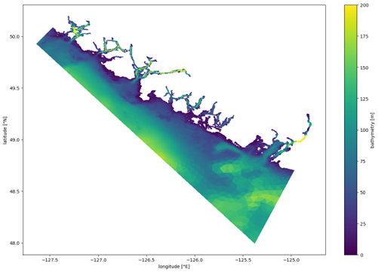

**Figure 1**

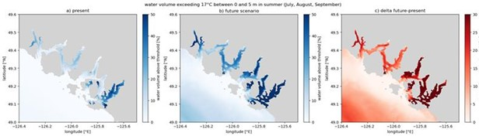

**Figure 2**

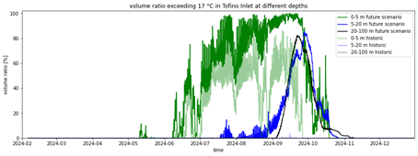

**Figure 3**

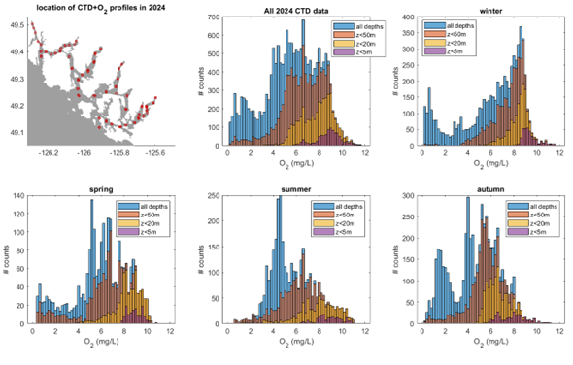

**Figure 4**

Figure 1. West coast Vancouver Island (WCVI) model domain. Colourscale shows the model bathymetry (in meters)

Figure 2. Maps of Clayoquot Sound showing the percentage of the top 5m of the water column exceeding 17°C in summer (July, August and September) in the (a) simulation for 2024 and (b) future scenario. Panel (c) shows the difference between both (future scenario minus 2024 simulation), highlighting the additional percentage of the surface waters that can exceed the temperature threshold in the future scenario.

Figure 3. Time series of the percentage of water volume that exceeds 17°C in Tofino inlet at different depth ranges and different simulations. Bold colours indicate the future scenario, while paler colours indicate the 2024 simulation. Green colours indicate the volume in the surface depth range (0 to 5 m), blue colours represent upper waters below the surface (5 to 20 m) and black/grey represent deep waters (20 to 100 m). At surface, both simulations exceed the threshold between spring and autumn, while below 5 m the threshold is exceeded mostly in the future scenario.

Figure 4. Location of the CTD profiles with oxygen data from 2024. The oxygen histograms show the distribution of oxygen data for the whole 2024 year and four seasons (winter: Jan-Mar, spring: Apr-Jun, summer: Jul-Sep, and winter: Oct-Dec). The different colours show the histograms for four different depth ranges: the whole water column (blue), top 50 meters (orange), top 20 meters (yellow) and top 5 meters (purple).

#### Insights

This project has added key oceanographic information related to known salmon stressors (temperature, oxygen) to help understand the environment encountered by salmon while migrating towards/from the open ocean. Furthermore, future scenarios provide a management framework to assess how these environments may change over time, allowing for decisions, policy and/or plans to access useful information in case they need to adapt to future conditions. Most importantly, this project created at tool that can be further applied, e.g. by looking into other inlets or sounds as well as by expanding the model or its analysis to include other variables.

In summary, this work has shown that the thermal tolerance of salmon can be exceeded in the southern inlets of Clayoquot Sound (particularly Tofino Inlet and especially in summer). Furthermore, the future scenario we analyzed (based on a “business as usual” scenario centered in 2055) shows an increase in the volume of waters that exceed the thermal threshold throughout Clayoquot Sound. While a less crucial stressor, we studied salinity and its potential future changes, since salmon-affecting bacteria may increase at higher salinities. We are still working on the model improvements needed to extend the analysis to oxygen conditions, which are also vital for salmon health, but observational analysis indicates that concentrations below the optimal range for salmon are ubiquitous in Clayoquot Sound.

#### Next Steps

The first next step would be to extend current analyses to other Sounds of WCVI, beyond Clayoquot Sound. But it is noteworthy that while this project has focused on temperature and oxygen, the model provides a larger set of environmental variables. Future studies could expand and deepen the analysis of existing model results, investigating the potential role of changes in other ecosystem variables currently modelled (e.g., phytoplankton, zooplankton, nutrients, etc.). Furthermore, future projects could extend the model capabilities by including the carbonate system and/or submerged aquatic vegetation modules. The former would allow for the study of ocean acidification as an environmental stressor and the latter could inform the understanding of climate change in habitat quality. Both modules are available within the modelling framework, but not yet applied to the WCVI model.

Since warming temperatures and declining oxygen concentrations will be issues affecting nearshore environments utilized by Pacific salmon, it would be crucial for salmon conservation and management to consider, mitigate, and adapt to these factors as climate changes.

#### References

Rosen, S., Bianucci, L., Jackson, J.M., Hare, A., Greengrove, C., Monks, R., Bartlett, M. and Dick, J., 2022. Seasonal near-surface hypoxia in a temperate fjord in Clayoquot Sound, British Columbia. *Frontiers in Marine Science*, *9*, p.1000041.

Foreman, M.G.G., Chandler, P.C., Bianucci, L., Wan, D., Krassovski, M.V., Thupaki, P., Cooper, G. and Lin, Y., 2024. A circulation model for inlets along the central West Coast of Vancouver Island. *Atmosphere-Ocean*, *62*(1), pp.58-89.

### Project 2405: Biological models to support prioritizing salmon stocks under future climates

**Project Leads:** Jan Finke

Travis Tai

Brendan Connors

Cameron Freshwater

Patrick Thompson

**Collaborations:** Amber Holdsworth and Angelica Pena (Ocean Sciences Division); Dan Selbie, Howard Stiff, Greig Oldford, and Josie Iacarella (Ecosystem Science Division)

**Location:** Pacific Biological Station;#PSEC West Vancouver;#IOS Sidney

**Region:** British Columbia and Washington

**Species:** Sockeye Salmon

**Life History:** Lifecycle: Spawners, smolts, escapement

**Stock:** Population (if applicable)

#### Highlights

The goal of the project is to estimate how climate related environmental variables are influencing sockeye salmon productivity across different life stages and populations using quantitative models. These estimates will be combined with climate projections to estimate how future conditions may impact salmon populations in future decades.

Key initial findings, based on the 13 populations model:

Environmental drivers and life stages influencing future impacts vary among populations.

All assessed populations are sensitive to projected changes

Negative impacts are expected to be greatest in southern regions (Columbia, Fraser, WCVI) and driven by increased marine temperatures and freshwater temperatures during adult migrations, while some northern populations may initially benefit from warming.

These projections will help identify the life stages most vulnerable to climate change and guide management strategies by highlighting population-specific sensitivities.

#### Background

Many sockeye salmon populations have declined in abundance despite reductions in harvest, suggesting reduced productivity driven by environmental forcing, with poor marine survival identified as a key contributing factor (Peterman and Dorner 2012, Connors et al. 2020). Yet some sockeye salmon populations are stable or increasing (Brown et al. in press, Ogden et al. 2024). The cause of divergent trends in abundance is unclear, resulting in considerable uncertainty about which sockeye salmon populations are most likely to be resilient to changing environmental conditions.

Evaluating future risk requires information on both population-specific stressors and biological responses to those stressors. Although quantitative climate change vulnerability assessments have been performed for a number of Pacific salmon populations, they have largely focused on American Chinook salmon populations from a small number of watersheds (e.g. Crozier et al. 2021). Here we leveraged a unique dataset of juvenile and adult abundance from a network of thirteen sockeye salmon populations extending from the Columbia River to northern British Columbia. We parameterized an age-structured life cycle model that included freshwater and marine covariates to estimate population-specific functional responses, then evaluated how populations fared under various climate change scenarios. Our study incorporated expertise from diverse collaborators, within and outside DFO, with expertise in stock assessment, global climate models, and salmon ecology. Our work can be used to identify Pacific salmon life stages that are most vulnerable to climate change and help prioritize management interventions.

#### Methods and Findings

Overview of the model We developed a full life cycle model that consists of two stages: 1) spawner to smolt production and 2) smolt to adult recruit survival (Figure 1). Each stage of the model consists of a Beverton-Holt function, where density-independent production (i.e., survival) is a function of the environmental conditions experienced in that life stage. We modelled each age class separately because sockeye salmon vary in the number of years that they spend rearing in freshwater as well as in the ocean, and covariates were lagged so that each age class was only affected when it overlapped in space and time with a given covariate.

We used a state space approach that linked population dynamics to the observed data and accounted for cyclical feedback among generations. This structure allowed us to account for missing data, observation error, and variation in the life stage that was observed for juveniles (smolt vs. fry). The model was implemented in Stan and fit using Bayesian inference within a hierarchical framework, allowing information to be shared across populations.

Salmon data

Our model is based on thirteen populations of sockeye salmon (Figure 2) where there are estimates of spawner abundance, juvenile abundance (smolt or fry), and adult recruitment. In addition, we have estimates of age structure for juveniles, adult recruits, or both. These populations come from six different watersheds spanning the entire province of BC: Columbia, Somass, Fraser, Skeena, Stikine, Taku. We included data from 1981 to 2024 in our model.

Environmental covariates

We selected environmental covariates based on our understanding of the sockeye salmon lifecycle and when and where the populations experience different conditions. To do this, we developed a directed acyclic graph (DAG; simplified version in Figure 2) that outlines our hypothesized causal effects, as well as our understanding of how environmental covariates influence each other or are influenced by shared drivers (e.g., a common regional climate). We were unable to include all hypothesized covariates, because in many cases we do not have appropriate data for all populations. For example, we know that zooplankton community composition is likely to influence survival (Peterson and Schwing 2003) and that zooplankton dynamics are in turn influenced by temperature and mixed layer depth (Mackas et al. 2012). Thus, based on our model structure, we can interpret any effects of marine temperature and mixed layer depth as being, at least partially due to their effects on zooplankton. In this way, we use the DAG to understand whether our estimated environmental effects are likely to be biased or confounded, and to adjust our model and interpretation accordingly.

The environmental covariates (Figure 3) that we hypothesized could influence spawner to smolt production were: 1) winter (Oct. to Mar.) rearing temperatures (2 or 3 years after spawning), and summer (Apr. to Sep.) rearing temperatures (1 or 2 years after spawning) in nursery lakes. The environmental covariates that may influence smolt to adult recruit survival were: 1) near surface temperature averaged across the juvenile marine migration route for the period of April to June; 2) mixed layer depth averaged across the juvenile marine migration route for the period of April to June; 3) near surface temperatures in the open ocean in summer (Jul. to Sep., 1 or 2 years after ocean entry) and winter (Jan. - Mar.; 1,2, or 3 years after ocean entry); 4) river temperature during upstream migration , 5) river discharge during upstream migration.

Freshwater temperatures and discharge were sourced from the Pacific Climate Impact Consortium (Werner et al. 2019). The juvenile marine migration route is defined as all polygons in Figure 2 from the point of ocean entry for each population and north to Alaska along the continental shelf (i.e., depths less than 500 m). The open-ocean domain was defined by a rectangular polygon in the North Pacific, bounded by 170°W, 145°W, 60°N, and 45°N; areas shallower than 1000 m and regions north of the Aleutian Islands were excluded. Coastal temperature and mixed layer depth were sourced from the BCCM downscaled climate model (Peña and Fine 2024), the HOTSsea model (Oldford et al. 2024) and the GLORYS12 reanalysis (E.U. Copernicus Marine Service Information (CMEMS). Marine Data Store (MDS)). Open ocean temperatures were sourced from GLORYS12.

Future projections

We are still in the process of integrating our model with future climate projections.

This will be done by taking the estimated parameters of our model and applying them to averaged historical (1995 to 2025) baseline conditions as well as future projected (2041 to 2070) environmental conditions. This will allow us to estimate how the mean number of adult recruits per spawner is expected to change between these two periods, due to climate change. We plan to contrast the RCP 4.5 and 8.5 future climate scenarios to assess how sensitive our projections are to the specific emission scenario. Future climate projections will be sourced from the BCCM (Pena et al.) model, downscaled CMIP6 model (ACTEA) and PCIC (citation).

Initial results

We find that all populations are sensitive to environmental change at some point in the lifecycle (Figure 4). However, there is considerable variation across populations as to where in the lifecycle environmental conditions have the greatest impact. Southern populations (WCVI and Columbia) appear to be most sensitive to changes in the early marine stage. Fraser and Columbia populations appear to be most sensitive to warm waters experienced during upstream migration. In contrast, summer temperatures during lake residence had a relatively small effect on recruitment for all populations. Northern populations show greater variability in their responses, and some may even benefit from some degree of warming.

#### Tables and Figures

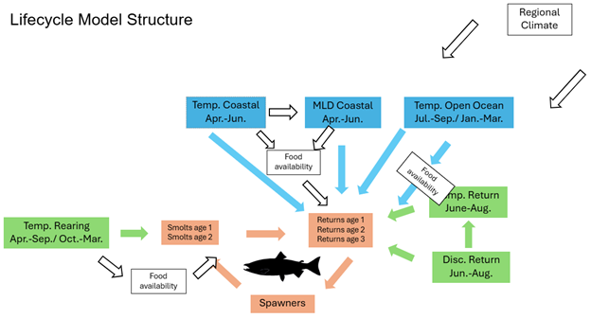

**Figure 1**

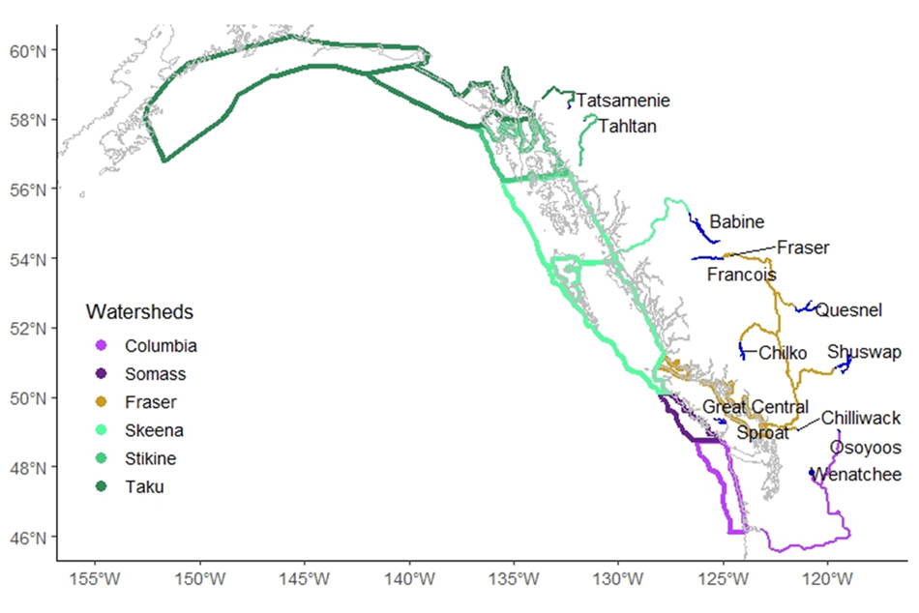

**Figure 2**

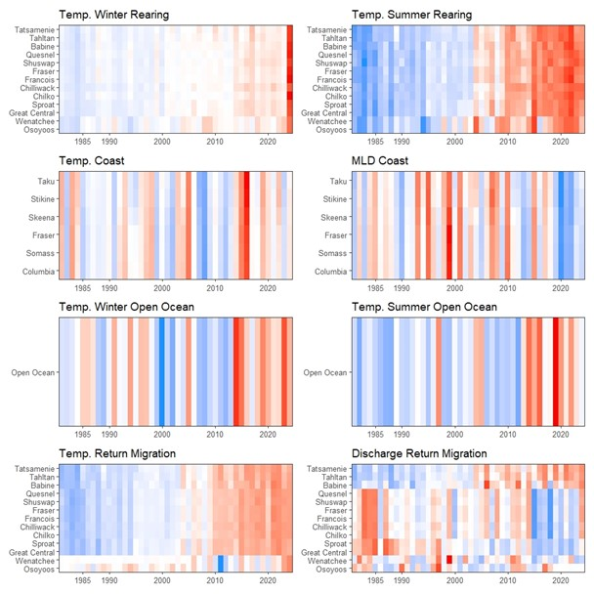

**Figure 3**

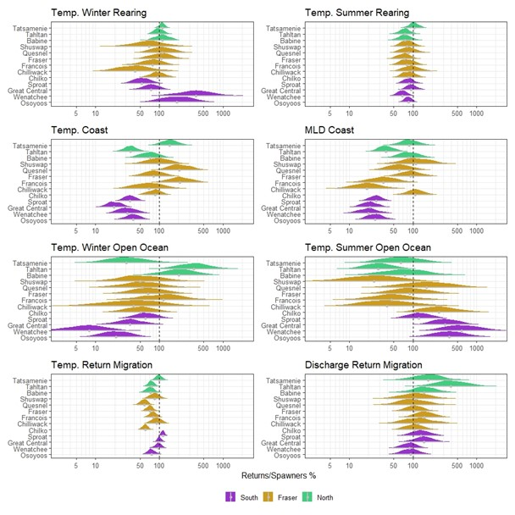

**Figure 4**

Figure 1. Directed acyclic graph of the lifecycle model linking environmental covariates to salmon productivity and survival. Orange boxes represent life stages; green boxes, freshwater covariates; blue boxes, marine covariates; and white boxes, unobserved variables that may introduce correlations requiring adjustment for causal inference.

Figure 2. Map of the populations included in the model. This includes the rearing lakes, the rivers, and the polygons that define the coastal shelf migration in the first marine summer. Open ocean domain (not shown) is shared among all populations.

Figure 3. Heat maps of environmental covariates used in the lifecycle model. Red indicates higher values and blue indicates lower values. All time series were standardized to allow direct comparison. Each panel represents one environmental variable, with rows showing different sockeye populations (freshwater variables), watersheds (coastal shelf variables), or the shared open ocean conditions (shared by all populations). MLD represents mixed layer depth on the coastal shelf.

Figure 4. Estimated percent change in returns per spawner for each population in response to a shift of 3 standard deviations (–1.5 to +1.5 SD), calculated relative to the range observed for that population. All other variables were held at their mean, so these represent marginal effects. This analysis highlights the sensitivity of each population to individual environmental drivers.

#### Insights

Although we are still integrating our population model with future climate projections, our preliminary results highlight striking similarities and differences among sockeye salmon populations that are relevant to management. The majority of populations showed marked declines in abundance as marine and freshwater temperatures increase. Yet the life stages and environmental drivers regulating future impacts varied among populations. These patterns suggest management interventions will be most effective if they are applied in a regional or population-specific context and target life stages that have the greatest impact on subsequent recruitment.

More broadly, our findings emphasize the value of leveraging life cycle models when evaluating climate change risk. Climate change vulnerability assessments often rely on predicted changes in putative stressors, rather than population level responses to those stressors. Such frameworks implicitly assume that populations respond similarly to, for example, one degree of warming. Furthermore, without clear linkages to a biological response, it is often challenging to evaluate the relative impact of stressors in different spatial domains (e.g., freshwater vs. marine temperatures) or representing different physical processes (e.g., changes in temperature vs. flow). Although qualitative approaches are necessary in data limited scenarios, uncertainties should be clearly communicated to decision makers.

Despite its complexity, our model only incorporated abundance data from three life stages, limiting our ability to precisely link indicators to biological responses. Marine spatiotemporal distributions are also relatively poorly resolved, particularly for more data-limited northern populations and for all populations during offshore residence. Both of these factors will increase the uncertainty associated with effect size estimates. Additionally, we could only incorporate indicators that were readily available in historical time series and climate projections, and we assumed that ecological responses to environmental drivers would remain constant in the future. Such assumptions are necessary in correlative models where the mechanisms linking, for example, temperature to survival remain unknown, but may lead to biased estimates of life stage-specific effects. Given the complexity of ecological systems (e.g., non-stationarity; Litzow et al. 2019), our predictions should be viewed cautiously and revised as additional data become available.

#### Next Steps

The goal of the project is to estimate how climate related environmental variables are influencing sockeye salmon productivity across different life stages and populations using quantitative models. These estimates will be combined with climate projections to estimate how future conditions may impact salmon populations in future decades.

Key initial findings, based on the 13 populations model:

Environmental drivers and life stages influencing future impacts vary among populations.

All assessed populations are sensitive to projected changes

Negative impacts are expected to be greatest in southern regions (Columbia, Fraser, WCVI) and driven by increased marine temperatures and freshwater temperatures during adult migrations, while some northern populations may initially benefit from warming.

These projections will help identify the life stages most vulnerable to climate change and guide management strategies by highlighting population-specific sensitivities.

#### References

Brown, N., Stiff, H., Bendriem, N., Luedke, W., Gibeau, P., Bocking, R., Lane, J., McHugh, D., Cunningham, D., Murrell, G., LaFlamme, J., Dobson, D. *In press.* Barkley Sound lake-type sockeye salmon (*Oncorhynchus nerka*) stock assessment in 2025. Can. Sci. Adv. Sec. Res. Doc.

Connors, B.C., Malick, M.J., Ruggerone, G.T., Rand, P., Adkison, M., Irvine, J.R., Campbell, R., Gorman, K. 2020. Climate and competition influence sockeye salmon population dynamics across the Northeast Pacific Ocean. Can. J. Fish. Aquat. Sci. 77: 943-949.

Crozier, L.C., Burke, B.J., Chasco, B.E., Widener, D.L., Zabel, R.W. 2021. Climate change threatens Chinook salmon throughout their life cycle. Comm. Biol. 4:222.

Litzow, M.A., Ciannelli, L., Cunningham, C.J., Johnson, B., Puerta, P. 2019. Nonstationary effects of ocean temperature on Pacific salmon productivity. Can. J. Fish. Aquat. Sci. 76: 1923-1928.

Mackas, D.L., Greve, W., Edwards, M., Chiba, S., Tadokoro, K., Eloire, D., Mazzocchi, M.G., Batten, S., Richardson, A.J., Johnson, C., Head, E., Conversi, A., Peluso, T. 2012. Changing zooplankton seasonality in a changing ocean: Comparing time series of zooplankton phenology. Prog. Ocean. 97-100: 31-62.

Ogden, A. Alex, K., Pestal, G., Alameddine, I., Davis, B., Judson, B., Stiff, H., Pham, S. 2025. Wild Salmon Policy status, limit reference point, and candidate escapement goals for Okanagan sockeye salmon. Can. Sci. Adv. Sec. Res. Doc. 2025/046: 102 p.

Oldford, G., Jarnikova, T., Christensen, V., Dunphy, M. 2024. HOTSSea v1: a NEMO-based physical hindcast of the Salish Sea (1980-2018) supporting ecosystem model development. Geosci. Model Dev. 18: 211-237.

Peña, M.A., Fine, I. 2024. Future Physical and Biogeochemical Ocean Conditions under Climate Change along the British Columbia Continental Margin. Atmosphere-Ocean. 62:2-23.

Peterman, R.M., Dorner, B. 2012. A widespread decrease in productivity of sockeye salmon (*Oncorhynchus nerka*) populations in western North America. Can. J. Fish. Aquat. Sci. 69: 1255-1260.

Peterson, W.T., Schwing, F.B. 2003. A new climate regime in northeast Pacific ecosystems. Geo. Res. Lett. 30: 1896.

Werner, A.T., Schnorbus, M.A., Shrestha, R.R., Cannon, A.J., Zwiers, F.W., Dayon G. Anslow, F. 2019. A long-term, temporally consistent, gridded daily meteorological dataset for northwestern North America, Scientific Data, 6:180299.

### Project 2406: Changing coastal productivity: Using sediment cores, water properties and archived plankton data to identify changes at the bottom of the food web in BC’s coastal waters

**Project Leads:** Sophia Johannessen

**Region:** BC coastal waters

**Species:** Waterbodies (if applicable)

**Waterbodies:** BC Inlets and Salish Sea

**Life History:** Region

**Stock:** Population (if applicable)

#### Highlights

The main idea of the project was to determine whether the bottom of the salmon food web (amount and type of phytoplankton production) had changed in recent decades as a result of climate change, using sediment core records combined with water properties data.

Results differ among inlets. The sediment core trends indicate a change toward a longer, less nutritious food web in some inlets but not others. Further work will explore the data more deeply to provide a robust interpretation in the context of climate-linked changes in freshwater inflow, productivity and seawater circulation.

The final results of this project will be available to inform the new, ecosystem-based approach to fisheries management on the BC coast.

#### Background

Until recently, fisheries models ascribed the decline in Salish Sea salmon populations to a 30% decrease in total primary productivity since the 1970s. Geochemical data (Johannessen et al., 2021, CJFAS) have since shown that total productivity has been constant for the last century in the Salish Sea. However, a change in the type of productivity could have affected salmon, by changing the nutritional value of available food. In addition, it is not known whether total productivity has changed outside the Salish Sea. A change from diatom- to dinoflagellate-dominance is thought to have occurred in nearby Puget Sound, due to a change in the ratios of dissolved nutrients and in the timing of freshwater discharge.

This project relates to drivers of salmon decline. Once complete, the results will be available to inform ecosystem models used to set fisheries catch limits. In the context of the new requirement for ecosystem variability to be included in salmon stock assessment, it will be crucial for fisheries managers to understand changes in the food web and in the physical and chemical properties of coastal seawater.

In addition to interpreting trends in primary productivity, based on sediment cores, the PI will collaborate with a biological oceanographer (Akash Sastri, DFO) and an American chemical oceanographer with data from Puget Sound (Christopher Krembs, Washington State Dept. of Ecology). The collaborations will permit a comparison with a time series of plankton taxonomic data and put the results from BC inlets into a wider regional context. The results will be published in scientific papers and in a proposed CSAS Science Response.

#### Methods and Findings

This project mainly used sediment cores, with water samples and electronic (CTD) data profiles to support the interpretation of environmental conditions.

#### Tables and Figures

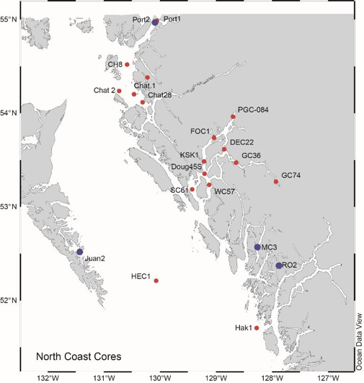

**Figure 1a**

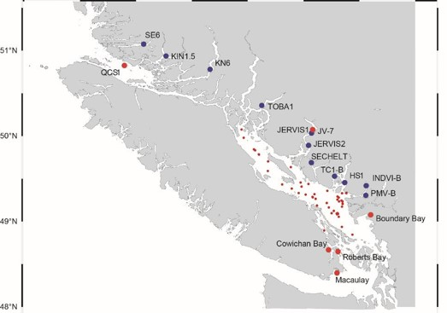

**Figure 1b**

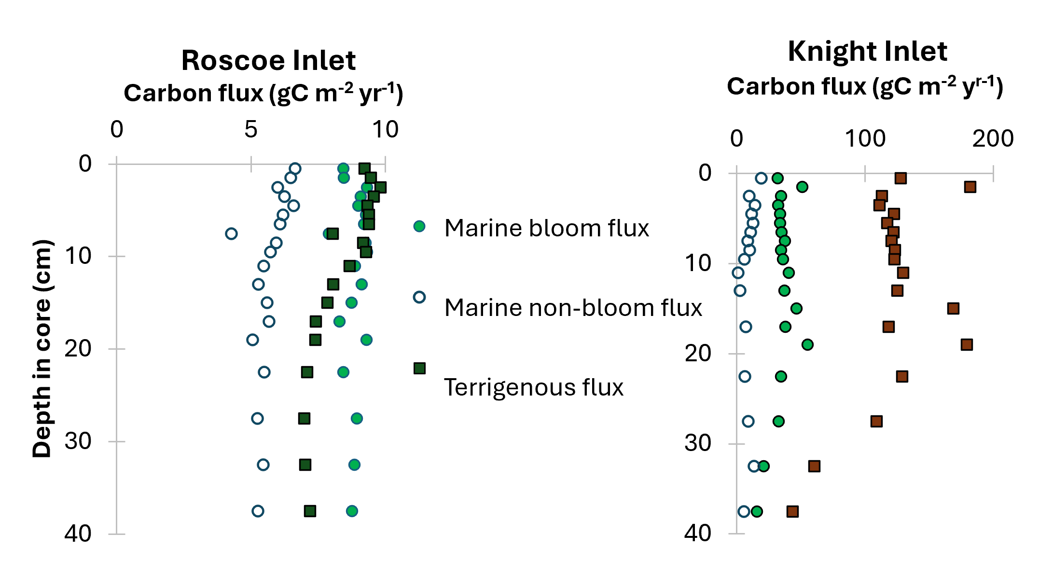

**Figure 2**

Figure 1. Sediment core location maps. Blue dots: New cores collected in 2022-2025, under PSSI and MCT programs. Red dots indicate existing cores, which will be used to provide context for the new cores.

Figure 2. Fluxes of marine-bloom, marine-non-bloom and terrigenous organic carbon

in a) Roscoe and b) Knight Inlets. Note that the x-axis scale (carbon flux) for Knight

Inlet is 20 times as high as that for Roscoe Inlet. “Marine” represents mainly

phytoplankton-derived organic matter. “Bloom” represents organic matter produced

under conditions of high productivity, with a short food chain, while “non-bloom”

represents low productivity and a long food chain. The oldest material is at the bottom of the

cores, with time progressing toward the surface. Due to the different sedimentation rates,

the Knight Inlet core represents about 45 years, while the Roscoe core represents about

270 years.

#### Insights

Results to date indicate that each inlet tells its own story. Knight Inlet, for example, has about twenty times the terrigenous carbon flux of Roscoe Inlet (Figure 2). However, the marine bloom flux (related to high productivity and a short (nutritious) food chain) is only five times as high in Knight as in Roscoe, and the non-bloom flux is similar in the two inlets. This indicates that the ratio of highly nutritious to less nutritious food at the base of the salmon food web is likely higher in Knight than Roscoe Inlet. In addition, the trends over time are different in the two inlets (Figure 2). It is possible that fisheries management in inlets will require inlet-specific consideration of environmental variables. Once the sediment core interpretation is complete and is put into the environmental context of each inlet, this information will be available to inform the ecosystem models that support salmon stock assessment.

#### Next Steps

The next steps are:

Complete the interpretation of the sediment core data: calculate trends in marine and terrigenous carbon flux in the remaining cores.

Calculate nutrient ratios from water samples for all inlets for spring and autumn/winter, and compare these to the ratios and trends over time in the Salish Sea.

Determine whether differences in marine fluxes among inlets are related to surface nutrients and/or freshwater discharge.

Work with colleagues in biological oceanography and fisheries to convert this information into an indicator that could be incorporated into the ecological models that inform fisheries stock assessment.

Recommended future work: Ongoing monitoring of inlets to detect changes due to climate change or local pressures.

#### References

Barwell-Clarke, J., and F.A. Whitney. 1996. Institute of Ocean Sciences nutrient methods and analysis. Can. Tech. Rep. Hydrogr. Ocean Sci. 182: vi + 43 p.

Calvert, S.E., and Pedersen, T.F. 1995. On the organic carbon maximum on the continental slope of the eastern Arabian Sea. Journal of Marine Research 53: 269-296.

Calvert, S.E., Pedersen, T.F., and Karlin, R.E. 2001. Geochemical and isotopic evidence for post-glacial palaeoceanographic changes in Saanich Inlet, British Columbia. Marine Geology 174: 287-305.

Eakins, J.D., and Morrison, R.T. 1978. A new procedure for the determination of lead-210 in lake and marine sediments. International Journal of Applied Radiation and Isotopes 29: 531-536.

Emerson, S., and Hedges, J.I. 1988. Processes controlling the organic carbon content of open ocean sediments. Paleoceanography 3(5): 621-634.

Johannessen, S.C., Macdonald, R.W., and Strivens, J.E. 2021. Has primary production declined in the Salish Sea? Canadian Journal of Fisheries and Aquatic Sciences 78(3): 312-321. doi:10.1139/cjfas-2020-0115.

Johannessen, S.C., Macdonald, R.W., and Wright, C.A. 2019. Rain, Runoff, and Diatoms: the Effects of the North Pacific 2014–2015 Warm Anomaly on Particle Flux in a Canadian West Coast Fjord [journal article]. Estuaries and Coasts 42(4): 1052-1065. doi:10.1007/s12237-018-00510-0.

Mathieu, G.G., Biscaye, P.E., Lupton, R.A., and Hammond, D.E. 1988. System for measurement of 222Rn at low levels in natural waters. Health Phys 55(6): 989-992.

### Project 2407: Follow the Fish: An integrated Chinook salmon assessment and monitoring program for the West Coast of Vancouver Island

**Project Leads:** Jessy Bokvist

**Collaborations:** •Ahousaht First Nation

• Coal Harbour Ltd.

• British Columbia Conservation Foundation

• Cedar Coast Field Station

• Charter Tofino

• Ditidaht First Nation

• Ehattesaht/Chinehkint First Nation

• Ha’oom Fisheries Society

• Hesquiaht First Nation

• Hupačasath First Nation

• Huu-ay-aht First Nations

• The Juanes Lab (University of Victoria)

• Ka:’yu:’k’t’h’/Che:k:tles7et’h’ First Nations

• LGL Limited

• Maaqutusiis Hahoulthee Stewardship Society

• M.C. Wright and Associates Ltd.

• Mowachaht-Muchalaht First Nations

• Nootka Sound Watershed Society

• Nuu-Chah-Nulth Tribal Council

• Nuchatlaht Tribe

• Pacheedaht First Nation

• Pacific Salmon Foundation

• Quatsino First Nation

• Redd Fish Restoration Society

• Thornton Creek Enhancement Society

• Tla-o-qui-aht First Nation

• Toquaht Nation

• Tseshaht First Nation

• T’Sou-ke Nation

• Uchucklesaht Tribe

• Yuułuʔiłʔatḥ Government

**Location:** Stamp River;#Sarita River;#Nitinat;#Barkley Sound

**Region:** Pacific

**Species:** Chinook Salmon

**Waterbodies:** Sooke Basin, Port San Juan, Nitinat Lake, Barkley Sound, Clayoquot Sound, Nootka Sound, Kyuquot Sound, Quatsino Sound

**Life History:** Juvenile, first marine year

**Stock:** Population (if applicable)

**Conservation Unit:** CK-31, CK-32, CK-33

#### Methods and Findings

In collaboration with 17 First Nations, and 12 Non-Governmental Organizations (NGOs), this project has caught and sampled juvenile Chinook during their first marine year on the WCVI. Salmon surveys aimed to “follow” juvenile Chinook salmon as they enter marine waters from their natal rivers, and through the summer and first marine winter as they rear along the West Coast of Vancouver Island (WCVI).

From 2023-2024, Chinook originating from Stamp River, Sarita River and Nitinat River were caught during their marine outmigration using seining and dip netting methods. In the Stamp River and Somass estuary, juvenile Chinook originating from Stamp River were caught through dip net and beach seine surveys with Hupacasath First Nation. In the Sarita Estuary, beach and purse seine surveys were led by Huu-ay-aht First Nation and LGL Limited and data and samples were shared with this project. In Nitinat Lake, beach seine surveys were carried out with Ditidaht First Nation to catch juveniles from the Nitinat River population. Juvenile Chinook from these populations were then caught during their first marine summer in Barkley Sound via purse seine surveys from 2022-2025 in collaboration with Huu-ay-aht First Nation and LGL Limited. Finally, juvenile salmon were followed through their first winter at sea with microtrolling surveys carried out in nearshore marine waters in Sooke Basin through Quatsino Sound on the WCVI. These overwinter surveys were carried out with 27 local First Nation and NGO collaborators from 2020-2025.

### Project 2408: Improvement, Expansion and Modernization of Salmonid Health Diagnostic Services For Optimizing Salmonid Hatchery Health Management.

**Project Leads:** Amy Long

**Collaborations:** Kyle Garver, DFO

Ahmed Siah, BC Centre for Aquatic Health Sciences

**Location:** Pacific Biological Station;#Fulton Hatchery;#Nadina Spawning Channels;#Chehalis River Hatchery;#Quinsam River;#Inch Creek Hatchery;#Nanaimo River Hatchery;#Big Qualicum River Hatchery

**Region:** Pacific

**Species:** See Supplemental Table 1

**Life History:** Juveniles, broodstock

**Stock:** See Supplemental Table 1

#### Highlights

The project focused on developing, validating, and implementing quantitative PCR (qPCR) assays for seven endemic fish pathogens in British Columbia to improve disease detection and support salmon health management.

Targeted surveillance revealed differences in pathogen prevalence among salmon stocks and tissues, with *F. psychrophilum* more frequently detected in spleen samples than kidney, alongside observed genetic diversity in isolates. For *R. salmoninarum*, ELISA testing was more reliable than qPCR, with non-lethal sampling methods under ongoing evaluation.

Improved diagnostic tools enhance pathogen detection and understanding of disease prevalence, aiding targeted interventions in salmon hatcheries.

#### Background

Historically, Fisheries and Oceans Canada’s (DFO) Salmonid Enhancement Program (SEP) has worked closely with the Science Branch’s Aquatic Animal Health (AAH) Section to implement disease monitoring and mitigation programs aimed at reducing the impacts of endemic diseases in salmonid hatcheries. These efforts are critical for maintaining hatchery productivity and supporting broader salmon conservation and enhancement objectives. However, reductions in funding for salmon health research within both SEP and the Science Branch have limited the ability of the Finfish Diagnostic Laboratory (FDL) at the Pacific Biological Station (PBS) to modernize and adopt emerging diagnostic technologies. As a result, diagnostic capacity has not kept pace with current best practices, and opportunities for effective technology transfer between Science Branch and SEP have diminished.

This project sought to address these knowledge and capacity gap by re-establishing strong linkages between SEP and the Science Branch and leveraging scientific expertise to improve, expand, and modernize the FDL. The demand driving this work is the need for timely, accurate, and advanced diagnostic information to support proactive salmonid hatchery health management. Through strengthened collaboration among SEP, BC Centre for Aquatic Health Sciences, and Science Branch, a multi-year initiative was implemented that will result in sustainable disease monitoring and mitigation, ultimately improving hatchery health outcomes across SEP facilities.

#### Methods and Findings

Validation and transfer of diagnostic assays for endemic pathogens

In consultation with SEP veterinarians and fish health staff, the project identified seven endemic pathogens for which there was a need for improved diagnostic assays. Due to the need for high-capacity and rapid diagnostics, quantitative PCR (qPCR) assays were chosen for their accuracy and reliability. The targeted pathogens were as follows: *Tetracapsuloides bryosalmonae* (Bettge et al., 2009), *Flavobacterium columnare* (Gibbs et al., 2020), *Flavobacterium psychrophilum* (Ma et al., 2019; Marancik & Wiens, 2013), *Renibacterium salmoninarum* (Richmond & Plant, 2021), *Ichthyophthirius multifiliis* (Howell et al., 2019), IHNV (Purcell et al., 2013), and *Nucleospora salmonis* (Badil et al., 2011). Where pathogen nucleic acids were unavailable, synthetic double-stranded DNA fragments (gBlocks™) were used for validation work, e.g. limits of detection and quantification. In collaboration with BC Centre for Aquatic Health Sciences, the *R. salmoninarum* qPCR assay underwent interlaboratory validation in which both labs screened 170 samples. The results showed substantial agreement between labs (Cohen’s κ=0.68), confirming the reliability of assay transfer. Post-validation, assays were implemented to assist the FDL in disease investigations.

To ensure effective knowledge transfer, standard operating procedures were developed by the AAH team and shared with FDL staff. Training sessions covered all aspects of assay implementation, enabling FDL personnel to independently conduct analyses.

Deployment of assays for pathogen surveillance

In addition to assay validation and technology transfer, this project also focused on collection and analysis of longitudinal data on two high-priority pathogens: *F****.*** *psychrophilum* and *R****.*** *salmoninarum*. *F. psychrophilum* is the causative agent of bacterial coldwater disease and infections can cause significant disease and mortality in juvenile, hatchery-reared salmonids. Identified knowledge gaps for *F. psychrophilum* in BC include overall prevalence in broodstock, and the linkage between female broodstock bacterial load and outbreaks in fry. While outbreaks are common at most SEP facilities rearing salmonids, outbreaks are notably acute in Harrison River Chinook salmon (HRCS).

Surveillance conducted between 2023 and 2025 determined that prevalence was approximately 40% in HRCS broodstock during 2023–2024, with a significant reduction in 2025 (χ2=12.6, *p* < 0.01) (Table 1). It is possible that prevalence is cyclical in this stock but additional screening is necessary. Chehalis River broodstock, reared under similar conditions, showed comparable infection rates to HRCS in 2024, suggesting genetic differences between stocks may influence outbreak intensity.

Both kidney and spleen were collected to determine which tissue would be best for routine sampling. Agreement between the two tissues was slight (Cohen’s κ=0.16). The number of positive fish based on spleen results was more than double that of kidney indicating that spleen is more likely to result in a positive detection. Tissues were also streaked on bacterial agar and evaluated for growth of yellow-pigmented bacteria morphologically similar to *F. psychrophilum*. Using novel sequencing techniques, we identified unexpected genetic heterogeneity within *F. psychrophilum* isolates from BC.

In 2024, the SEP Fish Health group conducted a pilot study to evaluate the effectiveness of pre-fertilization egg disinfection in reducing bacterial loads. Unfertilized eggs from 20 HRCS females were treated in an Ovadine®:saline solution (100 ppm:0.75%) for 15 minutes. Egg disinfection is typically carried out post-fertilization; however, iodophor cannot penetrate eggs to eliminate bacteria already present within. A previous study by Lennox et al. (2023) suggested that pre-fertilization disinfection in an iodophor:saline solution may decrease intra-egg bacterial concentrations, supporting the basis for this pilot. Eggs from each female were sampled at three key stages (pre-fertilization and pre-treatment, pre-fertilization and post-treatment, and post-fertilization and post-treatment) and screened for *F****.*** *psychrophilum* by AAH staff. The number of positive samples decreased from eight (pre-treatment and pre-fertilization) to one (post-treatment and post-fertilization). Fish were not monitored post-hatch, so long-term effectiveness of the treatment could not be assessed, though no adverse impacts on fertilization or hatching were noted.

The study was repeated in fall 2025, expanding to include all HRCS eggs as well as all chum salmon eggs at the Tenderfoot hatchery. Samples from the HRCS eggs were collected and will be analyzed using qPCR before the end of the fiscal year to further evaluate the efficacy of this treatment approach.

*R. salmoninarum* is the causative agent of Bacterial Kidney Disease (BKD), and is vertically transmitted from female broodstock to progeny. As such, kidney is collected from spawning female broodstock and submitted to the FDL for BKD screening using an enzyme-linked immunosorbent assay (ELISA). In the current study, 637 samples were screened by ELISA and qPCR. Assay agreement was slight (Cohen’s κ=0.20), and overall, more samples were positive by ELISA as compared to qPCR. The ELISA measures bacterial antigen concentrations and serves as a proxy for previous *R. salmoninarum* exposure. Conversely, the qPCR measures the total amount of nucleic acid present, i.e. an active infection. Therefore, although the *R. salmoninarum* qPCR assay is sensitive and specific, the ELISA remains the gold standard method for broodstock screening. Longitudinal surveillance of select stocks was also conducted from 2023 through 2025 (Table 2). Prevalence, as determined by ELISA, is high at these facilities every year. Results from 2025 are pending but will be available by the end of this fiscal year.

This project also explored the use of non-lethal sampling methods for *R. salmoninarum*. To do so, lethal (kidney) and non-lethal (mucus, gill clip, anal fin clip, and ventral swab) samples were collected from female broodstock at Nitinat and Big Q hatcheries. All samples were screened by the qPCR assay and kidney was also screened by ELISA (Table 3). In 2024, results showed limited agreement between non-lethal samples and kidney, with mucus samples providing the highest detection rates. Given the amount of handling during the spawning process, mucus also has the highest risk of contamination. Consequently, mucus sampling was excluded in 2025, with evaluation ongoing for gill clip and anal fin sampling methods.

#### Tables and Figures

*Error loading file Table 1.xlsx: ‘knit_print.flextable’ is not an exported object from ‘namespace:flextable’*

*Error loading file Table 2.xlsx: ‘knit_print.flextable’ is not an exported object from ‘namespace:flextable’*

*Error loading file Table 3.xlsx: ‘knit_print.flextable’ is not an exported object from ‘namespace:flextable’*

*Error loading file Table 4.xlsx: ‘knit_print.flextable’ is not an exported object from ‘namespace:flextable’*

Table 1. Longitudinal surveillance results for *Flavobacterium psychrophilum*. Broodstock were classified as positive if the bacterium was re-isolated from tissue samples or if tissues tested positive by qPCR. Total prevalence was calculated as the number of unique positive broodstock identified by qPCR and/or culture divided by the total number of samples collected. Subscripts denote statistically significant differences in prevalence among years (χ2=12.6, *P* < 0.01).

Stock

Year

Total prevalence (No. screened)

Harrison River

2023

0.43a (121)

2024

0.44a (122)

2025

0.25b (125)

Chehalis River

2024

0.2 (60)

Table 2. Longitudinal surveillance results for *R. salmoninarum* at select facilities. Broodstock were classified as positive if the ELISA optical density value was greater than the mean optical density of the negative control or kidney tested positive by qPCR. ELISA prevalence estimates included samples classified as ‘low level of detection’ as these samples are considered positive but are often kept by facilities.

Facility

Species

2023

2024

No. of samples

ELISA prevalence

qPCR prevalence

No. of samples

ELISA prevalence

qPCR prevalence

Big Q

Coho

30

0.93

0.03

60

0.83

0.05

Chehalis

Coho

30

0.93

0.13

60

1

0.07

Inch Creek

Coho

20

0.95

0.05

60

1

0.02

Nitinat

Coho

40

1

0.55

45

1

0.18

Puntledge

Coho

20

1

0.35

88

0.86

0.25

Puntledge summer

Chinook

11

1

0.09

18

0.94

0

Table 3. Non-lethal BKD screening samples. Female Coho salmon broodstock were sampled at both facilities. Agreement values were calculated using Cohen’s kappa analysis and all tissues were compared to kidney.

Year

Facility

No. sampled

Samples collected

Sample agreement

2024

Nitinat

40

Kidney

Gill clip

Mucus

Ventral swab

Anal fin clip

Gill: <0

Mucus: 0.11

Ventral swab: 0.085

Anal fin clip: <0

2025

Nitinat

40

Kidney

Gill clip

Anal fin

NA

Big Q

40

Kidney

Gill clip

Anal fin

NA

Supplemental Table 1. Stock and species sampled.

Stock

Species

Big Q

Coho

Chehalis

Coho

Chehalis

Chinook

Chilko

Chinook

Chilliwack

Coho

Fraser

Sockeye

Fulton

Sockeye

Inch

Coho

Kitimat

Coho

Maria Slough

Chinook

Nanaimo River

Chinook

Nitinat

Coho

Norrish (Inch)

Coho

Puntledge

Coho

Puntledge Fall

Chinook

Puntledge Summer

Chinook

Quatse

Coho

Robertson

Chinook

Skeena

Sockeye

Sooke

Chinook

Thornton

Chinook

Viner River

Chum

#### Insights

This project has provided new information about salmon populations and their health by generating data on the distribution and detection of various pathogens. By employing molecular diagnostic tools like qPCR, the study has documented pathogen presence in juvenile and broodstock salmon populations, contributing to an improved understanding of pathogen dynamics in these systems. The longitudinal data gathered offers insight into how pathogen prevalence varies among different salmon stocks and over multiple years.

The results of the project can inform certain aspects of salmon management. For example, the findings regarding pathogen screening in broodstock populations may assist in reviewing fish movement protocols or stock enhancement practices. Additionally, evaluation of pre-fertilization egg disinfection suggests a potential approach that could be further explored as a disease prevention tool for hatcheries, particularly in relation to bacterial coldwater disease. The study also identified important considerations related to tissue type variability in pathogen detection, which highlights potential trade-offs when exploring non-lethal sampling methods screening broodstock for *R. salmoninarum*. These findings are relevant for hatchery planning and emphasize the importance of balancing disease mitigation efforts with the logistical and operational constraints of hatchery facilities.

This research also provides additional information about factors influencing salmon health, such as stressors and potential risk pathways related to pathogen transmission, hatchery practices, and environmental conditions. While the findings highlight areas for further research or development, the project offers practical data that may aid in specific management decisions, operational guidelines, and planning for salmon conservation efforts.

#### Next Steps

The findings from this project have identified several knowledge gaps and areas for further study. With respect to *R. salmoninarum*, future efforts should focus on analyzing existing data to evaluate prevalence trends across different stocks over time, refining qPCR assays to improve diagnostic reliability, and optimizing non-lethal sampling methods. For *F. psychrophilum*, additional research is needed to investigate genomic differences among BC-specific isolates and potential influence on virulence. Continued investigation into stock- and year-specific variations in pathogen prevalence, particularly in high-risk stocks, will further clarify susceptibility patterns and inform management strategies. Additional work on evaluating the efficacy of pre-fertilization egg disinfection is necessary to assess its role as a disease prevention tool.

This project also emphasizes the need for standardized diagnostic practices and improved methods for pathogen detection to reduce uncertainties in disease monitoring. Strengthening partnerships between the Science Branch and SEP is vital to hatchery health management. By improving access to advanced diagnostic technologies, and supporting the capacity of the FDL through ongoing training and collaboration, improved disease monitoring and response strategies can be developed. The integration of these findings into hatchery operations and broader conservation strategies may help address emerging risks and ultimately support salmon stock sustainability.

#### References

Badil, S., Elliott, D. G., Kurobe, T., Hedrick, R. P., Clemens, K., Blair, M., Purcell, M. K. 2011. Comparative evaluation of molecular diagnostic tests for *Nucleospora salmonis* and prevalence in migrating juvenile salmonids from the Snake River, USA. J. Aquat. Anim. Health. 23:19–29. doi:10.1080/08997659.2011.559418.

Bettge, K., Wahli, T., Segner, H., & Schmidt-Posthaus, H. 2009. Proliferative kidney disease in rainbow trout: time- and temperature-related renal pathology and parasite distribution. Dis. Aquat. Org. 83:67–76. doi: 10.3354/dao01989.

Gibbs, G. D., Griffin, M. J., Mauel, M. J., & Lawrence, M. L. 2020. Validation of a quantitative PCR assay for the detection of 2 *Flavobacterium columnare* genomovars. J. Vet. Diagn. Investig. 32:356–362. doi:10.1177/104063872091576.

Howell, C. K., Atkinson, S. D., Bartholomew, J. L., & Hallett, S. L. 2019. Development and application of a qPCR assay targeting *Ichthyophthirius multifiliis* in environmental water samples. Dis. Aquat. Org. 134:43–55. doi: 10.3354/dao03351.

Lennox, S.M.G., Shavalier, M.A., Brenden, T.O., Knupp, C.K., & Loch, T.P. 2023. Developing an improved egg disinfection method to reduce *Flavobacterium psychrophilum* transmission risk in rainbow trout (*Oncorhynchus mykiss*). American Fisheries Society – Fish Health Section Summer Seminar Series. https://sites.google.com/umn.edu/fishhealthseminar/archived-seminars/2023-seminar-series/lennox

Ma, J., Bruce, T. J., Oliver, L. P., & Cain, K. D. 2019. Co-infection of rainbow trout (*Oncorhynchus mykiss*) with infectious hematopoietic necrosis virus and *Flavobacterium psychrophilum*. J. Fish Dis. 42:1065–1076. doi:10.1111/jfd.13012.

Marancik, D. P., & Wiens, G. D. 2013. A real-time polymerase chain reaction assay for identification and quantification of *Flavobacterium psychrophilum* and application to disease resistance studies in selectively bred rainbow trout *Oncorhynchus mykiss*. FEMS Microbiol. Lett. 339:122–129. doi:10.1111/1574-6968.12061.

Purcell, M. K., Thompson, R. L., Garver, K. A., Hawley, L. M., Batts, W. N., Sprague, L., Sampson, C. and Winton, J. R. 2013. Universal reverse-transcriptase real-time PCR for infectious hematopoietic necrosis virus (IHNV). Dis. Aquat. Org. 106: 103-115. doi: 10.3354/dao02644.

Richmond, Z., & Plant, K. 2021. Quantitative PCR (RT-qPCR) for Detection of *R.sal* using AgPath-ID One-Step RT-qPCR kit in Multiorgan tissue of Finfish Species. BC Centre For Aquatic Health Sciences, SOP 83-v5.1.

### Project 2409: Convergent tracks: a tagging study to quantify salmon predation by sea lions

**Project Leads:** Cameron Freshwater and Strahan Tucker

**Collaborations:** Salmon: Justin Fleming and Jackie King (DFO ESD), Erin Rechisky (DFO South Coast Stock Assessment), Andy Seitz and Michael Courtney (University of Alaska Fairbanks)

Sea lions: Chad Nordstrom, Ali Bowker, Sheena Majewski, Kurt Trzcinski (DFO ESD), Marty Haulena (Vancouver Aquarium), Christine Rock (ECCC)

**Location:** Triangle Island;#Haida Gwaii

**Region:** BC coast

**Species:** Sockeye salmon

**Waterbodies:** Continental shelf, Queen Charlotte Strait, Johnstone Strait, Strait of Georgia

**Life History:** Adult marine

**Stock:** Fraser River

**Conservation Unit:** Chilko dominant

#### Highlights

Increased predation by Steller sea lions (SSL) has been identified as a potential cause of declines in Fraser River sockeye salmon abundance; however, there were previously no relevant data on SSL diets and distribution or sockeye salmon mortality rates to test the hypothesis.

We found evidence of high sockeye salmon mortality rates; however, the majority of mortality was associated with salmon sharks, not SSL. The SSL predation that did occur was concentrated in Queen Charlotte Strait, not the largest rookery at Triangle Island. While SSL diet results are pending, SSL tagging data demonstrated evidence of restricted foraging during the initial portion of sockeye salmon migration (as animals are tied to breeding/pupping rookery) followed by rapid dispersal (particularly by males) away from Triangle Island and diverse foraging strategies among individuals. Widespread overlap of the SSL stock with migrating Fraser River sockeye salmon appears to be less than presumed.

Collectively, these results suggest sockeye salmon may be vulnerable to a broader range of predators than previously considered, and that predator communities, and predation risk, vary through space and time. Thus, previous estimates of SSL consumption rates may be biased high.

#### Background

Fraser River sockeye salmon productivity has been poor since the early 1990s (Peterman and Dorner 2012). Although the mechanism remains unclear and is likely multifaceted (Cohen 2012), bottom-up processes that reduce juvenile marine survival have been identified as a

#### Methods and Findings

We used multiple methods to evaluate SSL foraging ecology, quantify sockeye salmon mortality rates, and ultimately draw inference on the likely impact of SSLs on migrating Fraser River sockeye salmon. The following activities occurred during the 2024 and 2025 field seasons (Figure 1).

*Sockeye* ***Salmon*** *Methods*

Sockeye salmon were captured aboard a charter purse seine vessel from sites near Rennell Sound (west coast Haida Gwaii; 2024 and 2025) and Queen Charlotte Strait (2025 only). Sockeye salmon were landed and transferred to a flow through seawater trough where biological data, including genetic stock identification (GSI) samples, were collected. Individuals in good physical condition were tagged with either an acoustic or satellite tag before being immediately released. We deployed acoustic transmitters on sockeye salmon (n=625) which allowed individuals to be detected on moored receiver arrays near Haida Gwaii, Triangle Island, Queen Charlotte Strait, throughout the Salish Sea, and the lower Fraser River. The acoustic receiver network included approximately 40 receivers deployed by DFO throughout coastal British Columbia, as well as infrastructure maintained by NOAA, the Ocean Tracking Network, Kintama, and the University of British Columbia. Detections data will be used to parameterize mark-recapture models to estimate survival rates along the migration corridor and identify hotspots of mortality. We also deployed popup archival satellite tags (PSATs) on a smaller number of sockeye salmon (n=35). After releasing from the animal these tags transmit light, temperature, and pressure sensor data that can be used to identify predator taxa (Seitz et al. 2019).

*Sockeye Salmon Findings*

GSI results are currently only available for the 2024 field season; however, the majority (>98%) of tagged sockeye salmon were identified as belonging to Fraser River populations with Chilko Lake being the dominant conservation unit (~55% of all samples). Only a subset of detections data are currently available for 2025; however preliminary results in both years (Figure 2) indicate overall survival from Haida Gwaii to the Fraser River was poor (<8%). ~50% of individuals tagged at northern sites were detected on Haida Gwaii arrays; however, mark-recapture models that account for imperfect detection probability on these arrays are required for robust estimates of survival. Survival to the Fraser River of tags deployed in Queen Charlotte Strait was markedly higher (~40%). 2% of tags were detected in the study area after deployments were completed, suggesting short-term mortality due to tagging or handling was minimal. Only two tags were detected at Triangle Island (both in 2025), however 46 tags were detected in 2025 at sea lion haul outs throughout Queen Charlotte Strait. Importantly, additional analysis is required to determine how many of these fish were likely consumed by pinnipeds based on subsequent detections. No fish were reported as intercepted by fisheries in 2024, but 5% of tagged fish were recaptured by marine and in-river fisheries and reported in 2025.

We deployed 18 PSATs at Haida Gwaii sites in 2024 and 17 in 2025 (ten in Haida Gwaii and seven in Queen Charlotte Strait). Six of the 2024 PSATs failed to report due to engineering issues. All of the remaining 12 reported before their programmed release data, suggesting the fish were predated. Of the confirmed mortalities, three could not be classified because the tag was not ingested, one was consumed by a benthic ectotherm, and eight were consumed by salmon sharks (Figure 3). In 2025, all PSATs reported and five survived to release, all from the Queen Charlotte Strait study area. Of the ten Haida Gwaii tags, four were consumed by blue sharks, three by a benthic ectotherm, and three by salmon sharks. Neither of the two Queen Charlotte Strait mortalities could be classified (Figure 3).

*SSL Methods*

We deployed satellite tags (paired head-mounted splash and flipper-mounted spot tags) on adult male (n=7) and female (n=14) SSLs on Triangle Island. Animals were sedated via darting gun and tagged with the assistance of staff from the Vancouver Aquarium. Females were captured near the end of July following pupping; males were captured at the beginning of June as animals staked out territories for the breeding period. Head mounted tags were epoxied to the fur and were shed by fall during the annual moult while the flipper mounted tags should stay affixed for multiple years although tag programming and battery life will ultimately determine transmission duration. The high resolution, yet shorter deployment splash tags will allow for an understanding of foraging behaviour (location and dive profiles) and sex-specific habitat use revealing explicit spatial-temporal overlap with sockeye salmon during their migration through Queen Charlotte Sound. This distribution data is critical in evaluating the relative proportion of the SSL population that has the opportunity to predate sockeye salmon. The longer-term flipper tags (8-16 months; multi-year) will allow for multi-season information on coarse foraging patterns.

We also collected SSL diet information via biochemical tracers and scats from sites on Triangle Island, as well as key haul outs in Queen Charlotte Strait, southwest coast of Vancouver Island, and the southern Strait of Georgia. The two biochemical tracers we have focused on, fatty acid profiles and stable isotopes, provide estimates of diet composition integrated over weeks to month. The fatty acid analysis (FAA; Budget et al. 2006) will provide more discrete diet estimation (prey-specific proportions) while the stable isotope analysis (SIA; Layman et al. 2012) will be useful to discriminate feeding source (pelagic vs demersal, nearshore vs shelf vs shelf break) such that we can broadly characterize foraging behaviour beyond the satellite tagged individuals. Diets estimated from scats provide a short-term (~ 1 day) estimate requiring far more extensive, repeated sampling to capture temporal variation in diet-particularly if the objective is to capture a potential pulse of a relatively rapidly migrating prey. While we collected scats (n=1,200), there was insufficient funding provided to analyze these, let alone undertake a full-fledged sampling design for scats. These are therefore archived for potential future work and analysis focused on the integrated tracer samples. In total, ~400 sea lion biopsy samples were obtained directly from satellite tagged animals or randomly via a crossbow system. To estimate diet, over 1500 potential fish and invertebrate prey samples were obtained from various DFO research cruises.

*SSL Findings*

During the 5 – 6-week deployments prior to moult, female foraging was concentrated on the continental shelf (Figure 4a). In the initial weeks, animals used Triangle Island as a central place for short foraging forays. As pups inevitably grew and became more independent, there was a gradual expansion and dispersal away from Triangle east to Cook Bank and Queen Charlotte Strait and south-east to Quatsino Sound with females ultimately moving to sites both east and south of Triangle Island. During the 14 – 16-week deployments prior to moult, males demonstrated very limited foraging activity during the breeding period (Figure 4b). Subsequently by mid-July there was rapid and directed dispersal immediately post-breeding with individuals ranging as far north as southeast Alaska and south to the Washington border. Triangle was not used as major haul out outside of the breeding period for either females or males. More in-depth analysis of distribution and dive behaviour is underway to explicitly parameterize sea lion foraging effort in a spatial context and provide support for interpreting diet results.

Stable isotope and fatty acid datasets for potential prey and sea lions have been completed for 2023-2024 samples; 2025 samples are currently being processed and analyzed. Preliminary analysis of 2023-2024 SI values for known age class and sex animals suggests that males and females are exploiting different prey/habitats diverging further with age (Figure 5).

#### Tables and Figures

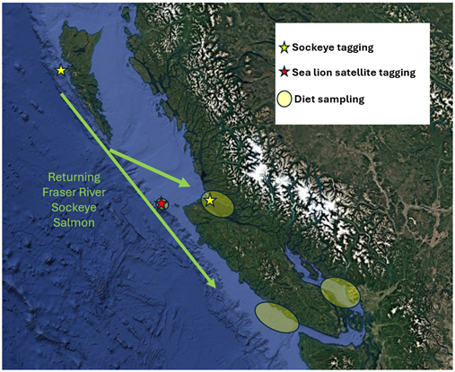

**Figure 1**

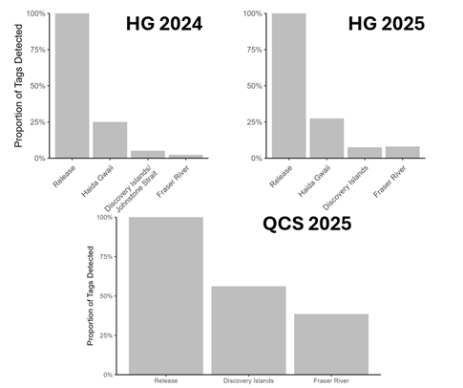

**Figure 2**

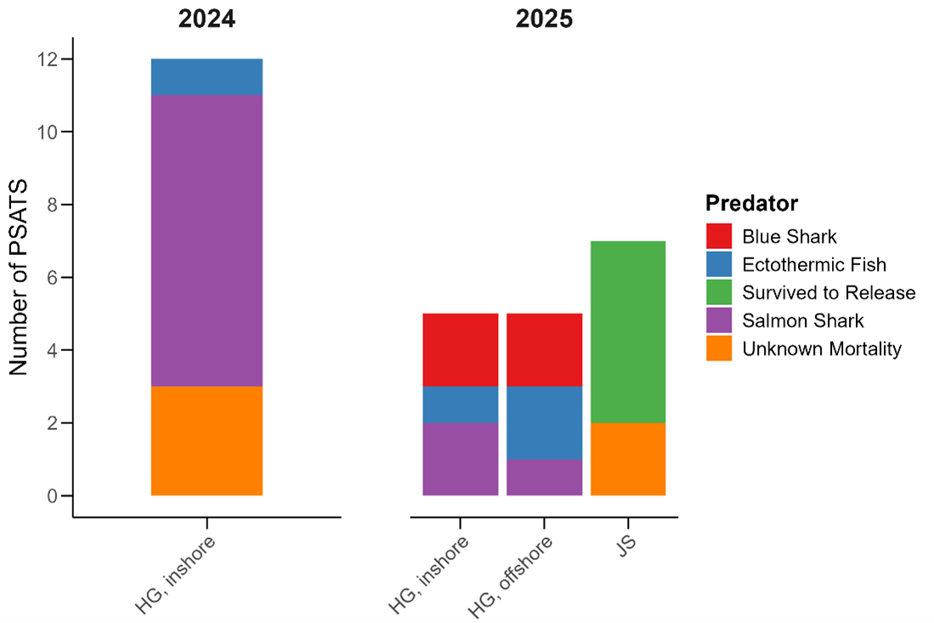

**Figure 3**

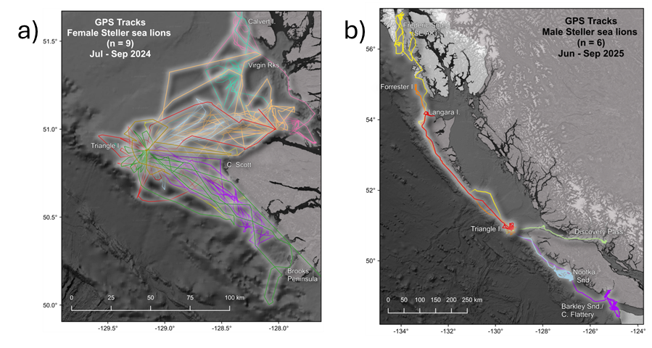

**Figure 4**

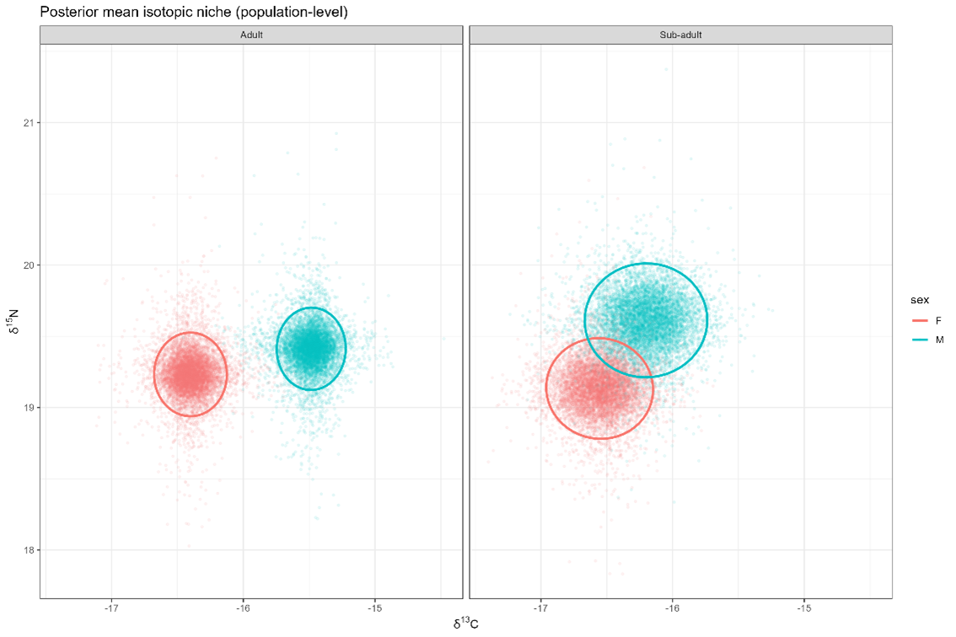

**Figure 5**

Figure 1. Map of study area showing approximate Fraser River sockeye salmon migration corridor, sockeye salmon and Steller sea lion tagging sites, and diet sampling locations.

Figure 2. Proportion of tagged sockeye salmon detected along migration corridor by release cohort (HG is Haida Gwaii, QCS is Queen Charlotte Strait). Detections provide an approximate estimate of survival but do not account for imperfect detection probability. Final results require parameterization of mark-recapture model.

#### Insights

Although analyses are underway, there are several key preliminary results. We found that sockeye salmon mortality rates during adult marine migrations may be considerably higher than previously assumed (e.g. Cohen 2012). At the same time, it is clear that the predator community varies along the migratory corridor—while we found some evidence of pinniped predation in Queen Charlotte Strait that warrants additional investigation, we found no evidence of pinniped predation near Haida Gwaii where mortality rates were high and apparently driven by shark predation. Similarly, we found evidence that predation impacts likely vary among and within sea lion haul outs. Despite the large size of the Triangle Island rookery, we found a very small number of tags at this location, particularly relative to Queen Charlotte Strait haul outs.

Steller sea lion satellite tag paths highlight important nuances in foraging behaviour during the months when Fraser River sockeye salmon are available. At this time of year, mature SSL are tied to pupping, nursing and breeding with only intermittent foraging. Peak pupping typically occurs early July. Females stay with their pups fasting for 1-2 weeks after which they make short foraging trips. Females appeared to disperse from Triangle by mid-August to other haul outs around Queen Charlotte Sound and WCVI. Males had very limited movements during the breeding period. Rapid and directed dispersal immediately post breeding (mid-July) was observed. Despite the large number of animals concentrated on Triangle Island during the breeding period (coincident with sockeye salmon migration), adjacent waters do not appear to be a major feeding ground this time of year. These foraging and dispersal patterns generally run counter to blanket assumptions for SSL impacts on sockeye and will have implications for foraging models. Ongoing diet analyses will provide additional information on individual, spatial, and seasonal variability in Steller sea lion foraging.

Our results emphasize the impacts of at least three predator taxa (salmon sharks, blue sharks, Steller sea lions) on sockeye salmon warrant additional consideration. Given a potential latitudinal gradient in shark abundance (Williams et al. 2010, Proudfoot et al. 2024), population level impacts may be sensitive to where Fraser River sockeye salmon intercept the continental shelf during their return migrations. All else being equal, fish making landfall near Haida Gwaii will migrate through a longer gauntlet of predators than those making landfall in Queen Charlotte Sound, which may in turn be at greater risk than those migrating through Juan de Fuca Strait. The location of landfall is uncertain, but if it is correlated with diversion rate, as seems likely, will vary among stocks as well as among years (Grant et al. 2017). If we find evidence of year-specific differences in survival rate, consistent with expected density dependent effects on predator foraging behaviour, this will add substantial additional variability due to sockeye salmon cyclicity. In short, a fixed, average predation rate applied to all stocks is likely inappropriate. Unfortunately, using statistical models to quantify the relative impact of each taxa is not possible given a lack of abundance data for blue and salmon sharks.

#### Next Steps

Our findings highlight successful ecosystem-based management of sockeye salmon requires careful consideration of factors that are often overlooked when quantifying predator impacts. First, studies on predation impacts have focused on cetaceans and pinnipeds (Chasco et al. 2017a & b, Walters et al. 2020, Nelson et al. 2024), which have robust time series of abundance. However, the effect of pinniped impacts will be biased high if the abundance of multiple predator taxa have increased in synchrony. In this scenario, reducing cetacean or pinniped effects may simply result in the remaining predator taxa increasing in abundance. Second, bioenergetics models are commonly used to quantify the population level impact of predators (Chasco et al. 2017a & b, Walters et al. 2020); however, these methods are sensitive to assumptions about the relative contribution of different species and size classes to the diet (Nelson et al. 2021). These uncertainties are further amplified by seasonal and spatial variability in predator diets, as well as differences among individuals in foraging behaviour. Finally, the total impact on prey species is also sensitive to the proportion of the prey population that is vulnerable to predation. Our findings suggest that each of these components is highly relevant when evaluating Steller sea lion impacts on Fraser River sockeye salmon.

In particular, we suggest ongoing and future work should address the following major dimensions. Seasonal and spatial variability in Steller sea lion diets should be quantified—this work will proceed using collected biochemical tracers. Seasonal, sex-specific variability in Steller sea lion distributions should be used to estimate the relative proportion of the population that is likely to overlap spatially and temporally with migrating sockeye salmon—this work could proceed using existing satellite and overflight survey data. Steller sea lion distributions should be paired with estimates of interannual and stock-specific variability in sockeye salmon migration routes to evaluate relative risk—this work is proceeding using historical catch data, but it is currently unclear whether existing data are sufficient. Since salmon-predator interactions are highly context-dependent (Wells et al. 2025), until the above data gaps are addressed efforts to mitigate predator impacts should proceed with caution and a careful consideration of the associated uncertainties.

#### References

Budge, S.M., Iverson, S.J. and Koopman, H.N., 2006. Studying trophic ecology in marine ecosystems using fatty acids: a primer on analysis and interpretation. Marine Mammal Science, 22(4).

Chasco, B., Kaplan, I., Thomas, A., Acevedo-Gutiérrez, A., Noren, D., Ford, M., Hanson, M., Scordino, J., Jeffries, S., Marshall, K., Shelton, A., Matkin, C., Burke, B. & Ward, E. 2017a. Competing tradeoffs between increasing marine mammal predation and fisheries harvest of Chinook salmon. Scientific Reports, 7.

Chasco, B., Kaplan, I., Thomas, A., Acevedo-Gutiérrez, A., Noren, D., Ford, M., Hanson, M., Scordino, J., Jeffries, S., Pearson, S., Marshall, K. & Ward, E. 2017b. Estimates of Chinook salmon consumption in Washington State inland waters by four marine mammal predators from 1970 to 2015. Canadian Journal of Fisheries and Aquatic Sciences 74: 1173-1194.

Cohen, B. 2012. The Uncertain Future of Fraser River Sockeye Salmon Volume 2: Causes of the Decline. 212 p.

Crossin, G.T., Hinch, S.G., Cooke, S.J., Welch, D.W., Batten, S.D., Patterson, D.A., Van Der Kraak, G., Shrimpton, J.M., and Farrell, A.P. 2007. Behaviour and physiology of sockeye salmon homing through coastal waters to a natal river. Mar. Biol. 152: 905-918.

Crossin, G.T., Hinch, S.G., Cooke, S.J., Cooperman, M.S., Patterson, D.A., Welch, D.W., Hanson, K.C., Olsson, I., English, K.K., and Farrell, A.P. 2009. Mechanisms influencing the timing and success of reproductive migration in a capital breeding semelparous fish species, the sockeye salmon. Phys. Biochem. Zool. 82: 635-652.

Freshwater, C., Burke, B.J., Scheuerell, M.D., Grant, S.C.H., Trudel, M., and Juanes, F. 2018. Coherent population dynamic associated with sockeye salmon juvenile life history strategies. Can. J. Fish. Aquat. Sci. 75: 1346-1356.

Layman, C.A., Araujo, M.S., Boucek, R., Hammerschlag‐Peyer, C.M., Harrison, E., Jud, Z.R., Matich, P., Rosenblatt, A.E., Vaudo, J.J., Yeager, L.A. and Post, D.M., 2012. Applying stable isotopes to examine foodweb structure: an overview of analytical tools. Biological reviews, 87(3), pp.545-562.

McKinnell, S., Curchitser, E., Groot, K., Kaeriyama, M., and Trudel, M. 2014. Oceanic and atmospheric extremes motivate a new hypothesis for variable marine survival of Fraser River sockeye salmon. Fish. Ocean. 23: 322-341.

Nelson, B., Pearson, S., Anderson, J., Jeffries, S., Thomas, A., Walker, W., Acevedo-Gutiérrez, A., Kemp, I., Lance, M., Louden, A. & Voelker, M. 2021. Variation in predator diet and prey size affects perceived impacts to salmon species of high conservation concern. Canadian Journal of Fisheries and Aquatic Sciences 78: 1661-1676.

Nelson, B.W., McAllister, M.K., Trites, A.W., Thomas, A.C. and Walters, C.J. 2024. Quantifying impacts of harbor seal *Phoca* *vitulina* predation on juvenile Coho Salmon in the Strait of Georgia, British Columbia. Marine and Coastal Fisheries 16(1), p.e210271.

Peterman, R.M. and Dorner, B.D. 2012. A widespread decrease in productivity of sockeye salmon (*Oncorhynchus nerka*) populations in western North America. Can. J. Fish. Aquat. Sci. 69: 1255-1260.

Proudfoot, B., Thompson, P.L, Vaidyanathan, T., Robb, C.K. 2024. Spatial estimate of blue shark, salmon shark, Pacific sleeper shark, and bluntnose sixgill shark presence in British Columbia. Can. Tech. Rep. Fish. Aquat. Sci. 3600: 27 p.

Rechisky, E.L., Porter, A.D., Clark, T.D., Furey, N.B., Gale, M.K., Hinch, S.G., and Welch, D.W. 2019. Quantifying survival of age-2 Chilko Lake sockeye salmon during the first 50 days of migration. Can. J. Fish. Aquat. Sci. 76: 136-152.

Seitz, A.C., Courtney, M.B., Evans, M.D., and Manishin, K. 2019. Pop-up satellite archival tags reveal evidence of intense predation on large immature Chinook salmon (*Oncorhynchus tshawytscha*) in the North Pacific Ocean. Can. J. Fish. Aquat. Sci. 76: 1608-1615.

Walters, C.J., McAllister, M.K., and Christensen, V. 2020. Has Steller sea lion predation impacted survival of Fraser River sockeye salmon? Fish. 45: 597-604.

Wells, B.W., Huff, D.D., Quinn, T.P., Santora, J.A., Gomes D.G.E. et al. 2025. When, where, and why salmon become vulnerable to predation. ICES J. Mar. Sci. 82: fsaf162.

Williams, R., Okey, T.A., Wallace, S.S., Gallucci, V.F. 2010. Shark aggregation in coastal waters of British Columbia. Mar. Ecol. Prog. Ser. 414: 249-265.

### Project 2410: Improved decision making for salmon by understanding the threats of freshwater Aquatic Invasive Species both now and in the future

**Project Leads:** Thomas Therriault

**Collaborations:** Province of British Columbia, Pacific Salmon Commission

**Region:** Pacific Region

**Species:** All

**Waterbodies:** All; Freshwater Ecoregions of the World

**Life History:** All

**Stock:** All

**Conservation Unit:** All

#### Highlights

This project has prioritized the risk of 515 Aquatic Invasive Species across multiple taxa (primarily fish, invertebrates and plants) for five freshwater ecoregions in the Pacific Region.

Several high risk AIS were identified within each taxonomic group and ecoregion that could negatively impact salmon stocks throughout the Pacific Region.

Managers and other decision makers need to explicitly consider the many threats posed by AIS in management and recovery plans for all salmon stocks in Pacific Region, recognizing these threats will not be uniform.

#### Background

Climate change and Aquatic Invasive Species (AIS) are leading threats to biodiversity globally. In British Columbia (BC), many salmon stocks have been assessed as at-risk by COSEWIC (Committee on the Status of Endangered Wildlife in Canada), but while climate change has been increasingly considered in salmon management and policy, the threat posed by AIS has largely been ignored. Further, stressors like increasing global temperatures are out of the control of regional management while AIS can be managed locally given resources and interest. By targeting those AIS most likely to have the biggest impact on salmon survival or productivity, we can improve salmon recovery by reducing the stress that these invasive species cause. AIS impacts on salmon are well documented in the US Pacific Northwest where, for example, invasive Walleye consume up to 2 million smolts a year in the Columbia River (Sanderson et al. 2009). The expansion of Northern Pike in Alaska has led to the decline of salmon productivity in some regions and all five salmon species have been classified as highly vulnerable to pike invasion in at least part of their Alaskan range (Jalbert et al. 2021). Habitat alteration can also impact salmon: Schwoerer et al. (2019) estimated the potential for $159 million annual damage to the Alaskan Sockeye salmon industry from one invasive plant species, Elodea. However, the extent and relative impact of freshwater AIS threats to salmon habitat and productivity have yet to be assessed in the Pacific Region (BC/Yukon). Here we will fill this gap by applying a novel screening level risk assessment tool to prioritize species (fish, invertebrates and plants) that have already invaded BC/Yukon, are nearby or in a known vector/pathway. By using freshwater ecoregions we are able to characterize the general risk of these species both now and in the future at a scale suitable to many management and policy venues.

Information generated via this project will have tremendous utility to those managers, First Nations, and stakeholders being impacted by AIS both now and in the future. As the freshwater assessments wrap up our intent is to reach out to various groups to convey the risk of the many species assessed here and to work with them on management or control plans based on their needs.

#### Methods and Findings

The Non-Indigenous Species Screening Tool (NISST, Wilcox et al. 2025), was developed in collaboration with this PSSI project to fill gaps and address common limitations in previous tools for screening potentially invasive species. It is organized into three separate modules examining steps in the invasion process combined with both ecological and socioeconomic impacts. This tool provides a semiquantitative valuation of risk which explicitly incorporates uncertainty into the score (using a novel Monte Carlo method) and recognizing the increasing importance of considering climate change when assessing invasion risk, this tool also incorporates a modifier for this. From the global species pool we identified >3200 species (including fish, invertebrates and plants) that could become AIS in the Pacific Region and potentially impact salmon. From this master list, we identified 515 to be screened using NISST; with most having some history of invasiveness, being associated with a known invasion vector (e.g., organisms in trade, aquaculture, shipping, etc.), and/or having some climate match to the five freshwater ecoregions that have boundaries within the Pacific Region (British Columbia and Yukon) (Figure 1). This included 245 fish, 83 invertebrates, and 180 plants. This project will produce a ranked list of priority AIS by ecoregion, including arrows to indicate the change in risk under a future climate and a measure of uncertainty using error bars, for both species that have already invaded or have yet to invade. Further, it is possible to produce bi-plots showing the relative contribution of Invasion Potential vs. Ecological Impacts or Socioeconomic Impacts both now and in the future.

The resulting ranked list of AIS by freshwater ecoregion showing taxonomic identity of the invader (fish, invertebrate or plant), its invasion status (present vs not yet detected), the effect of climate change and uncertainty. Additional project data will identify key vectors and pathways (i.e., recreational boating, natural dispersal, organisms in trade, etc.), and AIS-specific impacts to freshwater ecosystems and salmon stocks specifically. The identification of higher risk AIS is essential to refine other PSSI-related assessments of the multiple, often interacting threats to various Pacific salmon stocks and can be used in management plans, recovery assessments, or policy documents. For example, such information can be used to refine estimates of salmon mortality, recovery or productivity thus improving fisheries management advice for salmon. Further, the ranked list of AIS generated through these assessments will inform AIS monitoring and early detection programs both within DFO (AIS NCP), the Province of British Columbia (BC MOE) and the Yukon. Finally, higher risk species can be considered in future amendments to the AIS Regulation in the Fisheries Act and vectors and pathways common among higher risk AIS can be prioritized for policy and regulatory action.

To highlight key NISST outputs we include here working examples of the modular bi-plot outputs (Figure 2) and total risk scores (Figure 3) for some of the higher risk and lower risk fish species assessed for the Alaska and Canada Pacific Coastal ecoregion (FEOW 103 in Figure 1). Please note that there were 245 fish AIS to be assessed with NISST so the final products are likely to differ and these figures are included to illustrate what can be expected at the end of this project. As expected the range of scores obtained for species that are known to be introduced to this ecoregion and those not yet known were comparable across modules (Figure 2) and total risk scores (Figure 3) using two independent assessors. Further, the inclusion of climate change to the scores for each module typically increased the scores (Figures 2 and 3) although the magnitude varied by species.

Although work is ongoing to finalize the highest risk species for each of BC’s five freshwater ecoregions and specific ranks are subject to change, there are notable differences between northern and southern ecoregions with southern ones (103 and 120) having more AIS present including well known invaders such as brown bullhead (*Ameiurus nebulosus*), goldfish (*Carassius auratus*), common carp (*Cyprinus carpio*), and rosy red minnow (*Pimephales* *promelas*). Further, there are higher risk AIS belonging to other taxa such as plants like Brazilian elodea (*Egeria **densa*), purple loosestrife (*Lythrum* *salicaria*), curled pondweed (*Potamogeton* ***crispus), and invertebrates like Asian clam (Corbicula*** *fluminea*) and Chinese mystery snail (*Cipangopaludina** chinensis*). When complete it will be possible to consider risk not only at the ecoregion level but across taxonomic groups and invasion status.

Among some of the highest-ranking fish species, common carp and goldfish are known to be environmental generalists, able to survive in a wide range of habitats. Goldfish (*Carassius auratus*) in particular are also widely available in the aquarium trade and thus their potential (illegal) release is an ongoing concern (Chan et al. 2019). Their ability to consume plant and animals, including eggs, makes them a potential threat to most aquatic organisms at some life stage, and their feeding activities can cause increased turbidity and disruption of aquatic plants, modifying the habitat (i.e., ecosystem engineers) resulting in both ecological and socioeconomic impacts (e.g., Deacon et al. 1964; Moyle 1976; Richardson et al. 1995; Miller and Beckman, 1996; Egertson and Downing, 2004; Weber and Brown, 2009, Jackson et al., 2010). They also carry an extensive number of diseases and parasites with the potential to impact native fish (e.g. Gilad et al., 2004; Poelen et al., 2014).

Another group of higher risk species include some catfish species. For example, channel catfish (*Ictalurus** punctatus*) can spread rapidly due to a high reproductive rate and wide environmental tolerances (Jones et al., 1978). In the Columbia River they consume large numbers of juvenile salmon (Vigg et al. 1991; Sanderson et al. 2009) and predate on fish such as perch, shad, sunfish, razorback suckers, chubs, and endangered frogs (e.g. Robinette and Knight, 1981; Lentsch et al., 1996; Marsh and Douglas, 1997). Similarly, brown bullhead (*Ameiurus nebulosus*) negatively impact native fish via predation of eggs and competition with species such as endemic sticklebacks (*Gasterosteus* spp.) on Vancouver Island (Dextrase and Mandrak 2006), brassy minnows (*Hybognathus* *hankinsoni*) in the Fraser River (Nowosad and Taylor, 2013), and cisco, herring and lake trout in other parts of Canada (Scott and Crossman, 1973). In addition, they serve as vectors for finfish diseases such as viral haemorrhagic septicaemia (Faisal et al., 2012).

Perhaps not surprisingly most of the lowest risk species had poor climate match to Pacific Region ecosystems, were not known to be invasive elsewhere or possess traits known to facilitate invasion, and lacked documented ecological and socioeconomic impacts. Although several are expected to benefit from a future climate, in most cases they are still not expected to become problematic. Almost half of these species were aquarium fish (116/245) representing both temperate organisms like weatherfish or tropical ones like danios and many (133/245) are known to be in trade in Canada.

#### Tables and Figures

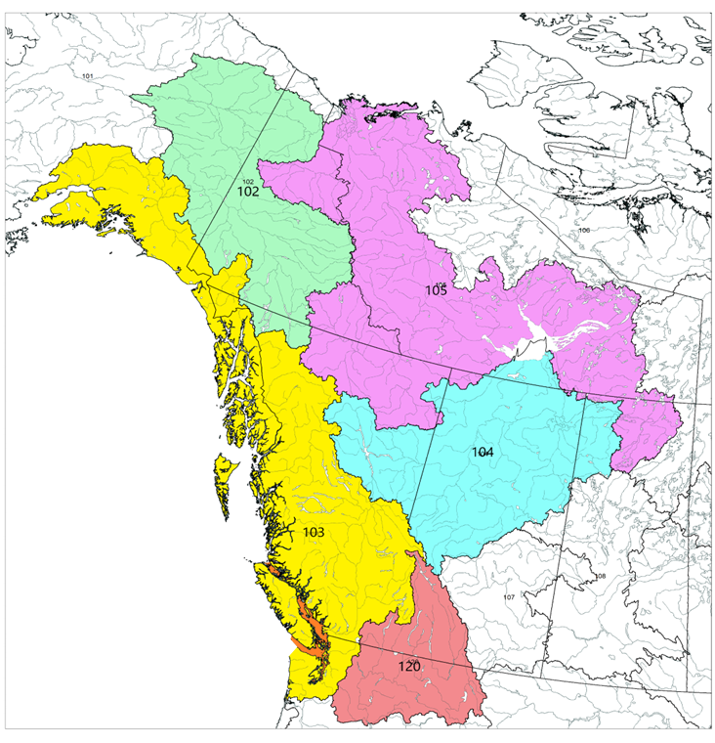

**Figure 1**

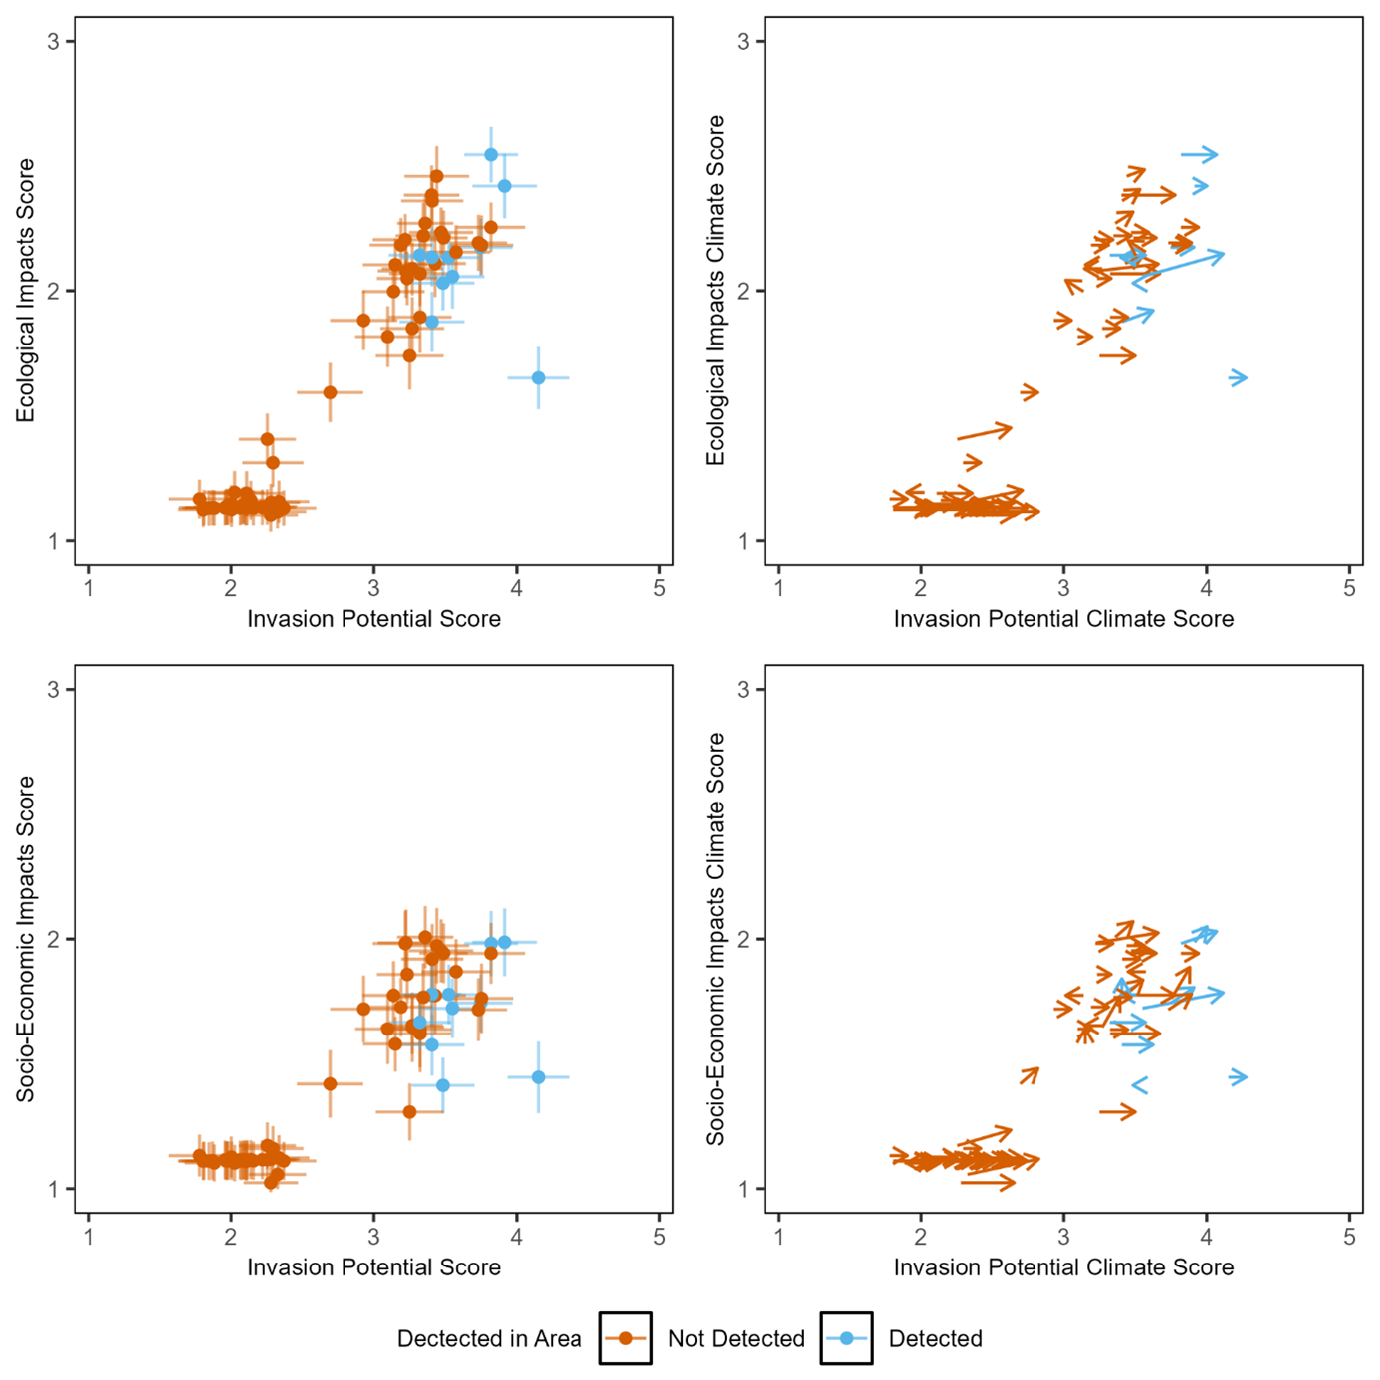

**Figure 2**

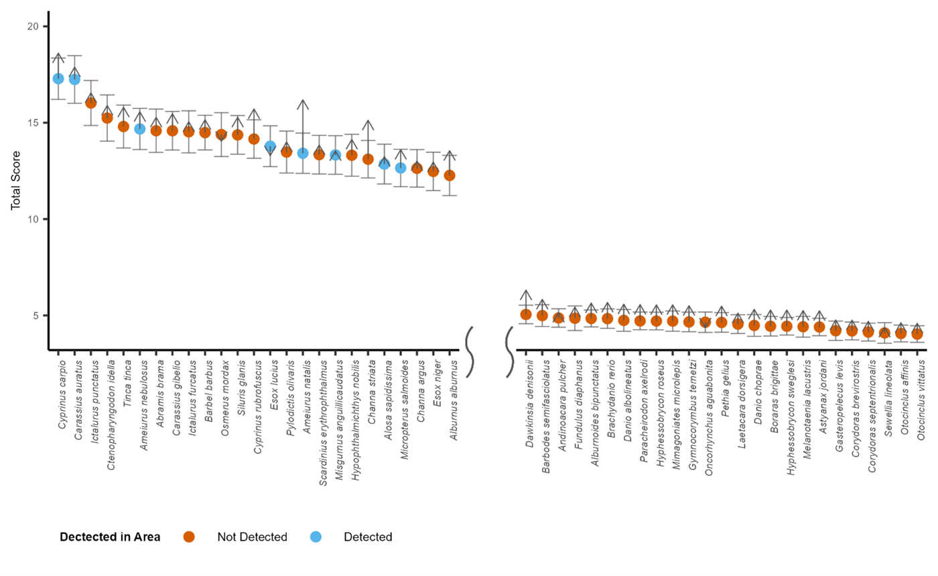

**Figure 3**

Figure 1: Map of the five freshwater ecoregions of the world (FEOW) that overlap with the Pacific Region. These ecoregions include the Upper Yukon FEOW (102), the Alaska and Canada Pacific Coast FEOW (103), the Upper Mackenzie FEOW (104), the Lower Mackenzie FEOW (105) and the Columbia Glaciated FEOW (120).

Figure 2: Biplots showing impact (ecological in the top panel and socioeconomic in the bottom panel) plotted against invasion potential for each example fish species screened using NISST for the Alaska and Canada Pacific Coast FEOW (103). Error bars represent the propagated error based on standard deviations from the Monte Carlo simulations. Vector plots showing the change in scores when using the climate modifier questions, where the base of the arrow depicts the unmodified score and the tip of the arrow depicts the climate modified score (Right). The length of the line depicts magnitude and the direction indicates the relative contributions of impacts and invasion potential to the modified scores. This plot is only showing a selection of higher risk and lower risk species – the same as those included in Figure 3. Note the final product will produce a continuum of scores.

Figure 3: Ranked NISST scores for example fish species for the Alaska and Canada Pacific Coast FEOW (103). A selection of higher risk and lower risk species are shown (the final product will produce a continuum for the full extent of species assessed). Error bars represent propagated error based on standard deviations from the Monte Carlo simulation. Arrows depict the climate modified scores.

#### Insights

It has been recognized for some time that AIS are a significant ecosystem stressor, especially in freshwater ecosystems (Sala et al. 2000), but also that ecosystem impacts can be highly context-dependent. This project is the first to comprehensively prioritize AIS for five freshwater ecoregions in Pacific Region both now and under future climate scenarios to improve management and policy decisions by explicitly considering higher risk AIS at multiple levels of decision making. NISST does not specify thresholds for high, medium or low risk species but rather allows flexibility for management to set these to ensure they are fit-for-purpose. For example, different thresholds might be set for different ecoregions depending on external factors such as salmon conservation units.

Salmon management should more explicitly consider the risks of AIS (and likely other stressors) in the development of truly integrated management plans and Species-at-Risk recovery documents. By recognizing the threat posed by AIS managers can prioritize locations where preventing introductions or spread are a priority and can develop early detection programs for the highest risk species. In locations where AIS might already exist preventing spread or mitigating impacts, especially those on at-risk species, could help preserve ecosystem structure and function, including many salmon stocks. Finally, our project identified that several AIS will benefit from climate change and impacts are expected to increase. Accounting for these types of interactions and cumulative effects could improve management and policy outcomes.

Downscaling the ecoregion risk assessments may be necessary for specific waterbodies in BC to improve salmon or ecosystem management decisions and outcomes. The goal of screening level assessments like NISST is that they provide a relatively rapid characterization of risk for relatively similar areas (here ecoregions) but they are not intended to provide a detailed assessment for any specific waterbody/location within the assessment area. Here detailed risk assessments could be undertaken or screening assessments in conjunction with additional information/data could be used.

Finally, it should be recognized that there was considerable data/information gathered for both the species being assessed and the assessment area in this process (see databases in development above). This information can be used in many decision making processes beyond the screening assessments themselves. For example, this information can be used by managers when developing early detection networks, rapid response, control or management plans for specific AIS, or recovery plans for at-risk species or areas being impacted by AIS. Further, this information can serve as a starting point for additional assessments beyond the Pacific Region as critical information will remain the same and can be used for assessment elsewhere in Canada or beyond.

#### Next Steps

AIS are not confined to freshwater ecosystems, given salmon life cycles they are likely to encounter additional high risk AIS in estuarine and marine ecosystems. Work is currently underway to identifying these higher risk AIS (fish, inverts, plants and algae) as well.

This project has identified higher risk AIS using a new screening tool such that results are standardized and can be used to inform potential regulatory amendments to the Aquatic Invasive Species Regulations in the Fisheries Act. A large number of higher risk AIS are not yet known from Pacific Region so listing could facilitate proactive measures to keep these species out or have early detection/surveillance and rapid response plans in place should they arrive.

Identifying and responding to AIS is a shared responsibility so communication products are needed to raise awareness among First Nations, stakeholders, and the public about the risks AIS pose to BC ecosystems, including salmon. This should include where to report suspicious species so the proper management actions can be undertaken (and responses are for AIS and not similar looking native species).

#### References

Chan, F.T., Beatty, S.J., Gilles Jr, A.S., Hill, J.E., Kozic, S., Luo, D., Morgan, D.L., Pavia Jr, R.T., Therriault, T.W., Verreycken, H. and Vilizzi, L., 2019. Leaving the fish bowl: the ornamental trade as a global vector for freshwater fish invasions. *Aquatic Ecosystem Health & Management*, *22*(4), pp.417-439.

Deacon, J.E., Hubbs, C. and Zahuranec, B.J., 1964. Some effects of introduced fishes on the native fish fauna of southern Nevada. *Copeia*, pp.384-388.

Dextrase, A.J. and Mandrak, N.E., 2006. Impacts of alien invasive species on freshwater fauna at risk in Canada. *Biological Invasions*, *8*(1), pp.13-24.

Egertson, C.J. and Downing, J.A., 2004. Relationship of fish catch and composition to water quality in a suite of agriculturally eutrophic lakes. *Canadian Journal of Fisheries and Aquatic Sciences*, *61*(9), pp.1784-1796.

Faisal, M., Shavalier, M., Kim, R.K., Millard, E.V., Gunn, M.R., Winters, A.D., Schulz, C.A., Eissa, A., Thomas, M.V., Wolgamood, M. and Whelan, G.E., 2012. Spread of the emerging viral hemorrhagic septicemia virus strain, genotype IVb, in Michigan, USA. *Viruses*, *4*(5), pp.734-760.

Gilad, O., Yun, S., Zagmutt-Vergara, F.J., Leutenegger, C.M., Bercovier, H. and Hedrick, R.P., 2004. Concentrations of a Koi herpesvirus (KHV) in tissues of experimentally-infected Cyprinus carpio koi as assessed by real-time TaqMan PCR. *Diseases of aquatic organisms*, *60*, pp.179-187.

Jackson, Z.J., Quist, M.C., Downing, J.A. and Larscheid, J.G., 2010. Common carp (Cyprinus carpio), sport fishes, and water quality: ecological thresholds in agriculturally eutrophic lakes. *Lake and Reservoir Management*, *26*(1), pp.14-22.

Jalbert, C.S., Falke, J.A., López, J.A., Dunker, K.J., Sepulveda, A.J. and Westley, P.A., 2021. Vulnerability of Pacific salmon to invasion of northern pike (Esox lucius) in Southcentral Alaska. *PLoS** One*,*16*(7), p.e0254097.

Jones, P.W. and Martin, F.D., 1978. *Development of Fishes of the Mid-Atlantic Bight: **Acipenseridae** Through **Ictaluridae*. pp 323.

Lentsch, L.D., Muth, R., Thompson, P.D., Crowl, T.A. and Hoskins, B.G., 1996. Options for selectively controlling non-indigenous fish in the Upper Colorado River Basin. *Final Report. Publication*, pp.96-14.

Marsh, P.C. and Douglas, M.E., 1997. Predation by introduced fishes on endangered humpback chub and other native species in the Little Colorado River, Arizona. *Transactions of the American Fisheries Society*, *126*(2), pp.343-346.

Miller, A.I. and Beckman, L.G., 1996. First record of predation on white sturgeon eggs by sympatric fishes. *Transactions of the American Fisheries Society*, *125*(2), pp.338-340.

Moyle, P.B. 1976. Inland fishes of California. University of California Press, Berkeley, CA.

Nowosad, D.M. and Taylor, E.B., 2013. Habitat variation and invasive species as factors influencing the distribution of native fishes in the lower Fraser River Valley, British Columbia, with an emphasis on brassy minnow (*Hybognathus* *hankinsoni*). *Canadian journal of zoology*, *91*(2), pp.71-81.

Poelen, J.H., Simons, J.D. and Mungall, C.J., 2014. Global biotic interactions: An open infrastructure to share and analyze species-interaction datasets. *Ecological informatics*, *24*, pp.148-159.

Richardson, M.J., Whoriskey, F.G. and Roy, L.H., 1995. Turbidity generation and biological impacts of an exotic fish Carassius auratus, introduced into shallow seasonally anoxic ponds. *Journal of fish biology*, *47*(4), pp.576-585.

Robinette, H.R. and Knight, S.S., 1981. Food of channel catfish during flooding of the Tombigbee River, Mississippi. In *Proceedings of the Southeastern Association of Fish and Wildlife Agencies* (Vol. 35, pp. 598-606).

Sala, O.E., Stuart Chapin, F.I.I.I., Armesto, J.J., Berlow, E., Bloomfield, J., Dirzo, R., Huber-Sanwald, E., Huenneke, L.F., Jackson, R.B., Kinzig, A. and Leemans, R., 2000. Global biodiversity scenarios for the year 2100. *science*, *287*(5459), pp.1770-1774.

Sanderson, B.L., Barnas, K.A. and Rub, A.M.W., 2009. Nonindigenous species of the Pacific Northwest: an overlooked risk to endangered salmon?. *BioScience*, *59*(3), pp.245-256.

Schwoerer, T., Little, J.M. and Adkison, M.D., 2019. Aquatic invasive species change ecosystem services from the world’s largest wild sockeye salmon fisheries in Alaska. *Journal of Ocean and Coastal Economics*, *6*(1), p.2.

Scott, W.B., 1973. Freshwater fishes of Canada. *Fish. Res. Board Can. Bull.*, *184*, pp.1-966.

Vigg, S., Poe, T.P., Prendergast, L.A. and Hansel, H.C., 1991. Rates of consumption of juvenile salmonids and alternative prey fish by northern squawfish, walleyes, smallmouth bass, and channel catfish in John Day Reservoir, Columbia River. *Transactions of the American Fisheries Society*, *120*(4), pp.421-438.

Weber, M.J. and Brown, M.L., 2009. Effects of common carp on aquatic ecosystems 80 years after “carp as a dominant”: ecological insights for fisheries management. *Reviews in Fisheries Science*, *17*(4), pp.524-537.

Wilcox, M.A., Johnson, D., Dyke, K., Gunsch, D., Lyons, D.A., DiBacco, C. and Therriault, T.W., 2025. Identifying higher risk invaders to the Columbia Glaciated Freshwater Ecoregion using a new screening tool: the Non-Indigenous Species Screening Tool (NISST). *Management of Biological Invasions*, *16*(1), pp.187-210.

### Project 2412: Investigation of the impacts of singular and coinciding acute climate stressors on the nutritional quality of the pteropod Limacina helicina, a juvenile Pacific salmon dietary species

**Project Leads:** Chris Pearce, Clara Mackenzie, Ian Forster (DFO, Nearshore Ecosystems Section)

**Collaborations:** Chrys Neville (DFO, Salmon Marine Interactions Program, Regional Ecosystem Effects on Fish & Fisheries Section)

**Location:** PBS Nanaimo;#PSEC West Vancouver

**Region:** Pacific

**Species:** N/A.

**Waterbodies:** Strait of Georgia

**Life History:** N/A.

**Stock:** N/A.

**Population:** N/A.

**Conservation Unit:** N/A.

#### Highlights

The nutritional status (*i.e.* fatty acid (FA) profiles) of *L**.* *helicina* was quantified in (a) field samples collected via plankton tow throughout the SOG between 2014 and 2023; and (b) laboratory samples following short-term experimental exposure to coinciding ocean warming and ocean acidification (OA) conditions, in order to investigate how changing oceanic conditions may impact the feed quality of a Pacific salmon prey species.

Overall, findings suggest that OA and, to a lesser degree elevated seawater temperatures, may result in altered fatty acid composition in pteropods, potentially leading to shifts in nutritional quality and associated impacts on trophic energy transfer. Additionally, results indicate that temperature stress could pose more immediate threat to pteropod survival.

We propose that any changes in the nutritive status of *L. **helicina* under climate stressor conditions could have carry-over impacts to juvenile salmon growth, health, and survival. However, we highlight that this study represents preliminary findings only and future research is needed to assess multi-trophic impacts.

#### Background

Under global climate change, co-occurrence of gradual physical changes in seawater and extreme events pose a substantial threat to marine ecosystems (IPCC, 2023). This PSSI-funded project focused on the Strait of Georgia (SOG) within the Northeast Pacific coastal region where steady rises in mean seasonal seawater temperatures and *p*CO2 levels, and increasingly prevalent acute stressor events such as heatwaves and low-pH upwellings, are already occurring (Bylhouwer et al., 2013; Evans et al., 2019; Okey et al., 2024; Raymond et al., 2022; Talloni-Alvarez et al., 2014). Moreover, the SOG is distinctive as conditions of high *p*CO2 and aragonite undersaturation persist year-round across a wide extent of the water column (Moore-Maley et al., 2016; Simpson et al., 2024). *Limacina* *helicina*, a cold-water pteropod well-represented within the region’s zooplankton communities, is highly susceptible to climate change stressors, with documented impacts of ocean warming and ocean acidification (OA) on shell development, growth, and survival (Bednaršek et al., 2016, 2022; Lischka et al., 2022; Lischka & Riebesell, 2012). However, there has been minimal investigation of climate change effects on the species’ nutritional status (*e.g.* fatty acid (FA) composition) under regionally-relevant conditions. Given the importance of *L. **helicina* as a dietary item for some populations of juvenile Pacific salmon species in the Northeast Pacific (Brodeur et al., 2007; Doubleday & Hopcroft, 2015; Sturdevant et al., 2012), it was proposed that any change in the nutritive status of *L. **helicina* under climate stressor conditions could have carry-over impacts to juvenile salmon growth, health, and survival.

The project involved cross-program collaboration between DFO researchers based at the Pacific Biological Station (PBS) and the Pacific Science Enterprise Centre (PSEC) for investigation of the impacts of warming and OA conditions (representative of future conditions in the SOG) on FA profiles of *L. **helicina* populations in the region. *Limacin**a* *helicina* samples were collected and processed as part of juvenile Pacific salmon survey fieldwork carried out in the SOG during 2014−2023 by the *Salmon Marine Interactions** Program* at PBS (Lead: Neville). The program also supported live collection (within the SOG) of *L. **helicina* for a climate change experiment (2023). Subsequent field sample sorting (*i.e.* extraction of whole pteropods from historical size-fractionated plankton samples) and laboratory experimentation (*i.e.* conducting of a climate change experiment in the Fisheries and Oceans Climate Change and Ocean Acidification Laboratory (FOCCOAL)), and nutritional analyses (*i.e.* FA analyses via gas chromatography) were carried out by the *Sustainable Invertebrate Aquaculture Program* at PBS (Lead: Pearce) and *Nutrition Program* at PSEC (Lead: Forster), respectively.

#### Methods and Findings

Climate Change Experiment: Live *L. **helicina* (Figure 1) were collected from the SOG in early October 2023 for use in a climate stressor experiment. Collection of approximately 800 pteropods was carried out over a 7-h period across a centrally-located area of the SOG via a series of vertical tows (N=9) using a bongo net collar assembly with two 58-cm diameter Nitex nets (253-µm mesh) deployed to a maximum depth of 300 m. Following, jars with animals were kept in a temperature-controlled cool box (~12°C, dark conditions). Within 24 h of collection, all pteropods were transported to the FOCCOAL at PBS for application to a climate change experiment. A full factorial design was applied to the experiment, resulting in four treatments: *Control,* *OA*, *Warming*, *OA+Warming* (*n*=6 tanks per treatment). Treatment conditions were achieved via use of the FOCCOAL, which employs a programmable logic controller and automated seawater and gas mixing systems to tightly control seawater temperature and *p*CO2, respectively. Pteropods were exposed to singular and coinciding warming (mean summer seawater temperature + 4°C) and OA (Ωaragonite < 1) conditions, with subsequent FA analyses carried out on 48-h and 5-d timepoint samples via gas chromatography (at PSEC). Results indicated a significant impact of OA on nutritional status at 48 h (Figure 2) and a significant impact of temperature on survival at 5 d (Figure 3).

Time-series Analyses (Field Samples):

Additionally, FA analyses of *L. **helicina* picked from historical plankton samples collected in the SOG as part of juvenile Pacific salmon survey work (Neville et al., 2025, 2026a, 2026b, 2026c, 2026d, 2026e; Neville & Spencer, 2026) were carried out to examine time-series changes in FA profiles in relation to regional temperature records (*e.g.* DFO British Columbia Shore Station Oceanographic Program*,* Chrome Island Lightstation temperature dataset). A subset (N=35) of frozen 1-mm size-fractioned samples covering a 10-year time series (2014–2023) were compiled to carry out pteropod FA profiling. Within a given year (N=7), five sampling stations were selected according to target tow depth and location. Sub-samples of the 1-mm size class samples from each station were used to obtain whole pteropods for FA analyses. FA analyses was carried out at PSEC via gas chromatography with results indicating significant differences in a number of fractions between year groups and in the overall FA profiles of a number of year groups (2016 and 2019; 2018 and 2021) (Figure 4), the latter findings parallelled by minor to moderate divergences in seasonal temperature conditions.

#### Tables and Figures

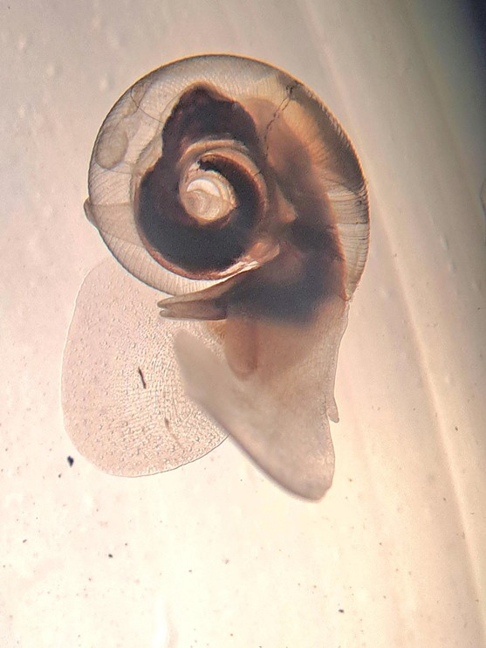

**Figure 1**

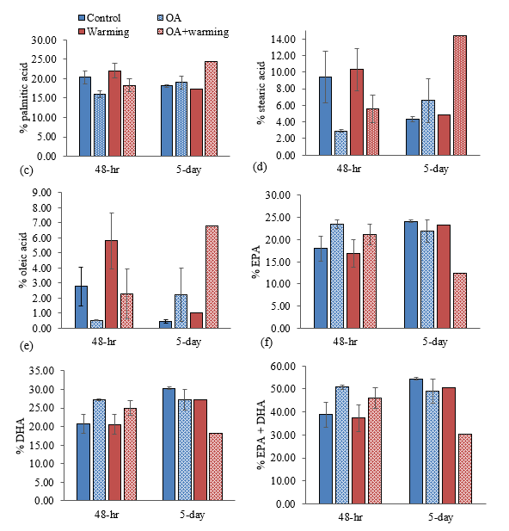

**Figure 2**

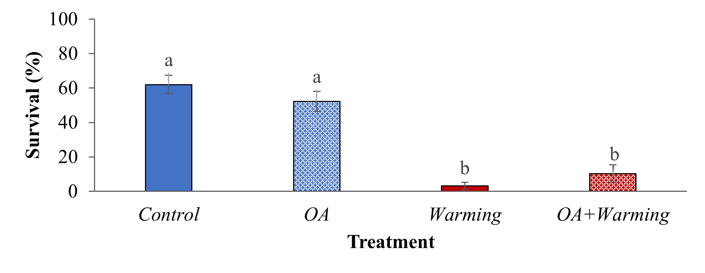

**Figure 3**

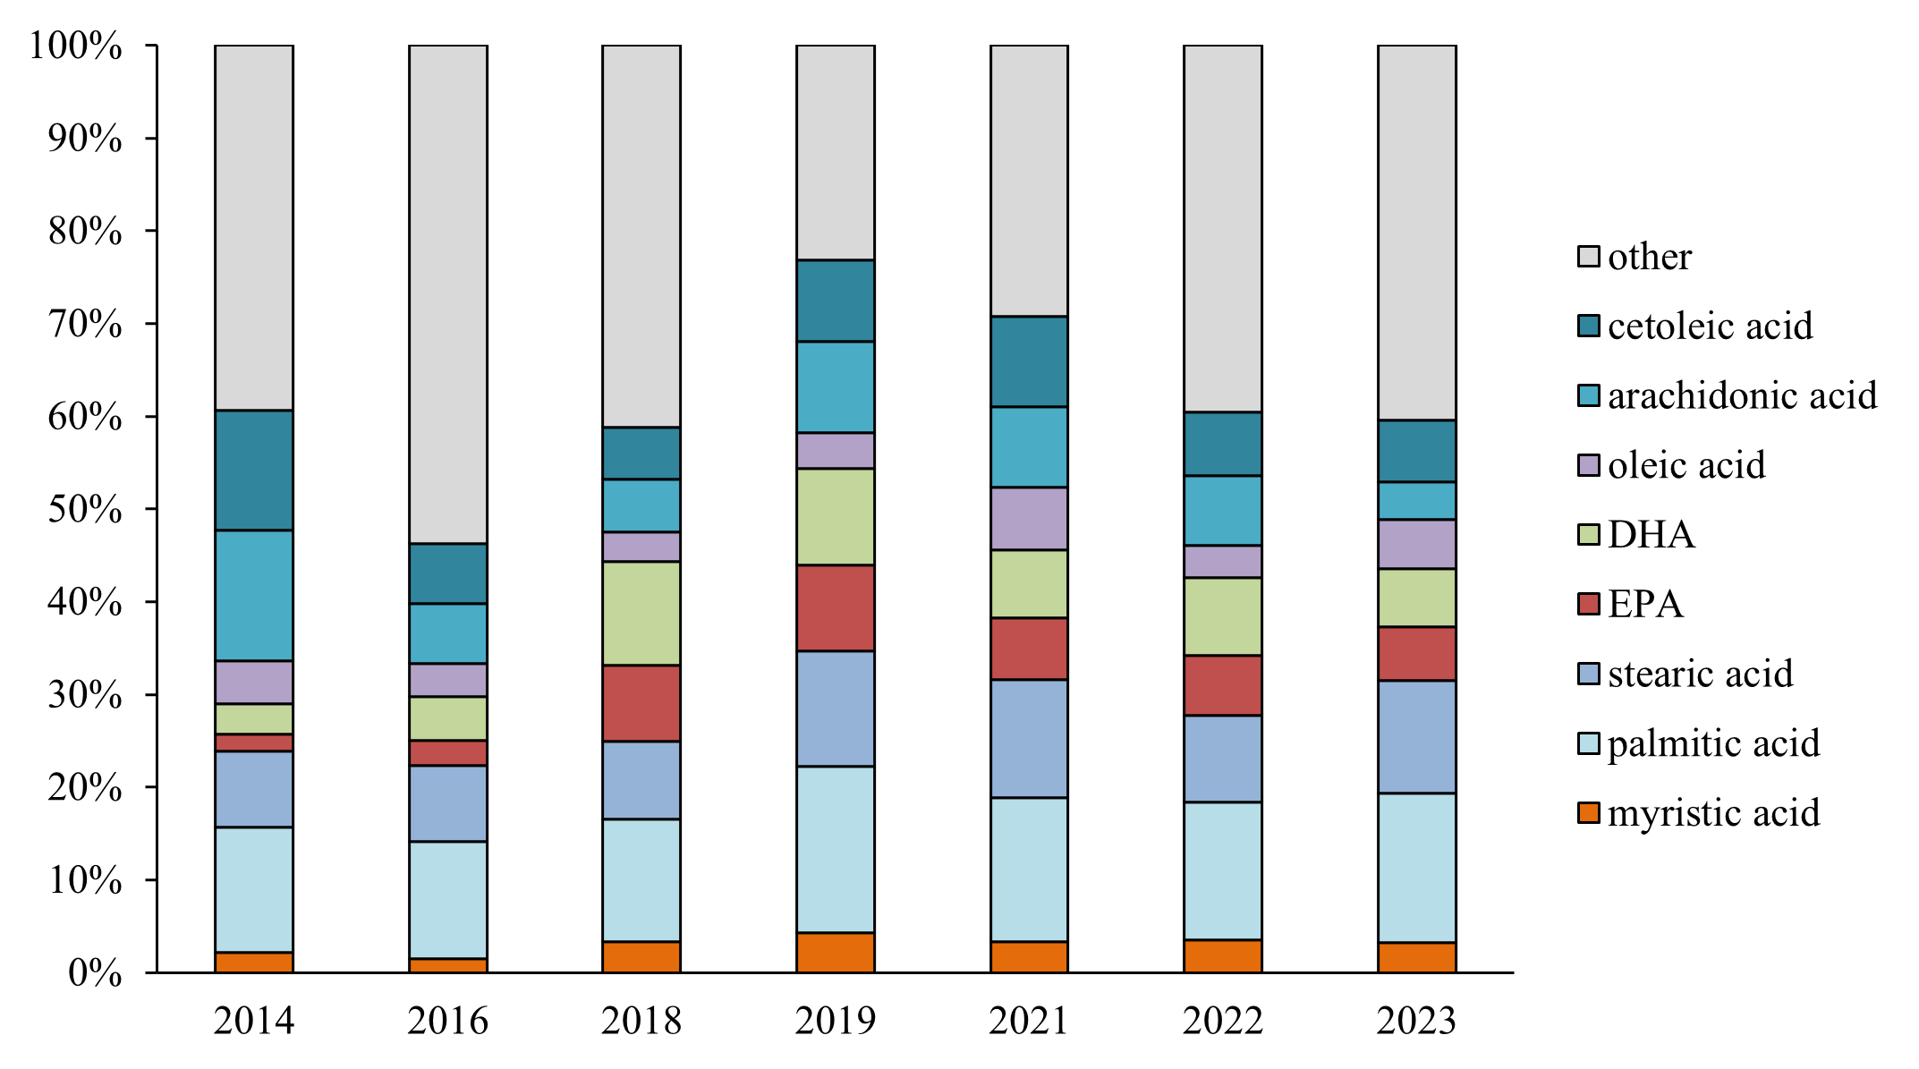

**Figure 4**

Figure 1. Photograph of *Limacina* *helicina* (M. Poerner Loureiro, Vancouver Island University).

Figure 2. Mean ± SE percentage (%) of (a) palmitic acid, (b) stearic acid, (c) oleic acid, (d) eicosapentaenoic acid (EPA), (e) docosahexaenoic acid (DHA), and (f) EPA+DHA in *Limacina* *helicina* following 48-h and 5-d exposures to singular and coinciding temperature and *p*CO2 stressors (*Control*: 10°C, ~650 ppm *p*CO2, Ωarag > 1; *OA*: 10°C, ~1500 ppm *p*CO2, Ωarag < 1; *Warming*: 14°C, ~650 ppm *p*CO2, Ωarag > 1; *OA+Warming*: 14°C, ~1500 ppm *p*CO2, Ωarag < 1). Note that all replicates of *Warming* and *OA**+Warming* treatments at the 5-d timepoint were pooled (resulting in *Warming*: N=3 pteropods and *OA**+Warming*: N=9 pteropods) for analyses due to high mortality across all replicate tanks.

Figure 3. Mean ± SE survival (%) of *Limacina* *helicina* following a 5-d exposure to singular and coinciding temperature and OA stressors (*Control*: 10°C, ~650 ppm *p*CO2, Ωarag > 1; *OA*: 10°C, ~1500 ppm *p*CO2, Ωarag < 1; *Warming*: 14°C, ~650 ppm *p*CO2, Ωarag > 1; *OA**+Warming*: 14°C, ~1500 ppm* p*CO2, Ωarag < 1). Differing lowercase letters above bars denote significant (*p *< 0.05) differences between treatments.

Figure 4. Mean percentages (%) of myristic acid, palmitic acid, stearic acid, eicosapentaenoic acid (EPA), docosahexaenoic acid (DHA), oleic acid, arachidonic acid, cetoleic acid, and remaining fatty acids (other) in *Limacina* *helicina* collected at plankton survey stations in the Strait of Georgia (British Columbia, Canada) for the period 2014–2023. Note: Surveys were not conducted in 2015, 2017, or 2020.

#### Insights

Project data may be fed into predictive habitat distribution modelling and climate change vulnerability assessments for Pacific salmon species (*e.g.* ACCASP’s Fish Stock Climate Vulnerability Assessment Tool (FSCVAT)). This would enable environmental/aquaculture managers and decision-makers to prepare for and respond to the impacts of climate change.

#### Next Steps

Findings here provide preliminary evidence that *L. **helicina* of the SOG region may tolerate persistent OA conditions with minimal impact to survival, but potentially at the expense of energy stores. Moreover, declining aragonite saturation state across the area could pose further detriment to their role as a food source to upper trophic species. In addition, we propose that temperature stress could pose more immediate threat to survival, particularly if warming in upper surface layers extends throughout the wider water column. Results highlight the need for improved understanding of ecological interactions under climate change conditions with regard to food-web dynamics, and the importance of considering multiple stressors when determining vulnerability of *L. **helicina* to future climate change conditions. Recommendations for future studies include the development of larger experimental mesocosms for improved pteropod holding facilities and extension of experimental time lines to encompass longer-term exposure periods. The current work could also be followed-up with laboratory-based salmon feeding trials to determine whether (and to what extent) impacts to pteropods relay to juvenile salmon growth/health (*e.g.* multi-trophic impacts).

#### References

Bednaršek, N., Carter, B. R., McCabe, R. M., Feely, R. A., Howard, E., Chavez, F. P., Elliott, M., Fisher, J. L., Jahncke, J., & Siegrist, Z. (2022). Pelagic calcifiers face increased mortality and habitat loss with warming and ocean acidification. Ecol. Appl*.* 32(7), e2674. https://doi.org/10.1002/EAP.2674

Bednaršek, N., Harvey, C. J., Kaplan, I. C., Feely, R. A., & Možina, J. (2016). Pteropods on the edge: Cumulative effects of ocean acidification, warming, and deoxygenation. Prog. Oceanogr. 145, 1–24. https://doi.org/10.1016/J.POCEAN.2016.04.002

Brodeur, R. D., Daly, E. A., Sturdevant, M. V, Miller, T. W., Moss, J. H., Thiess, M. E., Trudel, M., Weitkamp, L. A., Armstrong, J., & Norton, E. C. (2007). Regional comparisons of juvenile salmon feeding in coastal marine waters off the west coast of North America. Am. Fish. Soc. Symp. 57, 183–203.

Bylhouwer, B., Ianson, D., & Kohfeld, K. (2013). Changes in the onset and intensity of wind-driven upwelling and downwelling along the North American Pacific coast. J. Geophys. Res.: Oceans 118(5), 2565–2580. https://doi.org/10.1002/JGRC.20194

Doubleday, A. J., & Hopcroft, R. R. (2015). Interannual patterns during spring and late summer of larvaceans and pteropods in the coastal Gulf of Alaska, and their relationship to pink salmon survival. J. Plankton Res. 37(1), 134–150. https://doi.org/10.1093/PLANKT/FBU092

Evans, W., Pocock, K., Hare, A., Weekes, C., Hales, B., Jackson, J., Gurney-Smith, H., Mathis, J. T., Alin, S. R., & Feely, R. A. (2019). Marine CO2 patterns in the Northern Salish Sea. Front. Mar. Sci. 5, 1–18. https://doi.org/10.3389/fmars.2018.00536

IPCC. (2023). Climate Change 2023: Synthesis Report. Contribution of Working Groups I, II and III to the Sixth Assessment Report of the Intergovernmental Panel. In Climate Change 2023: Synthesis Report. Contribution of Working Groups I, II and III to the Sixth Assessment Report of the Intergovernmental Panel on Climate Change [Core Writing Team, H. Lee and J. Romero (eds.)]. https://doi.org/doi:10.59327/IPCC/AR6-9789291691647

Lischka, S., Greenacre, M. J., Riebesell, U., & Graeve, M. (2022). Membrane lipid sensitivity to ocean warming and acidification poses a severe threat to Arctic pteropods. Front. Mar. Sci. 9, 1–18. https://doi.org/10.3389/fmars.2022.920163

Lischka, S., & Riebesell, U. (2012). Synergistic effects of ocean acidification and warming on overwintering pteropods in the Arctic. Global Change Biol. 18(12), 3517–3528. https://doi.org/10.1111/GCB.12020

Moore‐Maley, B. L., Allen, S. E., & Ianson, D. (2016). Locally driven interannual variability of near‐surface pH and Ω A in the Strait of Georgia. J. Geophys. Res.: Oceans 121(3), 1600–1625. https://doi.org/10.1002/2015JC011118

Neville, C. M., Kevin, M., & Spencer, S. (2026a). Juvenile Pacific Salmon Survey in the Strait of Georgia and Associated Waters, September 22 to October 4, 2022 (SOG Survey 2022-04). Can. Data Rep. Fish. Aquat. Sci. 1460.

Neville, C. M., Kevin, M., & Spencer, S. (2026b). Juvenile Pacific Salmon Survey in the Strait of Georgia and Associated Waters, September 18 to September 30, 2021 (SOG Survey 2021-02). Can. Data Rep. Fish. Aquat. Sci. 1459.

Neville, C. M., & Spencer, S., 2026. Juvenile Pacific Salmon Survey in the Strait of Georgia and Associated Waters, September 17 to October 12, 2014 (SOG Survey 2014-10). Can. Data Rep. Fish. Aquat. Sci. 1452.

Neville, C. M., Spencer, S., & Kevin, M. (2025). Juvenile Pacific Salmon Survey in the Strait of Georgia and Associated Waters, September 18 to October 1, 2020 (SOG Survey 2020-02). Can. Data Rep. Fish. Aquat. Sci. 1458.

Neville, C. M., Spencer, S., & Kevin, M. (2026c). Juvenile Pacific Salmon Survey in the Strait of Georgia and Associated Waters, September 10 to September 28, 2019 (SOG Survey 2019-03). Can. Data Rep. Fish. Aquat. Sci. 1457.

Neville, C. M., Spencer, S., & Kevin, M. (2026d). Juvenile Pacific Salmon Survey in the Strait of Georgia and Associated Waters, September 11 to September 28, 2018 (SOG Survey 2018-04). Can. Data Rep. Fish. Aquat. Sci. 1456.

Neville, C. M., Spencer, S., & Kevin, M. (2026e). Juvenile Pacific Salmon Survey in the Strait of Georgia and Associated Waters, October 17 to October 26, 2016 (SOG Survey 2016-16). Can. Data Rep. Fish. Aquat. Sci. 1454.

Okey, T. A., Alidina, H. M., Lo, V., & Jessen, S. (2014). Effects of climate change on Canada’s Pacific marine ecosystems: A summary of scientific knowledge. Rev. Fish Biol. Fish. 24(2), 519–559. https://doi.org/10.1007/s11160-014-9342-1

Raymond, W. W., Barber, J. S., Dethier, M. N., Hayford, H. A., Harley, C. D. G., King, T. L., Blair, P., Speck, C. A., Tobin, E. D., Raymond, A. E. T., & Mcdonald, P. S. (2022). Assessment of the impacts of an unprecedented heatwave on intertidal shellfish of the Salish Sea. Ecology 103(10), e3798. https://doi.org/10.1002/ecy.3798

Simpson, E., Ianson, D., Kohfeld, K. E., Franco, A. C., Covert, P. A., Davelaar, M., & Perreault, Y. (2024). Variability and drivers of carbonate chemistry at shellfish aquaculture sites in the Salish Sea, British Columbia. Biogeosciences 21, 1323–1353. https://doi.org/10.5194/bg-21-1323-202

Sturdevant, M. V, Orsi, J. A., & Fergusson, E. A. (2012). Diets and trophic linkages of epipelagic fish predators in coastal Southeast Alaska during a period of warm and cold climate years. Mar. Coastal Fish. 4(1), 526–545. https://doi.org/10.1080/19425120.2012.694838

Talloni-Álvarez, N. E., Sumaila, R. U., Le Billon, P., & Cheung, W. W. L. (2019). Climate change impact on Canada’s Pacific marine ecosystem: The current state of knowledge. Mar. Policy 104, 163–176. https://doi.org/10.1016/j.marpol.2019.02.035

### Project 2413: Barkley Sound and Clayoquot Sound Krill Monitoring

**Location:** Barkley Sound;#Clayoquot Sound

### Project 2414: South Coast freshwater ecological indicator pilot

### Project 2415: A Decision Support Framework for Identifying and Characterizing the Non-fishing Threats to Pacific Salmon

### Project 2416: Monitoring and predicting the exposure of Pacific salmon to harmful algal biotoxins

**Project Leads:** Andrew Ross

**Collaborations:** Cermaq Canada (Aquaculture Transition/CSRF)

Pacific Salmon Foundation (Citizen Science Program/CSRF)

Snuneymuxw First Nation

**Location:** Barkley Sound

**Region:** WCVI

**Species:** Chinook

**Waterbodies:** Barkley Sound

**Life History:** Juvenile/Early Marine

**Stock:** Sarita, Robertson

**Population:** WCVI

#### Highlights

to assess the risk posed by harmful algal biotoxins to juvenile WCVI Chinook in their critical habitat.

juvenile WCVI Chinook salmon are exposed to and take up harmful algal biotoxins in Barkley Sound.

biotoxins known to harm fish peak in summer/fall in Barkley Sound in both water and fish tissues.

results suggest that biotoxin exposure/impacts can be mitigated e.g. via timing of hatchery releases.

#### Background

Biotoxins produced by harmful algae are know to cause illness and mortality in marine animals including juvenile fish (Lefebvre et al., 2005). Regular monitoring of harmful algal biotoxins in B.C. coastal waters since 2020 (Ross et al., 2025b) has revealed significant correlations between climate variables (e.g. water temperature) and the concentrations of these toxins in areas known to be frequented by Pacific salmon. These include at-risk WCVI Chinook salmon populations, for which harmful algae were identified as an emerging threat during the WCVI Chinook Rebuilding Plan Marine Risk Assessment (MRA) Workshop #3 held in April 2022. However, the levels of harmful algal biotoxins to which juvenile WCVI Chinook salmon are exposed in critical habitats such as Barkley and Clayoquot Sounds are unknown. This is an important knowledge gap, given that low early marine survival is contributing to declines in WCVI Chinook and other Pacific salmon populations.

The goal of this PSSI ‘Follow the Fish’ project was to build upon our Biotoxin Monitoring Program (Ross and Mueller, 2024) by adapting established analytical methods and procedures to measure harmful algal biotoxins in juvenile WCVI Chinook salmon tissues (gill, liver) and habitat (Barkley Sound) using samples collected by ‘Follow the Fish’ krill and salmon survey teams, in partnership with local First Nations. This information is being combined with environmental data (water properties, eDNA), assessments of fish health and condition (biometrics, gene expression), and information on life history (otolith microchemistry) to help forecast and potentially mitigate early marine exposure of WCVI Chinook salmon to harmful algal biotoxins, and associated impacts on their health and survival.

#### Methods and Findings

Harmful algal biotoxins were measured in sea water using the method developed for our Marine Biotoxin Monitoring Program (Ross and Mueller, 2024). Surface sea water was collected at 5 locations in Barkley Sound (Fig. 1) during krill surveys carried out at the beginning of each month and filtered on board to obtain filter and filtrate samples, from which biotoxins were extracted and analyzed by liquid chromatography and tandem mass spectrometry to obtain dissolved and particulate biotoxin concentrations (Ross et al., 2025a). These were combined to obtain monthly values of total biotoxin concentration at each location (Fig. 2). To assess exposure to harmful algal biotoxins, juvenile WCVI Chinook salmon captured by purse seining close to krill survey locations were dissected to obtain gill and liver tissue samples, which were pooled as necessary to obtain sufficient material for analysis.

Products and tools developed during this project include a Regional Biotoxin Database (in progress) for organizing, storing and retrieving biotoxin and related environmental, biological, and taxonomic information for sea water and biological samples collected during this project (and the Marine Biotoxin Monitoring Program) with the goal of making it available to co-workers via DMApps.

Advances in methodology during this project include procedures to minimize cross-contamination while dissecting and pooling of tissues for biotoxin analysis, and adaptation of the method for sea water analysis to measure harmful algal biotoxins in very small amounts of tissue, thereby allowing them to be studied in individual fish, organs and/or early life stages (Mueller et al., in preparation).

Examples of communication and knowledge transfer include a Newsletter (Ross and Loseto, 2025) that describes the monitoring of biotoxins and contaminants during the PSSI ‘Follow the Fish’ project. Results from the monitoring of biotoxins in Barkley Sound during fall 2023 were also included in a report prepared for Snuneymuxw First Nation (Ross, 2024) on the measurement of harmful algal biotoxins near Nanaimo at the same time, to provide context for the interpretation of those results. Knowledge about seasonal trends in biotoxin concentration obtained during this project, and how it can be used to mitigate risks associated with biotoxin exposure in juvenile salmon through the timing of hatchery releases, was presented during a Fish Health & Hatchery Biology Seminar (Ross, 2025).

Key results include:

detection and identification of seasonal patterns in the concentrations of harmful algal biotoxins in Barkley Sound, including those know to be harmful to juvenile fish (Fig. 2).

detection of certain biotoxins in the tissues of juvenile WCVI Chinook salmon present in Barkley Sound when those biotoxins are relatively abundant in the surrounding water (June to September).

recognition that WCVI Chinook are being exposed to harmful algal biotoxins in their critical habitat during early marine life stages, at levels sufficient to cause uptake in gill and liver tissues (Fig. 3).

#### Tables and Figures

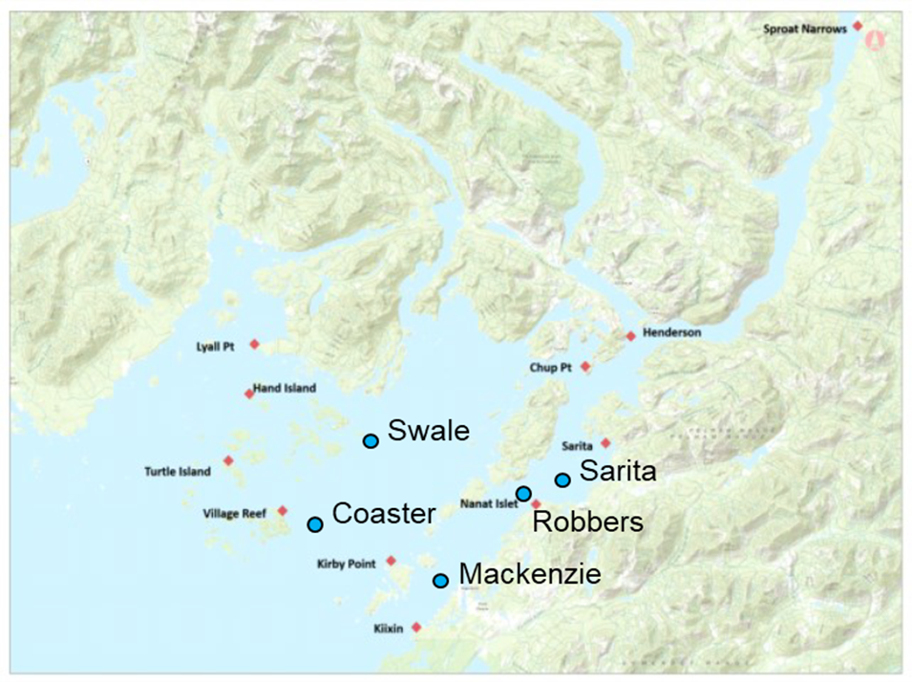

**Figure 1**

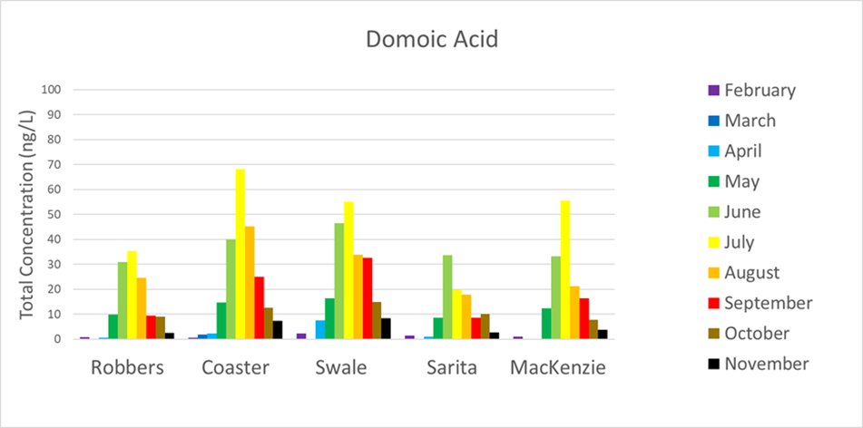

**Figure 2a**

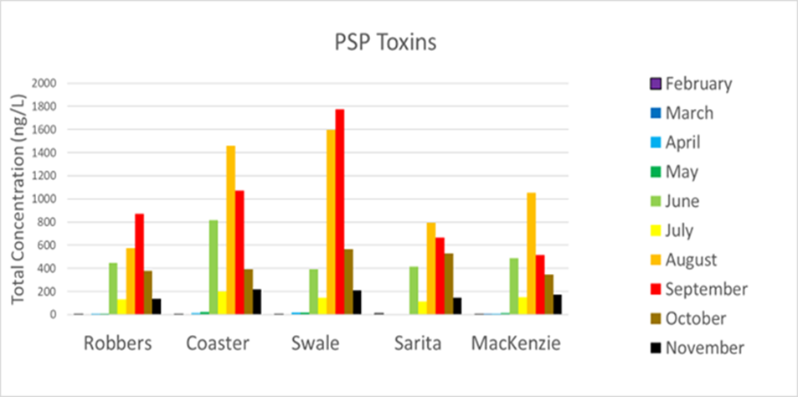

**Figure 2b**

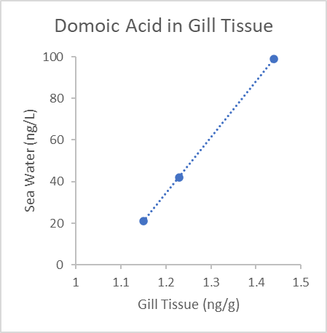

**Figure 3a**

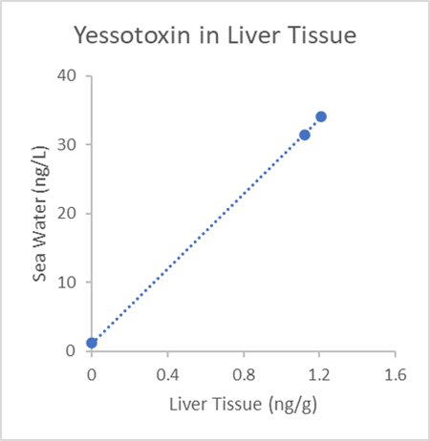

**Figure 3b**

Figure 1. Krill survey sites (blue circles) in Barkley Sound where water samples were collected for biotoxin analysis, and salmon survey locations (red diamonds) including those close to krill survey sites, where juvenile WCVI Chinook were caught and analyzed for biotoxins in gill and liver tissues.

Figure 2. Total concentrations of the harmful algal biotoxin domoic acid (upper panel) and paralytic shellfish poisoning (PSP) toxins (lower panel) at krill survey sites in Barkley Sound during 2024. These toxins, which are known to harm juvenile fish, were most abundant between June and September.

Figure 3. Concentrations in sea water versus gill tissue for domoic acid (left panel) and liver tissue for yessotoxin (right panel) in juvenile WCVI Chinook salmon caught July to September 2023 at Coaster.

#### Insights

This project has revealed that juvenile WCVI Chinook salmon present in Barkley Sound during late summer are exposed to harmful algal biotoxins at levels sufficient to cause uptake in their tissues.

biotoxins present in Barkley Sound follow seasonal trends similar to those observed elsewhere in B.C. coastal waters (Fig. 2).

juvenile WCVI Chinook salmon in Barkley Sound are exposed to increasing levels of algal biotoxins from May onwards, particularly at central and outer locations (Coaster, Swale, Mackenzie: Fig. 1).

exposure of juvenile WCVI Chinook salmon to biotoxins is confirmed by detection of domoic acid, yessotoxin, and the paralytic shellfish poisoning (PSP) toxin saxitoxin in gill and/or liver tissue from purse seined fish caught in Barkley Sound in late summer 2023 and/or 2024.

levels of biotoxins detected in tissues seem to correlate with those in the surrounding water (Fig. 3).

Results from our Marine Biotoxin Monitoring Program suggest that certain biotoxins including those harmful to juvenile fish are trending upwards in B.C. coastal waters, and that higher biotoxin levels may be associated with climate-related factors such as increasing temperature and/or nutrient limitation due to stratification caused by higher temperatures or freshwater inputs (Ross at al., 2025).

Tools are being developed (CSRF project 2025-26-11-07) to predict future levels of biotoxin exposure and uptake based upon linkages with environmental conditions measured at the same time. This will allow DFO to forecast and potentially mitigate levels and impacts of biotoxin exposure in WCVI Chinook; for example, by timing the release of hatchery fish to minimize exposure (Ross, 2025).

Meanwhile, gene expression analysis is being carried out (Art Bass et al.) to see whether observed levels of biotoxin exposure result in stress responses, biological effects and/or health impacts in juvenile salmon, thereby helping to identify biologically significant thresholds of exposure for these limiting factors.

We are working with the Contaminants group (Lisa Loseto et al.) to investigate the separate and cumulative effects of biotoxins and contaminants on juvenile WCVI Chinook salmon, taking advantage of the observed seasonal trends in biotoxin exposure.

We are also working with the Otolith Microchemistry group (Nicole LaForge, Micah Quindazzi) to relate biotoxin exposure and impacts to life stage and history (e.g. estuary residence time, age at entry) for specific populations (Sarita, Robertson), and with the eDNA group (Christoph Deeg et al.) on interactions of juvenile WCVI Chinook salmon with harmful algae and other marine species.

In addition to providing total biotoxin concentrations, the analysis of filter and filtrate samples (Ross et al., 2025a) allows us to compare biotoxin levels in different salmon tissues with dissolved and particulate biotoxin concentrations in the surrounding water, and to see if the data support a particular pathway of exposure (e.g. uptake via ingestion would likely give a better correlation with particulate biotoxins whereas uptake via gills would likely correlate better with dissolved biotoxins).

The analytical tools used in this project (e.g. high performance liquid chromatography and tandem mass spectrometry) provide a high degree of confidence in the measured concentrations of harmful algal biotoxins in sea water and fish tissues. However, the west coast of Vancouver Island is a highly dynamic environment while the lifecycles of anadromous fish like WCVI Chinook salmon extend beyond the 3-year timeframe of this PSSI project. Consequently, more data is needed to confirm our initial findings. Ideally, this would involve the collection and analysis of samples and data for at least another 2 years, work that is current planned for the CSRF Project “Linking climate variables to algal biotoxin production and impacts on Pacific salmon” (2025-26-11-07) which runs until March 31, 2028.

#### Next Steps

Remaining knowledge gaps include additional monitoring data with which to establish longer-term trends in biotoxin production in Barkley Sound and how these may relate to climate change. They also include future data on adult returns and indicators of health, recruitment, etc. for salmon that were exposed to the observed concentrations of biotoxins in Barkley Sound during this project (i.e. from July 2023 to November 2025). This will allow long-term risks associated with ‘carry forward’ impacts of biotoxin exposure to be assessed, along with any early marine life stage impacts revealed by gene expression analysis and/or biometric indicators of fish health in juvenile salmon during this project.

Meanwhile, the findings of this project can be operationalized by incorporating information on the temporal and spatial distributions of harmful algal biotoxins in Barkley Sound (Figs. 1 and 2) into the scheduling of hatchery releases for different populations (Sarita, Robertston) based on knowledge of their migration behaviour (incl. salt water entry and estuarine residence times) to minimize biotoxin exposure and impacts in juvenile salmon. The observed relationships between biotoxin levels in fish tissues and dissolved, particulate and/or total biotoxin concentrations (Fig. 3) in the surrounding water can also be used to help identify pathways of exposure and evaluate current and future risks posed by measured and projected biotoxin concentrations to juvenile WCVI salmon in Barkley Sound.

#### References

Lefebvre, K.A., Elder, N.E., Hershberger, P.K., Trainer, V.L., Stehr, C.M., Scholz, N.L. (2005). Dissolved saxitoxin causes transient inhibition of sensorimotor function in larval Pacific herring (*Clupea harengus pallasi*). Marine Biology 147: 1393-1402. https://link.springer.com/article/10.1007/s00227-005-0048-8

Ross, A.R.S. (2024). Analysis of harmful algal biotoxins in samples collected by the Snuneymuxw First Nation during fall 2023. Report to Snuneymuxw First Nation Marine Division.

Ross, A.R.S., Mueller, M. (2024). Monitoring harmful algal biotoxins in British Columbia coastal waters. PICES Press 32 (2), 37-39. https://meetings.pices.int/publications/pices-press/PICES-Press-2024-Vol32No2.pdf#page=37

Ross, A.R.S. (2025) Seasonal trends in harmful algal biotoxins & salmon enhancement. Fish Health & Hatchery Biology Seminar Series, March 18.

Ross, A.R.S., Loseto, L. 2025. Monitoring biotoxins and contaminants and their impacts on WCVI Chinook salmon. Follow the Fish Newsletter Volume 3, 12 p. https://publications.gc.ca/collections/collection_2025/mpo-dfo/Fs141-15-2025-3-eng.pdf

Ross, A.R.S., Ip., B., Mueller, M., Surridge, B., Hartmann, H., Hundal, N., Matthews, N., Shannon, H., Hennekes, M., Sastri, A., and Perry, R.I. (2025a). Seasonal monitoring of dissolved and particulate algal biotoxins in the northern Salish Sea using high performance liquid chromatography and tandem mass spectrometry. Harmful Algae 145, 102854. https://www.sciencedirect.com/science/article/pii/S1568988325000563

Ross, A.R.S., Mueller, M., Ip, B., Hundal, N., Matthews, N., Surridge, B., Hartmann, H., Nesbitt, B., McKenzie, P., Frederickson, N., Esenkulova, S., Pearsall, I., Sastri, A., Hennekes, M., Galbraith, M., Young, K., Taves, R., Raftery, E., Kafrissen, S., Loro, F. and Perry, R.I. (2025b) ‘Marine biotoxin monitoring in B.C. coastal waters’, in Boldt, J.L., Joyce, E., Tucker, S., Gauthier, S. and Jackson, J. (eds.) *State of the physical, biological and selected fishery resources of Pacific Canadian marine ecosystems in 2024*. Can. Tech. Rep. Fish. Aquat. Sci. 3687. Nanaimo, B.C.: Fisheries and Oceans Canada, pp. 337. https://www.dfo-mpo.gc.ca/oceans/publications/soto-rceo/2024/pac-technical-report-rapport-technique-eng.html

### Project 2417: Optimization of feeds used in the hatchery production of Pacific Salmon.

**Project Leads:** Dr. Erika Eliason; Dr. Ian Forster; Greig Oldford

**Collaborations:** Salmon Enhancement Program Hatcheries

**Region:** British Columbia

**Species:** Chinook salmon (*Oncorhynchus tshawytscha*)

**Life History:** First feeding to release

**Stock:** Stream-type and ocean-type chinook from Chilliwack River Hatchery

#### Highlights

Given that early marine survival can be very low for hatchery-reared salmonids, the present study investigated the effects of a transition diet on the smoltification, growth and survival of stream-type and ocean-type Chinook salmon during the transition from freshwater to seawater.

Fish fed the transition diet did not show any apparent advantages over fish fed the control diet, in terms of smoltification (enzymatic activities of gill Na+, K+ ATPase), growth performance or survival.

We do not recommend broadscale adoption of transition diets at DFO hatcheries at this time, given that they do not appear to be an effective way to improve early marine survival.

#### Background

The main objectives of salmon hatcheries in Canada are to enhance wild populations and support salmon fisheries, but are often hindered by low early marine survival of salmon after release (Beamish et al. 2010, 2012). While low early marine survival can be attributed to various factors, smoltification [the morphological, behavioural, and physiological changes salmon undergo to enable them to adjust to the marine environment (McCormick 2012; Brauner and Richards 2020)], is potentially a major bottleneck. During smoltification, one of the key changes is elevated enzyme activities of gill Na+, K+ ATPase (NKA), which plays a crucial role in facilitating primary salt secretion at the gills (McCormick 2012; Brauner and Richards 2020). Both elevated gill NKA levels (McCormick and Saunders 1987; Stich et al. 2015b, 2015a) and high survival post seawater transition (Clarke 1982) are considered valid indicators of smoltification development of salmonids.

In hatchery settings, a change in photoperiod (increasing daylength) can trigger smoltification, while temperature (warming) can accelerate its development in salmonids (Clarke et al. 1989; Muir et al. 1994; Duston and Saunders 1995; Ban 2000; Strand et al. 2018). In addition, past studies have also reported that salt supplementation in the diet could facilitate smoltification development of salmonids (positive effects: Zaugg et al. 1983; Trombetti et al. 1996; Staurnes and Finstad 2000; Hanson et al. 2016); but also negative effects see: Trombetti et al. 1996; Hanson et al. 2016). Manipulating the diet represents a feasible and relatively simple approach to further improve the smoltification success and thus early marine survival of hatchery salmon in BC. In collaboration with the DFO Salmon Enhancement Program, the objective of the present study was to investigate the impact of a seawater transition diet (Adapt Flex-transition diet vs control diet), on the smoltification, growth and survival of stream-type (ST, typically resides in freshwater for >1 year prior to migrating to the ocean) and ocean-type (OT, typically resides in freshwater for <6 months) Chinook salmon (*Oncorhynchus tshawytscha )* during the transition from freshwater to seawater.

#### Methods and Findings

On March 18th 2025, stream type (ST) and ocean type (OT) Chinook salmon from Chilliwack hatchery were transferred to 200 L indoor tanks (N=4 tanks per treatment, per strain) at 10°C under natural photoperiod at Pacific Science Enterprise Centre (PSEC), in West Vancouver, BC. Fish were fed control diets to satiation 3-4 times daily until the start of the experiment. The experiment started on April 2, 2025 for ST Chinook (control: 4.96 ± 0.02 g, 7.58 ± 0.01 cm; treatment: 4.87 ± 0.05 g, 7.55 ± 0.03 cm) and April 30, 2025 for OT Chinook (control: 4.29 ± 0.03 g, 7.30 ± 0.02 cm), respectively. These timings were also around 5 weeks before the time when the fish would usually be released by the hatchery to begin their outmigration. Fish (N = 55 per tank for ST, and N = 50 per fish for OT; 4 tanks per diet treatment per life stage) were fed one of two diets to satiation daily during a 5 week growth trial in freshwater: control (BioClark’s Fry, 3.0 mm, Bio-Oregon, Canada) or treatment transition diet (Adapt Flex 3 mm, EWOS, Canada), which contained 5% NaCl, and additional other proprietary ingredients (e.g. an immunostimulant compound and mix of exclusive nucleotide). Fish were maintained on their treatment diets for an additional 34 days (ST) and 7 days (OT) until the seawater transition. The timing of the seawater transition was determined when the majority of the fish in experiment tanks showed visual cues of smolt transformation, specifically the development of silvering body colour, and fading of parr marks. The fish were transitioned to seawater over 1 day, and then all fish were fed the same control diet for 4 weeks, after which the experiment was terminated and all remaining fish were euthanized (TMS at 0.2 g/L).

Fish were sampled for body size (mass and fork length) and gill Na+, K+ ATPase (NKA; 5 - 8 fish per tank per sampling time, except on day 0, when total 30 fish were sampled prior to tank stocking) on: (1) day 0; (2) after 5 weeks on the experimental diets in freshwater; (3) 1 day after seawater transition; and (4) after 4 weeks in seawater. The Specific growth Rate (SGR) for each replicate tank was calculated for 2 periods: (1) the 5-week freshwater trial; (2) from the end of freshwater trial to the end of the seawater trial, using the formula below:

SGR (%) = [ln (F) – ln (I)] × 100 / T

Where I = initial mean fish weight per tank (g), F = final mean fish weight per tank (g), and T = experiment duration (days)

Enzyme activities of gill Na+ K+ ATPase (NKA) were analyzed using methods as described by Mccormick (1993).

Fish growth and gill NKA levels were analyzed using two-way analysis of variance (ANOVA) using Sigmaplot 14. A statistical level of 0.05 is considered significant, and all data were expressed as mean ± standard error of the mean (SEM).

Overall, there were no differences in the trends between OT and ST Chinook salmon. Survival was excellent for both ST and OT Chinook salmon throughout the entire study (>91% across Chinook strains and diet treatments; Table 1). As expected, gill NKA activity increased during the experiment, indicating that smoltification processes were progressing over time (Figure 1; significant main effect of sampling stage; ST p = 0.002; OT p<0.001). However, there were no differences in gill NKA levels between diet treatments (ST: p = 0.21; OT: p = 0.30). For growth, fish grew faster on the control diet compared to the transition diet, but only in freshwater (Figure 2; significant interaction between diet and sampling stage; ST: p < 0.001; OT: p = 0.028). In freshwater, control fish had significantly higher SGR than the treatment fish. However, in seawater, SGR were similar for both groups, when all fish were fed the same control diet. Notably, SGR levels were much lower (up to 50% reduced) in seawater compared to freshwater (Figure 2).

#### Tables and Figures

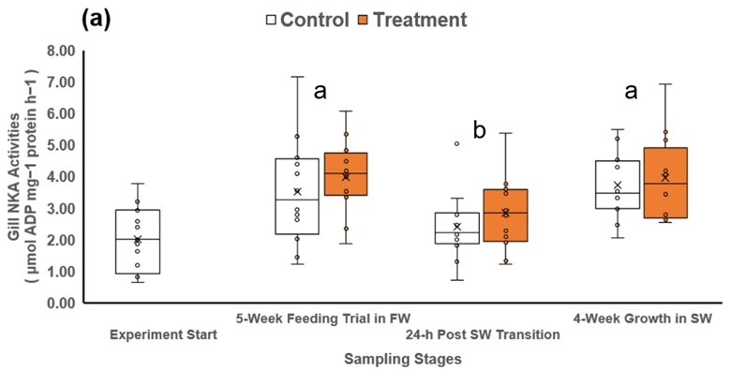

**Figure 1a**

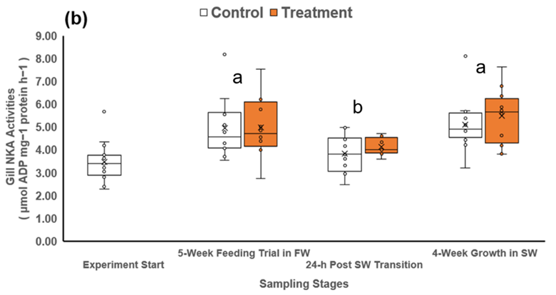

**Figure 1b**

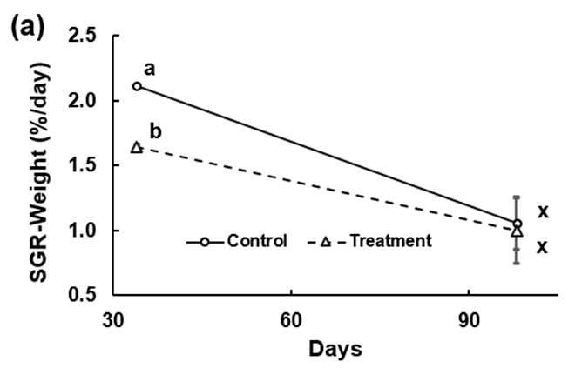

**Figure 2a**

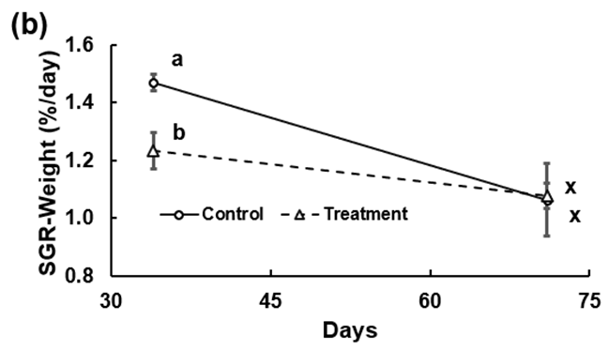

**Figure 2b**

Table 1. Survival of stream-type (ST) and ocean-type (OT) Chinook salmon at different stages of the experiment.

Figure 1. Gill Na+ K+ ATPase (NKA) activities of (a) stream-type chinook salmon, and (b) ocean-type chinook salmon from the control or treatment diet group at different experiment stages (n = 12 per sampling time per diet group). The cross symbol (×) in the box plot indicates mean values within each group. Different superscripts denote significant differences among each sampling stage (p < 0.05, two-way ANOVA, followed by all pairwise multiple comparison tests with the Holm-Sidak method).

Figure 2. The mean specific-growth rates (SGR) of (a) stream-type (ST) Chinook salmon, and (b) ocean-type (OT) Chinook salmon from the control or treatment diet group at the end of the freshwater growth trial (day 34) and seawater growth trial (ST = day 98; OT = day 71) There was a significant interaction between diet and sampling stage on the SGR of both ST and OT chinook. Different superscripts denote significant differences between data within the each experiment stage (p < 0.05, two-way ANOVA, followed by all pairwise multiple comparison tests with the Holm-Sidak method). The error bars indicated standard error of the mean (SEM).

#### Insights

This study investigated the effects of a transition diet on the smoltification development, growth and survival of ST and OT Chinook salmon during the transition from freshwater to seawater with the overall goal to improve early marine life survival. Throughout the lab experiment, all fish appeared robust, as they were able to handle multiple handling and sampling events without showing obvious adverse effects such as post sampling mortalities. By the end of the study, regardless of the diet, both ST and OT Chinook salmon apparently smolted well, as indicated by the elevated Gill NKA levels after the experiment started (Fig. 1), and the high survival 24-h and 4-weeks post seawater transfer (Table 1). Moreover, the overall data trends are highly similar between ST and OT Chinook salmon, indicating that both life history types responded comparably to the diet treatment and seawater transfer.

Overall, the results of this study showed no apparent advantage of using the transition diet over the control diet in rearing Chinook salmon. First, for each strain of Chinook salmon, fish fed both the transition diet and control diet reached very similar smoltification status in terms of gill NKA activities and exhibited high survival post seawater transition. Secondly, compared to the control diet, the transition diet did not show an advantage on fish growth performance. In fact, for both ST and OT Chinook salmon, the control fish grew significantly faster in freshwater (Figure 2), and this is also in agreement with other studies (Salman and Eddy 1988; Hanson et al. 2016). In the present study, the growth differences observed may be related to the fish appetite for the feed, which was reflected by the amount of food fed to reach visual satiation. Particularly for ST Chinook salmon, the control fish consistently displayed a bigger appetite for feeding, and were thus offered more feed than the treatment fish throughout the study; this behaviour might thus translate into the observed larger body mass gains in control fish than treatment fish.

Despite high survival, transition to seawater resulted in compromised growth rates for both ST and OT Chinook salmon. While all fish were fed the same control diet in seawater, the SGR of all fish decreased to a similar rate of 1 – 1.08 % after 4 weeks in seawater (Figure 2); indeed, the SGR of control ST Chinook salmon, which was the highest in freshwater (2.11 ± 0.00% per day), had the largest reduction of almost 50%. This slower growth of Chinook salmon post seawater transfer has been reported by other studies as well (Clarke et al. 1981; Morgan and Iwama 1991). With the increased metabolic rate of Chinook salmon in increased salinity (Morgan and Iwama, 1991), the fish may thus have less net energy for supporting growth (Brauner and Richards 2020), resulting in slower SGR at this stage. While the seawater growth phase was only 4 weeks in the present study, these Chinook salmon might need more time to physiologically adjust for the seawater condition, before compensating for their growth. In a wild setting, elevated metabolic rates and incomplete smoltification processes leading to reduced SGR could contribute to early marine mortality. In this regard, sufficient estuary rearing areas could be pivotal to support smoltification processes, feeding opportunities and protection from predation during this critical transition stage (McNatt et al. 2016; Moore et al. 2016; Chalifour et al. 2021).

Interestingly, the smoltification development rates likely differed between the strains. At the start of the present study, the gill NKA levels (unit: μmol ADP·mg protein−1·h−1) of ST Chinook salmon (2.02 ± 0.26) are comparable to those reported from Chinook salmon at the beginning of river migration (mean 1.34 – 1.64; Ewing et al. 2001), while OT Chinook salmon (3.48 ± 0.22) had already reached a similar level of those caught in estuaries (3.8 ± 0.32; Ewing et al., 2001). This finding suggested that while OT Chinook salmon were held for 4 weeks longer until experiment start, they were also in more advanced smoltification development, which was also supported by fish morphology observation during initial tank stocking. After 4 weeks in seawater, the gill NKA levels of OT Chinook salmon were still higher than ST Chinook salmon (mean value of control and treatment; OT: 5.30 ± 0.24; ST: 3.78 ± 0.24); these levels are comparable to those of Chinook salmon smolt at early stage of seawater transfer at 34 ppt (mean around 4; Quinn et al. 2003), but lower than those observed after 10 days in seawater (mean: 6; Quinn et al. 2003). In fact, Houde et al. (2019) reported even higher gill NKA levels from Chinook salmon smolt both in freshwater (5.0 ± 2.5) and seawater (9.6 ± 2.8).

It is possible that the positive effects of a transition diet on smoltification were masked by other factors, such as temperature. Increasing temperature has been reported to accelerate smoltification processes, in terms of earlier elevation and higher gill NKA activities in Atlantic salmon (Solbakken et al. 1994; Mccormick and Moriyama 2000; McCormick et al. 2002), Chinook salmon (Muir et al. 1994), and sockeye salmon (Ban 2000). In the present study, all fish experienced an increase of water temperature during transfer from the hatchery (5.8 ± 0.4oC for ST, and 7.4 ± 0.2oC for OT) to PSEC (10°C). Therefore, it is possible that smoltification development had already been accelerated soon after they were introduced to the holding tanks, before the experiment started. In this case, the effects of the transition diet may have been masked, as both control and treatment fish would show accelerated smoltification development. While the initial higher gill NKA levels of OT Chinook salmon discussed above, seemed to support this hypothesis, more concrete evidence are still needed. To mitigate the potential interference of a water temperature effect, future studies could design similar experiments so that the fish would not experience a significant change in water temperature, such as running the entire study at the hatchery as reported by Hansen et al. (2016).

#### Next Steps

We found no evidence to suggest that using seawater transition diets (Adapt Flex by EWOS Canada Ltd.) will improve early marine survival for hatchery fish. The results of the present study showed that there were no apparent advantages of using this seawater transition diet over the routine control diet on rearing ST and OT Chinook salmon in terms of smoltification, growth and seawater survival. Indeed, all these performance parameters measured in the present studies showed very similar trends between ST and OT Chinook. As such, we do not recommend broadscale use of these transition diets at DFO hatcheries at this time.

On the other hand, future studies are encouraged to investigate knowledge gaps revealed here. One recommendation is to conduct a similar study in a hatchery setting, in order to have the most direct insights into how a transition diet may benefit the hatchery production of salmon at DFO. Hatchery and lab conditions vary in several aspects, including water source, fish density, temperature, and rearing environment. In the present study, it was speculated that the inevitable change in water temperature from hatchery to the lab might have accelerated the smoltification development in both control and treatment fish, thus masking the effects of transition diet. Conducting a similar study in a hatchery setting could reveal the effects of the transition diet, while eliminating similar potential interfering factors that may exist in lab environment. Moreover, while the present study focused on growth and gill NKA as traditional development indicators, future studies could further investigate dietary effects on the physiological and behavioural performance parameters relevant to survival post hatchery-release. For example, swimming or migration performance (Pedersen et al. 2008; Serrano et al. 2009; Wilson et al. 2021), standard and maximum metabolic rates (Farrell 2009; Auer et al. 2015) and predator avoidance behaviours (Olla et al. 1998; Jackson and Brown 2011) are known to be critical to salmon survival in the early marine environment. Finally, given that the transition diet does not appear to be effective at improving early marine survival, we recommend considering how alternative diets could confer other desirable traits in fish, such as the possibility that high lipid diets could reduce the jacking rate in salmon.

#### References

Auer, S.K., Salin, K., Anderson, G.J., and Metcalfe, N.B. 2015. Aerobic scope explains individual variation in feeding capacity. Biol. Lett. 11(11): 10–12. doi:10.1098/rsbl.2015.0793.

Ban, M. 2000. Effects of Photoperiod and Water Temperature on Smoltification of Yearling Sockeye Salmon (*Oncorhynchus nerka*). Bull. Natl. Salmon Resour. Cent. (3): 25–28.

Beamish, R.J., Sweeting, R.M., Lange, K.L., Noakes, D.J., Preikshot, D., and Neville, C.M. 2010. Early Marine Survival of Coho Salmon in the Strait of Georgia Declines to Very Low Levels. Mar. Coast. Fish. 2(1): 424–439. doi:10.1577/c09-040.1.

Beamish, R.J., Sweeting, R.M., Neville, C.M., Lange, K.L., Beacham, T.D., and Preikshot, D. 2012. Wild chinook salmon survive better than hatchery salmon in a period of poor production. Environ. Biol. Fishes 94(1): 135–148. doi:10.1007/s10641-011-9783-5.

Brauner, C.J., and Richards, J.G. 2020. Physiological performance in aquaculture: Using physiology to help define optimal conditions for growth and environmental tolerance. Fish Physiol. 38: 83–121. Elsevier Inc. doi:10.1016/bs.fp.2020.10.001.

Chalifour, L., Scott, D.C., Macduffee, M., Stark, S., Dower, J.F., Beacham, T.D., Martin, T.G., and Baum, J.K. 2021. Chinook salmon exhibit long-term rearing and early marine growth in the fraser river, British Columbia, a large urban estuary. Can. J. Fish. Aquat. Sci. 78(5): 539–550. doi:10.1139/cjfas-2020-0247.

Clarke, W.C. 1982. Evaluation of the seawater challenge test as an index of marine survival. Aquaculture 28(1–2): 177–183. doi:10.1016/0044-8486(82)90020-5.

Clarke, W.C., Shelbourn, J.E., and Brett, J.R. 1981. Effect of artificial photoperiod cycles, temperature, and salinity on growth and smolting in underyearling coho (*Oncorhynchus kisutch*), chinook (*O. Tshawytscha*), and sockeye (*O. nerka*) salmon. Aquaculture 22(C): 105–116. doi:10.1016/0044-8486(81)90137-X.

Clarke, W.C., Shelbourn, J.E., Ogasawara, T., and Hirano, T. 1989. Effect of initial daylength on growth, seawater adaptability and plasma growth hormone levels in underyearling coho, chinook, and chum salmon. Aquaculture 82(1–4): 51–62. doi:10.1016/0044-8486(89)90395-5.

Duston, J., and Saunders, R.L. 1995. Advancing smolting to autumn in age 0+ Atlantic salmon by photoperiod, and long-term performance in sea water. Aquaculture 135(4): 295–309. doi:10.1016/0044-8486(95)01034-3.

Ewing, R.D., Ewing, G.S., and Satterthwaite, T.D. 2001. Changes in gill Na+, K+-ATPase specific activity during seaward migration of wild juvenile chinook salmon. J. Fish Biol. 58(5): 1414–1426. doi:10.1006/jfbi.2000.1550.

Farrell, A.P. 2009. Environment, antecedents and climate change: Lessons from the study of temperature physiology and river migration of salmonids. J. Exp. Biol. 212(23): 3771–3780. doi:10.1242/jeb.023671.

Hanson, K.C., Twibell, R.G., Glenn, R.A., Barron, J.M., and Gannam, A.L. 2016. The Effects of a Transition Diet on the Smoltification of Chinook Salmon. N. Am. J. Aquac. 78(4): 307–313. doi:10.1080/15222055.2016.1185064.

Houde, A.L.S., Akbarzadeh, A., Gu, O.P., Li, S., Patterson, D.A., Farrell, A.P., Hinch, S.G., and Miller, K.M. 2019. Salmonid gene expression biomarkers indicative of physiological responses to changes in salinity and temperature , but not dissolved oxygen. doi:10.1242/jeb.198036.

Jackson, C.D., and Brown, G.E. 2011. Differences in antipredator behaviour between wild and hatchery-reared juvenile Atlantic salmon (*Salmo salar*) under seminatural conditions. Can. J. Fish. Aquat. Sci. 68(12): 2157–2165. doi:10.1139/F2011-129.

McCormick, S.., and Saunders, R.L. 1987. Preparatory physiological adaptations for marine life in salmonids: osmoregulation, growth and metabolism. Am. Fish. Soc. Symp.: 211–229.

Mccormick, S.D. 1993. Methods for non biopsy and measurement of Na+, K+-ATPase activity. Can. J. Aquat. Sci. 50: 9–11.

McCormick, S.D. 2012. Smolt Physiology and Endocrinology. *In* Fish Physiology. Elsevier Inc. pp. 199–251. doi:10.1016/B978-0-12-396951-4.00005-0.

Mccormick, S.D., and Moriyama, S. 2000. Low temperature limits photoperiod control of smolting in atlantic salmon through endocrine mechanisms. Am. J. Physiol. - Regul. Integr. Comp. Physiol. 278(5 47-5): 1352–1361. doi:10.1152/ajpregu.2000.278.5.r1352.

McCormick, S.D., Shrimpton, J.M., Moriyama, S., and Björnsson, B.T. 2002. Effects of an advanced temperature cycle on smolt development and endocrinology indicate that temperature is not a zeitgeber for smolting in Atlantic salmon. J. Exp. Biol. 205(22): 3553–3560. doi:10.1242/jeb.205.22.3553.

McNatt, R.A., Bottom, D.L., and Hinton, S.A. 2016. Residency and Movement of Juvenile Chinook Salmon at Multiple Spatial Scales in a Tidal Marsh of the Columbia River Estuary. Trans. Am. Fish. Soc. 145(4): 774–785. doi:10.1080/00028487.2016.1172509.

Moore, J.W., Gordon, J., Carr-harris, C., Gottesfeld, A.S., Wilson, S.M., and Russell, J.H. 2016. Assessing estuaries as stopover habitats for juvenile Pacific salmon. 559: 201–215. doi:10.3354/meps11933.

Morgan, D.J., and Iwama, K.G. 1991. Effects of Salinity on Growth, Metabolism, and Ion Regulation in Juvenile Rainbow and Steelhead Trout (*Oncorhynchus mykiss*) and Fall Chinook Salmon (*Oncorhynchus tshawytscha*). Can. J. Fish. Aquat. Sci. 48: 2083–2094.

Muir, W.D., Zaugg, W.S., Giorgi, A.E., and McCutcheon, S. 1994. Accelerating smolt development and downstream movement in yearling chinook salmon with advanced photoperiod and increased temperature. Aquaculture 123(3–4): 387–399. doi:10.1016/0044-8486(94)90073-6.

Olla, B.L., Davis, M.W., and Ryer, C.H. 1998. Understanding how the hatchery environment represses or promotes the development of behavioral survival skills. Bull. Mar. Sci. 62(2): 531–550.

Pedersen, L.F., Koed, A., and Malte, H. 2008. Swimming performance of wild and F1-hatchery-reared Atlantic salmon (*Salmo salar*) and brown trout (*Salmo trutta*) smolts. Ecol. Freshw. Fish 17(3): 425–431. doi:10.1111/j.1600-0633.2008.00293.x.

Quinn, M.C.J., Veillette, P.A., and Young, G. 2003. Pseudobranch and gill Na+, K+-ATPase activity in juvenile chinook salmon, *Oncorhynchus tshawytscha*: Developmental changes and effects of growth hormone, cortisol and seawater transfer. Comp. Biochem. Physiol. - A Mol. Integr. Physiol. 135(2): 249–262. doi:10.1016/S1095-6433(03)00067-9.

Salman, N.A., and Eddy, F.B. 1988. Effect of dietary sodium chloride on growth, food intake and conversion efficiency in rainbow trout (*Salmo gairdneri* Richardson). Aquaculture 70(1–2): 131–144. doi:10.1016/0044-8486(88)90012-9.

Serrano, I., Larsson, S., and Eriksson, L.O. 2009. Migration performance of wild and hatchery sea trout (*Salmo trutta* L.) smolts-Implications for compensatory hatchery programs. Fish. Res. 99(3): 210–215. doi:10.1016/j.fishres.2009.06.004.

Solbakken, V.A., Hansen, T., and Stefansson, S.D. 1994. Effects of photoperiod and temperature on growth and parr-smolt transformation in Atlantic salmon and subsequent performance in seawater. Aquaculture 121: 13–27.

Staurnes, M., and Finstad, B. 2000. The effects of dietary NaCl supplement on hypo-osmoregulatory ability and sea water performance of Arctic charr (*Salvelinus alpinus* L.) smolts. Aquac. Res. 31(10): 737–743. doi:10.1046/j.1365-2109.2000.00495.x.

Stich, D.S., Zydlewski, G.B., Kocik, J.F., and Zydlewski, J.D. 2015a. Linking Behavior, Physiology, and Survival of Atlantic Salmon Smolts During Estuary Migration. Mar. Coast. Fish. 7(1): 68–86. doi:10.1080/19425120.2015.1007185.

Stich, D.S., Zydlewski, G.B., and Zydlewski, J.D. 2015b. Physiological preparedness and performance of Atlantic salmon Salmo salar smolts in relation to behavioural salinity preferences and thresholds. J. Fish Biol. 88(2): 595–617. doi:10.1111/jfb.12853.

Strand, J.E.., Hazlerigg, D., and Jørgensen, E.H. 2018. Photoperiod revisited: is there a critical day length for triggering a complete parr-smolt transformation in Atlantic salmon Salmo salar? J. Fish Biol. 93: 440–448.

Trombetti, F., Ventrella, V., Pagliarani, A., Ballestrazzi, R., Galeotti, M., Trigari, G., Pirini, M., and Borgatti, A.R. 1996. Response of rainbow trout gill (Na++K+)-ATPase and chloride cells to T3 and NaCl administration. Fish Physiol. Biochem. 15(3): 265–274. doi:10.1007/BF01875577.

Wilson, S.M., Robinson, K.A., Gutzmann, S., Moore, J.W., and Patterson, D.A. 2021. Limits on performance and survival of juvenile sockeye salmon (*Oncorhynchus nerka*) during food deprivation: A laboratory-based study. Conserv. Physiol. 9(1): 1–18. doi:10.1093/conphys/coab014.

Zaugg, W.S., Roley, D.D., Prentice, E.F., Gores, K.X., and Waknitz, F.W. 1983. Increased seawater survival and contribution to the fishery of chinook salmon (*Oncorhynchus tshawytscha*) by supplemental dietary salt. Aquaculture 32(1–2): 183–188.

### Project 2418: Prediction of reproductive success of Chinook salmon based on Thiamine concentrations in returning adults.

**Project Leads:** Dr. Erika Eliason; Dr. Ian Forster; Greig Oldford

**Collaborations:** Salmon Enhancement Program Hatcheries

**Location:** Albion Test Fishery

**Region:** British Columbia

**Species:** Chinook salmon; coho salmon, sockeye salmon, pink salmon

**Life History:** Egg stage; adult

**Stock:** Capilano early and mid Coho

Chilliwack Fall Chinook

Cheakamus Chinook

Harrison Sockeye

Chilko Sockeye

Weaver Creek Sockeye

Chehalis Pink

#### Highlights

Thiamine deficiency complex (TDC) is an emerging concern in Pacific salmon, potentially contributing to en route and prespawn adult mortality and elevated fry mortality, yet little is known about the prevalence of TDC in Canadian Pacific salmon populations.

This project established thiamine analysis capability for fish tissues (e.g. eggs, plasma, muscle, liver) by the Nutrition lab at the DFO Pacific Science Enterprise Centre (PSEC).

Preliminary data discovered that total thiamine levels in eggs of both coho and Chinook salmon in BC generally ranged from 6 – 13 nmol/g, most pink Salmon contained 4 – 8 nmol/g, but most sockeye salmon eggs only contained 2 – 6 nmol/g, which suggests that some Pacific salmon populations in BC may exhibit TDC and warrant further monitoring.

#### Background

Thiamine (Vitamin B1) is an essential water soluble vitamin for fish, supporting physiological functions such as metabolism, immune, neuron and cardiac functions (Bâ 2008; Manzetti et al. 2014; Roman-Campos and Cruz 2014; Whitfield et al. 2018), normal development (Carvalho et al. 2009), growth (Reed et al. 2023; Lee et al. 2026) and reproductive success (Fitzsimons et al. 2005; Honeyfield et al. 2005; Mantua et al. 2025). In aquatic systems, thiamine is synthesized by bacteria and phytoplankton at the base of the food web (Croft et al. 2007; Tang et al. 2010; Paerl et al. 2015; Hylander et al. 2024; Suffridge et al. 2024), and fish obtain thiamine exclusively through their diet (Fridolfsson et al. 2018; Harder et al. 2018; Ejsmond et al. 2019; Hylander et al. 2024). Thiamine deficiency complex (TDC) is a syndrome that is caused by a chronic deficiency in thiamine, impacting salmon across the life cycle. In adult salmon, reduced swimming and migratory ability, and increased pre-spawn mortality have been linked to TDC (Brown et al. 2005a; Fitzsimons et al. 2005). For early-stage salmon fry hatched from thiamine-deficient eggs, symptoms include loss of equilibrium (Fitzsimons et al. 2005), abnormal swimming behaviour (i.e. swimming in a corkscrew pattern) (Mantua et al. 2025), impaired vision and foraging ability (Carvalho et al. 2009), and high mortality (Koski et al. 1999; Mantua et al. 2025). TDC is caused by low availability of thiamine in the diet and/or ingestion of prey high in thiaminase (enzyme that degrades thiamine, Fisher et al. 1998; Brown et al. 2005a; Honeyfield et al. 2005; Houde et al. 2015; Mantua et al. 2025). Both extrinsic (e.g. changing environmental conditions, variation in the migration experience) and intrinsic factors (e.g. species, size, sex, disease state) could further modulate fish thiamine levels.

TDC has been linked to salmonid population declines globally, including Atlantic salmon *Salmo **salar* in the Baltic Sea (Amcoff et al. 1999), lake trout *Salvelinus **namaycush* in the Great Lakes (Ladago et al. 2020), and Chinook salmon in Alaska (Strasburger et al. 2023) and California (Mantua et al. 2025). However, there is little published information about the status of TDC in Pacific salmon, especially in British Columbia (BC), Canada (but see Welch et al. 2018). More research is thus urgently needed to investigate how thiamine status has been impacting Pacific salmon in BC, Canada. The objectives of this project were to: (1) establish thiamine analysis capacity at DFO to support studies and programs investigating the thiamine status of salmonids in Canada. Until this project, there were no Canadian labs providing thiamine analysis services, thus Canadian projects must rely on a few labs in the USA, creating a bottleneck (costly, delayed, sample loss risk) in thiamine analysis. (2) determine preliminary thiamine status in eggs collected from both wild and hatchery-derived stocks of Chinook salmon, coho salmon, pink salmon and sockeye salmon in BC. And (3) assess the effectiveness of thiamine treatment practices being tested at some DFO hatcheries. This research was conducted in collaboration with the Pelagic Ecosystem Lab at University of British Columbia (UBC), DFO Salmon Enhancement Program (SEP) and DFO Environmental Watch Program (EWATCH).

#### Methods and Findings

Thiamine analysis capacity was established by researchers in the Nutrition lab at the DFO Pacific Science Enterprise Centre (PSEC), based on the methodology of Brown et al. (1998) with expert advice from Dr. Jacques Rinchard from SUNY Brockport and Dr. Cody Pinger from National Oceanic and Atmospheric Administration (NOAA). To confirm the reliability of our analysis protocol, we analyzed 27 Chinook salmon egg samples collected in 2023 by Pelagic Ecosystem Lab at UBC and compared our results with those provided to UBC by the lab at SUNY Brockport. There was a strong and significant linear relationship (Fig 1; y = 0.8183 x – 0.4131) between SUNY Brockport and PSEC’s results on total mean thiamine levels (p < 0.001) providing confidence that the methodology employed by PSEC is reliable and accurate. Overall, PSEC reported consistently lower total mean thiamine levels, especially lower TPP levels, compared to SUNY Brockport. This is not surprising given that PSEC conducted the analysis in 2025, almost 2 years later than SUNY Brockport. Given the sensitivity of thiamine (temperature, light, pH; Brown et al. 1998; Wright et al. 2005; Edwards et al. 2017; Rocchi et al. 2022), thiamine degradation in tissues is expected to occur over time with prolonged storage and multiple sample handing events.

Additional salmon samples from both hatcheries and the wild were collected to obtain baseline, preliminary data on the thiamine status of salmon in BC. Sample collection included: Chilliwack River hatchery coho salmon (N=10 females; eggs, plasma), Chilliwack River hatchery Chinook salmon (N=10 females; eggs, plasma), Capilano hatchery mid coho salmon (N=10 females; eggs), Harrison River sockeye salmon (N=10 females; eggs, ventricles, plasma), Chilko River sockeye salmon (N=10 females; eggs, ventricles, plasma), Weaver Creek sockeye salmon (N = 9, eggs, ventricles, plasma), Chehalis pink salmon (N = 11 females; eggs ). Tissues were immediately frozen (dry shipper or dry ice) and stored at -80oC until analysis. Ventricle and plasma analysis is ongoing, only egg data are presented here. Total thiamine levels were very similar in the Chinook and coho eggs assessed here (Figure 2), mostly ranging between 6 – 13 nmol/g. However, sockeye salmon eggs had much lower total thiamine levels of mostly 2 – 6 nmol/g, while total thiamine in pink salmon eggs mostly ranged from 4 – 8 nmol/g. Using the thiamine thresholds as established by Mantua et al. (2025), 20 – 40% of each coho and Chinook salmon population are considered as being likely impacted by thiamine deficiency to some degree (< 7.7 nmol/g; Figure 3). However, all sockeye salmon samples are below 7.7 nmol/g, with over 50 – 100% of eggs considered having low (2.7 -5.9 nmol/g) or critically low thiamine (< 2.7 nmol/g) levels. For the Chehalis pink salmon population, 72% of samples are considered to be likely thiamine deficient (< 7.7 nmol/g), with 45% of eggs in the low category (2.7 – 5.9 nmol/g; Figure 3).

To counteract the effects of TDC, thiamine supplementation is seen as an effective strategy to improve salmon reproduction success in hatcheries (Harder et al. 2025) and is currently implemented at a few DFO hatcheries. Current practices include injecting thiamine (500 mg thiamine hydrochloride) into broodfish ~12-25 days prior to spawning (Shuswap River hatchery) or immersing fertilized eggs in a static bath made of 1000 ppm thiamine mononitrate for 1 hour (Tenderfoot Creek hatchery, Capilano hatchery). We sampled thiamine-injection-treated eggs from Middle Shuswap Chinook salmon at Shuswap River hatchery (N=6, no control fish were available).We sampled both untreated (control) and thiamine-bath-treated eggs (immediately after the 1 h bath) from Cheakamus Chinook salmon at Tenderfoot Creek hatchery (N=4 females), early coho (N=20 females) , mid coho salmon (N=20 females) and late coho salmon (N=20 females) from Capilano hatchery. In addition, thiamine-bath treated eggs were sampled ~1 month post-fertilization in coho salmon from Capilano hatchery (N= 400 eggs each for early, mid and late Coho; eggs from different females were mixed; no control fish were available).

Thiamine injection-treatment (Middle Shuswap Chinook salmon at Shuswap River hatchery) produced eggs with total thiamine levels ranging between 16-27 nmol/g (Table 1). While there are no control fish for comparison, these levels are above egg thiamine levels in untreated eggs from other locations (Tenderfoot and Chilliwack hatchery Chinook salmon, Figure 2). This suggests that the thiamine injection treatment likely was effective at increasing total thiamine levels in the eggs. Unfortunately, the effectiveness of the thiamine bath treatment (Tenderfoot Creek hatchery and Capilano hatchery) could not be resolved here. Sampling eggs immediately following the 1 h thiamine bath treatment resulted in extremely elevated and highly variable total thiamine levels (range = 256.8 – 327.0 nmol/g). In fact, we were unable to determine accurate total thiamine levels for the bath-treated samples from Capilano, as the results were contradictory (i.e. varying from 0.95 – 291.20 nmol/g). While we reported consistently high total thiamine from bath-treated eggs from Tenderfoot Creek Hatchery, these levels are not biologically reasonable and were likely produced by excess thiamine associated with the bath. Given this, we sampled some eggs ~1 month post bath treatment from Capilano Hatchery and found levels to vary among batches (early coho batch#1: 0.90 ± 0.06, batch #2: 2.49 ± 0.60; mid coho batch#1: 3.86 ± 1.18; N=5 tests, unit = nmol/g). However, without control, un-treated eggs at the same life stage, we are unable to assess whether the thiamine bath treatment was successful at increasing thiamine levels in these eggs.

#### Tables and Figures

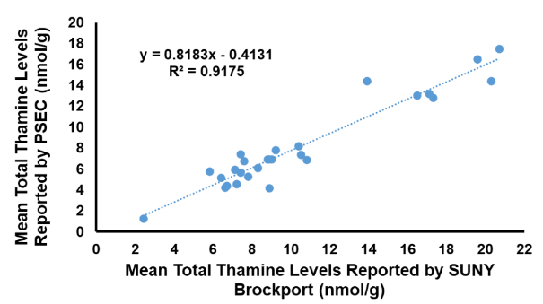

**Figure 1**

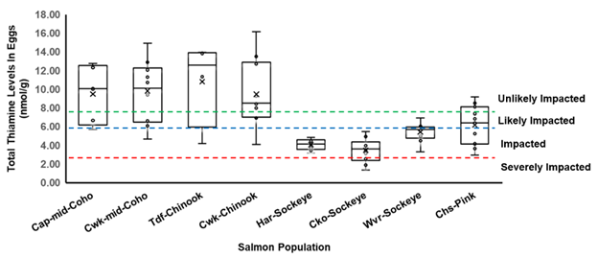

**Figure 2**

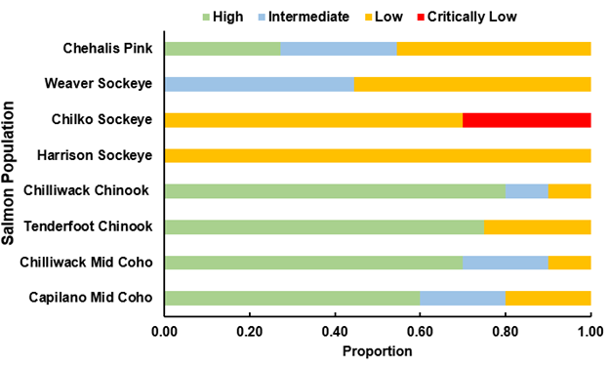

**Figure 3**

Table 1. Results of total thiamine levels detected in chinook salmon eggs treated or untreated with thiamine.

Figure 1. Results of linear regression analysis on the total mean thiamine level results reported by SUNY Brockport and PSEC on the same set of chinook salmon eggs. Each dot represents an individual sample.

Figure 2. Results of the total thiamine levels in untreated and unfertilized eggs collected from Capilano mid coho (Cap-mid-Coho, n=5), Chilliwack mid coho (Cwk-mid-Coho, n=10), Tenderfoot Cheakamus Chinook (Tdf-Chinook, n=4), Chilliwack fall Chinook (Cwk-Chinook, n=10), Harrison sockeye (Har-Sockeye, n=10), Chilko sockeye (Cko-Sockeye, n=10), Weaver sockeye (Wvr-Sockeye, n=9) and Chehalis pink (Chs-Pink, n=11). Note that the Harrison sockeye eggs were considered not ripe during sample collection; Tenderfoot Cheakamus Chinook data came from results of untreated eggs reported in Table 1. The dash lines represent thiamine level thresholds established by Mantua et al. (2025) to illustrate the likelihood of being impacted by thiamine deficiency: high - unlikely impacted (> 7.7 nmol/g), intermediate - likely impacted (5.9-7.7 nmol/g), low - impacted (2.7-5.9 nmol/g) and critically low - severely impacted (< 2.7 nmol/g). The cross symbol (×) in the box plot indicates mean values within each group.

Figure 3. Proportion of salmon eggs from different populations measured by the thiamine level thresholds established by Mantua et al. (2025). Different category of total thiamine level represents different likelihood of being impacted by thiamine deficiency: high - unlikely impacted (> 7.7 nmol/g), intermediate - likely impacted (5.9-7.7 nmol/g), low - impacted (2.7-5.9 nmol/g) and critically low - severely impacted (< 2.7 nmol/g). Eggs were collected from different salmon species and population: Capilano mid coho (n=5), Chilliwack mid coho (n=10), Tenderfoot Cheakamus Chinook (n=4), Chilliwack fall Chinook (n=10), Harrison sockeye (n=10), Chilko sockeye (n=10), Weaver sockeye (n=9) and Chehalis pink (n=11).

#### Insights

This project successfully established thiamine analysis capability at PSEC, which is currently the only known laboratory in Canada conducting these analyses. A detailed protocol outlining the equipment, consumables and procedural steps is available for distribution to other research groups at DFO to set up the same analysis capacity. Our lab at PSEC is currently welcoming thiamine analysis requests and collaborative projects to support research programs monitoring the thiamine status of Pacific salmon and their prey in Canada.

The thiamine levels in coho and Chinook salmon eggs were within the expected range, consistent with previous work on Chinook salmon in Alaska (Honeyfield et al. 2016; Larson and Howard 2019) and California (Mantua et al. 2025), and preliminary data available for BC (Lerner and McLaskey 2024). Notably, the relatively wide range of thiamine levels suggests considerable variation among individuals within each population. Future studies should consider increasing the sample size from each population (i.e. >10 fish per population) to have a more precise estimate of salmon thiamine status. In contrast, the total thiamine amounts in sockeye salmon eggs from Weaver Creek, Harrison and Chilko River were less variable, but also had lower levels (mostly within 2 – 6 nmol/g). While the Harrison River samples were considered not fully ripe, the thiamine levels in these eggs were similar to those of fully ripe fish in Chilko River. Notably, a previous study found much higher total thiamine levels in eggs of sockeye salmon from Harrison River, and pink salmon from Seton River in 2015 (Sockeye: 10.9 ± 1.2 nmol/g, n = 5; pink: 19.5 ± 2.3 nmol/g, n=20; Welch et al., 2018). The cause of these differences in thiamine levels between studies of the same population conducted ~10 years apart is unknown, but may be related to changes in prey (and thus dietary thiamine/thiaminase levels), changing ocean or migration conditions or other factors not identified.

Based on the thiamine thresholds by Mantua et al. (2025), 20 – 40 % of the eggs analyzed from each coho and Chinook salmon population in this study, are considered to be likely impacted by thiamine deficiency (Figure 3). However, the total thiamine in all eggs from sockeye salmon from both Harrison and Chilko River are well below this threshold, and only 27% of Chehalis pink salmon eggs were above it. It must also be noted that the threshold from Mantua et al. (2025) is set based on Chinook salmon, but the susceptibility to TDC, or thiamine threshold, is likely species-specific (Brown et al. 2005b; Fitzsimons et al. 2007; Honeyfield et al. 2008; Harder et al. 2018). To our knowledge, there are no published data on thiamine status of sockeye and pink salmon other than Welch et al. (2018). Future research should track thiamine status of Pacific salmon in BC, especially sockeye salmon.

The broodfish-thiamine-injection method appeared to effectively improve the total thiamine levels, mostly in form of TH, in Chinook salmon eggs. Although there were no untreated, control eggs available as a comparison at Shuswap River Hatchery, the injection-treated eggs (20.5 ± 4.8 nmol/g, range from 16 - 27 nmol/g) contained up to 2 – 3 times the usual thiamine amount in untreated eggs of other Chinook salmon stocks (Figure 2 and 3, 6 – 13 nmol/g). The total thiamine levels in eggs from these injection-treated fish are within the range reported for similar studies on coho salmon (21.925 ±1.694 nmol/g, Fitzsimons et al., 2005) and steelhead trout *Oncorhynchus mykiss* (total thiamine 20.4 ± 11.3 nmol/g; Futia et al 2017; mean total thiamine: 33.5 nmol/g, range: 15.4 – 51.1 nmol/g; Reed et al 2023). Unfortunately, our study could not resolve the effectiveness of thiamine bath-treated eggs because of supra-biological and varying levels measured in eggs sampled immediately after the 1 h treatment bath (e.g. 302.5 ± 31.2 nmol/g in Chinook salmon at Tenderfoot Creek hatchery; 0.95 – 291.20 nmol/g in mid Coho salmon eggs at Capilano Hatchery). Thus, it was unknown how much of the thiamine was actually retained and biologically available to the eggs over time. Future work should resolve the effectiveness and necessity of these thiamine treatments, as these methods could prove highly valuable in both minimizing the potential negative impacts of TDC on early fry and optimizing hatchery salmon production (Futia et al. 2017; Reed et al. 2023; Harder et al. 2025).

#### Next Steps

With the thiamine analysis capacity established at PSEC, DFO can now further expand research relevant to thiamine and fish in Canada. First of all, more research is urgently needed to determine the status of TDC across stocks of all 5 species of Pacific salmon in BC and the Yukon, across the life cycle (especially adults and eggs). Second, we need to establish how thiamine levels vary across tissue types (e.g. muscle, ventricle, liver, plasma, eggs) and identify whether plasma thiamine levels could be used as a non-lethal indicator of adult salmon thiamine status. Third, we need to establish the thiamine and thiaminase status of the primary prey species in both ocean and freshwater habitats and how these may be changing over time. As such, a next step for the Nutrition lab at PSEC is to establish a protocol for thiaminase activity and begin collaborating with other groups to collect and assess prey. Fourth, we need to determine TDC thresholds for impairment for all 5 species of Pacific salmon species, in both eggs and migrating adults. Finally, we need carefully controlled experiments to assess the effectiveness and necessity of thiamine treatment (both bathing eggs and injecting broodstock) for hatcheries in BC.

#### References

Amcoff, P., Börjeson, H., Landergren, P., Vallin, L., and Norrgren, L. 1999. Thiamine (vitamin B1) concentrations in salmon (*Salmo salar*), brown trout (Salmo trutta) and cod (Gadus morhua) from the Baltic Sea. Ambio 28(1): 48–54.

Bâ, A. 2008. Metabolic and structural role of thiamine in nervous tissues. Cell. Mol. Neurobiol. 28(7): 923–931. doi:10.1007/s10571-008-9297-7.

Brown, S.B., Fitzsimons, J.D., Honeyfield, D.C., and Tillitt, D.E. 2005a. Implications of thiamine deficiency in Great Lakes salmonines. J. Aquat. Anim. Health 17(1): 113–124. doi:10.1577/H04-015.1.

Brown, S.B., Honeyfield, D.C., Hnath, J.G., Wolgamood, M., Marcquenski, S. V., Fitzsimons, J.D., and Tillitt, D.E. 2005b. Thiamine status in adult salmonines in the Great Lakes. J. Aquat. Anim. Health 17(1): 59–64. doi:10.1577/H04-059.1.

Brown, S.B., Honeyfield, D.C., and Vandenbyllaardt, L. 1998. Thiamine analysis in fish tissues. Am. Fish. Soc. Sumpos. 21(January 1998): 73–81.

Carvalho, P.S.M., Tillitt, D.E., Zajicek, J.L., Claunch, R.A., Honeyfield, D.C., Fitzsimons, J.D., and Brown, S.B. 2009. Thiamine deficiency effects on the vision and foraging ability of lake trout fry. J. Aquat. Anim. Health 21(4): 315–325. doi:10.1577/H08-025.1.

Croft, M.T., Moulin, M., Webb, M.E., and Smith, A.G. 2007. Thiamine biosynthesis in algae is regulated by riboswitches. Proc. Natl. Acad. Sci. U. S. A. 104(52): 20770–20775. doi:10.1073/pnas.0705786105.

Edwards, K.A., Tu-Maung, N., Cheng, K., Wang, B., Baeumner, A.J., and Kraft, C.E. 2017. Thiamine Assays—Advances, Challenges, and Caveats. ChemistryOpen 6(2): 178–191. doi:10.1002/open.201600160.

Ejsmond, M.J., Blackburn, N., Fridolfsson, E., Haecky, P., Andersson, A., Casini, M., Belgrano, A., and Hylander, S. 2019. Modeling vitamin B1 transfer to consumers in the aquatic food web. Sci. Rep. 9(1): 1–11. Springer US. doi:10.1038/s41598-019-46422-2.

Fisher, J.P., Brown, S.B., Wooster, G.W., and Bowser, P.R. 1998. Maternal blood, egg and larval thiamin levels correlate with larval survival in landlocked Atlantic salmon (*Salmo salar*). J. Nutr. 128(12): 2456–2466. American Society for Nutrition. doi:10.1093/jn/128.12.2456.

Fitzsimons, J.D., Williston, B., Amcoff, P., Balk, L., Pecor, C., Ketola, H.G., Hinterkopf, J.P., and Honeyfield, D.C. 2005. The effect of thiamine injection on upstream migration, survival, and thiamine status of putative thiamine-deficient coho salmon. J. Aquat. Anim. Health 17(1): 48–58. doi:10.1577/H04-003.1.

Fitzsimons, J.D., Williston, B., Williston, G., Brown, L., El-Shaarawi, A., Vandenbyllaardt, L., Honeyfeld, D., Tillitt, D., Wolgamood, M., and Brown, S.B. 2007. Egg thiamine status of Lake Ontario salmonines 1995-2004 with emphasis on lake trout. J. Great Lakes Res. 33(1): 93–103. Elsevier. doi:10.3394/0380-1330(2007)33[93:ETSOLO]2.0.CO;2.

Fridolfsson, E., Lindehoff, E., Legrand, C., and Hylander, S. 2018. Thiamin (vitamin B1) content in phytoplankton and zooplankton in the presence of filamentous cyanobacteria. Limnol. Oceanogr. 63(6): 2423–2435. doi:10.1002/lno.10949.

Futia, M.H., Hallenbeck, S., Noyes, A.D., Honeyfield, D.C., Eckerlin, G.E., and Rinchard, J. 2017. Thiamine deficiency and the effectiveness of thiamine treatments through broodstock injections and egg immersion on Lake Ontario steelhead trout. J. Great Lakes Res. 43(2): 352–358. doi:10.1016/j.jglr.2017.01.001.

Harder, A.M., Ardren, W.R., Evans, A.N., Futia, M.H., Kraft, C.E., Marsden, J.E., Richter, C.A., Rinchard, J., Tillitt, D.E., and Christie, M.R. 2018. Thiamine deficiency in fishes: causes, consequences, and potential solutions. Rev. Fish Biol. Fish. 28(4): 865–886. Springer International Publishing. doi:10.1007/s11160-018-9538-x.

Harder, A.M., Reed, A.N., and Rowland, F.E. 2025. Evolutionary perspectives on thiamine supplementation of managed Pacific salmonid populations. Can. J. Fish. Aquat. Sci. 82(Bettendorff 2013): 1–10. doi:10.1139/cjfas-2024-0109.

Honeyfield, D.C., Hinterkopf, J.P., Fitzsimons, J.D., Tillitt, D.E., Zajicek, J.L., and Brown, S.B. 2005. Development of thiamine deficiencies and early mortality syndrome in lake trout by feeding experimental and feral fish diets containing thiaminase. J. Aquat. Anim. Health 17(1): 4–12. doi:10.1577/H03-078.1.

Honeyfield, D.C., Murphy, J.M., Howard, K.G., Strasburger, W.W., and Matz, A.C. 2016. An Exploratory Assessment of Thiamine Status in Western Alaska Chinook Salmon (*Oncorhynchus tshawytscha*). North Pacific Anadromous Fish Comm. Bull. (6): 21–31.

Honeyfield, D.C., Peters, A.K., and Jones, M.L. 2008. Thiamine and fatty acid content of Lake Michigan Chinook salmon. J. Great Lakes Res. 34(4): 581–589. Elsevier. doi:10.1016/s0380-1330(08)71603-4.

Houde, A.L.S., Saez, P.J., Wilson, C.C., Bureau, D.P., and Neff, B.D. 2015. Effects of feeding high dietary thiaminase to sub-adult Atlantic salmon from three populations. J. Great Lakes Res. 41(3): 898–906. International Association for Great Lakes Research. doi:10.1016/j.jglr.2015.06.009.

Hylander, S., Farnelid, H., Fridolfsson, E., Hauber, M.M., Todisco, V., Ejsmond, M.J., and Lindehoff, E. 2024. Thiamin (vitamin B1, thiamine) transfer in the aquatic food web from lower to higher trophic levels. *In* PLoS ONE. doi:10.1371/journal.pone.0308844.

Koski, P., Pakarinen, M., Nakari, T., Soivio, A., and Hartikainen, K. 1999. Treatment with thiamine hydrochloride and astaxanthine for the prevention of yolk-sac mortality in Baltic salmon fry (M74 syndrome). Dis. Aquat. Organ. 37(3): 209–220. doi:10.3354/dao037209.

Ladago, B.J., Futia, M.H., Ardren, W.R., Honeyfield, D.C., Kelsey, K.P., Kozel, C.L., Riley, S.C., Rinchard, J., Tillitt, D.E., Zajicek, J.L., and Marsden, J.E. 2020. Thiamine concentrations in lake trout and Atlantic salmon eggs during 14 years following the invasion of alewife in Lake Champlain. J. Great Lakes Res. 46(5): 1340–1348. International Association for Great Lakes Research. doi:10.1016/j.jglr.2020.06.018.

Larson, S., and Howard, K. 2019. Exploration of AYK Chinook Salmon egg thiamine levels as a potential mechanism contributing to recent low productivity patterns, 2014 and 2015.

Lee, Y., Kim, S., Hasanthi, M., Song, S., Kim, S., and Lee, K.J. 2026. Dietary thiamine supplementation enhances the growth performance, digestive enzyme activity, intestine development, immunity and anti-inflammatory gene expression of juvenile olive flounder (*Paralichthys olivaceus*). Comp. Biochem. Physiol. Part - B Biochem. Mol. Biol. 281(September 2025): 111162. Elsevier Inc. doi:10.1016/j.cbpb.2025.111162.

Mantua, N.J., Bell, H., Todgham, A.E., Daniels, M.E., Rinchard, J., Ludwig, J.M., Field, J.C., Lindley, S.T., Rowland, F.E., Richter, C.A., Walters, D., Finney, B., Distajo, H.A.R., Tillitt, D., and Honeyfield, D.C. 2025. Widespread thiamine deficiency in California salmon linked to an anchovy- dominated marine prey base. Proc. Natl. Acad. Sci. 122(26): e2426011122. doi:10.1073/pnas.

Manzetti, S., Zhang, J., and Van Der Spoel, D. 2014. Thiamin function, metabolism, uptake, and transport. Biochemistry 53(5): 821–835. doi:10.1021/bi401618y.

Paerl, R.W., Bertrand, E.M., Allen, A.E., Palenik, B., and Azam, F. 2015. Vitamin B1 ecophysiology of marine picoeukaryotic algae: Strain-specific differences and a new role for bacteria in vitamin cycling. Limnol. Oceanogr. 60(1): 215–228. doi:10.1002/lno.10009.

Reed, A.N., Rowland, F.E., Krajcik, J.A., and Tillitt, D.E. 2023. Thiamine Supplementation Improves Survival and Body Condition of Hatchery-Reared Steelhead (*Oncorhynchus mykiss*) in Oregon. Vet. Sci. 10(2): 1–11. doi:10.3390/vetsci10020156.

Rocchi, R., van Kekem, K., Heijnis, W.H., and Smid, E.J. 2022. A simple, sensitive, and specific method for the extraction and determination of thiamine and thiamine phosphate esters in fresh yeast biomass. J. Microbiol. Methods 201(August): 106561. Elsevier B.V. doi:10.1016/j.mimet.2022.106561.

Roman-Campos, D., and Cruz, J.S. 2014. Current aspects of thiamine deficiency on heart function. Life Sci. 98(1): 1–5. Elsevier Inc. doi:10.1016/j.lfs.2013.12.029.

Strasburger, W.W., Honeyfield, D.C., Murphy, J.M., and Pinger, C. 2023. A Review of the Thiamine Status of Alaskan Chinook Stocks and the U . S . West Coast. Available from https://meetings.pices.int/Publications/Presentations/2022-SPF/S1-Strasburger.pdf.

Suffridge, C.P., Shannon, K.C., Matthews, H., Johnson, R.C., Jeffres, C., Mantua, N., Ward, A.E., Holmes, E., Kindopp, J., Aidoo, M., and Colwell, F.S. 2024. Connecting thiamine availability to the microbial community composition in Chinook salmon spawning habitats of the Sacramento River basin. Appl. Environ. Microbiol. 90(1). American Society for Microbiology. doi:10.1128/aem.01760-23.

Tang, Y.Z., Koch, F., and Gobler, C.J. 2010. Most harmful algal bloom species are vitamin B1 and B 12 auxotrophs. Proc. Natl. Acad. Sci. U. S. A. 107(48): 20756–20761. doi:10.1073/pnas.1009566107.

Welch, D.W., Futia, M.H., Rinchard, J., Teffer, A.K., Miller, K.M., Hinch, S.G., and Honeyfield, D.C. 2018. Thiamine Levels in Muscle and Eggs of Adult Pacific Salmon from the Fraser River, British Columbia. J. Aquat. Anim. Health 30(3): 191–200. doi:10.1002/aah.10024.

Whitfield, K.C., Bourassa, M.W., Adamolekun, B., Bergeron, G., Bettendorff, L., Brown, K.H., Cox, L., Fattal-Valevski, A., Fischer, P.R., Frank, E.L., Hiffler, L., Hlaing, L.M., Jefferds, M.E., Kapner, H., Kounnavong, S., Mousavi, M.P.S., Roth, D.E., Tsaloglou, M.N., Wieringa, F., and Combs, G.F. 2018. Thiamine deficiency disorders: diagnosis, prevalence, and a roadmap for global control programs. Ann. N. Y. Acad. Sci. 1430(1): 3–43. doi:10.1111/nyas.13919.

Wright, G.M., Brown, S.B., Brown, L.R., Moore, K., Villella, M., Zajicek, J.L., Tillitt, D.E., Fitzsimons, J.D., and Honeyfield, D.C. 2005. Effect of sample handling on thiamine and thiaminolytic activity in alewife. J. Aquat. Anim. Health 17(1): 77–81. doi:10.1577/H03-074.1.

### Project 2419: Pilot skills study of new hatchery tray configuration.

### Project 2421: Measurement of stress hormones in scales and its application for the identification of conditions causing chronic stress in Pacific Salmon.

**Project Leads:** Stewart Johnson

**Collaborations:** Mr. Reid Williams, MSc student

Dr. Nicholas Bernier, University of Guelph

Dr. Fredrick Laberge University of Guelph

**Location:** PBS Nanaimo

**Region:** Pacific

**Species:** Chinook

**Life History:** smolt

**Stock:** Population (if applicable)

#### Highlights

Main idea: Determine the usability of scale corticosteroids as biomarkers of chronic stress in Pacific salmon.

Scale corticosteroid content can differ by underlying factors such as sex or life-stage. Furthermore, both cortisol and cortisone content rapidly increases in scales following a single acute stressor and returns to baseline levels within 72 hours. Both corticosteroids can also decrease at increasing rates while under chronic stress. Finally, the dynamics of scale corticosteroids can differ depending on the type of prolonged stress.

Implications: As scale corticosteroids can be elevated while plasma values are normal following acute stress, and the opposite can occur during chronic stress, we do not currently recommend using scale cortisol, nor cortisone, as biomarkers of chronic stress in Chinook salmon.

#### Background

Exposure of fish to stressors can elicit physiological changes at multiple levels of animal organization, these alterations are collectively known as the stress response. The hypothalamic-pituitary-interrenal (HPI) axis which is activated in response to most forms of stress in fish, initiates and regulates the stress response. In fish cortisol is the predominant glucocorticoid released as part of the primary stress response, and is critical for mediating adaptive metabolic, physiological, and behavioral adjustments. However, prolonged elevation of cortisol, due to extended or repeated exposure to stressors, caused chronic stress that can negatively affect fish behavior, growth, reproduction, and immune functions (reviewed in Schreck and Tort, 2016). With respect to salmon, the period of parr-to-smolt transition (smoltification) is one of the most sensitive periods to stressors, with chronic stress resulting in impaired ability to smolt (Bernard et al., 2019; Vehanen et al., 2023). For these reasons, there is a significant need to identify and validate biomarkers of chronic stress in different stages of Pacific salmon, which can be used identify and where possible control/manage factors lo reduce levels of chronic stress.

The analysis of circulating (serum/plasma) cortisol is the most common method used in stress response assessments in fish. This method works well under controlled situations, where fish can be caught and rapidly sampled (within minutes to avoid the rapid increase in cortisol which occurs in response to capture stress) and it provides information on the acute stress response at the time of collection (immediate state of stress). To understand chronic stress the past cortisol history of individuals needs to be understood, Unfortunately, due to how cortisol is physiologically regulated, circulating cortisol levels are well recognized as poor predictors of chronic stress (Aerts et al., 2015).

In higher vertebrates, measurement of cortisol in hair (Raul et al., 2004) and feathers (Macbeth et al., 2010), has been demonstrated to allow for retrospective assessment of levels of stress. Building upon these studies fish scales were identified as a biomaterial that accumulates cortisol, and other physiologically important hormones including cortisone, over long periods of time. The measurement of scale cortisol content was proposed as a way to determine past cortisol history in fish, and for use as a biomarker of chronic stress (Aerts et al., 2015; de Vrieze et al., 2012). However, unlike hair and feathers in which cortisol levels remain fixed after deposition, the exchange of cortisol between the circulatory system and scales is an ongoing dynamic process, which is poorly understood, Moreover, scale cortisol levels appear not to be affected by single acute stress events such as those associated with capture (reviewed in Laberge et al. 2019; Kennedy and Janz, 2023).

This project examined the usefulness of the measurement of scale stress hormone content (SSHHC) biomarker of chronic stress in Pacific salmon. Laboratory and hatchery-based studies were conducted to determine and validate/optimize: 1) sampling methods (e.g. study spatial heterogeneity of scale stress hormone content (SSHC)), 2) effects of acute vs. chronic stress on SSHC, 3) relationship between plasma and SSHC, 4) individual, stock and temporal variability in SSHC, including changes associated with smoltification, and 5) effects of unpredictable chronic stress on plasma and SSHC.

This project was in collaboration with the Bernier and Laberge labs at the University of Guelph. Gill homogenate NKA activity was measured by the BC Centre for Aquatic Health Sciences (Campbell River, BC, Canada).

#### Methods and Findings

List and describe samples collected/analyzed (number of samples)

#### Tables and Figures

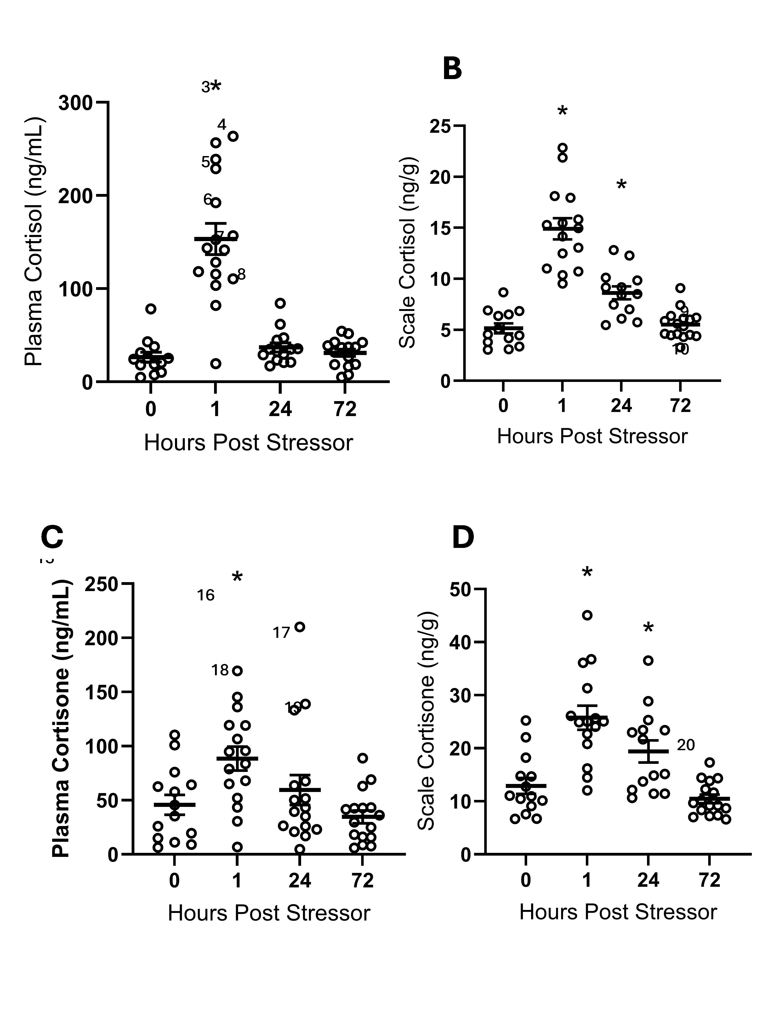

**Figure 1**

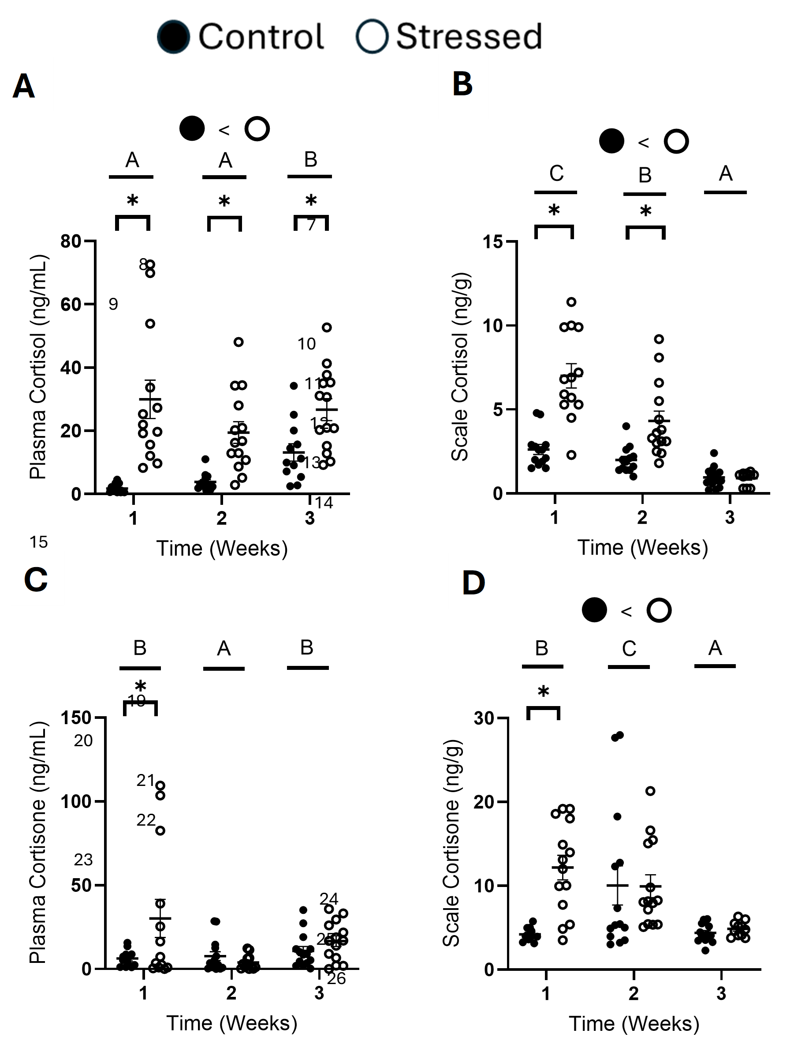

**Figure 2**

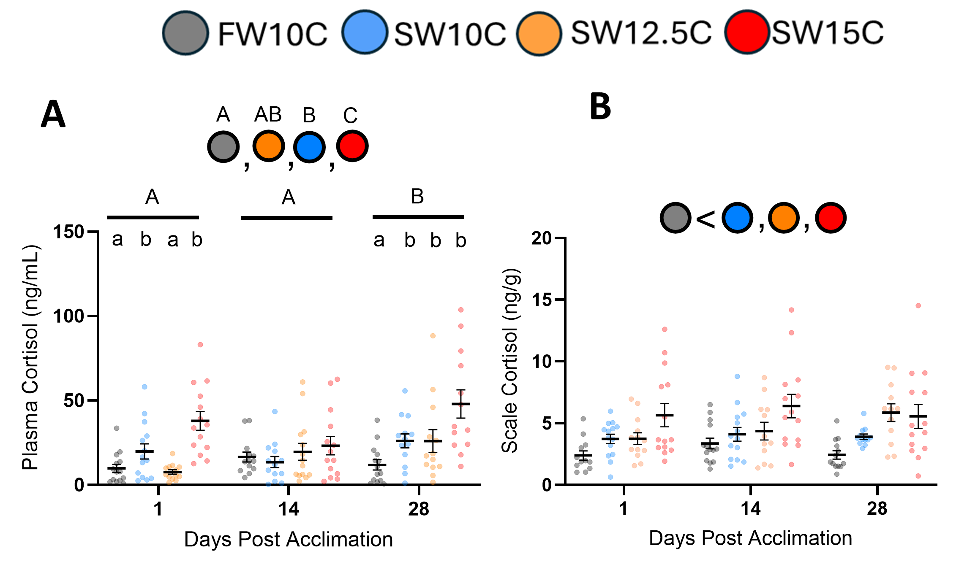

**Figure 3**

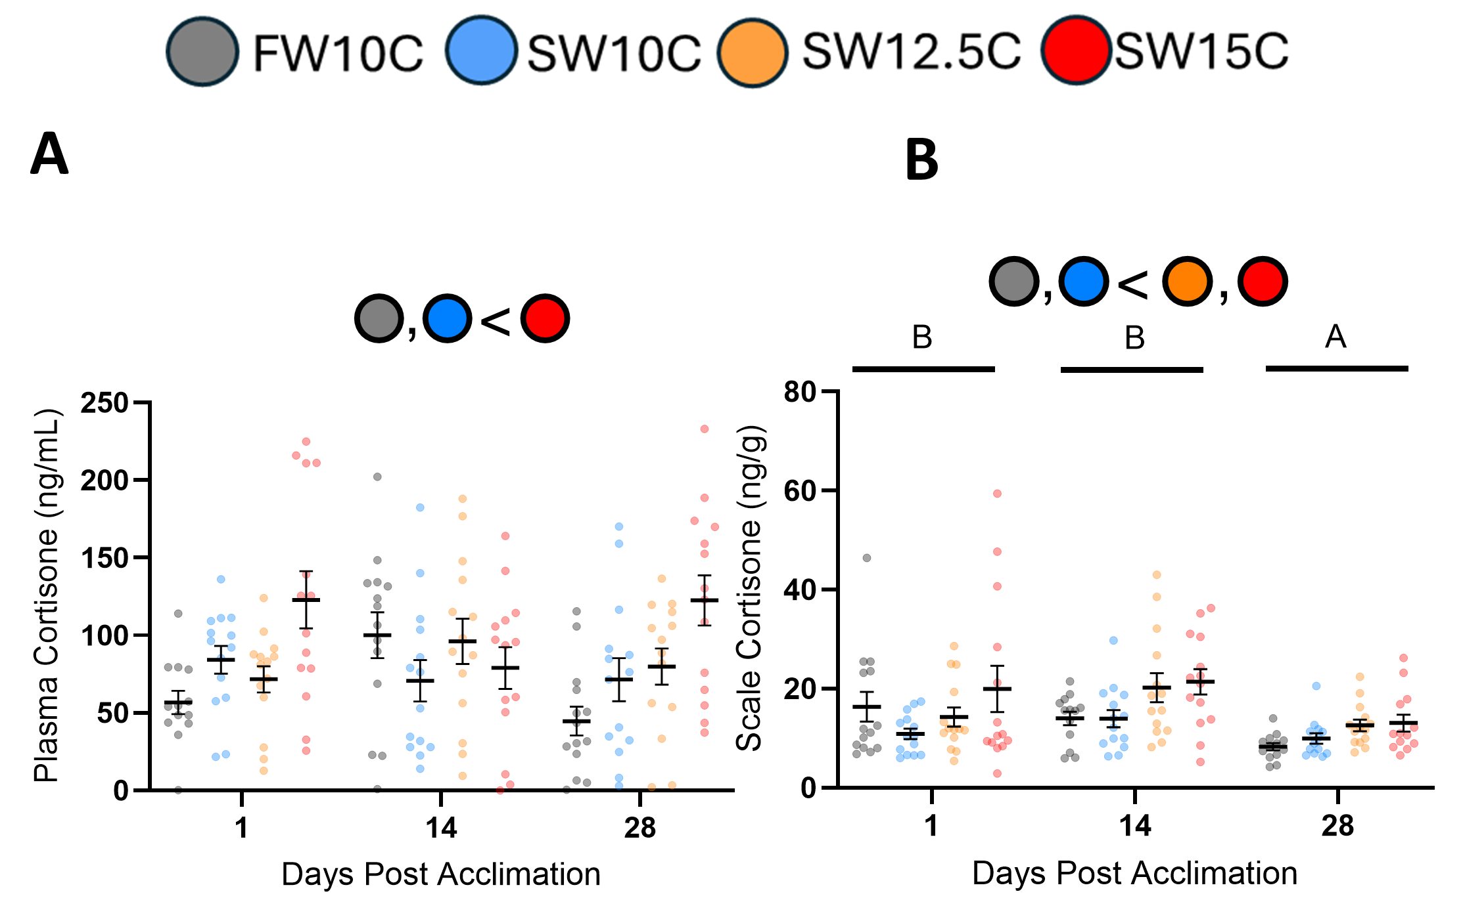

**Figure 4**

Figure 1. Effect of an acute stressor on (A) plasma cortisol, (B) scale cortisol, (C) plasma cortisone, and (D) scale cortisone in Chinook salmon smolts. Fish were stressed by being held out of water for one min. Time 0 non-handled fish served as controls. Plasma cortisol levels were compared with a Kruskal-Wallis test followed by a post hoc Dunn’s test. Plasma cortisone and scale corticosteroid values were compared with one-way ANOVAs followed by post hoc Dunnet’s post hoc tests. Differences from time 0 values for a given variable are indicated by an asterisk. Data are means ± SEM, along with individual data points (plasma cortisol, n = 13-16; scale cortisol, n = 13-16; plasma cortisone, n = 14-16; scale cortisone, n = 14-16).

#### Insights

Overall, this project has vastly elevated our understanding of scale corticosteroid dynamics and usability for Chinook (and Coho, to a lesser degree) salmon.

While scale cortisol content has been proposed as a reliable, retrospective look into the stress history of fishes, similar to hair (Koren et al. 2011) or feathers (Macbeth et al. 2010), our data shows that levels of corticosteroids in fish scales are far more dynamic than previously thought.

In juvenile Chinook salmon, the measurement of scale corticosteroids has limited use as biomarkers of chronic stress, due to their susceptibility to acute stress, rapid clearance after acute stress, and the onset of a corticosteroid clearance response under prolonged chronic stress. Furthermore, both scale cortisone and the scale cortisol-cortisone ratio were found to be less consistent, more variable, and cleared faster than scale cortisol, and thus are unlikely to be better biomarkers of chronic stress than scale cortisol alone. Whether this is true for other species of salmon is unclear.

Our results identify a number of factors necessary to consider when planning studies and/or evaluating/interpreting the results of previously published studies, to ensure that measured differences in scale corticosteroids are due to differences in how the fish are responding to their environment rather than being an artefact of study design.

#### Next Steps

Laboratory Studies

Scale preparation and extraction of corticosteroids followed the methods described by Laberge et al., (2019) with a few small modifications. Preliminary studies were done to determine the number of scales required for analysis, as well as to examine whether scale cortisol concentrations varied across body regions.

Using hatchery-reared juvenile Chinook salmon, three experiments were performed to assess the temporal profiles of cortisol accumulation and clearance in plasma and scales in response to stressors of varying intensity and duration: an acute stressor, three weeks of unpredictable chronic stress, and the transition from freshwater (FW) to seawater (SW) under elevated temperatures. Cortisone, the breakdown product of cortisol, was also quantified to determine whether whole animal and local cortisol metabolism contribute to scale cortisol levels and whether scale cortisol-cortisone ratios can be used for long-term stress monitoring.

Effects of Acute Stress on SSHC in Juvenile Chinook Salmon

Methods

Groups of juvenile Chinook Salmon were acclimated and held in 12.5 ºC SW. Following acclimation, undisturbed control fish were sampled to obtain baseline plasma and scale corticosteroid values. Experimental groups were subjected to a 1 minute air exposure. Control groups were not handled. Plasma and scale samples collected from both groups at 1, 24, or 72 h post-stress were analyzed to determine levels of cortisol and cortisone.

Major Findings

As expected the acute handling stress (air exposure) resulted in the rapid increases in plasma cortisol and cortisone levels and the ratio of cortisol-cortisone (Fig. 1) These increases returned to baseline levels within 24 hours.

Interestingly, a similar same pattern of increases in scale cortisol and cortisone levels was observed, with levels returning to baseline within 72 hours. Scale corticosteroid clearance lags behind clearance from plasma. The ratio of cortisol-cortisone followed a similar pattern returning to baseline within 24 hours.

Interpretation:

Our results contradict the finding of Laberge et al. (2019) in goldfish, where the scales did not show an increase in cortisol content following the same acute air exposure stressor. However, during our study McKinley et al. (2025) reported that scale cortisol content can increase within 30 min following an acute stressor in both goldfish and green sunfish. The difference in scale cortisol accumulation in goldfish observed between studies led McKinley et al. (2025) to suggests that underlying factors such as stressor exposure history and the cortisol concentration gradient between scale and blood may influence scale cortisol accumulation under acute stress. This is an area where additional work appears to be warranted.

Scale cortisol concentrations are now commonly used as a biomarker of chronic stress, especially in populations of wild fish. The majority of these studies have assumed that stress associated with capture has no effect on levels of scale cortisol. Our work and the recent study by McKinley et al. (2025) provides evidence that this assumption is not necessarily true. Future studies need to consider how acute stress during capture and the timing of their scale sampling relative to capture might inflate scale cortisol values.

Effects of Unpredictable Chronic Stress (UGS) in Juvenile Chinook Salmon

Methods

Juvenile Chinook Salmon were transferred into twelve experimental tanks and assigned into two treatments, control (6 tanks) or UCS (6 tanks). Fish held in 12.0 ºC SW and acclimated for 3 weeks. Following acclimation, all tanks assigned to the UCS treatment group were exposed to one of the following randomly assigned stressors once a day for 3 weeks: holding out of water in a net for 1 min; chasing with a dip net for 10 min; holding in shallow water for 5 min. These stressors were applied at randomly assigned times (9 am, 12 pm, or 3 pm) to prevent anticipation of the stressor. Fish in the control groups were not handled. Scale and plasma samples were obtained from half of the fish from each tank (7-8 fish/tank) and treatment at 1, 2, and 3 weeks following the onset of UCS. Sampling was conducted ~18 h after the last stressor exposure to avoid the influence of the last acute stress response on the measurements.

Major Findings

We found novel evidence that scale cortisol can decrease while plasma cortisol remains elevated under conditions of chronic stress (Fig. 2). Cortisol and cortisone levels in the plasma and scales of controls remained low throughout the experiment. Sustained elevation in plasma cortisol, along with the absence of growth in body size, during the UCS period, indicates that fish in the UCS group were chronically stressed. Despite this, scale cortisol levels in the UCS fish returned to baseline by week 3, indicating that a mechanism for cortisol clearance from the scales was engaged late in the UCS period. Interestingly, plasma and scale cortisone levels showed only a temporary elevation at week 1, suggesting high cortisone clearance rates earlier in the UCS period, potentially both in plasma and scales.

Interpretation

Our results differ from those reported for UCS studies in other species of fish (Laberge et al. 2019; Aerts et al. 2015; Samaras et al. 2021; Kennedy and Janz, 2023). These studies reported that levels of scale corticosteroids remain elevated, or continually increase while under UCS, regardless of plasma levels. More recently, McKinley et al. (2025) and Opinion et al. (2023) demonstrated that green sunfish and Atlantic salmon can acclimate to UCS by decreasing plasma and scale cortisol over time.

This suggests that the dynamics of the corticosteroid responses to chronic stress in both plasma and scales varies among species of fish. Scale cortisol levels may be only a suitable biomarker for some species of fish.

Our results also indicate that clearance of corticosteroids increased with time under stress, however, it is unknown the mechanism behind this.

Effects of Smoltification at Different Temperatures on Plasma and Scale Stress Hormone Content (SSHHC) in Chinook Salmon Smolts

Methods

In anadromous salmonids, the parr-to-smolt transition, which prepares juvenile fish to survive the migration from freshwater (FW) into seawater (SW), is more sensitive to environmental stressors than other life stages. As such, this study hypothesized that combined thermal stress and the transfer from FW to SW would induce chronic stress and increase scale cortisol content in Chinook salmon smolts. Control fish were kept in FW at 10oC, while experimental fish were acclimated (0.5oC/day) to 10, 12.5, or 15oC and then transferred to SW over 48h. Plasma, scale and gill samples were obtained from all groups at 1, 14 and 28 days post-transfer.

Major Findings

Following transfer to SW, especially at higher temperatures, plasma cortisol generally increased within treatments with time, especially in the highest temperature (12.5 and 15.0oC) treatments . Within treatments scale cortisol remained relatively constant over time, with the 15oC saltwater group having the highest levels at 1 and 14 days (Fig. 3).

When compared to controls and other experimental groups plasma cortisone values were elevated in the 15oC seawater group, at 1 and 28 days (Fig 4A). Scale cortisone was measured at higher levels than cortisol at all time periods. Scale cortisone was highest in the 12.5 and SW15oC seawater treatments, with some evidence that levels declined with time.

Neither gill NKA activity, nor plasma osmolality explain the differences observed in corticosteroid content.

Interpretation

In contrast to what we found in our unpredictable chronic stress study scale cortisol levels remained relatively constant over time in this study. This suggests that scale corticosteroid dynamics may differ depending on the type, and temporal application of chronic stress.

#### References

Aerts, J., Metz, J.R., Ampe, B., Decostere, A., Flik, G., and Saeger, S.D. 2015. Scales Tell a Story on the Stress History of Fish. PLOS ONE 10(4): e0123411. Public Library of Science. doi:10.1371/journal.pone.0123411.

Bernard, B., Leguen, I., Mandiki, S.N.M., Cornet, V., Redivo, B., and Kestemont, P. 2020. Impact of temperature shift on gill physiology during smoltification of Atlantic salmon smolts (Salmo salar L.). Comp Biochem Physiol A Mol Integr Physiol 244: 110685. doi:10.1016/j.cbpa.2020.110685.

Kennedy, E.K.C., and Janz, D.M. 2022. First Look into the Use of Fish Scales as a Medium for Multi-Hormone Stress Analyses. Fishes 7(4): 145. Multidisciplinary Digital Publishing Institute. doi:10.3390/fishes7040145.

Koren, L., Nakagawa, S., Burke, T., Soma, K.K., Wynne-Edwards, K.E., Geffen, E., 2011. Non-breeding feather concentrations of testosterone, corticosterone and cortisol are associated with subsequent survival in wild house sparrows. Proceedings of the Royal Society B: Biological Sciences 279, 1560–1566. https://doi.org/10.1098/rspb.2011.2062

Laberge, F., Yin-Liao, I., and Bernier, N.J. 2019. Temporal profiles of cortisol accumulation and clearance support scale cortisol content as an indicator of chronic stress in fish. Conservation Physiology 7(1): coz052. doi:10.1093/conphys/coz052.

Macbeth, B.J., Cattet, M.R.L., Stenhouse, G.B., Gibeau, M.L., and Janz, D.M. 2010. Hair cortisol concentration as a noninvasive measure of long-term stress in free-ranging grizzly bears (Ursus arctos): considerations with implications for other wildlife. Can. J. Zool. 88(10): 935–949. doi:10.1139/Z10-057.

McKinley, A.M., Best, C., and Bernier, N.J. 2025. Scale cortisol reflects the acute but not the chronic stress status in green sunfish (*Lepomis cyanellus*). General and Comparative Endocrinology 372: 114797. doi:10.1016/j.ygcen.2025.114797.

Opinion, A.G.R., Vanhomwegen, M., De Boeck, G., and Aerts, J. 2023. Long-term stress induced cortisol downregulation, growth reduction and cardiac remodeling in Atlantic salmon. J Exp Biol 226(22): jeb246504. doi:10.1242/jeb.246504.

Raul, J.-S., Cirimele, V., Ludes, B., and Kintz, P. 2004. Detection of physiological concentrations of cortisol and cortisone in human hair. Clin Biochem 37(12): 1105–1111. doi:10.1016/j.clinbiochem.2004.02.010.

Samaras, A., Dimitroglou, A., Kollias, S., Skouradakis, G., Papadakis, I.E., and Pavlidis, M. 2021. Cortisol concentration in scales is a valid indicator for the assessment of chronic stress in European sea bass, *Dicentrarchus labrax* L. Aquaculture 545: 737257. doi:10.1016/j.aquaculture.2021.737257.

Schreck, C. B., & Tort, L. 2016. The Concept of Stress in Fish. In: Schreck, C. B., Tort, L., Farrell, A. P., & Brauner, C. J. (Eds.), *Biology of Stress in Fish: Fish Physiology Volume 35* (pp. 1–34). Academic Press/Elsevier

Vehanen, T., Sutela, T., and Huusko, A. 2023. Potential Impact of Climate Change on Salmonid Smolt Ecology. Fishes 8(7): 382. Multidisciplinary Digital Publishing Institute. doi:10.3390/fishes8070382.

de Vrieze, E., Heijnen, L., Metz, J.R., and Flik, G. 2012. Evidence for a hydroxyapatite precursor in regenerating cyprinid scales. Journal of Applied Ichthyology 28(3): 388–392. doi:10.1111/j.1439-0426.2012.01989.x.

### Project 2422: Development and application of laser ablation-inductively coupled plasma-mass spectrometry (LA-ICP-MS) to determine saltwater entry size of juvenile salmonids and track habitat usage.

**Project Leads:** Xiangjun Liao

Nicole LaForge

Micah Quindazzi

Andrew Ross

**Collaborations:** DFO Stock Assessment, LGL Ltd, Huu-ay-aht First Nation

**Location:** IOS Sidney

**Region:** WCVI

**Species:** Chinook Salmon *Oncorhynchus tshawytscha*

**Waterbodies:** Barkley Sound, Clayoquot Sound, Nitinat Lake, San Juan River, Sarita River, Stamp River, Bedwell River

**Life History:** Fry, parr, smolt, adult

**Stock:** Sarita, Stamp/Robertson, Nitinat, San Juan, Bedwell

#### Highlights

Goal: Develop internal DFO capacity to analyse otolith microchemistry using LA-ICP-MS and use it to compare juvenile Chinook sizes at estuary entry and estuary residence times by back-calculating the fork lengths (FL) from the microchemically derived otolith radii.

Findings: We measured the otoliths of outmigrating Chinook and constructed FL-otolith radii regression relationships: determined that they were segmented break-point models and river system specific. We focused on PSSI priority WCVI systems: identified population specific patterns of estuary entry and residency for the Sarita, Nitinat, Stamp, Bedwell and San Juan systems.

Implications: Microchemistry analysis reveals that Chinook Salmon in each river system have a unique proportion of several life-history patterns, including whether they leave as fry or parr, use the estuary for an extended period of time or merely transit through it, and then either remain in the marine environment or return for a duration of time to their own or another river’s estuary.

#### Background

Impetus: WCVI natural-origin (NO) Chinook are very important for the economic, social and cultural well being of many coastal communities, including First Nations, and both freshwater & marine ecological communities. Low early marine survival has been identified as a threat for rebuilding these stocks and has been understudied in NO Chinook

Knowledge gap: A method was needed to identify successful life-history types in returning adults in order to determine how best to rebuild them. Analysis of otolith microchemistry can fill this gap because otoliths are inert once incorporated and preserve chemical signals related to environmental patterns (e.g. transition from fresh to saltwater) unlike other tissues such as bone and scales. This means analyzing the chemistry across the otolith can reveal where salmon were through time at some size and stage.

Partnerships: Otoliths have been stored by DFO from collections undertaken by many programs including Stock Assessment and the more recent Follow the Fish program. Collaboration with these programs can provide a large archive of both current and historical otoliths to analyse microchemically and track the changes across the life spans of individual fish and the changes in life-history patterns of populations from past to present.

#### Methods and Findings

This project is the first to develop the capacity to use otolith microchemistry analysis by Laser Ablation-Inductively Coupled Plasma-Mass Spectrometry (LA-ICP-MS) internally within DFO. With the existing instruments and expertise housed in the Mass Spectrometry Lab at IOS, we have the capacity to microchemically analyse thousands of otoliths per year in a cost effective manner and use the life-history knowledge gleaned from them to inform fisheries and conservation policy.

This technique involves polishing otoliths to expose the earliest layers, which are formed before the fish hatches, and then vaporising a line transect from the core to edge with a tiny, precise laser connected to a mass spectrometer. The spectrometer counts and identifies the changing elemental composition of the otolith material over each fish’s life-span, and the timing of these changes can be calculated based on the known speed and position of the laser beam and applied to real world times and locations of relevance.

Findings:

Otolith microchemistry of WCVI Chinook shows evidence for freshwater to marine carry-over effects

Most NO juveniles leave the estuary early and small as fry, but the small percentage of later, larger parr outmigrants have a much higher survival rate, although the proportions differ by year and river system

While hatchery origin (HO) outmigrants have a higher survival rate overall than NO outmigrants, the larger, later NO outmigrants survive better than their similarly sized HO counterparts

The largest, oldest returning spawners tend disproportionately to have been early, small outmigrants. Therefore, releasing hatchery juveniles as late, large outmigrants appears to be promoting the return of spawners as younger, smaller adults which may be driving follow-on effects such as lower fecundity, fewer eggs per female, smaller average egg sizes and increased competition for optimal redd sites.

#### Tables and Figures

Figure 1. Outmigration life-history types of Sarita River Chinook salmon smolts captured in an RST located in the lower Sarita River.

Figure 2. Outmigration life-history types of Sarita River Chinook salmon as identified in returning adults through LA-ICP-MS. Fry outmigrants that made up 95% of the outmigrating smolts only constituted around 63% of returning adults.

#### Insights

Our research has really highlighted the need to address Pacific salmon stocks from the perspective of life history types, rather than as monoliths. By identifying what life-history types leave the river and what life-history types return, we can identify differential survival across these life-history types and start getting at what makes a successful Pacific salmon. This can improve Pacific salmon management by providing assessments of how habitat, such as freshwater rearing habitat, may improve the overall survival of stocks by allowing more members of the population to make use of a more successful life history type. We have also shown that there are different ages at return amongst life history types, which could improve management by addressing not only changes in survival, but changes in fitness. By addressing carry over effects of early life history decisions, we can start to better address where the bottlenecks to survival exist and how targeted restoration could be rolled out.

#### Next Steps

As we study more systems, it is clear that each system has its own unique set of circumstances. An early life history type that may be successful in Sarita may not be successful elsewhere. We have also found that brood year specific analyses are more helpful to pinpoint certain problematic years which can then be investigated further to find a cause. We are working on finishing up these reports on various systems highlighted above, as well as working with other members of FTF to provide details about how these carry over effects may be manifesting in biological data we already have collected.

### Project 2423: Complementing British Columbia’s coasts longest Sea Surface Temperature and Salinity records with 21st century technology to monitor a changing climate.

### Project 2424: Mechanistic modelling to link hydrology to juvenile salmon habitat quality and productivity

**Project Leads:** Sean Naman

**Collaborations:** Doug Braun

Josephine Iacarella

Secwépemc Fisheries Commission

**Location:** Thompson

**Region:** Interior

**Species:** Coho

**Waterbodies:** North Thompson

**Life History:** Juvenile

**Stock:** Population (if applicable)

#### Highlights

This project developed and applied methods to estimate instream flow needs for juvenile salmonids in a warming climate. Habitat simulation models incorporating temperature were developed in 17 coho rearing tributaries across the North Thompson watershed.

Relationships between flow and rearing habitat availability varied across streams, suggesting that conventional generic low flow thresholds may not be widely applicable. Temperature effects on flow-habitat relationships were also variable, but in some cases suggested higher flows are required if temperatures are warmer.

Model outputs will inform real-time hydrometric monitoring and planning in the North Thompson, but the methods are broadly applicable to other salmon systems where both flow and temperature are of interest.

#### Background

Low flows during summer months can be an important bottleneck for stream-rearing rearing salmon. Determining how much water fish need is therefore a critical management question, especially given rising human water use and climate warming. Elevated water temperature is another threat facing stream-rearing salmon that is often linked to low flows. However, conventional modelling tools for determining instream flow needs have generally not explicitly considered temperature. This is a gap for management as it is unclear if current instream flow assessments will apply in a warmer future.

This project developed an analytical framework to integrate water temperature into habitat simulation models, a widely used tool for determining instream flow needs. We used a bioenergetics framework that relates channel hydraulics (e.g., depth and velocity) and temperature to the daily energy balance of juvenile salmonids. We then applied the approach to 17 coho-rearing streams across the North Thompson watershed, interior BC. This work was collaborative with Secwépemc Fisheries Commission and Simpcw First Nation and will inform instream flow management through the lens of climate change.

#### Methods and Findings

We used a habitat simulation model framework that links streamflow to channel hydraulics, then channel hydraulics to fish using bioenergetics. The end result is a matrix of relative habitat availability across combinations of flow and water temperature. This can be used as a tool to support real-time flow and temperature monitoring or be linked to flow and temperature projections under contrasting climate change scenarios. Initial model outputs have been shared with Secwépemc Fisheries Commission to support drought monitoring in several priority systems.

Flow-habitat relationships were variable across the different streams, suggesting that generic thresholds of flow (e.g., 20% of mean annual discharge) may not always apply. The combined effect of flow and temperature was also variable, reflecting the complex nonlinear pathways that temperature influences fish.

While the specific model outputs generated to date are applicable to the North Thompson, the general approach is broadly applicable to other systems where the combined impacts of flow and temperature change are of interest.

#### Tables and Figures

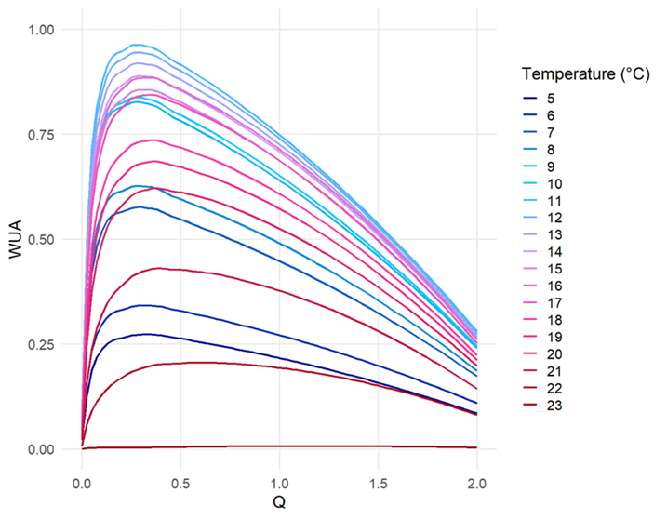

**Figure 1**

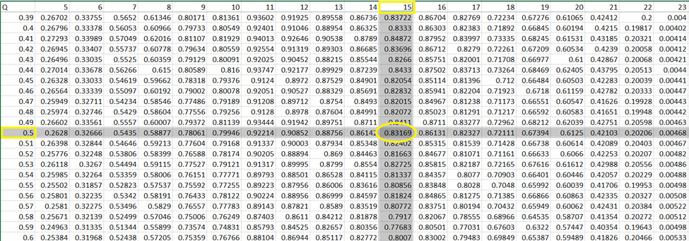

**Table 1**

Figure 1. Example model output plotting weighted usable area (WUA), the relative area of suitable rearing habitat, against flow (Q) across different temperatures.

Table 1. Matrix of model predictions of relative area of suitable rearing habitat across combinations of flow and temperatures in a coho rearing stream in the North Thompson watershed. This table supports real-time flow and temperature monitoring during summer baseflow conditions.

#### Insights

Flow and temperature are both critical habitat dimensions for salmon in freshwater, but there is still significant uncertainty in their combined effects on fish. This study provides a framework to integrate temperature into instream flow models, which support a number of management decisions, including regulatory authorizations, watershed planning, and water governance. It is also relevant for cumulative effects, where flow and temperature are common pathways where various activities impact salmon and their ecosystems.

As with any modelling tool, there are simplifications and assumptions that should temper inferences. The approach developed here is intentionally simple and conforms to conventional habitat simulation modelling constraints. This simplicity is a benefit in that it maintains tractability, but a limitation in that the method is subject to many of the longstanding critiques of habitat simulation modelling approaches (see Railsback 2016).

#### Next Steps

Undertaking this work highlighted several important empirical knowledge gaps that should be the focus of future studies. First, there is surprisingly scarce empirical data on how salmonids shift their behaviour and habitat use at high temperatures in the wild. Predictions from our models at high temperatures should therefore be tempered. Second, there is considerable variation in how flow and temperature covary. For instance, low flows are often associated with warming water temperature, but this may not be the case in systems with groundwater influence. Work to better predict these complex dynamics would benefit the application of this modelling tool.

The analytical framework developed from this project is accessible and should be readily available to interested practitioners. Habitat simulation modelling is widely used and the advances from this project can be readily integrated (see Naman et al. 2020). Model outputs can provide a more dynamic perspective on flow needs for fish in a warming climate.

#### References

Railsback, S.F., 2016. Why it is time to put PHABSIM out to pasture. *Fisheries*, *41*(12), pp.720-725.

Naman, S.M., Rosenfeld, J.S., Neuswanger, J.R., Enders, E.C., Hayes, J.W., Goodwin, E.O., Jowett, I.G. and Eaton, B.C., 2020. Bioenergetic Habitat Suitability Curves for Instream Flow Modeling: Introducing User‐Friendly Software and its Potential Applications. *Fisheries*, *45*(11), pp.605-613.

### Project 2425: Development of geospatial tools for large-scale freshwater salmon habitat assessment by the Freshwater Spatial Ecology Program

**Project Leads:** Josephine Iacarella, Keegan Paterson, Daniel Weller

**Region:** Fraser

**Species:** Coho, Chinook, Sockeye, Pink, Chum

**Waterbodies:** Fraser River

**Life History:** All freshwater phases

**Stock:** Population (if applicable)

**Conservation Unit:** CK-03, CK-04, CK-05, CK-06, CK-07, CK-08, CK-09, CK-10, CK-11, CK-12, CK-14, CK-16, CK-17, CK-18, CK-19, CO-05, CO-07, CO-08, CO-09, CO-48, SEL-03-02, SEL-03-03, SEL-03-04, SEL-04-01, SEL-05-02, SEL-06-07, SEL-06-10, SEL-06-11, SEL-06-13, SEL-06-14, SEL-06-16, SEL-07-01, SEL-09-xx, SEL-10-01, SEL-10-03, SER-02, CK-13, CK-15, CK-82, CM-02, CO-04, CO-47, PKE-9005, PKO-01, SEL-03-01, SEL-03-05, SEL-06-01, SEL-06-02,

SEL-06-20, SEL-09-02, SEL-09-03, SER-03

#### Highlights

Human activities, landscape disturbances, and climate change are presenting numerous individual and cumulative threats to fish and their freshwater habitat across British Columbia (BC). Modern tools and approaches for tracking and assessing these threats are needed to support responsive and integrated regulatory, planning, partnership, and monitoring activities to help safeguard fish and fish habitat.

We developed geospatial estimates of individual and cumulative threats to salmon and Species At Risk habitat in the Fraser River Basin from human activities, landscape disturbance, and climate change (e.g. pollutant loading, sedimentation, flow alteration, high stream temperatures). We modelled and mapped 13 threats for the full stream network and identified where and for which species threats were higher. We further applied the threat scores and indicators of important habitat for salmon in the Thompson-Nicola to help inform restoration planning for salmon ecosystems.

This project is the first to provide spatially extensive estimates of freshwater threats to salmon and inform how restoration and management actions can potentially improve population outcomes. The estimated threats are now used in salmon population life-cycle modelling to evaluate the impact on salmon across their freshwater life cycle.

#### Background

Understanding where and how fish and fish habitat are impacted by human activities and climate change is critical information for targeting effective conservation and management actions to help preserve populations. Geospatial cumulative effects assessments offer a powerful approach for evaluating simultaneous threats across large spatial scales, improving upon traditional field-based assessments (Halpern et al. 2008a; Halpern and Fujita 2013). However, many existing assessments rely on simple proxies of human activity (e.g., road density) rather than mechanistic metrics that directly link stressors to ecological responses relevant to fish and fish habitat (e.g., sediment loading or flow alteration) to provide more meaningful applications (e.g., stressor-response curves; Rosenfeld et al. 2022). To address this gap, this project advanced existing geospatial tools, indicators, and threat metrics for the Pacific Region (DFO 2022) by incorporating a mechanistic approach to better quantify anthropogenic and climate change impacts and inform management actions for salmon and Species at Risk (SAR) in the Fraser River Basin (FRB).

The Thompson-Shuswap and Nicola River watersheds were identified as pilot areas to deliver Integrated Planning for Salmon Ecosystems (IPSE) under the Pacific Salmon Strategy Initiative (PSSI). Within the scope of this project, we conducted a case-study on the Thompson-Nicola Ecological Drainage Unit (EDU) by developing examples of how individual and cumulative threat scores can be applied to help inform restoration prioritization and management actions. The Thompson-Nicola spatial analysis was used to inform IPSE collaborative planning processes in the Thompson-Nicola watersheds.

#### Methods and Findings

We developed a geospatial tool to summarize anthropogenic and climate change related cumulative threats to freshwater species and habitats using open-source input data and software that can be reproduced for different time periods and freshwater species and their habitats. All threats were estimated for each stream reach within the BC Freshwater Atlas (FWA). We derived nine individual human-activity and landscape disturbance threats: aquatic invasive species, riparian disturbance, in-stream habitat destruction, flow alteration, latitudinal fragmentation, sedimentation, pollutant loading, and nutrient loading. The input data was processed and combined to produce an individual threat score that characterizes the mechanism of disturbance to freshwater species for each score. For climate change threats, we compiled model outputs of projected stream flow and temperature to estimate threats of flood-risk, low and high stream flow, and high summer stream temperature from 2040-2060 under Representative Concentration Pathway (RCP) 4.5 and 8.5 scenarios. The individual threat scores were standardized across the study area, weighted equally, and added together to calculate a human activity and landscape disturbance cumulative threat score and a climate change based cumulative threat score (see Iacarella et al. 2025 for detailed methods). Finally, both cumulative threat scores were paired with salmon and SAR distributions (i.e., CU boundaries and delineated stream habitats, respectively) and evaluated to identify where threats were greatest and which species and CUs were exposed to the highest threat levels.

For the Thompson-Nicola EDU case study, we focused on human activity threats that may reasonably be mitigated, including riparian disturbance, water withdrawal, and longitudinal fragmentation from dams. We identified overlap between these threats and two approaches used to identify areas important to salmon: (1) CU delineations and (2) modelled environmentally favourable spawning habitats. The modelled environmentally favourability predictions were derived from large-scale environmental niche models to predict shifts in habitat favourability from current to future climate conditions (Iacarella and Weller 2023). We multiplicatively combined threat scores with environmental favourability for salmon spawning to create composite scores that reflect a gradient of potential management implications (see Fig. 20 in Iacarella et al. 2025). A high threat score combined with a high favourable habitat probability identifies an area that warrants localized investigation and potential restoration or mitigation actions. Conversely, a low threat score combined with a low favourable habitat probability identifies an area that is less likely to need management attention based on salmon values (i.e., predicted spawning habitat) and low level of anthropogenic impact.

Our results indicated the highest cumulative threat scores around the lower Fraser River and within the interior plateau of the FRB for both human activity and landscape disturbance based threats and climate change based threats (Figure 1). Watershed groups with the highest median cumulative threats were the Nicola River, Guichon Creek, and San Jose River. These heightened scores were predominately driven by riparian disturbance, nutrients, and sedimentation for the human activity based threats and high stream temperatures for the climate change based threats. Roads were the most frequent input that influenced human activity based threats across the FRB, and contributed consistently to in-stream habitat destruction, riparian disturbance, nutrients, and sedimentation. Other important inputs to these threats were forest fires, forest pest defoliation, rangeland, and forestry. We found that SAR with limited ranges (i.e., Coastrange Sculpin, Green Sturgeon, Nooksack Dace, and Salish Sucker) had higher median human activity cumulative threat scores relative to all streams in the FRB, corresponding to their at risk status (Figure 2). Median human activity threat scores tended to be more similar among salmon CUs and relative to all streams, though a few of the Threatened and Endangered Sockeye salmon CUs had notably higher median threat scores (Figure 2).

Within the Thompson-Nicola EDU, median cumulative threat composite scores within watershed groups based on the multiplicative value of human activity cumulative threats and favourable spawning habitat under current and future conditions were highest for Sockeye (Figure 3). The greatest shifts in median composite scores from current to future climate conditions (i.e., based on changes in predicted spawning favourability), were increases in Upper North Thompson River for Chinook (median score change = 0.14), Bonaparte River for Pink (0.06), and Deadman River for Sockeye (0.11), and a decrease in Thompson River for Coho (-0.06). Overall, the Deadman and Adams River watershed groups were identified as having the highest cumulative composite scores under current and future climate conditions across salmon species in the EDU.

#### Tables and Figures

*Figure 1. (a) Human activity and landscape disturbance based additive cumulative threat score, and (b) Climate change additive cumulative threat score for 2040-2060 under RCP 4.5. **Blue indicates low threat levels and red indicates high threat levels.*

*Figure 2. Tukey’s box-whiskers plots of the cumulative threat scores from human activity and landscape disturbance based threats and climate change based threats for all streams in the FRB, (a & b) accessible streams within salmon CUs, and (c & d) delineated stream habitats of fish SAR. Salmon CUs identified as Special Concern, Threatened, or Endangered by COSEWIC were distinguished from those not at risk.*

*Figure 3. Median cumulative threat composite scores for watershed groups in the Thompson-Nicola EDU based on the multiplicative value of human activity and landscape disturbance based cumulative threats and modeled environmental favourability for spawning (row a) Chinook, (b) Coho, (c) Pink, and (d) Sockeye Salmon. Modeled environmental favourability probabilities used in the composite score were based on projected (column a) current and (b) future conditions for all stream reaches (≥ 4th order) including inaccessible streams from dams and natural barriers. Watershed groups that are largely inaccessible are identified by hatched lines, and* ***s****almon CU boundaries in black outlines.* *Colour scale **indicates increasing need for localized investigation and potential restoration. *

#### Insights

This project is the first to provide spatially extensive estimates of human activity and climate change threats that are directly linked to salmon, SAR, and their habitats at the stream reach scale. The approaches used to estimate each of the indicators provide an initial broad-scale standardized framework that can be applied to characterize threats throughout the Pacific Region. Within the FRB, we observed the highest threats in the Lower Fraser and interior plateau, and specifically, within the Nicola River, Guichon Creek, and San Jose River. Overall, roads were the greatest contributor to human activity-based threats, disturbing in-stream habitats, riparian areas, and contributing to sediment and nutrient loading. These results improve our understanding of the spatial distribution and relative magnitude of threats across the FRB, providing a foundation for predicting population-level impacts from cumulative effects and life-cycle modelling.

A major source of uncertainty is the spatial accuracy of the BC Freshwater Atlas. Known issues to the FWA include overestimates of headwater streams in interior regions, misaligned stream delineations and large river catchment areas. Each of the individual threat scores have their own uncertainties and limitations, as detailed in Table 2 of Iacarella et al. (2025). In general, the input data are subject to limitations arising from potentially misclassified land cover or land use, features included in datasets but not present on the landscape, and unmapped activities or features, which introduce uncertainty into individual threat scores and the cumulative score. An additional source of uncertainty is the unresolved habitat use and distribution of salmon and SAR within the FRB. The approach used to combine individual threats into a cumulative threat score (e.g., addition, multiplication, etc.) is another source of uncertainty that can be evaluated in future work by modelling population responses to individual and cumulative threats.

#### Next Steps

Although our threat estimates represent the mechanisms by which salmon and freshwater SAR are affected, the magnitude at which these threats influence salmon population dynamics remains unknown. To address this gap, we are continuing to refine existing threat estimates and developing new threats that are explicitly linked to stressor-response functions for cumulative effects and life-cycle modelling. For example, we have developed additional riparian disturbance metrics that better capture the impacts to riparian function (e.g., large-woody debris recruitment, disturbance to stream-shading, riparian filtering), which were not included in the original report. Moreover, we are developing a stage-structured population model for Interior Fraser Coho (IFC) to estimate how stressors (estimated threats) are influencing the population across their freshwater life stages. For this work, we are utilising the Cumulative Effects Model for Prioritizing Recovery Actions (CEMPRA), which applies stressor-response functions to account for the impact of stressors on vital rates and the overall population overtime and under different climate change and mitigation scenarios (Bayly et al*.* 2024).

Additional next steps for this work include expanding the cumulative threats model to other watersheds in the Pacific Region. To date, the model has also been applied to the Upper Bulkley Watershed to aid in salmon habitat restoration planning. Validation is an important step of most modelling exercises, though is often not a standard component of cumulative effect assessments (Halpern and Fujita 2013). Validating these threats through field verification and in situ data would be beneficial for threats that involve applied relationships and estimations, such as the flow accumulated loadings (i.e., nutrients, pollution, sedimentation). Future work could re-run the model at regular intervals to evaluate change in threats over time. Finally, additional analyses could quantify uncertainty in modelled threats and evaluate underlying assumptions through sensitivity tests.

#### References

Bayly, M., Tekatch, A., Rosenfeld, J., Jarvis, L. & Enders, E. 2024. Cumulative Effects Model for Prioritizing Recovery Actions (CEMPRA): User Guide. Documentation prepared by ESSA Technologies Ltd. for the BC Water, Land and Resource S. Available from: https://essatech.github.io/CEMPRA/ [accessed 29 December 2025].

DFO. 2022. Geospatial mapping tools, indicators, and metrics for fish habitat in the Pacific Region. DFO Can. Sci. Advis. Sec. Sci. Resp. 2022/047.

Halpern, B.S., and Fujita, R. 2013. Assumptions, challenges, and future directions in cumulative impact analysis. Ecosphere. 4: art131. doi:10.1890/ES13-00181.1

Halpern, B.S., McLeod, K.L., Rosenberg, A.A., and Crowder, L.B. 2008a. Managing for cumulative impacts in ecosystem-based management through ocean zoning. Ocean Coast. Manage. 51: 203–211. doi:10.1016/j.ocecoaman.2007.08.002

Iacarella, J.C. and Weller, J.D., 2023. Predicting favourable streams for anadromous salmon spawning and natal rearing under climate change. Can. J. Fish. Aquat. Sci., 81(1), pp.1-13. doi:10.1139/cjfas-2023-0096

Iacarella, J.C., Paterson, K., Potapova, A., and Weller, J.D. 2025. Geospatial Indicators and Metrics for Threats to Fish Habitat in the Fraser River Basin with Thompson-Nicola as a Case Study. DFO Can. Sci. Advis. Sec. Res. Doc. 2025/013. xiii + 126 p.

Rosenfeld, J., Gonzalez-Espinosa, P., Jarvis, L., Enders, E., Bayly, M., Paul, A., MacPherson, L., Moore, J., Sullivan, M., Ulaski, M., and Wilson, K. 2022. Stressor-response functions as a generalizable model for context dependence. Trends Ecol. Evolut. 37: 1032–1035.

doi:10.1016/j.tree.2022.09.010

### Project 2426: Sakinaw Sockeye Juvenile Research on Measures to Increase Marine Survival

**Project Leads:** Kevin Pellett

Karalea Filipovic

Nicolette Watson

**Collaborations:** shíshálh Nation

**Location:** Hodgson Islands;#Sakinaw Lake;#Salish Sea;#Strait of Georgia

**Region:** Sunshine Coast

**Species:** Sockeye

**Waterbodies:** Sakinaw Lake, Malaspina Strait

**Life History:** Juvenile, Adult

**Stock:** ECVI/Mainland Sockeye Salmon

**Population:** Sakinaw Lake Sockeye

**Conservation Unit:** Sakinaw (SEL-11-07)

#### Highlights

Main Idea:

This project tests the hypothesis that early marine survival of Sakinaw Sockeye is negatively impacted by local predation at the Hodgson Island pinniped haul-out shortly after smolts enter the marine environment. If correct, smolts transported via boat past Hodgson Island, into Malaspina Strait, would have higher marine survival than smolts that outmigrate from Sakinaw Lake and pass the haul-out on their own. Marine survival is assessed by comparing the adult returns from PIT tagged transported smolts and hatchery PIT tagged fry and smolts released in the lake.

Key Findings:

PIT tagging sample size objectives were achieved (1000-2500 tags)

Table 1: The number of PIT tagged and transported Sakinaw Sockeye Smolts each year of the project and the dates of releases.

Year

Date

PIT Tagged & Transported

2023

May 15-17

2659

2024

May 6-9

4845

2025

May 6-8

243*

* Infrastructure issues at the Sakinaw Lake dam prevented enough smolts from being trapped for the project.

Transporting via aerated tanks on a boat is a successful method for moving smolts past the pinniped haul-out (Hodgson Island). Survival to release was over 99% and release condition and behavior was observed to be excellent.

Marine survival comparisons are still being monitored, with the 2024 transport group returning as adults in summer 2026. Preliminary results from the 2023 transport group indicate that survival was not improved for the transported smolts, with only 1 PIT tagged transport fish returning to the lake as an adult.

Implications:

Early marine survival may not be the limiting factor for this population. If transport returns continue to be low in the 2026 adult return, the recommendation would be to not pursue smolt transport as a restoration tool for Sakinaw Sockeye. See Insights and Next Steps for more detail.

#### Background

Sakinaw Sockeye have been listed as endangered with COSEWIC since 2003, and a *Species at Risk Act* Recovery Potential Assessment (RPA) was completed in 2017 (Ramshaw et al. 2019). The RPA cited low marine survival as the greatest limiting factor in recovery, with predator abundance and assumed predation on smolts and adults ranked as high risk, with a critical level of impact. Perpetually low marine survivals are preventing recovery such that the persistence of the population is entirely dependent on a captive brood program.

Sakinaw Sockeye smolts out-migrate from Sakinaw Lake each spring into the Malaspina Strait and Strait of Georgia. Localized marine predation is considered a major limiting factor for the survival of this stock. On water surveys (since 2019) of pinnipeds from the estuary to the seal haul-outs on Hodgson Islands (approximately 2km from the estuary, Figure 1) have observed approximately 100-350 harbour seals in the area during the spring out-migration.

This project was started as a pilot (2022) in collaboration with shíshálh Nation to test the hypothesis that the Hodgson Island harbour seal population is negatively affecting smolt survival, and subsequently adult returns. The goal of the project is to transport and release smolts past the seal haul-out and then compare marine survival rates between transported smolts and those out-migrating naturally. The pilot project began with a low number of smolts transported in small trial releases to test the effect of handling, Passive Integrated Transponders (PIT) tagging, and increased osmoregulation on fish.

The initial proposal indicated a minimum of 1,000 and up to 2,500 PIT tagged sockeye are recommended per year such that a 1% survival will yield a total of 10-25 tag returns. Return rates of less than 1% may be too low to justify operationalizing this activity long term. Return rates for smolts entering the estuary naturally are well documented through annual census programs so additional tagging of a control group is not necessary.

#### Methods and Findings

Methods

All sockeye smolts outmigrating from Sakinaw Lake encounter a smolt fence with a slide and overhead camera. A portion or all smolts can be directed into a trap box (6x6x3’ aluminum framed) depending on slide configuration (Figure 2). For the purpose of this project the slide was set to 100% capture to meet tagging goals.

Smolts were tagged with Biomark APT12 PIT Tags (12 x 2.12 mm, 0.1 g). Following sedation with TMS (Tricaine methanesulfonate), the tags are injected into the body cavity with an individual pre-loaded 12-guage needle and a Biomark MK 25 implanter. Tagged fish were then scanned and recorded via Biomark BioLogic DCM digital board, Biomark hand scanner, and a bluetooth connected tablet (Figure 3). Tag insertion and fish handling techniques described in the Columbia River PIT Tag Marking Procedures Manual (Columbia Basin Fish & Wildlife Authority PIT Tag Steering Committee, 1999) were modified slightly. As per recommendations from the DFO Veterinarian, the procedure for tagging was to insert the needle ahead of the pelvic girdle along the midline and inject the tag forward. Air bubblers and ice were used in each tagging bin to keep water temperatures cool and well oxygenated. Following tagging, smolts were returned to the trap box for recovery.

Smolts were held in recovery for a minimum of three hours before the transportation process began. At high-tide, shíshálh Nation’s 30’ Landing Craft was brought into the estuary, where six large plastic garbage bins on board were filled with saltwater and frozen water bottles (500ml). At the smolt fence & trap box, eight waterproof backpacks (dry bags) were filled with ~5 gallons of water and 50 smolts (Figure 4). Smolts were carried 900 m down to the beach, where they were transported to the Landing Craft via 12’ skiff with electric motor. Smolts were then poured into the garbage bins with 20 mg/L of O2 from an oxygen tank (Figure 5). Smolts were then transported and released in the Malaspina Strait.

Key Results

PIT tagging sample size objectives were achieved (1000-2500 tags). It was determined that sample size objectives could be met during the peak of smolt outmigration under normal operating conditions, as seen in 2023 & 2024, with the number of fish PIT tagged exceeding the goal of 2500 (Table 1).

Transporting via aerated tanks on a boat is a successful method for moving smolts past the pinniped haul-out (Hodgson Island). Survival to release was over 99% and release condition and behavior was observed to be excellent.

Challenges included high water temperatures during tagging and transport. This was mitigated with ice and a start date earlier in May.

Marine survival comparisons are still being monitored, with the 2024 transport group returning as adults in summer 2026. Preliminary results from the 2023 transport group indicate that survival was not improved for the transported smolts, with only 1 PIT tagged transport fish returning to the lake as an adult.

#### Tables and Figures

Table 1: The number of PIT tagged and transported Sakinaw Sockeye Smolts each year of the project and the dates of releases.

Year

Date

PIT Tagged & Transported

2023

May 15-17

2659

2024

May 6-9

4845

2025

May 6-8

243*

* Infrastructure issues at the Sakinaw Lake dam prevented enough smolts from being trapped for the project.

Figure 1. Map of the study area with the Hodgson Island haul out, Sakinaw Lake counting fence, and approximate release location.

Figure 2. Smolt dewatering slide at the Sakinaw Lake outlet with flash board for camera counts (left) and trap box with smolts ready to be tagged (right).

Figure 3. PIT tagging process at the Sakinaw Lake fence with pre-loaded trays, marking gun and hand held scanner in action.

Figure 4. Smolts being transferred into a waterproof backpack for transport to the skiff and landing craft.

Figure 5.Transporting and releasing fish aboard the landing craft.

#### Insights

This project was an exploration of new options to restore the Sakinaw Sockeye population to a self-sustaining run. It was conducted at a pilot scale to avoid making large investments in equipment or infrastructure before understanding the effectiveness of smolt transport as a tool to increase adult returns.

Given the timelines of the project in relation to the biology of the population we don’t yet have all of the results in hand. Preliminary findings from the first group of ~2,600 smolts suggests this is not an effective tool at increasing survival due to low (1) returns in 2025. A second cohort of over 5000 tags is expected to return in summer 2026 and will confirm these results.

Assuming a similarly low return in 2026 the recommendation is to not pursue smolt transport as a restoration tool for Sakinaw Sockeye. If the results are taken at face value they do raise some important discussion points and potential future directions. For example, early marine survival may not be the limiting factor for this population and later stage mortality may be more important than previously thought. Further investigations should focus on the hypothesis that late stage mortality is an important factor for this population based on the known milling behavior in the terminal area. It has been well documented that Sakinaw Sockeye adults school and stage in the bay while waiting for optimal migration conditions. These are typically described as a high tide at night with sufficient water levels which only occur on specific days within key migration months (e.g. July). Prolonged staging could be exposing this population to higher levels of predation than for example Fraser bound Sockeye and should be specifically evaluated.

Moreover; stock composition data from the Johnstone Strait test fishery indicate Sakinaw Sockeye are regularly encountered each season. Although numbers are low (<10/yr) the probability of this occurring should be near zero when comparing current escapements (low hundreds) to Fraser River run size (low millions; or 1 in 10,000). This suggests there are more adults enroute to Sakinaw than expected providing additional support for the above hypothesis.

#### Next Steps

Following the recommendations above, here are a few directions to go with respect to future work:

Revisit Sockeye test fishing data and conduct a run reconstruction to estimate the pre-terminal abundance of Sakinaw Sockeye relative to escapement.

Work with test fishing crews in 2026 to scan some or all of the test fishing catch with a PIT antenna as sets are spilled during enumeration (underway). Tags in adults should be at a maximum this year and any IDs detected can be compared to results from the river to estimate survival.

Increase monitoring of staging behavior in the bay particularly in the month of July (peak season). Consider installation of fixed SONAR stations in the bay to look for evidence of predation, particularly at night as fish attempt river entry. Overhead camera installations with zoom capability may also be useful.

Consider PIT tagging clipped adults in the test fishery to test the above hypothesis. This should be combined with DNA sampling to ensure they are Sakinaw origin fish. Alternatively; consider applying acoustic tags and receivers to see where mortality is occurring. Sakinaw Sockeye may stand out in the catch given their relatively small size and adipose clip. Dip netting individuals out of the bunt could be explored. Sorting entire sets is not feasible unless the boat is chartered specifically for that activity.

At this time the recommendation is to avoid operationalizing smolt transport activities to support recovery of Sakinaw Sockeye. It also brings into question the utility of similar activities that are designed to mitigate high early marine survival (e.g. net pens).

#### References

Columbia Basin Fish and Wildlife Authority PIT Tag Steering Committee. 1999. PIT tag marking procedures manual. Available from https://wiki.ptagis.org/images/6/60/MarkingProceduresManual.pdf

Brock Ramshaw, Wilf Luedke and Josh Korman. 2019. Recovery Potential Assessment for the Sakinaw Lake Sockeye Salmon (Oncorhynchus nerka). Can. Sci. Advis. Sec. Res. Doc. ISSN 1919-5044.

### Project 2427: Salish Sea plankton and oceanography

**Location:** Strait of Georgia;#Salish Sea

### Project 2430: Feasibility of Estimating Chilko River Smolt Abundance Using Upward- and Side-Looking SONAR Methods

**Project Leads:** Daniel Doutaz

**Collaborations:** Aquacoustics Inc.

Tŝilhqot’in National Government (TNG)

**Location:** Chilko

**Region:** Pacific (Fraser River)

**Species:** Sockeye Salmon

**Waterbodies:** Chilko River

**Life History:** Juvenile (smolt stage)

**Stock:** Chilko ES/S CU

**Conservation Unit:** CU 3 (Chilko-ES); CU 4 (Chilko-S)

#### Highlights

The main goal of the project was to test the use of SONAR technology to enumerate Sockeye salmon smolt outmigration, while concurrently running a counting fence to evaluate its performance over a four year period.

Over the course of three years (2025 results are pending), the total number of Sockeye smolts estimated with SONAR when compared to estimates generated at the enumeration fence, ranged from 5-33% (5% in 2024, 8% in 2023, 33% in 2022).

This method has been shown to be effective at enumerating Sockeye smolts, which is an important and often lacking piece of information in salmon stock assessments (e.g. estimating early freshwater survival, generating stock-recruit relationships). However, using SONAR in this configuration is highly dependent on site selection, stream morphology, flow conditions, and the ability to adequately sample smolts for size measurements used in the analysis.

#### Background

Chilko Sockeye salmon represent the only wild Sockeye indicator stock in the Fraser watershed. The annual Chilko Lake Sockeye smolt assessment (1951-present) comprises the only long-term time series data available to assess juvenile recruitment, and freshwater and marine productivity for wild Fraser River Sockeye salmon. Since program inception, Sockeye smolts have been enumerated during their out-migration from Chilko Lake using a traditional fish counting weir and photographic sampling/counting techniques. During the first six decades of the program (1951-2012), interruptions in weir operation were relatively rare: in only three years (1979, 1993, 2006) did early freshets necessitate removal of the weir before the vast majority of smolts had migrated from Chilko Lake.

Recently, unusually early freshets have been experienced in the Chilko watershed that have translated into high and variable water conditions much earlier in the season. As such, DFO Stock Assessment crews were not able to operate the weir in 2015 due to high water flows, and have had to remove the weir structure prior to the completion of smolt migration on numerous other recent years (e.g., 2019). The observed increase in the frequency of early freshets in the Chilko watershed is consistent with predicted hydrographic changes for interior BC streams as a whole in response to climate variability, with the average timing of the spring freshet expected to continue shifting earlier as air temperatures rise. The future of operating the Chilko Sockeye smolt weir is in jeopardy given the current trend related to the timing, frequency, and strength of the spring freshets. If proven effective, the SONAR method would provide an alternate assessment method for the Chilko watershed that could be quickly employed in years when high flows either prevent the installation of the weir at the beginning of the migration, or necessitate the removal of the weir before the smolt migration is largely complete.

The objective of this work was:

Test the feasibility of using upward-looking SONAR technology to assess daily abundances of Chilko Lake sockeye smolts as they migrate downstream through the Chilko River.

Evaluate the reliability of using daily SONAR-derived abundance indices predict the daily migration totals observed at the counting weir that is deployed annually on the Chilko River.

This work was conducted in collaboration with the Tŝilhqot’in National Government (TNG).

#### Methods and Findings

Acoustic data were collected with two Simrad WBT Mini SONAR systems deployed approximately 2 km downstream of the Chilko River smolt enumeration fence. Each SONAR system operated with a 7° circular 120 kHz split-beam transducer. For the up-looking system, the transducer was mounted on the river bottom, in the thalweg, aimed straight up towards the water surface. For the side-looking system, the transducer was mounted nearshore on the left bank of the river, with its center approximately 15 cm below the surface, aimed across the river with a transducer tilt angle of approximately 3° down from horizontal. Data were recorded with a ping rate of 20 pings per second on the up-looking (maximum range 4 m), 12 pings per s on the side-looking system (maximum range 12 m). Both systems were set to 50 W power output. For all four years of the study, SONAR data were collected from mid-April to late-May during the entire Chilko Sockeye smolt outmigration period.

SONAR data was manually reviewed and edited using Echoview software to remove noise, and echo integrated in 1 hour x 1 m range cells (side-looking) or 1 hour x 0.2 m range cells (up-looking). The results were exported as csv files, and all echo integration csv files belonging to the same transducer and site were concatenated for further analysis in Microsoft Excel. Excel was then used to convert the echo integration results to smolt passage estimates, which were then compared to the estimates generated at the Chilko River smolt enumeration fence.

In 2023 and 2024 (2025 results pending), daily estimates of smolt passage showed close correspondence (5% in 2023, 9% in 2024) between fence counts and independent acoustic estimates both in time and magnitude. In the first year of the study (2022), daily SONAR estimates were in good agreement with the fence counts over the first 9 days of the study, but consistently higher over the last 9 days (May 3rd and thereafter). At present, the source of this divergence is unclear.

This project is one of few that have used split-beam SONARs configured in this manner to enumerate outmigrating salmon smolts. While further testing needs to be conducted in both the Chilko River where the study was conducted, and in other candidate systems, the preliminary results of this study are promising. These methods could be modified and applied to a variety of salmon stock assessment programs to gain crucial information on survival in the early freshwater life stages (egg to smolt survival), however, considerable planning and care needs to be taken when selecting a suitable site.

#### Tables and Figures

Figure 1. 2024 daily estimates of Chilko River Sockeye smolt passage: side-looking SONAR estimates versus fence counts.

Figure 2. 2023 daily estimates of Chilko River Sockeye smolt passage: side-looking SONAR estimates versus fence counts.

Figure 3. 2022 daily estimates of Chilko River Sockeye smolt passage: side-looking SONAR estimates versus fence counts.

#### Insights

This project has shown Sockeye salmon at the smolt life stage can be effectively enumerated using SONAR, and is an easily-deployed and operated alternative to installing large enumeration fences which are typically labor-intensive and may disturb stream substrates. Many salmon stocks are solely assessed through adult escapements, which does not capture survival during the early freshwater life stages, and creates additional challenges when investigating individual stock recruitment and forecasting returns that are used in fisheries management and planning.

Using SONAR to enumerate salmon at the smolt stage enables researchers to investigate survival metrics during the early freshwater period in which there is often little or no data at the population or Conservation Unit (CU) level. In systems where there is ongoing juvenile enumeration work (e.g. with counting fences, rotary screw traps (RST), incline plane traps (IPT), etc.), this method may provide a suitable, and less invasive alternative to conventional methods. Further to this, the observed increase in frequency of early freshets and hydrographic changes in response to climate variability may preclude the operation of some juvenile assessment methods, leading to the need for other means of collecting juvenile salmon data.

Sources of uncertainty raised from this project include discrepancies in SONAR counts when compared to fence counts (particularly in the 2022 study year), which at this time are unresolved. Additionally, there in uncertainty how the system deployed would operate under heavy flow conditions, in systems with different stream characteristics, and in systems with multiple species of Pacific salmon with overlapping outmigration timing.

#### Next Steps

This work describes how split-beam SONAR systems can be deployed and configured to enumerate outmigrating salmon smolts, which can provide crucial information on egg to smolt survival, stock recruitment, and freshwater habitat conditions and quality. This additional information can then be used to inform management strategies or mitigations for stocks below conservation benchmarks, or inform enhancement work conducted by the DFO Salmonid Enhancement program where no metrics exist other than adult escapements to evaluate performance (e.g. Bowron, Pitt, Taseko rivers).

### Project 2432: Barkley Sound and Clayoquot Sound acoustic monitoring of salmon and salmon prey

**Project Leads:** Stéphane Gauthier

**Collaborations:** Follow the Fish team

**Location:** Barkley Sound;#Clayoquot Sound

**Region:** West Coast Vancouver Island

**Species:** Waterbodies (if applicable)

**Life History:** juvenile

**Stock:** Population (if applicable)

#### Highlights

Large scale acoustic surveys off the BC coast revealed persistent euphausiids hotspots – such data (along with further work on forage species) could ultimately inform on conditions critical for adult salmon marine survival.

Fine temporal scale monitoring in nearshore coastal areas of Barkley Sound revealed year-long habitat use by juvenile salmon, with clear pulses in late Summer and early Fall.

These juvenile salmon densities are linked to densities and availability of euphausiids.

Competition and predation pressures from other fish species (Pacific herring and demersal predators like walleye pollock/Pacific hake) are present year-round and are found near surface water at night (co-occurring with juvenile salmon). Predation events from birds/marine mammals have been recorded multiple times at these sites, and did not appear to be density dependent.

#### Background

Fisheries acoustics can be used to answer a number of questions related to Salmon ecology and dynamics. On large spatial scales, acoustic surveys are used to assess salmon prey (e.g forage fish and krill) conditions along the BC coast, identify prey hotspots, and assess changes in productivity through time. On a finer temporal scale, moored autonomous echosounders can provide information on juvenile salmon coastal habitat use, in conjunction with prey availability and predation pressures.

Autonomous echosounder system were used to address key elements affecting juvenile salmon during the first stage of marine life, including the timing of juvenile salmon use of coastal areas (time spent in key areas and within the water column), the prey conditions (e.g. euphausiids dynamic) they encounter in these areas, and the competition and predation pressures that affect them.

#### Methods and Findings

We used active acoustics methods as a remote sensing tools to assess the salmonsphere (salmon as well as their prey and predators). Large scale fisheries acoustic surveys conducted along the BC coast over the continental shelf and slope are used to assess marine conditions and the abundance and distribution of key prey species for adult Chinook salmon (e.g. Pacific herring and euphausiids). On a finer temporal scale, we used moored inverted echosounders to monitor juvenile salmons (and salmonsphere ecosystem components) in coastal areas within Barkley Sound.

Two autonomous systems were moored on the bottom of Barkley Sound nearshore areas with the transducers facing upward toward the sea surface, detecting juvenile salmon and all marine organisms as they go through the acoustic beam. Previous work in coastal areas using direct sampling methods (e.g. purse seine) combined with such moorings, as well as libraries of acoustic-trawl surveys and frequency-based signal processing techniques is enabling the classification of acoustic backscatter into species group (juvenile salmon, Pacific herring, walleye pollock and similar demersal fish, euphausiids) to obtain fine scale temporal data on their prevalence and relationship over more than a year of continuous data collection. In addition, surface predation events (from diving birds and/or marine mammals) are documented for the entire time-series. Acoustic methods are not capable of identifying juvenile salmon to species. To achieve species-specific interpretations the data will rely on other available sampling and ancillary data (seine, micro-trolling, eDNA, hatchery release timing) to further partition the acoustic information that was attributed to juvenile salmon.

#### Tables and Figures

Figure 1. Typical echogram observed in Barkley Sound, where the top red band indicate the water surface, total depth displayed is around 80 m. a) dense juvenile salmon schools near the surface, b) typical herring schools, with one displaying the release of gas bubbles, c) demersal fish schools (likely walleye pollock within the deeper krill layer, d) example of a surface predation event, showing multiple animals/fish diving deep.

#### Insights

Large spatial scale acoustic data have revealed persistent hotspots of euphausiids (a key salmon prey) along the BC coast – expansion of this work will include key forage fish species.

Moorings in nearshore coastal areas of Barkley Sound reveal the presence of juvenile salmon year-round, but having a clear pulse of activity and density in Late summer-early Fall. Although juvenile salmon have been detected throughout the top 50 m of the water column, they predominantly occupy the top 15-20 m of the water surface.

Pulses of juvenile salmon were closely linked to the availability and density of a key prey, euphausiids (krill). Krill display distinct diel vertical migrations (prey are at depth during the day and near surface at night).

Key competitors (Pacific herring) and fish predators (walleye pollock and/or Pacific hake) are present throughout the year, and also exhibit diel migration (mixing with juvenile salmon in the surface layer at night).

Further predation pressure from birds and/or marine mammals were identified throughout the time-series (documented daytime surface attacks), and does not appear to be density dependent, with many events occurring in the Winter when fewer surface schools are observed.

#### Next Steps

This study was implemented in the second year of PSSI. Acoustic data collected from moored systems are only available once instruments are recovered, in as such, we are just finalizing the processing and analyses of these acoustic data – integration with other sampling (micro-trolling, eDNA, etc) that occurred while the instrument were collecting data will be a critical step to fully interpret these data and publish the findings.

### Project 2433: Integrated Salish Sea acoustic monitoring of salmon and salmon prey

**Project Leads:** Stéphane Gauthier

**Collaborations:** Akash Sastri, Kelly Young, Jennifer Boldt, Chris Rooper, Doug Bertram

**Location:** Salish Sea

**Region:** Salish Sea

**Species:** Waterbodies (if applicable)

**Life History:** juvenile

**Stock:** Population (if applicable)

#### Highlights

Large scale acoustic surveys within the Salish Sea indicate the presence of Pacific hake (a significant source of potential predation for juvenile salmon) throughout the Salish Sea, with increasing biomass over the past years.

Fine temporal scale monitoring in nearshore coastal areas of the Strait indicate low abundance of juvenile salmon compare to juvenile Pacific herring, suggesting high levels of competition for food.

The nearshore moorings (including cameras) revealed a wide array of potential predators for juvenile salmon, but surface predation from birds and/or marine mammals were not as frequent as observed in nearshore coastal areas of Barkley Sound.

Deeper mooring in the central Strait of Gorgia revealed that Pacific hake (predators) were present almost year-round.

#### Background

Fisheries acoustics can be used to answer a number of questions related to Salmon ecology and dynamics. On large spatial scales, acoustic surveys are used to assess salmon prey (e.g forage fish and krill) conditions within the Salish Sea, identify prey hotspots, key predators of juvenile salmon, and assess changes in productivity through time. On a finer temporal scale, moored autonomous echosounders can provide information on juvenile salmon coastal habitat use, in conjunction with prey availability and predation pressures.

Autonomous echosounder system were used to address key elements affecting juvenile salmon during the first stage of marine life, including juvenile salmon use of coastal areas (time spent in key areas and within the water column), the prey conditions (e.g. euphausiids dynamic) they encounter in the Salish Sea, and the competition and predation pressures that affect them.

#### Methods and Findings

We used active acoustics methods as a remote sensing tools to assess the salmonsphere (salmon as well as their prey and predators). Large scale fisheries acoustic surveys conducted within the Salish Sea are used to assess marine conditions and the abundance and distribution of key prey species and predators for salmon. On a finer temporal scale, we used moored inverted echosounders to monitor juvenile salmons (and salmonsphere ecosystem components) in nearshore habitats and within the larger Strait of Georgia basin.

This project used the same methods as described for project 2432. More specifically, two autonmous echosounders were moored on the bottom near Departure Bay and French Creek as part of a separate project focused on Pacific herring in 2022-2023. These data were re-analyzed to identify juvenile salmon and associated species. Another mooring was deployed in 2024 in the middle of the Strait of Georgia to assess ecosystem conditions in the deeper larger basin, to provide insight on the dynamic of key salmon prey species (euphausiids) and piscivorous predators (e.g. Pacific hake). Another echosounder mooring was deployed in Malaspina Strait in 2025 (but these data are not available yet).

#### Tables and Figures

Figure 1. Seasonal dynamics of the Salish Sea nearshore environment as observed from continuous moored autonomous echosounder and regularly moored underwater cameras. Juvenile salmon where detected year-round at low densities (pale blue). The predators are listed in reddish and grey colors, while competitors are listed in green.

#### Insights

Large spatial scale acoustic data have revealed an increasing biomass of Pacific Hake throughout the Strait, with likely increased predation pressure for juvenile salmon, a sharp contrast to the West Coast, where Pacific hake biomass has drastically dropped over the past years.

Moorings in nearshore coastal areas revealed the presence of juvenile salmon year-round, but in relatively low abundance. The nearshore habitat in the Salish Sea was largely dominated by Pacific herring (suggesting juvenile salmon are exposed to much higher competition for food).

Potential predators of juvenile salmon were observed routinely on the moored acoustics as well as on regularly moored camera systems. Surface predation from birds and/or marine mammals were also observed, but far less frequently than on the West Coast (Barkley Sound).

Moored autonomous echosounder in the central part of the Strait of Georgia further indicated that large predators (Pacific hake) were in the area for most of the year, and there was a strong seasonal signal of euphausiids and epi and mesopelagic communities in the Spring/Summer.

#### Next Steps

This study was implemented in the second year of PSSI. Acoustic data collected from moored systems are only available once instruments are recovered, in as such, we are just finalizing the processing and analyses of acoustic data from moorings deployed in 2024 and 2025.

### Project 2434: SHERLOCK assay for rapid genotyping applications

**Location:** Puntledge River

### Project 2435: Intergenerational transfer and parental origins of DNA methylation variation in Coho and Chinook Salmon

**Location:** PBS Nanaimo

### Project 2436: Chum whole genome sequencing for improved stock delineation

**Project Leads:** Tigano, Anna; Rondeau, Eric; Healy, Timothy; Wellband, Kyle.

**Collaborations:** N/A

**Location:** Fraser;#Chilliwack River

**Region:** Southern BC and Puget Sound/Hood Canal

**Species:** Chum

**Waterbodies:** Fraser, Strait of Georgia, Puget Sound

**Life History:** Spawning adults

**Stock:** Population (if applicable)

**Conservation Unit:** Fraser, Howe and Georgia Strait – Southern Fjords

#### Background

GSI is routinely used in the Northeast Pacific to inform the management of Pacific salmon species, especially chinook (*Oncorhynchus tshawytscha*), sockeye (*Oncorhynchus nerka*), coho (*Oncorhynchus kisutch*), and chum (*Oncorhynchus keta*). Of these four species, chum is the most widely distributed in the Pacific Ocean, and displays the weakest population structure across its range. Chum is managed jointly by Canada and the United States under the Pacific Salmon Treaty to ensure that the fishery is sustainable on the long term, and GSI has become a pillar of effective stock assessment and management. Bilateral efforts between Canada and the USA have led to the development of GSI panels in each of the two countries, with bilateral collaboration ensuring a large overlap of SNPs between the panels developed in the two countries to foster exchange of data and results. The Canada chum GSI panel consists of 535 SNPs originally sourced from a series of RAD-seq (a genomic method to genotype thousands of genome-wide SNPs) studies targeting different parts of the range, but limited to Washington and Alaska (to be refined Small et al PSC report, Mckinney et al. 2020; Mckinney et al. 2022), and subsequently optimized independently from the USA counterpart. The Canadian baseline, the genetic database used as reference to assign samples of unknown origin to their stock of provenance, includes genotypic data for over 32,000 individuals from 384 collections across the species range (October 2025).

Despite the genotyping efforts, some areas in southern BC remain poorly resolved, with two areas being of particular interest: the lower Fraser and SOG. In the Fraser, the Albion test fishery, which provides crucial information on chum returns for stock assessment, relies on accurate separation of Chilliwack River returns from the rest of the Fraser, but it is currently challenging. To avoid misassignment and increase accuracy, albeit at the cost of resolution, all collections from the Fraser are lumped into a single reporting unit. In the Strait of Georgia, two main reporting units are currently recognized: Howe-Burrard, including collections from Howe Sound and Burrard Inlet; and Strait of Georgia, including collections from the west and east side of the strait that are not included in the Howe-Burrard reporting unit. Even though assignment accuracy between these two reporting units is low with the current SNP panel, the analysis of the baseline samples suggest that additional efforts may help discriminate collections from the east and the west side of the Strait, thus increasing overall resolution in the SOG.

#### Methods and Findings

We used whole genome sequencing to fully characterize genome-wide sequence variation within the Fraser, SOG and adjacent areas, including Puget Sound, Johnstone Strait, and West Coast Vancouver Island. We sequenced 15 individuals from each of 45 collections in these areas (Fig.1), and called variants using stringent quality filters. We identified more than 11 million SNPs (excluding rare variants) across 594 individuals, which is 21,000X the number of SNPs included in the current GSI panel (535 SNPs). We performed Principal Component Analyses (PCAs) to investigate population structure. Analyses based on 100,000 randomly selected SNPs, a subsample of the full catalogue of genomic variation, showed great resolution improvement compared to the reference baseline including data from the 535 SNPs of the GSI panel (Fig.2): the Fraser, SOG and Puget Sound were markedly differentiated from each other, the North Puget collections were clearly separated from the rest of the individuals, and we started to observe differentiation between Chilliwack and Fraser, and SOG east and west. More focused analyses including only Fraser-Chilliwack or SOG samples revealed significant differentiation within those two areas. To identify a set of highly informative SNPs to add to the GSI panel, we calculated FST, a measure of genetic differentiation, across all SNPs within each of the two areas and selected the 100 SNPs showing the highest differentiation in each area (Fraser and SOG).

We extracted the genotype data from the whole genome sequencing dataset for the SNPs in the GSI panel and the 200 highly differentiated SNPs in the Fraser and the SOG. 121 of the 535 SNPs in the GSI panel were not present in the whole genome dataset because they were either excluded due to quality and/or low minor allele frequency filters, or because they were not variable in the target geographic area. Using Leave-One-Out (LOO) analyses we tested for changes in GSI accuracy between the current GSI panel (414 SNPs) and the improved panel that includes the GSI panel and the 200 differentiated SNPs (614 SNPs). The addition of the 200 SNPs resulted in much improved assignments (Fig.3 and 4). When we tested the current GSI panel, assignments to the SOG had low true positive rates, indicating low assignment probabilities or misassignments, and individuals from each side of the strait showed similar probabilities to be assigned to SOG east or west (Fig.3). In the Fraser, Chilliwack individuals tended to be assigned to the rest of the Fraser, resulting in high false positive rate when the Fraser was the target reporting unit, and low true positive rates when the Chilliwack was the target reporting unit (Fig.3). In contrast, when we used the improved panel, all analyses showed low false discovery rate (FDR < 0.05) and high true discovery rate, hitting the target accuracy threshold of 80% of individuals assigned with 80% probability assignment, except for Chilliwack, which showed great improvement but fell slightly short on the true positive rate (70-75% instead of > 80%, Fig.4) . True positive rate of assignment to Chilliwack is likely to increase with greater sample sizes, which are generally targeted for the construction of the reference baseline. Overall, by adding 200 highly differentiated SNPs, true positive rate increased by 48% on average at a 80% of assignment probability threshold in the four target areas, with the greatest increases in Chilliwack (66%) and SOG west (63%), followed by SOG east (49%; Figs.3 and 4). The Fraser had the lowest increase in true positive rate as it was already high in the original GSI panel, even though its false discovery rate was the highest (10%) due to Chilliwack individuals tending to assign to the Fraser (Figs.3 and 4). Similarly, false discovery rate decreased by 5% and accuracy increased by 10% on average.

Finally, with funding from PSSI we expanded our whole genome dataset to include one collection from each designated Conservation Unit (CU) in BC and additional collections from Alaska, for a total of 512 individuals from 44 collections/CUs from Washington to Alaska. This dataset will be used to further characterize population structure across the BC range and beyond, investigate signatures of local adaptation and the environmental factors driving it, assess variation in genomic vulnerability to climate change across the NE Pacific range, estimate genetic diversity, reconstruct past changes in effective population size, and potentially further improve the GSI panel to increase geographic resolution of GSI.

#### Tables and Figures

Figure 1. Map showing the spawning location of the collections used to increase GSI resolution in the Fraser River and in the Strait of Georgia.

Figure 2. PCA plots showing population differentiation based on either the 535 SNPs included in the GSI panel (on the left) or 100,000 SNPs sampled randomly from a catalogue of 11 million SNPs from across the genome (on the right). The comparison shows higher genetic resolution when using more SNPs identified from the collections on interest.

Figure 3. Plots summarizing LOO analyses results for the current GSI panel for each of the four target geographic areas: Strait of Georgia on the left (West and East) and Fraser on the right (Fraser-excluding Chilliwack and Chilliwack).

Figure 3. Plots summarizing LOO analyses results for the improved GSI panel (current + 200 highly differentiated SNPs) for each of the four target geographic areas: Strait of Georgia on the left (West and East) and Fraser on the right (Fraser-excluding Chilliwack and Chilliwack).

### Project 2437: Adaptive genetic variation and climate change resilience in Canadian Pacific salmon

**Location:** PBS Nanaimo

### Project 2439: Fournier Transfer Near Infrared (FT-NIR) Spectroscopy; its application for rapid fish age estimation within the Sclerochronology Lab at the Pacific Biological Station

**Project Leads:** Stephen Wischniowski

**Collaborations:** Robert T. Ames1,2, Patrick D. Barry3, Matt W. Callahan1,2, Niels Leuthold1,2, Jodi C. Neil5, Taylor Scott6, Benjamin H. Adams6, and Jordan T. Watson7

1 Pacific States Marine Fisheries Commission.

2 Alaska Fisheries Information Network.

3 Alaska Fisheries Science Center, Juneau, AK, USA

5 Alaska Department of Fish and Game. Mark, Tag, and Age Laboratory, Juneau, AK, USA

6 Northern Southeast Regional Aquaculture Association. Sitka, AK, USA

7 Canadian Integrated Ocean Observing System Pacific Region, Ocean Networks Canada, Victoria, B.C., Canada

**Location:** Pacific Biological Station

**Region:** Pacific North West

**Species:** Chum and Chinook

**Life History:** Region

**Stock:** Population (if applicable)

#### Highlights

The Alternative Age Estimation program (AAE) in the Sclerochronology lab (SCL) is conducting research in Convolutional Neural Network (CNN) and Deep Machine Learning (DML) predictive age modeling with a goal to deploy an AI-driven pipeline that augments traditional ageing techniques and transforms fish age estimation.

Chum Salmon CNN predictive age models for the most common age classes have been very successful, attaining precision rates up to 94% (Ames et al. submitted CJFAS 2025). Fourier Transform-Near Infrared (FT-NIR) spectroscopy and Otolith Shape Analysis (OSA) have provided acceptable age predictions for Rougheye/Blackspotted (REBS complex), Yelloweye and Pacific Ocean Perch rockfish and have demonstrated excellent results for the REBS complex speciation and Yelloweye stock ID.

The steadily increasing demand for age data regularly exceeds program capacity, and with the SCL experiencing reductions in funding and skilled personnel, traditional age estimation has become a bottleneck in providing age data for the management of Pacific salmon. Automation of the age assignment process for salmon and rockfish species will facilitate increased capacity and supplement existing personnel providing key model age data to ensure fisheries are sustainably managed.

#### Background

The SCL program provides approximately 120,000 quality controlled age-estimates for salmon and groundfish species annually. Age data are inputs in calculating rates of reproductivity, growth and mortality, critical components in stock productivity and are key parameters in stock assessment analyses. Provision of timely age data estimates enables downstream modelling of stocks performance and allow for these information to be available for consultation processes which are pivotal for sustainable fisheries management, conservation strategies and ecological research. The steadily increasing demand for age data regularly exceeds program capacity forcing requests to be aged on a prioritized basis, with the SCL experiencing reductions in funding and skilled personnel, traditional age estimation has become a bottleneck in providing age data for the management of Pacific salmon and groundfish (Malde et al. 2020).

Traditional techniques, such as scale and otolith age assignment are labour intensive, time consuming, and prone to inter-reader variability. Improved and accelerated age estimates through the deployment of an AI-driven pipeline of CNN and DML predictive age modeling will augment traditional ageing techniques and transform fish age estimation (Moen et al. 2023; Vabø et al. 2021).

A multiple agency effort (DFO, Pacific States Marine Fisheries Commission (PSMFC), National Oceanic and Atmospheric Administration (NOAA), Alaska Department of Fish and Game (ADF&G) and the Northern Southeast Regional Aquaculture Association (NSRAA)) have developed working models to successfully predict Chum ages with an AI algorithm trained on 15,000 scale images. Although the existing models are coastwide (Alaska, BC and Washington), our research team is currently supplementing BC images to increase the robustness of the coastwide models while developing new models specific to Chum salmon captured in waters local to BC.

This is the first step in providing a multi-species Alternative Age Estimation pipeline designed to augment age assignment output capacity within the SCL.

#### Methods and Findings

For any AI predictive age model to function it requires input data or attributes, these are typically species and structure dependent. The SCL has focused on the attributes extracted from scales and otoliths for its investigations into predictive age assignment (Table 1).

In the case of salmon, specifically Chum the scale growth pattern is the attribute and a scale image is the means of interpretation (LaLanne and Safsten 1969; McNicol and MacLellan 2010). Chum salmon scales were collected by four agencies: NOAA, ADF&G, NSRAA and DFO. All groups prepare scales similarly for age estimation; scales are mounted to a gum card and acetate impressions are made. An automated high-speed Leica Emspira 3 mobile base camera system was used to selectively and rapidly image impressions of DFO Chum scales. CNN models were developed using 15,754 scale images; 24% of the total collection. Data were split into training (70%, n=11,012), validation (15%, n=2,365), and testing (15%, n=2,377) and randomly but stratified by age classes to ensure consistent age class distributions across each set. We deployed an ensemble of three CNN models architectures with a proven track record in their application for image classification and regression problems. The ensemble model of EfficientNetV2L, NASNetLarge, and ConvNeXtLarge provided excellent age predictions for the most common age classes of Chum recruiting to the fishery (Figure 1) (Ames, et al., In press).

In the case of groundfish, the otolith is the structure employed and its weight, shape morphometrics and Infrared spectral scan are the attributes. Together, the otolith morphometric attributes (weight, dimensional measurements, and shape outlines) and FT-NIR spectroscopic data (Benson et al. 2023) were used in machine learning algorithms in R to create predictive statistical models for species classification, stock delineation, and the automated age estimation of select rockfish species. Specifically, age estimation models of Rougheye, Yelloweye and Pacific Ocean perch provided estimates that met the lower acceptable precision rates set by quality control parameters for human generated precisions (Figure 2). Previously aged samples from the SCL Structure Library will be sourced, attribute data will be collected and incorporated into current models to increased the robustness of age predictions of these rockfish species.

The Alternative Age Estimation program has made great advancements in predictive age modeling based on key attributes of otoliths and scales with plans to apply these models to the most commonly aged species at the SCL.

#### Tables and Figures

**Figure 1**

**Figure 2**

**Figure 3**

Table 1. Represents the total number of structure attributes collected by species.

Figure 1. Predictive age results for Chum age classes one to seven.

Figure 2. Predictive age results for Sebastes aleutianus, alutus and ruberrimus compared to the age agreement target values set for each species.

#### Insights

Traditional age estimation methods rely on highly specialized skills developed through long-term mentorship, these methods are time-intensive and resource-heavy, limiting scalability and throughput. The steadily increasing demand for age data regularly exceeds program capacity forcing requests to be aged on a prioritized basis. While a significant amount of expertise is required to produce fish age estimates this is something AI can be trained to do. This modernization and the work to date establishes the groundwork for an AI-driven pipeline that augments traditional age estimation techniques, dramatically increasing efficiency while maintaining scientific rigor. Accurate and precise age estimation is pivotal for sustainable fisheries management, conservation strategies and ecological research.

Increased capacity benefits age-structured stock assessments that facilitate judicious fisheries resource management decisions commonly via science advice generated in CSAS processes which depend on high quality and consistent age-data. Commercial Fisheries programs are managed in partnership with stakeholders relying on scientific assessments and are dependent on consultative processes to develop and review policies, procedures and regulation.

The implementation of AI pipelines are designed to augment age output and not meant to replace age readers. SCL institutional ageing knowledge acquired over 40 years of ageing experience must be maintained to ensure predictive age assignments remain precise and do not drift as a result of environmental pressures such as climate change.

#### Next Steps

Model training, testing and validation will continue with previously aged samples in order to increase samples robustness of the three aforementioned rockfish species and Chum. New species (Chinook, Quillback Redbandded and Widow rockfish) are currently in the process of scale imaging, and otolith weighing, imaging and IR scanning. The overall goal is to create a image, weight and IR libraries of all species aged within the SCL age catalog. Model training, testing and validation will proceed on all species when enough structure attributes have been attained. This is the metadata foundation that will support age predictive AI age modeling.

Climate change, in the form of increasing water temperatures will diversely affect salmonid species causing variations in the physiological traits of growth and metabolic condition. Consequentially, driving a divergence from historical growth patterns causing interpretational difficulties that can result in the “smearing” of age classes. The creation of image based libraries has a two fold advantage; (1) it allows for automated predictive age assignments, and (2) it provides the ability to monitor changing growth rates by the direct measure of scale annuli. Measures of growth can provide information encompassing external environmental conditions as indicators of habitat quality, and internal physiological status of health, stress and reproductive state. The development of automated measures of annular growth are currently under investigation. As climate change becomes more prevalent the SCL expects that age requests will increase to compensate for the dynamic shifts in the ecosystem.

Current plans for operationalization of real-time age prediction of Chum salmon are underway. This will rely on a Frame Work laptop that is specifically design to run the Chum age predictive models and the SCL’s high speed automated scale imaging camera. The series of events are as such;

scale images will be auto captured from the high speed camera,

an R-script will create image file names of species and specimen ID,

all other attribute metadata such as measure of scale growth will be extracted,

scale age will be predicted, recorded, and exported to the Mark and Recovery database.

#### References

Ames, R.T., Barry, P.D., Callahan, M.W., Leuthold, N., Wischniowski, S.G., Neil, J.C., Gravel, S., Scott, T., Adams, B.H., and Watson, J.T. 2026. Employing deep learning for chum salmon (*Oncorhynchus keta*) age estimation through scale image analysis*,* submitted to CJFAS December 2025.

Benson, I., Helser, T.E., Marchetti, G., and Barnett, B. 2023. The future of fish age estimation: deep machine learning coupled with Fourier transform near-infrared spectroscopy of otoliths. Can. J. Fish. Aquat. Sci. 80: 1482–1494.

LaLanne, J., and Safsten, G. 1969. Age determination from scales of chum salmon (Oncorhynchus keta). J. Fish. Res. Board Can. 26: 671–676.

Malde, K., Handegard, N.O., Eikvil, L., and Salberg, A.-B. 2020. Machine intelligence and the data-driven future of marine science. ICES J. Mar. Sci. 77: 1274–1285.

McNicol, R.E., and MacLellan, S.E. 2010. Accuracy of using scales to age mixed-stock Chinook salmon of hatchery origin. Trans. Am. Fish. Soc. 139: 727–734.

Moen, E., Vabø, R., Smoliński, S., Denechaud, C., Handegard, N.O., and Malde, K. 2023. Age interpretation of cod otoliths using deep learning. Ecol. Inform. 78: 102325.

### Project 2440: Mat-37 Improvements to the evaluation of abundance and stock composition for Fraser River Juvenile Salmon

### Project 2442: Graduate Research into 1) habitat use by juvenile Chinook Salmon in the Canadian Okanagan River and Lake system and 2) predation on juvenile salmon in the Canadian Okanagan River and Lake system

**Project Leads:** Lauren Weir (DFO)

Tommy Pontbriand (DFO)

**Collaborations:** Thompson Rivers University (TRU)

Dr Brian Heise

Selena Carl (MSc student)

Torrie Bell (MSc student)

Okanagan Nation Alliance (ONA)

Elinor McGrath

**Region:** Okanagan

**Species:** Chinook

**Waterbodies:** Okanagan River and Lake system

**Life History:** Ocean-type (sub-yearling) summer population

**Stock:** Canadian Okanagan

**Population:** Canadian Okanagan

**Conservation Unit:** CK-01

#### Highlights

The objective of this project was to understand factors influencing the survival of juvenile Chinook Salmon in the Okanagan River and Lake system. We found that survival is low during the downstream migration of sub-yearling Chinook in the spring and early summer. Disturbed rearing habitat, high water temperatures, and predation pressure from smallmouth bass were identified as the main threats to Okanagan Chinook juvenile survival. This new knowledge will help us target recovery efforts for this endangered population.

#### Background

The Canadian Okanagan Chinook population is currently the only Columbia River basin Chinook population in Canada. Chinook escapements to the Okanagan River have been extremely low (less than 100 spawners annually) and many habitat challenges are preventing the recovery of the population. Okanagan Chinook were assessed as Endangered by COSEWIC in 2017, and the population is under review for listing under the Species at Risk Act. Some knowledge gaps that originated from those assessments were uncertainty around juvenile survival and factors influencing it.

To answer this knowledge gap, we partnered with Thompson Rivers University to support two graduate students to study factors influencing the survival of juvenile Chinook Salmon in the Okanagan River and Lake system. The project was also developed and implemented in collaboration with the Okanagan Nation Alliance’s fisheries biologist Elinor McGrath.

#### Methods and Findings

Habitat use and survival:

Subyearling Chinook (n=547) raised in the kł cp̓əlk̓ stim̓ hatchery were implanted with ATS SS400 injectable acoustic transmitters. They were released in two groups, with group A (n=273) released in the Okanagan River below Vertical Drop Structure (VDS) 17 and above Vaseux Lake, and group B (n=274) released downstream of Vaseux lake below McIntyre Dam. A network of 15 ATS SR3001 autonomous receivers was deployed from Okanagan Falls to Osoyoos Lake between 21 May and 8 August, 2024). Receivers were clustered into 7 detection sites, placed to form acoustic “gates” at lake inlets and outlets, narrows and channel constrictions, and potential rearing/migration corridors. An ATS SR3017 mobile receiver with hydrophone was used to survey shallow side channels, deeper offshore areas beyond stationary coverage, and upstream and downstream of VDS structures. The proportion of fish detected decreased sharply for both release groups as fish migrated downstream, which translated to low survival in both release groups. Tag burden was not deemed a source of direct mortality, but could have increased susceptibility to predation.

Smallmouth bass diet and predation:

Targeted angling was conducted in the Okanagan River, Vaseux Lake, Osoyoos Lake from May 3 to August 7, 2024. The dominant species captured were smallmouth bass, which comprised 76% of the total catch (n=196), followed by Northern Pikeminnow (16%, n=41) and Yellow Perch (4%, n=11). There was a spatial shift in the distribution of smallmouth bass caught during the study. In May, less than half (45%) of smallmouth bass were caught at Vertical Drop Structures (VDS), but the proportion of smallmouth bass captured at VDS structures increased to 100% and 80% in June and July, respectively. Bass were observed utilizing rocky substrate and rip rap below the VDS structures to ambush prey. Diet content visual analysis was performed on a subsample of 73 of the total 196 smallmouth bass. A total of 162 fish stomach samples were sent for DNA barcode sequencing. Chinook salmon was only detected once in the DNA samples, but direct evidence of bass predation on juvenile Chinook was obtained by recovery of an acoustic tag used in the juvenile migration and habitat use study. DNA metabarcoding identified a diverse assemblage of 146 unique prey taxa. Aquatic insects (Diptera, Ephemeroptera, Trichoptera), invasive fish (smallmouth bass, yellow perch, common carp), and native fish (prickly sculpin, mountain whitefish, sockeye/kokanee, chinook) were the most common prey items in smallmouth bass stomach contents.

#### Tables and Figures

Figure 1: Proportion of acoustic tagged juvenile Chinook detected at downstream detections sites and resulting survival curves for release Group A (n= 273 upstream of Vaseux Lake) and B (n=274 downstream of McIntyre Dam). In both release groups, there is a sharp decline in the proportion of fish detected and survival is low during the downstream migration.

Figure 2: DNA metabarcoding stomach content analysis of n=162 smallmouth bass (*Micropterus **dolomieu*) captured at various locations in the Okanagan River and Lake system. Aquatic insects (Diptera, Ephemeroptera, Trichoptera), invasive fish (smallmouth bass, yellow perch, common carp), and native fish (prickly sculpin, mountain whitefish, Sockeye/kokanee, Chinook) were the most common prey items identified.

Table 1: Total length (TL) and weight of the 196 smallmouth bass (*Micropterus **dolomieu*) captured in the juvenile Chinook predation study. Bass were captured by angling in the Okanagan River and Lake system and were sacrificed upon capture for stomach content analysis.

Location

Month

n

TL (mm ± SD)

Weight (g ± SD)

Okanagan River

May

88

290.5 ± 65.9

440.0 ± 381.7

Okanagan River

June

15

291.4 ± 68.7

424.1 ± 382.9

Okanagan River

July

35

243.7 ± 55.1

245.2 ± 264.6

Osoyoos Lake

May

1

232.0 ± NA

175.0 ± NA

Osoyoos Lake

June

8

316.8 ± 87.3

550.0 ± 636.1

Vaseux Lake

May

19

268.9 ± 59.1

324.1 ± 228.5

Vaseux Lake

June

18

314.6 ± 67.8

509.8 ± 310.6

Vaseux Lake

July

12

274.5 ± 55.8

328.7 ± 165.2

Total

196

282.2 ± 66.8

395.6 ± 354.1

#### Insights

The research conducted through this project added greatly to the limited knowledge of juvenile Chinook survival in the Okanagan River and Lake system.

The acoustic telemetry study revealed that juvenile Chinook survival is low during their spring outmigration in the Okanagan River. It identified critical freshwater mortality hotspots in Vaseux Lake, in the Okanagan River, and in the northern portion of Osoyoos Lake. This mortality was associated with warm water temperatures and habitat constraints, and provides evidence for supporting habitat restoration strategies to increase juvenile survival. Proposed actions include:

Reconnecting side channels

Re-naturalizing riparian zones

Adding deep pools, woody debris, and cover

Managing macrophyte growth

Adjusting dam operations for cold water inflow protection

Adapting hatchery release strategy (timing and location) to maximize juvenile survival

The predation study revealed that predation pressure by native and invasive fish species, especially by smallmouth bass, is likely high and contributes to the low survival of juvenile Chinook in the Okanagan River and Lake system. It also identified predation hotspots at Vertical Drop Structure (VDS) sites on the Okanagan River. Proposed actions to mitigate the impacts of smallmouth bass predation include:

Reduce predation hotspots at VDS sites with restoration efforts to remove or modify existing structures

Targeted smallmouth bass removal in the Okanagan River and Lake system with electrofishing or angling programs

Protect and enhance rearing habitat for juvenile Chinook by supporting the habitat restoration strategies listed above

#### Next Steps

The findings from this project should be considered in the rebuilding and conservation plan of this endangered conservation unit, as it identified specific and tangible actions that have the potential to increase juvenile Chinook survival, productivity, and abundance of the CU.

Remaining knowledge gaps and recommendations for future studies include:

Using predator-detecting acoustic tags to determine juvenile mortality from predation and finer-scale movement data to elucidate habitat use throughout the migration corridor

Estimating the smallmouth bass population size in the Okanagan River and Lake system to quantify the predation pressure on juvenile Chinook

Understanding the role of predation from other native and invasive piscivorous fish and avian predators on juvenile Chinook survival

#### References

None

### Project 2443: Quantitative assessment of the impact of Smallmouth Bass suppression efforts in Cultus Lake and SMB emigration from Cultus Lake

**Project Leads:** Dan Doutaz

**Collaborations:** Quantitative assessment of the impact of Smallmouth Bass suppression efforts in Cultus Lake and SMB emigration from Cultus Lake

**Location:** Cultus

**Region:** Pacific (Fraser River)

**Species:** Sockeye Salmon

**Waterbodies:** Cultus Lake

**Life History:** Juvenile (fry & smolt)

**Stock:** Cultus Lake

**Conservation Unit:** Cultus-L

#### Highlights

Smallmouth Bass (SMB) were recently introduced into Cultus Lake and pose a significant risk to native species in the system, including endangered Cultus Late Run Sockeye salmon and Pygmy Sculpin. The main goal of this project was to investigate the population dynamics of SMB in Cultus Lake, explore suppression methods that can be employed in future years to manage SMB to reduce impacts on native species in the lake, and minimize expansion of the population downstream into other areas of the lower Fraser River.

Key findings of this project indicate that the SMB population in Cultus Lake is expanding despite suppression efforts, and downstream movement through Sweltzer Creek towards the Vedder River has been detected at the DFO-operated juvenile enumeration fence. Biological samples have confirmed predation of SMB on juvenile salmonids and sculpin, confirming the potential risk on endangered Sockeye Salmon and Pygmy Sculpin, among other native species in the lake. Electrofishing has been shown to be extremely effective for suppression during the spring when SMB occupy near-shore habitat to build nests and spawn, however depths in which SMB occupy for most of the year (>20 feet) precludes their capture by electrofishing. In addition to SMB, the presence of Pumpkinseed, another non-native invasive species, was detected in Cultus Lake as part of this work. Since 2023, catch rates of Pumpkinseed while electrofishing have increased by ~1,200% indicating the population is rapidly expanding and poses a significant secondary risk to native species in the lake.

This project has highlighted the risk SMB (and also Pumpkinseed) pose both for native species within Cultus Lake, and in other areas of the Lower Fraser River if these populations continue to expand. Suppression efforts need to continue through time to both limit trophic effects within the lake, and downstream movement into the Fraser River through Sweltzer Creek.

#### Background

Smallmouth bass (Micropterus dolomieu), a piscivorous fish species native to eastern North America, have been introduced into Cultus Lake, British Columbia. Cultus Lake is home to endangered sockeye salmon (Oncorhynchus nerka) as well as endemic Cultus pygmy sculpin (Cottus aleuticus). Smallmouth bass introduced in other salmon-bearing habitat have been observed to exert substantial mortality on salmon fry and smolts, suggesting a similar impact may be possible in Cultus Lake. Observations of sockeye salmon, and Cultus pygmy sculpin in the diet of captured smallmouth bass, demonstrates predation upon two native species at risk. While smallmouth bass represent a threat to the Cultus Lake native fish community and species at risk specifically, they are also highly valued by some anglers. Importantly, as a source population, they also represent a real and present threat to other ecosystems in the Lower Mainland. Smallmouth bass are often found in streams and rivers; in fact, they have already been found downstream of Cultus Lake. Additionally, there is the threat of anglers moving smallmouth bass to other waterbodies in the Lower Mainland to create new bass fisheries, which themselves would create risk to receiving environments. While there are largemouth bass (M. salmoides) populations in various waterbodies throughout the Lower Mainland, this is the first verified smallmouth bass population, and has drawn a lot of attention from the angling community. Early work on this population has identified a divergence of public opinions: some value native species (especially sockeye salmon) and want to see bass suppressed; other values angling opportunities for smallmouth bass and will strongly oppose any measures to affect this valued fishery resource.

There are two issues that this project addresses: (1) understanding which suppression options will result in the lowest opposition from anglers and community members, thereby identifying the risk of unintended consequences (e.g., additional transfers to other lakes); and (2) determining the suppression strategy (combination of different suppression options) which will best inform estimates of effectiveness for each suppression option so as to maximize effective suppression moving forward to reduce impacts on sockeye salmon recruitment.

This project was conducted in collaboration with the Province of British Columbia (Ministry of Water, Land and Resource Stewardship), and Simon Fraser University.

#### Methods and Findings

Electrofishing and angling was conducted in the spring to target SMB as they move to near-shore habitat to build nests and spawn. The perimeter of Cultus Lake was divided into quadrants (Figure 1) and swept with a boat electrofishing unit to target spawning SMB. In 2023, ten consecutive days of electrofishing were conducted (June 1-10, 2023), and all SMB captured (by electrofishing and angling) were implanted with a PIT tag and released to get an initial baseline of the population in 2024. A subset of SMB (n=25) were also implanted with acoustic transmitters to track movements within the lake, and downstream movement from the lake (acoustic receivers also deployed in 2023 in various locations). In 2024, two consecutive days (east side of lake day one; west side of lake day two) of electrofishing and angling were conducted for six consecutive weeks (May 9 – June 7, 2024), and all SMB were euthanized to get a PIT tag recovery sample and to see how the population responded to the cull the following year. In 2025, operations were conducted in two day intervals, for seven consecutive weeks (May 1 – June 13, 2025). For the first two weeks of the project all SMB were euthanized to reduce the spawning potential of the population, and for subsequent weeks 25% of all SMB were implanted with PIT tags and released. A subset of 44 SMB were also implanted with acoustic transmitters to track movements within, and from Cultus Lake. A total of 3,654 biological samples (length, weight (Figure 2); subset of stomach contents (Figure 3), scales, otoliths) were collected from SMB between 2023-2025. Of these samples, 268 stomach samples, 2,069 scale samples, and 20 otoliths samples were collected. Age analysis and acoustic tracking results are pending, and will be included in the final report (written by SFU).

Between 2023 and 2025, a total of 6,650 SMB were captured by a combination of electrofishing and angling (942 in 2023, 1,616 in 2024, 4,092 in 2025; 95% by electrofishing, 5% by angling). A total of 1,469 PIT tags were deployed (897 in 2023, 572 in 2025), and 69 acoustic tags were surgically implanted in SMB (25 in 2023, 44 in 2025). Of the PIT tags deployed in 2023, 47 were recaptured in 2024 (4.8% recovery) and 12 were recaptured in 2025 (1.2% recovery), giving a rough population estimate of approximately 16,000 SMB in 2024. However, observations from staff at the Cultus Lake Laboratory, the Province of BC, and anglers have indicated a significant portion of the population occupy habitat at depths that preclude SMB from capture by electrofishing, thus, this estimate is likely biased low. The PIT tags deployed in 2025 have yet to be captured in 2026, therefore a current population estimate is unavailable at this time. It should be noted that in 2023, a total of two Pumpkinseed were captured during the electrofishing program. In 2024 the number increased to 60, and in 2025 increased to 2,553. Further to this, the capture of Pumpkinseed was incidental as there is some overlap in habitat with SMB, and if efforts were targeted for Pumpkinseed (i.e. heavily vegetated near-shore habitat), those numbers would be higher. The rapid increase in Pumpkinseed bycatch over the course of this work is alarming and should be investigated in future years.

The subset of stomach samples taken, approximately 10% of samples contained juvenile salmonids (fry or smolt stage), and 2% contained sculpins. It is noted that many stomach samples were at an advanced stage of digestion therefore these estimates are biased low. Acoustic tracking of SMB is ongoing and will be discussed in the final report. However, between 2024 and 2025 a total of 17 SMB were captured at the DFO-operated smolt enumeration fence (run March – June annually), indicating some downstream movement of SMB in Sweltzer Creek to the Vedder River (tributary to the Fraser River). At this time there are no confirmed reports of SMB in the Vedder or Fraser rivers, however, as the population in Cultus Lake expands, downstream colonization is likely.

The following results, in addition to acoustic tracking data, an evaluation of suppression methods (paired with feedback from the public and social survey results), and up-to-date SMB population estimates will be presented in the final report written by SFU, DFO and the Province of BC in 2027.

#### Tables and Figures

#### Insights

This work has highlighted the Cultus Lake ecosystem is in peril with the introduction and expansion of not only SMB, but also Pumpkinseed, threatening two endangered species (Sockeye salmon and Pygmy sculpin) and a variety of other native pacific salmonid populations (Chinook, Coho. Chum, Pink, trout sp.). Cultus Lake is a unique ecosystem that is also one of the most popular recreational lakes in the lower Fraser watershed and concurrently faces other threats (e.g. eutrophication/water quality issues, invasive plant encroachment) that likely cumulatively impact native species within the lake, particularly those of conservation concern with severely depressed abundance. Further to this, the presence of SMB and Pumpkinseed in Cultus Lake threatens the entire lower Fraser watershed as downstream movement from this source population has already been detected at the DFO juvenile enumeration fence for two consecutive years (2024 and 2025).

Given the conservation concerns for Sockeye salmon and Pygmy sculpin (both Red status under SARA), management decisions and mitigation planning should place a great emphasis on long-term suppression of SMB and Pumpkinseed to reduce the immediate predation impacts on native species, in addition to other cumulative threats such as habitat degradation from invasive plants and water quality issues that will inevitably lead to trophic effects within Cultus Lake.

#### Next Steps

Sources of uncertainty and recommendations raised from this work include:

The total population size of SMB in Cultus Lake is currently unknown, given a portion of the population occupies habitat that precludes capture by electrofishing. Future work should explore alternative methods of capture (e.g. increased angler effort, spearfishing, trapping) to target this portion of the population.

The degree of SMB predation on endangered Sockeye Salmon and Pygmy Sculpin is unclear as many samples were at an advanced stage of digestion and were not analyzed for DNA. Future work should include a more thorough analysis of SMB gut contents to inform conservation measures for these species.

The rapid increase in Pumpkinseed bycatch (1 in 2023, to 2,553 in 2025) over the course of this work is alarming, and further work is needed to determine critical habitat within Cultus Lake, the source population (natural reproduction vs. continued introductions), and a suppression plan created to limit further expansion.

This work has shown electrofishing to be an effective tool for SMB management, in addition to other invasive species that occupy near-shore habitat year-round or during their spawning period (e.g. bass, northern pike, pumpkinseed, crappie, perch, etc.). Electrofishing could be expanded into other areas of the lower Fraser River (e.g. sloughs, side channels, etc. to target other persistent populations of invasive species such as largemouth bass, sunfish sp., bullhead sp., perch, among others) and other areas of the watershed that house invasive species (e.g. Nicola Lake yellow perch, Pitt Lake largemouth bass).

### Project 2444: Assessment of the distribution and abundance of juvenile Chinook salmon in the lower Thompson River basin.

**Location:** Thompson;#Nicola River

### Project 2447: Innovative Ecosystem Based Approaches to identify cumulative stressors: Salmon Fit-Chips and eDNA

**Location:** Barkley Sound;#Clayoquot Sound

### Project 2448: Developing a proactive, modernized, holistic approach to ensure optimal health and condition of Hatchery Production

**Project Leads:** Christoph Deeg (Kristi Miller-Saunders, retired), Karia Kaukinen, Arthur Bass

**Collaborations:** SEP Hatcheries

Nitinat River Hatchery, Robertson Creek Hatchery, Chehalis River Hatchery, Tenderfoot Hatchery, and Puntledge Creek Hatchery.

**Location:** Robertson Creek;#Nitinat

**Region:** Vancouver Island and Lower Mainland

**Species:** Chinook

**Waterbodies:** Nitinat, Sarita, Robertson, Maria Slough (Chehalis), Puntledge, and Tenderfoot

**Life History:** Fry, pre-smolt, and smolt

**Stock:** Nitinat, Sarita, Robertson, Maria Slough (Chehalis), Puntledge, and Tenderfoot

**Population:** WCVI, Fraser River, Tenderfoot

#### Highlights

Idea of the project: Current fish health monitoring at SEP hatcheries is primarily reactive, responding to disease outbreaks. Molecular tools allow the detection of pathogens, disease, stress, and smoltification from minimally invasive gill biopsies via salmon Fit-Chips. Further, non-invasive e(nvironmental)RNA is able to detect infectious agents and stress on population level from water samples. Together, these tools may allow for proactive and adaptive fish health management to improve hatchery operations.

#### Background

The DFO salmon enhancement program (SEP) is undergoing a modernization process to improve hatchery effectiveness. Specifically, an increased focus is being placed on conservation-based hatcheries. Modernized practices aim to produce high quality rather than quantity of smolts and try to minimize husbandry practices associated with elevated stress or pathogen exposure. One intention is to minimize pathogen infections to reduce transmission risks to wild stocks, fostering better conservation outcomes. Smolt readiness is often critical to survival of hatchery releases, but conventional assessment is invasive, expensive, and slow. Novel molecular tools offer attractive avenues to assess the effectiveness of many of the SEP modernization goals and inform scientifically defensible hatchery operations. To achieve proactive and adaptive management, molecular data can monitor the effects of husbandry, mortality, and treatment in near real-time. In this project we aim to provide near real-time health monitoring based on gill tissue biopsies as well as eRNA through deploying salmon Fit-Chips in collaboration with the following SEP hatcheries: Nitinat River, Robertson Creek, Chehalis River, Tenderfoot creek, Puntledge River, Rosewall Creek.

#### Methods and Findings

Main methods used: Nucleic acids were extracted from salmon gill biopsies collected from hatchery cohorts and were run on the Fluidigm Biomark nanofluidic qPCR platform. Within a single analytical run, this platform allows for assays of 20 infectious agents and 58 salmon genes to be run against 80 gill samples. The salmon gene expression can be statistically analyzed to provide probabilities (0-1) for certain salmon “stressor states” including: food deprivation, imminent mortality, viral disease, smoltification, hypoxia, inflammation, and immune stimulation. Detailed methods for the Fit-Chip laboratory and statistical analysis can be found in Akbarzadeh et al. (2024). Salmon Fit-Chips were also used to analyze the nucleic acids extracted from water filtered at the hatcheries known as e(nvironmental)RNA. Crucially this approach allows for the detection of live pathogens present in the water around the fish or in the hatchery water source, acting as an early warning signal for pathogen exposure and infection. Similar to the stress assessment gill biopsies with Fit-Chips, using the relative ratios of salmon RNAs in the water can inform the stress status of a hatchery cohort on the group level, for instance detecting if fish are mounting an antiviral response indicative of viral infection, suffering from stress such as high temperatures or hypoxia, or if fish are getting ready for the transition to saltwater (smoltification), which dictates the optimal release date from the hatchery. Exploring the use of eRNA by comparing the results of cohort eRNA Fit-Chips results with the stress and pathogen signature of individuals within the cohort was a key objective of the initial phase of the project as it holds great promise for stocks of conservation concern due to the ability to monitor cohort health non-invasively.

Advancements in methodology, technology, and application/Products and tools produced: eRNA salmon Fit-Chips were refined for the non-invasive monitoring of hatchery cohorts. Specifically, pathogens could be assessed effectively while cohort level hypoxia and temperature stress measurements showed promising results in the eRNA Fit-Chips. Other parts of the eRNA Fit-Chips require additional research and development to streamline procedures and reduce variability.

Advancements in communication and knowledge transfer: An automated reporting pipeline was developed to classify Fit-Chip data and produce figures which streamlined data analysis and reporting, providing managers with expedited fish health metrics. While the reporting was not in real-time, this project did provide in season reporting and future iterations of the project would need to address the obstacles to real-time reporting identified throughout the project.

Key results and information generated: Fit-Chip data from eRNA and tissues provide useful information for hatchery managers, making them a promising tool for the future. Specifically, we demonstrate that Fit-Chips can …

efficiently track pathogen prevalence and load in fish tissues and eRNA water samples (Figure 1 and 2).

document pathogen exposure from source waters and cohort tanks across the entire rearing period (Figure 1-3)

document smoltification progression from gill biopsies which could be used to optimize release timing (Figure 4).

detect viral disease development signals in gill biopsies associated with known viruses and led to the discovery of a novel virus where no known viruses were detected (Figure 5)

detect specific stressors simultaneously from eRNA and gill biopsies (Figure 6)

#### Tables and Figures

#### Insights

With this project we demonstrate the utility of salmon Fit-Chips for proactive hatchery management through individual level gill biopsies as well as on cohort level through eRNA from water samples. Our data:

Identifies source water the occasional origin of pathogen exposure and infections (Figure 3)

Documents several instances of pathogen detections in water prior to detections in tissues (Figure 2)

Identifies changes in water properties as the likely source of stress (Figure 6)

Demonstrates that 30% of the mortalities at Chehalis (Maria Slough Chinook) displayed a food deprivation signature as well as low weight to length ratio, suggesting that the fish had ceased feeding weeks prior to their death.

Documents that smoltification status at release varied substantially between years (Figure 4)

Documents the association of viral disease development (VDD) signature with known viruses (Figure 5)

Identified a novel Influenza B-like virus associated with VDD positive fish of unknown impact (Figure 5)

This project informs salmon management by

Providing an early warning tool for pathogen and stress monitoring from non-invasive eDNA/eRNA samples of specific interest for stocks of conservation concern. This has generated substantial discussion with managers at Tenderfoot Creek hatchery.

Documenting the effects of water source on pathogen levels and highlighting pathogen vs imprinting tradeoffs:

River water → higher pathogen loads early

Well water → lower early infections but spikes when switched to mixed water

Continuous mixed water → lowest stable pathogen levels.

Monitoring smoltification progress over the rearing season, demonstrating that this approach could be used to inform release timing decisions

Monitoring pathogen abundance in source water to, demonstrating that this approach could be used to inform decisions to shift to new water sources

Providing a single tool to assess multiple stressors cumulatively impacting hatchery reared fish

Providing a baseline of cohort health against which to evaluate future return success to identify key factors impacting post release survival

Areas of uncertainty remain in

Addressing the sampling artifact(s) and/or the causes of mismatch in the smoltification, VDD, and imminent mortality panels assessed by eRNA and gill biopsy Fit-Chips

The impact of the two observed high prevalence viruses PsNV and InfB for which no formal pathogenicity data is available

#### Next Steps

Future optimization for Fit-Chip monitoring of hatchery cohorts will focus on the following:

Automated eRNA sampling systems installed on rearing tubs to alleviate the burden of sampling and permit more frequent sampling events.

Improved sample handling and laboratory processing

Tailored reporting to operational needs of specific hatcheries.

The data from this pilot project could be integrated into salmon conservation management by:

Integrating molecular data as a standard in hatchery management practices

Integrate the hatchery database with the molecular reporting pipeline to improve results turnaround.

Considering the impacts of microbes and pathogens, both positive and negative, within the natal systems for salmon conservation hatcheries. For example, rearing in surface waters may result in increased survival despite (Harstad et al., 2018).

#### References

Akbarzadeh A, Ming TJ, Schulze AD, Kaukinen KH, Li S, Gunther OP, Houde ALS, Miller KM (2024) “Developing molecular classifiers to detect environmental stressors, smolt stages and morbidity in coho salmon *Oncorhynchus kisutch.” Science of the Total Environment,* 951(15). https://doi.org/10.1016/j.scitotenv.2024.175626

Harstad DL, Larsen DA, Miller J, Adams I, Spangenberg DK, Nance S, Rhobach L, Murauskas JG, Beckman BR. 2018. Winter-rearing temperature affects growth profiles, age of maturation, and smolt-to-adult returns for yearling summer Chinook salmon in the Upper Columbia River Basin. North American Journal of Fisheries Management, 38:867-885.

### Project 2449: A decision-support tool that considers harvest, hatchery, and habitat management levers to support implementation of the Fisheries Act for Pacific salmon

**Project Leads:** Carrie Holt, Catarina Wor and Brendan Connors

**Collaborations:** Blue Matter Science

Huu-ay-aht First Nation

LGL

**Region:** Applicable across regions; case study on Sarita River Chinook within the South Coast region.

**Species:** Applicable to all species; case study on Chinook salmon

**Life History:** Complete life cycle

**Stock:** Applicable across populations and stocks; case study on Sarita River Chinook (component of West Coast Vancouver Island Chinook Stock Management Unit)

**Population:** Applicable across populations; case study on Sarita River Chinook

**Conservation Unit:** Applicable across populations and stocks; case study on Sarita River Chinook within West Vancouver Island-South Chinook CU

#### Methods and Findings

List and describe samples collected/analyzed (number of samples)

#### Tables and Figures

### Project 2451: Relative reproductive success of hatchery- versus natural-origin salmon in Canadian integrated populations

**Location:** Sarita River

### Project 2452: Genetic associations with age of return in male Canadian Chinook Salmon

**Location:** Chilliwack River;#Puntledge River;#Qualicum River

### Project 2453: Epigenetic variation between hatchery- and natural-origin Canadian Chinook Salmon

**Location:** Sarita River;#Chilliwack River;#Nicola River;#Quinsam River;#Atnarko River;#Thompson

### Project 2454: Kim Hyatt’s Legacy Data: Juvenile Sockeye Biosample Data and Summary Metrics for B.C. Study Lakes, 1977-present

### Project 2455: YTRA TBR Weather Stations

### Project 2493: Improved understanding of cumulative impacts on salmon survival across freshwater life-stages; tools and approaches for mechanistic assessments

**Location:** Thompson

### Project 2494: Modeling interactions of environmental, biological and infectious factors with respect to production of Pacific salmon (Oncorhynchus spp.) at the Quinsam River hatchery

### Project 2504: Identifying and characterizing tire-related chemical (6PPD-quinone) toxic hotspots in salmon habitat

**Location:** Greater Vancouver;#Squamish

### Project 2513: Characterizing and monitoring priority contaminants of concern in WCVI juvenile salmon

**Project Leads:** Lisa Loseto (prev. T. Brown)

**Collaborations:** Dr. T. Brown, SFU

Follow the Fish Program and associated partners and nations/organizations:: Huu-ay-aht First Nation, Toquaht Nation, Uchucklesaht Tribe, Hupačasath First* Nation*, Yuułuʔiłʔatḥ Government and Tseshaht First Nation

**Region:** WCVI

**Species:** Chinook

**Waterbodies:** Barkley Sound, Clayoquot Sound

**Life History:** Juvenile

**Stock:** Robertson

#### Highlights

The goal of the project was to better characterize contaminant levels and evaluate their potential impacts on the health of juvenile Chinook from the West Coast of Vancouver Island.

12 contaminant classes were analyzed in two composite samples collected in 2022 from Barkley Sound (completed) and polychlorinated biphenyls (PCBs), polycyclic aromatic hydrocarbons (PAHs) and metals were analysed in individual fish collected in 2023 and 2024 in Clayoquot Sound and Barkley Sound (in progress).

Metals, PAHs, and PCBs were the top three contaminant classes detected with the highest concentrations in the two composite samples from Barkley Sound.

Comparing our results to established effects thresholds, juvenile Chinook salmon from Barkley Sound may be at low risk of exposure to contaminants, specifically PCBs, PBDEs, Dichlorodiphenyltrichloroethane (DDT), PAHs and mercury.

Concentrations of contaminant classes measured in WCVI juvenile Chinook Salmon range from 3 to 100x lower than levels of contaminant classes documented in juvenile Chinook in the Fraser River. As such contaminant levels in WCVI juvenile provide a benchmark of ‘lower’ levels reflecting lower urban and industrial associated sources.

#### Background

The marine environment is under significant anthropogenic pressures including overfishing, habitat degradation shipping, climate change and contaminants (Quinn, 2018). Although declines in Chinook salmon abundance are thought to be linked to freshwater, estuarine and marine environmental conditions, contaminants may also play a role, especially exposure to contaminants during their early life stage. For example, exposure to contaminants in freshwater and/or estuaries have been shown to impact growth and survival of juvenile Chinook salmon (Lundin et al., 2019, 2023; Zabel et al., 2004; Meador et al., 2014).

A variety of contaminants have been detected in adult Chinook salmon collected from the West Coast of Vancouver Island (WCVI) (Holbert et al., 2024). Some of the highest concentrations (on a lipid weight basis) of alkylphenols (APs), total hexachlorocyclohexane (HCH), short chain chlorinated paraffins (SCCPs) and medium-chain chlorinated paraffins (MCCPs) have also been measured in WCVI adult Chinook relative to other stocks (Brown and Holbert, unpublished data). Juvenile salmon are exposed to a variety of contaminants during their seaward migration depending on the characteristics and anthropogenic activities of the watershed. In their study of hatchery-reared Chinook salmon, Meador et al. (2014) found that individuals transiting through contaminated estuaries had a survival rate that was 45% lower than for those transiting through uncontaminated estuaries. To better characterize contaminant levels and evaluate their potential impacts on the health of juvenile Chinook, we collected juvenile Chinook salmon throughout Barkley Sound on the WCVI in July 2022 to evaluate the levels of over 700 compounds from 12 different contaminant classes. In addition, PCBs, PAHs and metals were analysed in individual fish collected in 2023 and 2024 in Clayoquot Sound and Barkley Sound. This project was conducted in partnership with the Follow the Fish program.

#### Methods and Findings

Field collections:

2022: In 2022, the FtF program carried out purse seine surveys to catch and sample juvenile Chinook in the nearshore marine waters of Barkley Sound. Whole fish were frozen in the field using liquid nitrogen and sent to the Pacific Science Enterprise Center, West Vancouver, BC, where they were stored at -80 until further analyses.

2023/2024: In 2023/2024, the FtF program carried out microtrolling surveys to catch juvenile Chinook during their first winter at sea. Surveys were conducted in various sounds along the West Coast of Vancouver Island and we received samples from Barkley Sound (n=19) and Clayoquot Sound (n=30) that were collected between October 2023 and March 2024. In addition, we received samples from the purse seine surveys conducted in Barkley Sound in August (n=16) and September 2024 (n=22). As for the 2022 samples, the subset of captured juvenile Chinook salmon retained were euthanized and had their fork lengths measured and a fin clip taken for genetic stock identification. Samples were frozen in the field and sent to the Pacific Science Enterprise Center, West Vancouver, BC, where they were stored at -80 until further analyses.

Analytical methods:

Samples: In 2022, fish were pooled into two composite samples to have enough material to conduct the analyses of 12 different contaminant classes.

In 2023 and 2024, a muscle subsample from each individual fish was analyzed.

Genetic Stock identification: Fin clips collected in the field were sent to the Molecular Genetics Lab to determine stock of origin of fish using genetic stock identification (GSI) and parentage-based tagging (PBT) methods (Beacham et al., 2018).

Contaminants:

Samples from 2022 were analyzed for 12 different contaminant classes: legacy and current use pesticides using high resolution mass spectrometry (HRMS), polychlorinated biphenyls (PCBs) using HRMS, polybrominated diphenyl ethers (PBDEs) using HRMS, dioxins and furans using HRMS, per- and polyfluoroalkyl substances (PFAS) using liquid chromatography mass spectrometry/mass spectrometry (LC-MS/MS) , polycyclic aromatic hydrocarbons (PAHs) using gas chromatography mass spectrometry (GC/MS), pharmaceutical and personal care products (PPCPs) using LC-MS/MS, alkylphenols using GC/MS, hexabromocyclododecane (HBCDD)using LC-MS/MS, polychlorinated paraffins using GC/MS, brominated and chlorinated flame retardants using GC/MS metals using inductively coupled plasma collision reaction cell mass spectrometry (CRC-ICPMS) and mercury using Cold Vapor Atomic Absorption Spectroscopy (CVAAS). All analyses, except metals and mercury which were conducted at ALS Canada Ltd., Burnaby, were conducted at SGS AXYS Analytical Ltd., Sidney, B.C. Samples were run alongside reference samples and blanks to evaluate method performance.

While all samples from 2023 (n=19) and 2024 (n=60) were analyzed for metals and mercury at ALS, a subset was run for PAHs (n=8 and n=16, respectively) and PCBs (n=8 and n=9, respectively) at SGS AXYS.

Stable isotopes: Samples were analyzed for carbon and nitrogen stable isotopes at the Freshwater Institute Biotracers Laboratory as described in Rosenberg et al. (2015). Briefly, subsamples were freeze dried and one mg of sample was loaded into tin capsules and analyzed using a Thermo Advantage V Plus continuous flow Isotope Ratio Mass Spectrometer coupled with a Costech 4010 Elemental Analyzer.

Collaborative Analyses:

Otolith microchemistry: Otoliths were collected from the fish sampled and polished to prepare them for microchemical analysis using a laser and a mass spectrometer, called LA-ICP-MS, or ‘Laser Ablation Inductively Coupled Plasma Mass Spectrometry’. Results of this analysis show how concentrations of elements change in a fish during its entire life and help understand fish growth as well as differentiate between periods spent in the freshwater vs saltwater. This information can provide helpful life history information that can help interpret contaminant concentrations observed in juvenile fish.

Biotoxins: In addition to chemical pollutants, juvenile Chinook are also exposed to biological contaminants such as biotoxins, poisonous chemicals produced naturally by certain types of marine phytoplankton. A subset of the fish analyzed in 2023 and 2024 were also analyzed for biotoxins by the DFO biotoxin team (Institute of Ocean Sciences). Together with information on chemical pollutants, it will provide a fuller picture of contaminant exposure in these juvenile fish.

Transcriptomics: RNA is being extracted from liver samples from the 2023 and 2024 fish for which we have matching contaminant data. Briefly, tissues are being homogenized with TRIzol reagent and a 3 mm diameter tungsten-carbide bead using a mixer mill. Isolated total RNA is being resuspended in diethyl pyrocarbonate-treated distilled deionized water (DEPC) and stored at -80°C. RNA concentrations are being confirmed through spectrophotometry and 1 µg of each sample is being used to produce cDNA with the High Capacity cDNA reverse transcription kit (Applied Biosystems).

In addition to three normalizer genes (ribosomal protein L8, beta actin and Coil domain-containing protein 84), we are looking at genes known to be impacted by contaminants (aryl hydrocarbon receptor, cytochrome p450, estrogen receptor and vitttelogenin) as well as genes markers of stress response (catalase, heat shock protein 27 and metallothionein).

Key Findings:

In the 2022 juvenile fish from Barkley Sound, metals, PCBs and PAHs were the top three contaminants with the highest concentrations out of the 12 contaminant classes analyzed (Figure 1).

Overall, the levels of contaminants were generally lower than those reported in previous studies which were conducted mostly in more urban areas like Puget Sound, WA, and Oregon (O’Neil et al., 2020; Anzalone et al., 2022; Lundin et al., 2021; Figure 2) aligning with the fact that the West Coast of Vancouver Island is relatively remote from any major urban or industrial centers.

A recent study (Lo, 2026) has enabled comparison with juvenile chinook from Harrison stock collected from the Fraser River at an earlier life stage (March to June) and small size class (ranging from 0.3 to 4.8g) for comparison. Relative to contaminants measured in juvenile Chinook from Barkley Sound in July 2022, the levels of contaminants in Fraser River juveniles were higher for example, levels of PCBs were up to 6x higher, PPCPs were nearly 100x higher, Alkylphenols were approximately 20x higher, and pesticides approximately 10x higher with PFAS and PBDEs approximately 3x higher (Lo, 2026).

When comparing WCVI Robertson Creek juvenile Chinook concentrations to established effects threshold concentrations for contaminants (PCBs, PBDEs, DDT PAHs and mercury) and in fish (Meador et al., 2002; Berninger and Tillit, 2019; Arkoosh et al., 2017; O’Neill et al., 2015; Beckvar et al., 2005; Johnson et al., 2007), they are below all thresholds and therefore are likely at low risk contaminant associated effects due to these particular contaminants. Even though all fish collected in 2022 were collected at the same time within Barkley Sound, some differences in concentrations and patterns for some contaminants were observed between the two composite samples and may reflect variability of contaminant exposure related to the locations where they were collected in Barkley Sound or variability amongst individuals selected for each of the composite (influence of size).

Preliminary results from 2023 and 2024 support this conclusion as monthly variability were observed in mercury concentrations and levels were correlated with length (Figures 3 and 4).

#### Tables and Figures

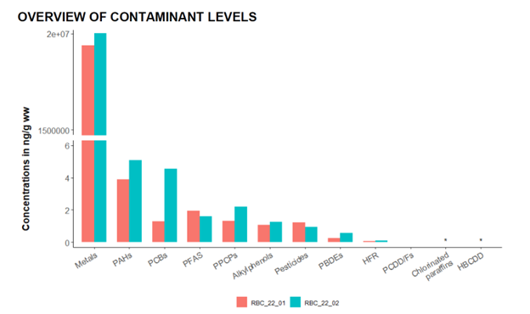

**Figure 1**

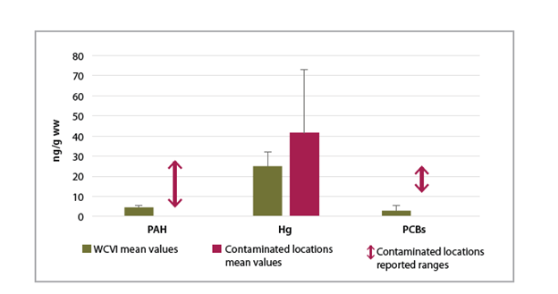

**Figure 2**

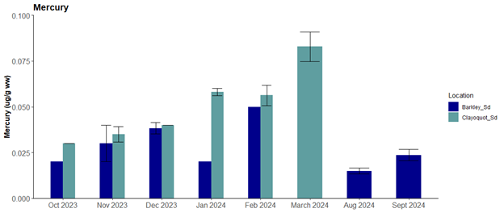

**Figure 3**

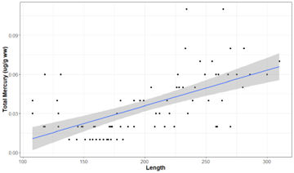

**Figure 4**

Figure 1: Total concentrations (ng/g wet weight (ww)) of each contaminant class analyzed in the two juvenile Robertson Creek Chinook salmon composite samples collected in 2022 ranked from highest to lowest. * indicates contaminants not detected

Figure 2. Concentrations in the top three contaminants in WCVI 2 composites relative to published studies of levels in juvenile Chinook salmon living in highly urbanized areas.

Figure 3. Temporal trends in mercury (ug/g ww) in WCVI juvenile salmon collected in Barkley Sound and Clayoquot sound in 2023 and 2024.

Figure 4. Significant positive relationship with juvenile Chinook salmon whole body mercury (ug/g ww) and length (p < 0.05, R – 0.36), for individuals collected from August to March (2023, 2024).

#### Insights

We have characterized, for the first time, contaminant concentrations in juvenile Chinook salmon from the West Coast of Vancouver Island. Our results indicate a low risk of contaminant associated health impacts for certain compounds and contaminant classes. However, concentrations in juvenile Chinook suggest that WCVI juvenile Chinook are exposed to moderate levels of contaminants, relative to other regions in B.C. and Washington State and, it is therefore important to evaluate contaminant associated risks in juvenile Chinook inhabiting these waters.

Management questions addressed by this project include those related to understanding and mitigating a significant stressor (i.e., contaminants) on at-risk salmon populations. Similarly, the recovery of *E**ndangered* Southern Resident killer whales and *T**hreatened* Northern Resident killer whales requires identifying and mitigating the significant threat posed by contaminants, and largely delivered via their priority prey, Chinook salmon.

#### Next Steps

Interpretation of the contaminant results for the 2023, 2024 samples.

Combine contaminant dataset with transcriptomic dataset to evaluate the impacts of contamination, both chemical and biological (biotoxins) on the health of juvenile Chinook salmon.

Interpretation with contaminated juvenile chinook from the Harrison stock collected from the Fraser River (Lo, 2026), that reflect exposure to sources in highly urbanized and industrialized habitats

Finding from our study may provide benchmarks for low contaminant levels and an associated no to low effects that other managed areas need to strive towards, in particular providing contextual comparisons to the Fraser River stocks.

### Project 2522: Explanation for the Collapse of the Commercial Chum Salmon Fishery in British Columbia

### Project 2534: Understanding the impact of Arctic outflow winds on British Columbia fjords.

**Location:** Mainland Inlets

### Project 2539: Climate Downscaling for salmon conservation in Marine Ecosystems

### Project 2540: Modelling to Support Annual Fraser River Sockeye and Pink Salmon Forecasts

### Project 2545: Genetics Stock Identification and Parentage Based Tagging of Pacific salmon

### Project 2546: Fishery & Assessment Data Section - Data Stewardship Unit

### Project 2547: Fishery & Assessment Data Section - Knowledge Mobilization Unit

### Project 2560: PSSI High Seas Salmon Research - West Coast Vancouver Island (and transition to ONE juvenile program)

### Project 2561: State of Pacific Salmon Report 2024-2025

### Project 2562: Climate Change Vulnerability Assessments

### Project 2563: Salmon Scanner and composite status data sets

### Project 2572: Assessing Salinity Alteration of Nursery Conditions for Salmon Smolts following Construction of Roberts Bank Terminal-2

### Project 3103: Drivers and functional consequences of hatchery epigenetic variation

### Project 3104: Establishing a feed assessment program in Pacific salmon enhancement hatcheries

### Project 3107: Scenario Planning: improving the adaptability of Pacific salmon hatchery planning and implementation to current and future climate changes

### Project 3119: Genomic consequences of stray hatchery introgression

### Project 3120: Genetic and epigenetic consequences of hatchery adaptation

### Project 3121: Impact of genetic divergence on outbreeding depression in Chinook Salmon

### Project 3124: A data pipeline to support more rapid calculation of Proportionate Natural Influence

### Project PSSI: Enhanced Monitoring of Chinook Salmon Mark Selective Fishery (MSF)

**Location:** Juan de Fuca Strait;#Salish Sea;#Mainland Inlets

# APPENDIX A. Project Summary Table

Table 1: **Summary of PSSI Research Projects**

| Project ID | Project # | Title | Leads | Location | Species |
| --- | --- | --- | --- | --- | --- |
| BCSRIF_2019_001 | BCSRIF_2019_001 | Elaho River Chinook Salmon Restoration | NA | Elaho River | NA |
| BCSRIF_2019_005 | BCSRIF_2019_005 | Creation of Salmon Conservation Facility | NA | Charters River, Sooke | NA |
| BCSRIF_2019_011 | BCSRIF_2019_011 | Development of North Island wet lab capacity to investigate wild/farm salmon interaction and stock restoration | NA | Campbell River | NA |
| BCSRIF_2019_014 | BCSRIF_2019_014 | Innovative Habitat Restoration Demonstration | NA | Thompson River System | NA |
| BCSRIF_2019_017 | BCSRIF_2019_017 | Historical review and Indigenous engagement to increase efficacy of, and Indigenous participation in the British Columbia Salmon Restoration and Innovation Fund (BCSRIF). | NA | BC Wide | NA |
| BCSRIF_2019_018 | BCSRIF_2019_018 | Rehabilitation of Critical Infrastructure to Improve Survival of Thompson Steelhead & Chinook | NA | Nicola River watershed, Merritt | NA |
| BCSRIF_2019_040 | BCSRIF_2019_040 | Determination of Bottlenecks Limiting Wild and Enhanced Juvenile Salmon and Steelhead Production in BC using PIT tags and Spatially Comprehensive Arrays | NA | Strait of Georgia | NA |
| BCSRIF_2019_040-136D | BCSRIF_2019_040-136D | Salish Sea Salmon Action Plan - Bottlenecks Limiting Juvenile Salmon Production | NA | Strait of Georgia | NA |
| BCSRIF_2019_041 | BCSRIF_2019_041 | Enhancing Estuary Resiliency: An Innovative Approach to Sustaining Fish and Fish Habitat in a Changing Climate | NA | Vancouver Island, Central Coast, Haida Gwaii | NA |
| BCSRIF_2019_045 | BCSRIF_2019_045 | Empowering Indigenous community fisheries with deep learning - computer vision for adaptive management of terminal salmon fisheries | NA | Bella Bella | NA |
| BCSRIF_2019_058 | BCSRIF_2019_058 | Enhancing Sustainability of capture & release marine recreational Pacific salmon fisheries using new tools/technology | NA | Pacific Ocean | NA |
| BCSRIF_2019_067 | BCSRIF_2019_067 | Elephant Hill Fire Riparian Restoration Project | NA | Elephant Hill Area (Ashcroft/Cache Creek) | NA |
| BCSRIF_2019_071 | BCSRIF_2019_071 | Plateau Fire Recovery – Riparian Plant Collection and Planting for Restoration of Chinook and Coho Salmon Habitat in the Nazko Area | NA | Nazko Area – West of Quesnel | NA |
| BCSRIF_2019_074 | BCSRIF_2019_074 | Place-based Risk of Climate Change to Sustainability of BC Wild and Hatchery-origin Salmon | NA | BC Wide | NA |
| BCSRIF_2019_080 | BCSRIF_2019_080 | Upper Fraser Chinook Strategic Enhancement Project | NA | Middle and Upper Fraser Watershed (Prince George) | NA |
| BCSRIF_2019_081 | BCSRIF_2019_081 | Inkaneep Creek Restoration | NA | Oliver | NA |
| BCSRIF_2019_083 | BCSRIF_2019_083 | Optimizing Recirculating Aquaculture Systems for Sustainable Salmon Production | NA | Vancouver | NA |
| BCSRIF_2019_092 | BCSRIF_2019_092 | Drivers of Inter-annual variability in Zooplankton Feeding in the Strait of Georgia: A combined model-observation approach | NA | Vancouver | NA |
| BCSRIF_2019_100 | BCSRIF_2019_100 | Seymour Watershed Restoration Project | NA | North Vancouver | NA |
| BCSRIF_2019_104 | BCSRIF_2019_104 | Upper Adams Salmon Restoration Program | NA | Upper Adams Watershed | NA |
| BCSRIF_2019_107 | BCSRIF_2019_107 | Broughton wild salmon restoration project | NA | Broughton | NA |
| BCSRIF_2019_108 | BCSRIF_2019_108 | Independent BC First Nations Genomics Lab Project - Phase 1 | NA | Broughton | NA |
| BCSRIF_2019_108B | BCSRIF_2019_108B | Phase 2: Independent First Nations' Genomic Lab for BC | NA | Broughton | NA |
| BCSRIF_2019_109 | BCSRIF_2019_109 | Implementation of the Broughton First Nations Indigenous Monitoring and Inspection Plan | NA | Broughton | NA |
| BCSRIF_2019_112 | BCSRIF_2019_112 | Percy Walkus Hatchery Upgrade | NA | Rivers Inlet (Central Coast) | NA |
| BCSRIF_2019_113 | BCSRIF_2019_113 | Field application and testing of tools for identifying, mapping and quantifying important forage fish populations and their habitats to support enhanced conservation of chinook salmon in coastal BC | NA | NA | NA |
| BCSRIF_2019_118 | BCSRIF_2019_118 | Chilliwack Coho PIT Tag Escapement Project | NA | Vedder Canal/Chilliwack River | NA |
| BCSRIF_2019_124 | BCSRIF_2019_124 | Resilient Waters Project: Phase 1 | NA | Fraser River | NA |
| BCSRIF_2019_125 | BCSRIF_2019_125 | Millstream Fishway Project | NA | Saanich | NA |
| BCSRIF_2019_129 | BCSRIF_2019_129 | Partnership for a novel framework for assessing and managing Pacific Herring fisheries on the West Coast of Vancouver Island | NA | NA | NA |
| BCSRIF_2019_130 | BCSRIF_2019_130 | Cowichan River Salmon Restoration program - Sustainable Water Supply - Engineering | NA | Cowichan Lake | NA |
| BCSRIF_2019_136 | BCSRIF_2019_136 | Science-based review of hatchery results in the DFO Pacific Region | NA | Straight of Georgia | NA |
| BCSRIF_2019_137 | BCSRIF_2019_137 | BC Fish Passage Joint Venture | NA | BC Wide | NA |
| BCSRIF_2019_148 | BCSRIF_2019_148 | Kitwanga River Sockeye Salmon Recovery Plan Implementation | NA | Skeena River | NA |
| BCSRIF_2019_172 | BCSRIF_2019_172 | Bear River Autonomous Salmon Enumeration | NA | Bear River, Skeena River Watershed | NA |
| BCSRIF_2019_181A | BCSRIF_2019_181A | Promotion of Habitat Restoration and Stewardship on Agricultural Lands in the BC | NA | BCI | NA |
| BCSRIF_2019_184A | BCSRIF_2019_184A | IYS: International Pan-Pacific Salmon Expedition (2021) | NA | Pacific Ocean | NA |
| BCSRIF_2019_190 | BCSRIF_2019_190 | BC Fishing App | NA | Pacific Ocean | NA |
| BCSRIF_2019_191 | BCSRIF_2019_191 | Vision 2021 | NA | Pacific Ocean | NA |
| BCSRIF_2019_192 | BCSRIF_2019_192 | Winter Salmon Survey in the Gulf of Alaska | NA | Gulf of Alaska | NA |
| BCSRIF_2020_208 | BCSRIF_2020_208 | Kingfisher Intake Restoration | NA | Enderby | NA |
| BCSRIF_2020_209 | BCSRIF_2020_209 | Chapman Creek Hatchery water supply and capacity upgrades | NA | Sechelt | NA |
| BCSRIF_2020_210 | BCSRIF_2020_210 | Seymour Hatchery Infrastructure Renewal | NA | North Vancouver | NA |
| BCSRIF_2020_212 | BCSRIF_2020_212 | Modernizing catch reporting in Canada's Pacific Region Salmon Fisheries | NA | Coastal BC, Victoria, BC | NA |
| BCSRIF_2020_216 | BCSRIF_2020_216 | Chemainus/Koksilah Twinned Watershed Sustainability Project | NA | Duncan | NA |
| BCSRIF_2020_217 | BCSRIF_2020_217 | Developing a cumulative effects modelling framework for the recovery of aquatic salmonid populations | NA | Vancouver | NA |
| BCSRIF_2020_218 | BCSRIF_2020_218 | UAV Habitat Mapping to Inform wild Salmon Stewardship | NA | Lower Fraser River, Skeena River, Okanagan | NA |
| BCSRIF_2020_219 | BCSRIF_2020_219 | Skeena Estuary Habitat Management and Protection Planning | NA | Areas within the Skeena River Estuary, North Coast of British Columbia | NA |
| BCSRIF_2020_224 | BCSRIF_2020_224 | Selective Fishing Using a Salmon Trap | NA | Tsawwassen | NA |
| BCSRIF_2020_225 | BCSRIF_2020_225 | Highway 16 corridor fish stranding | NA | Terrace | NA |
| BCSRIF_2020_226 | BCSRIF_2020_226 | Babine Lake Creel Survey | NA | Houston, BC | NA |
| BCSRIF_2020_232 | BCSRIF_2020_232 | Development and establishment of Vancouver Island Chinook Committee | NA | Fraser Canyon ( Soda Creek to Yale) BC | NA |
| BCSRIF_2020_233 | BCSRIF_2020_233 | Landslide impact on the flow dynamics, fish migration and genetics of Fraser River Salmon | NA | Fraser Canyon – Yale to Soda Creek | NA |
| BCSRIF_2020_238 | BCSRIF_2020_238 | Assessment of sampling methodologies, March 2022 Gulf of Alaska | NA | Gulf of Alaska | NA |
| BCSRIF_2020_239 | BCSRIF_2020_239 | Causes and consequences of vateritic otoliths in hatchery-reared Coho salmon | NA | Victoria | NA |
| BCSRIF_2020_241 | BCSRIF_2020_241 | Climate Action Priorities for Salmon | NA | NA | NA |
| BCSRIF_2020_242 | BCSRIF_2020_242 | Clayoquot Wild Chinook Salmon Initiative | NA | Central Coast Sub-region, BC | NA |
| BCSRIF_2020_247 | BCSRIF_2020_247 | First Nations-led Freshwater Salmon Habitat Assessment & Restoration Planning in the Central Coast | NA | Bella Coola | NA |
| BCSRIF_2020_251 | BCSRIF_2020_251 | Kleanza Creek Salmon Habitat Enhancement and Restoration Project | NA | Terrace | NA |
| BCSRIF_2020_259 | BCSRIF_2020_259 | Understanding FRIM in the BC Public Fishery | NA | Coast wide | NA |
| BCSRIF_2020_260 | BCSRIF_2020_260 | Modernizing Recreational Catch Monitoring, Data Collection and Communication | NA | Coast wide | NA |
| BCSRIF_2020_261 | BCSRIF_2020_261 | Recreational Release Mortality Studies and Fishing Related Incidental Mortality (FRIM) | NA | Fraser | NA |
| BCSRIF_2020_262 | BCSRIF_2020_262 | Fraser Salmon Management Program | NA | Fraser River Estuary | NA |
| BCSRIF_2020_268 | BCSRIF_2020_268 | Fraser River Estuary Salmon Habitat (FRESH) Restoration Projects | NA | Harrison River and adjacent Lower Fraser River | NA |
| BCSRIF_2020_269 | BCSRIF_2020_269 | Conservation Fishing - A First Nations Demonstration Selective Fishing in the Lower Fraser River | NA | Coast wide | NA |
| BCSRIF_2020_270 | BCSRIF_2020_270 | SFAB Vision - Phased Implementation | NA | Salmon River, Columbia-Shuswap Regional District | NA |
| BCSRIF_2020_273 | BCSRIF_2020_273 | Salmon River Collaborative Salmonid Habitat Enhancement and Restoration Initiative | NA | Lower Fraser Valley | NA |
| BCSRIF_2020_276 | BCSRIF_2020_276 | MakeWay - Resilient Waters Lower Fraser Valley Rehabilitation | NA | NA | NA |
| BCSRIF_2020_278 | BCSRIF_2020_278 | Wuikinuxv Assessment and Restoration of Rivers Inlet Salmon | NA | Rivers Inlet | NA |
| BCSRIF_2020_279 | BCSRIF_2020_279 | Supporting the Ongoing Use and Development of the Pacific Salmon Explorer | NA | Fraser River | NA |
| BCSRIF_2020_282 | BCSRIF_2020_282 | Selective Fishing Gear Pilot in the Fraser River | NA | Pacific Coast | NA |
| BCSRIF_2020_284 | BCSRIF_2020_284 | Technology for more sustainable fisheries in BC | NA | Central Coast Sub-region, BC | NA |
| BCSRIF_2020_292 | BCSRIF_2020_292 | First Nations-led catch monitoring to inform sustainable mixed-stock fisheries management on the Central Coast | NA | Bella Coola | NA |
| BCSRIF_2020_294 | BCSRIF_2020_294 | Collaborative Freshwater Research and Restoration Initiative in the Thompson Watershed | NA | Thompson River Watershed - Deadman River | NA |
| BCSRIF_2020_298 | BCSRIF_2020_298 | Nanaimo Hatchery Upgrades to Improve Hatchery Performance and Assessment and Monitoring Capabilities | NA | Nanaimo | NA |
| BCSRIF_2020_300 | BCSRIF_2020_300 | Coastal First Nations Salmon Enhancement and Restoration Initiative | NA | Great Bear Rainforest (Haida Gwaii, North and Central Coast) | NA |
| BCSRIF_2020_301 | BCSRIF_2020_301 | Watershed Restoration Prioritization Tool/Solutions for Gold River Steelhead | NA | Gold River area, Nootka Sound, West Coast Vancouver Island | NA |
| BCSRIF_2020_304 | BCSRIF_2020_304 | Kitwanga River Sockeye Salmon Enhancement Project | NA | Terrace | NA |
| BCSRIF_2020_311 | BCSRIF_2020_311 | The application of nanopore technology for the rapid detection and characterization of pathogenic organisms in enhancement hatcheries | NA | Campbell River | NA |
| BCSRIF_2020_313 | BCSRIF_2020_313 | Monitoring lipid content of Fraser-bound Chinook at Albion | NA | Vancouver | NA |
| BCSRIF_2020_314 | BCSRIF_2020_314 | Deadman River Hatchery Upgrades | NA | Savona | NA |
| BCSRIF_2020_316 | BCSRIF_2020_316 | Rebuilding Wet'suwet'en Sockeye Salmon Abundance and Diversity | NA | Smithers | NA |
| BCSRIF_2020_318 | BCSRIF_2020_318 | Kus Kus Sum – Restoration of key habitat to re-establish ecosystem services that will support BC fisheries. | NA | Courtenay | NA |
| BCSRIF_2022_319 | BCSRIF_2022_319 | Fishing BC App: Tidal Waters Licence Integration and Recreational Catch Monitoring and Data Collection Enhancements Project | NA | Coastwide | NA |
| BCSRIF_2022_321 | BCSRIF_2022_321 | Squamish Estuary Chinook Salmon Habitat Restoration Project | NA | Squamish | NA |
| BCSRIF_2022_322 | BCSRIF_2022_322 | San Juan and Gordon Rivers – Salmon Estuarine Habitat Restoration | NA | Port Renfrew | NA |
| BCSRIF_2022_326 | BCSRIF_2022_326 | Aeromonas salmonicida Genome Sequencing and qPCR Test Development | NA | Surrey | NA |
| BCSRIF_2022_328 | BCSRIF_2022_328 | Salmon Recovery – advancing planning and action | NA | All of BC - particular on the Fraser | NA |
| BCSRIF_2022_329 | BCSRIF_2022_329 | Meziadin River Up-looking Hydroacoustic Sockeye Smolt Enumeration Project | NA | Stewart | NA |
| BCSRIF_2022_331 | BCSRIF_2022_331 | Bute Inlet Salmon Viability Strategy | NA | Bute Inlet Homalco Band Office is located in Campbell River BC | NA |
| BCSRIF_2022_332 | BCSRIF_2022_332 | Research in support of Sarita Chinook as an Ecological Indicator and WCVI Chinook Salmon Rebuilding | NA | Sarita River watershed near Bamfield and Anacla, Barkley Sound, Westcoast Vancouver Island | NA |
| BCSRIF_2022_334 | BCSRIF_2022_334 | First Nations led salmon habitat and population monitoring, research and cumulative effects assessment in the Lower Fraser River and Boundary Bay | NA | Surrey, White Rock, Langley and surrounding areas | NA |
| BCSRIF_2022_337 | BCSRIF_2022_337 | Chinook Salmon Assessments and WCVI Chinook Salmon Rebuilding in the Kaouk and Artlish Watersheds | NA | Kaouk River and Artlish River watersheds located in Kyuquot Sound, Westcoast Vancouver Island | NA |
| BCSRIF_2022_339 | BCSRIF_2022_339 | NEWSS-Salmon Habitat Recovery Projects | NA | Nechako Valley (Vanderhoof) | NA |
| BCSRIF_2022_341 | BCSRIF_2022_341 | ʔaayaaqa (Herring) Herring Spawn Dynamics | NA | NA | NA |
| BCSRIF_2022_345 | BCSRIF_2022_345 | Digital Imaging of Wild Coho Returns to the Lillooet River Conservation Unit | NA | Pemberton | NA |
| BCSRIF_2022_346 | BCSRIF_2022_346 | Genetic monitoring of Kokanee-sockeye salmon (Oncorhynchus nerka) hybrid fitness and long term outcomes associated with an experimental re-introduction program | NA | Skaha Lake, BC | NA |
| BCSRIF_2022_347 | BCSRIF_2022_347 | Selective Fishing Using a Salmon Trap in the Campbell River Estuary | NA | Campbell River, Vancouver Island | NA |
| BCSRIF_2022_348 | BCSRIF_2022_348 | Chemainus-Koksilah Twinned Watershed Salmon Sustainability Project- Phase 2 | NA | Chemainus/Crofton and Duncan, BC | NA |
| BCSRIF_2022_349 | BCSRIF_2022_349 | Clayoquot Pacific Salmon Recovery Initiative | NA | Clayoquot Sound | NA |
| BCSRIF_2022_351 | BCSRIF_2022_351 | Estimating aggregate Coho salmon escapement to the Lower Fraser Management Unit | NA | Chilliwack (PIT Assessment site and Hatchery) and New Westminster (Coho Assessment Fishery) | NA |
| BCSRIF_2022_356 | BCSRIF_2022_356 | Campbell River Estuary Salt Marsh and Eelgrass Restoration | NA | Campbell River, BC | NA |
| BCSRIF_2022_357 | BCSRIF_2022_357 | TFN Fish Trap – Capacity Building, Communications and Operations 2023-26 | NA | Steveston, BC | NA |
| BCSRIF_2022_358 | BCSRIF_2022_358 | Determining the mechanisms of impacts of a changing climate on zooplankton in the Salish Sea using models and observations | NA | Vancouver | NA |
| BCSRIF_2022_360 | BCSRIF_2022_360 | Basin-scale Events to Coastal Impacts (BECI) | NA | Sidney | NA |
| BCSRIF_2022_361 | BCSRIF_2022_361 | Identifying and mitigating hot spots of salmon exposure to toxic road runoff | NA | Vancouver | NA |
| BCSRIF_2022_362 | BCSRIF_2022_362 | Watershed Futures Initiative: Towards climate resilience of salmon watersheds | NA | British Columbia | NA |
| BCSRIF_2022_366 | BCSRIF_2022_366 | Restoration of salmon habitat at Cultus Lake, BC: a Green Shores® demonstration project | NA | Cultus Lake | NA |
| BCSRIF_2022_368 | BCSRIF_2022_368 | Thompson-Shuswap Salmon Habitat Assessment, Monitoring & Restoration Program (2023-26) | NA | Thompson-Shuswap sub-region | NA |
| BCSRIF_2022_370 | BCSRIF_2022_370 | 10,000 Wetlands Project | NA | BC Wide and Coastal Waters | NA |
| BCSRIF_2022_371 | BCSRIF_2022_371 | Skeena River Fish Trap Project | NA | Prince Rupert | NA |
| BCSRIF_2022_373 | BCSRIF_2022_373 | Resilient Waters Phase 3: Restoration and Research for Salmon and Flood Resilience in the Lower Fraser Watershed | NA | Vancouver | NA |
| BCSRIF_2022_374 | BCSRIF_2022_374 | Scaling the Implementation of Riparian Restoration | NA | Vancouver Island, Greater Vancouver, Fraser Valley, Okanagan, Interior, Cariboo, Kootenays | NA |
| BCSRIF_2022_377 | BCSRIF_2022_377 | Lower Adams Habitat Restoration Initiative (LAHRI) | NA | Squilax, BC; Tsutswecw Provincial Park | NA |
| BCSRIF_2022_379 | BCSRIF_2022_379 | Strait of Georgia Herring: Restoring the Salmon Food Web | NA | NA | NA |
| BCSRIF_2022_383 | BCSRIF_2022_383 | Restoring Fraser River Estuary Salmon Habitat (ReFRESH) | NA | Lower Fraser River and Estuary, Richmond, BC | NA |
| BCSRIF_2022_384 | BCSRIF_2022_384 | Development of High-resolution Climate Change Freshwater Hazard Data for BC | NA | Coastal British Columbia and Fraser basin | NA |
| BCSRIF_2022_385 | BCSRIF_2022_385 | Tsecmenúl̓ecwem-kt (We Repair the Land) - Deadman Recovery & Resiliency Initiative | NA | Deadman Watershed (Savona, BC) | NA |
| BCSRIF_2022_387 | BCSRIF_2022_387 | Charting a Path for Coastal First Nations’ Community Salmon Enhancement Initiatives | NA | North Coast, Central Coast, Haida Gwaii | NA |
| BCSRIF_2022_389 | BCSRIF_2022_389 | Mitigating Inputs of Tire Wear Toxins to Protect Salmonid Habitat on Vancouver Island | NA | Vancouver Island | NA |
| BCSRIF_2022_397 | BCSRIF_2022_397 | Mapping, monitoring and restoring important forage fish habitats in Coastal British Columbia to support salmon conservation efforts. | NA | Vancouver Island, Sunshine Coast, Howe Sound and the Lower Mainland. | NA |
| BCSRIF_2022_399 | BCSRIF_2022_399 | Evaluating climate change scenarios for the Quesnel Watershed to determine flood, fire and temperature risks posed to Upper Fraser salmon stocks. | NA | Quesnel | NA |
| BCSRIF_2022_401 | BCSRIF_2022_401 | Supporting and connecting community-based monitoring for climate-resilient salmon ecosystems | NA | Spans across BC | NA |
| BCSRIF_2022_404 | BCSRIF_2022_404 | Oolichan From Estuary to Offshore: Assessment of Early Marine Populations and Limiting Factors of Central Coast Oolichan (Eulachon: Thaleichthys pacificus) in Douglas Channel and Gardner Canal | NA | NA | NA |
| BCSRIF_2022_407 | BCSRIF_2022_407 | Watershed Restoration Prioritization Tool/Solutions for Gold River Steelhead | NA | Nootka Sound, West Coast Vancouver Island; Gold River watershed | NA |
| BCSRIF_2022_410 | BCSRIF_2022_410 | Portage Creek Chinook Salmon Recovery Program | NA | Seton Portage | NA |
| BCSRIF_2022_412 | BCSRIF_2022_412 | Post Flood Support for Fish and Fish Habitat Recovery in the Nicola Watershed | NA | Merritt | NA |
| BCSRIF_2022_414 | BCSRIF_2022_414 | Columbia River Salmon Reintroduction Initiative (CRSRI): Bringing the Salmon Home | NA | Upper Columbia River basin | NA |
| BCSRIF_2022_415 | BCSRIF_2022_415 | Restoring freshwater connectivity for Pacific salmon | NA | Upper Fraser, Lower Nicola Watershed, Lower Fraser, Skeena and Central Coast | NA |
| BCSRIF_2022_425 | BCSRIF_2022_425 | Empirically resolving interspecific competition experienced by North Pacific salmon in the open ocean | NA | Vancouver | NA |
| BCSRIF_2022_426 | BCSRIF_2022_426 | Investigation of water acidification and habitat on imprinting and homing in Pacific salmon | NA | Vancouver | NA |
| BCSRIF_2022_427 | BCSRIF_2022_427 | Fish Passage Restoration in Gitksan Territory | NA | Terrace | NA |
| BCSRIF_2022_430 | BCSRIF_2022_430 | Resilient Estuaries in the Salish Sea: Phase Two (Baseline Assessments and Ground-truthing) | NA | Strait of Georgia | NA |
| BCSRIF_2022_433 | BCSRIF_2022_433 | Towards food security: restoring salmon and their habitat | NA | Houston and Smithers are closest towns. | NA |
| BCSRIF_2022_435 | BCSRIF_2022_435 | Colquitz River Salmonid Restoration and Monitoring Project | NA | Victoria | NA |
| BCSRIF_2022_436 | BCSRIF_2022_436 | Establishing baselines, risks, and mechanisms of thiamine deficiency in British Columbia Chinook salmon | NA | S Strait of Georgia,east of Vancouver Island,Fraser River,Howe Sound,Juan de Fuca Strait | NA |
| BCSRIF_2022_438 | BCSRIF_2022_438 | Highway 16 and CN Corridor Stranding Remediation/Willow Creek Arch Culvert/Mid-Scully Creek Spawning Gravel Addition. | NA | Highway16betweenTerracePrince RupertWillow CreekCrossingofJohnstone RoadNorth TerraceLakelse Lake | NA |
| BCSRIF_2022_439 | BCSRIF_2022_439 | Nanwakolas 50 Watersheds Project | NA | Campbell River | NA |
| BCSRIF_2022_442 | BCSRIF_2022_442 | Identifying factors that influence early marine survival of WCVI Chinook salmon | NA | West Coast Vancouver Island | NA |
| BCSRIF_2022_442 | BCSRIF_2022_442 | Identifying factors that influence early marine survival of WCVI Chinook salmon | NA | West Coast Vancouver Island | NA |
| BCSRIF_2022_444 | BCSRIF_2022_444 | Enhancing Estuary Resilience: A Collaborative Approach to the Monitoring and Restoration of Estuaries with Coastal First Nations | NA | BC Wide and Coastal Waters | NA |
| BCSRIF_2022_447 | BCSRIF_2022_447 | Xá:y Syí:ts’emílep: Gill Bar Restoration and Management Plan | NA | Chilliwack | NA |
| BCSRIF_2022_448 | BCSRIF_2022_448 | Chilako River and Tributary Stream Corridor Restoration Demonstration | NA | Prince George | NA |
| BCSRIF_2022_449 | BCSRIF_2022_449 | Analysis of forestry effects on Pacific salmon in Musgamagw Dzawada’enuxw territory and across coastal BC. | NA | Broughton Archipelago. | NA |
| BCSRIF_2022_450 | BCSRIF_2022_450 | Gwa’sala ‘Nakwaxda-xw Fully-Integrated Salmon Habitat Restoration Project (GNN-FISHR) | NA | Smith Inlet/Seymour Inlet | NA |
| BCSRIF_2022_451 | BCSRIF_2022_451 | Boundary Bay Chinook salmon restoration in the TA’TALU watershed | NA | Surrey | NA |
| BCSRIF_2022_453 | BCSRIF_2022_453 | Establishing a Test Fishery for Chinook Salmon in key areas of the BC Coast | NA | BC Wide and Coastal Waters | NA |
| BCSRIF_2022_454 | BCSRIF_2022_454 | FRIM – Short term mortality holding and respirometry studies | NA | Bamfield | NA |
| BCSRIF_2022_456 | BCSRIF_2022_456 | Informed Approaches to Determine Bottlenecks to Survival for Chinook and Coho Salmon and Steelhead | NA | Vancouver Island | NA |
| 2400 | 2400 | Assessment of SEP Chinook and Coho broodstock ELISA screening data by modelling for explanatory variables, and yearling DFAT prevalence data by modelling for predictive variables. | Amy Long | Spius Creek;#Puntledge River;#Nitinat | Chinook salmon (Fall, Spring, and Summer) Coho salmon (Fall) |
| 1261 | 1261 | Salmon Marine Interactions - SMI - COE Section | NA | NA | NA |
| 2394 | 2394 | Enhanced salmon bycatch monitoring and sampling in the Pacific region groundfish trawl fishery | Cory Lagasse, Kathryn Fraser | NA | All Oncorhynchus |
| 2397 | 2397 | Identifying good practices for considering Indigenous Knowledge in Rebuilding Plan targets and stock assessment reference poi | NA | NA | NA |
| 2398 | 2398 | WCVI Sediment Transport and Redd Scour Assessment | NA | Tranquil Creek | NA |
| 2399 | 2399 | Risk Assessment Method for Salmon – Development for Regional Implementation | NA | NA | NA |
| 2401 | 2401 | Epidemiological modeling of infectious hematopoietic necrosis virus in Sockeye salmon | Kyle Garver | Okanagan;#Nadina Hatchery;#Fulton Hatchery;#Pinkut Hatchery;#Weaver Creek Spawning Channels | Sockeye salmon |
| 2402 | 2402 | Quantifying Yukon Chinook migration mortality and its implications for fisheries management and rebuilding under the Fish Stock Provisions of the Fisheries Act | NA | Yukon River | NA |
| 2403 | 2403 | San Juan River Adult and Juvenile Assessment Program | NA | San Juan River;#Port San Juan;#4 Mile Creek | NA |
| 2404 | 2404 | Improving baseline knowledge of environmental conditions in Vancouver Islands fjords through observations and modelling, with a focus on hypoxia dynamics, climate change, and the potential implications for Pacific salmon | Laura Bianucci | Clayoquot Sound | Waterbodies (if applicable) |
| 2405 | 2405 | Biological models to support prioritizing salmon stocks under future climates | Jan Finke Travis Tai Brendan Connors Cameron Freshwater Patrick Thompson | Pacific Biological Station;#PSEC West Vancouver;#IOS Sidney | Sockeye Salmon |
| 2406 | 2406 | Changing coastal productivity: Using sediment cores, water properties and archived plankton data to identify changes at the bottom of the food web in BC’s coastal waters | Sophia Johannessen | NA | Waterbodies (if applicable) |
| 2407 | 2407 | Follow the Fish: An integrated Chinook salmon assessment and monitoring program for the West Coast of Vancouver Island | Jessy Bokvist | Stamp River;#Sarita River;#Nitinat;#Barkley Sound | Chinook Salmon |
| 2408 | 2408 | Improvement, Expansion and Modernization of Salmonid Health Diagnostic Services For Optimizing Salmonid Hatchery Health Management. | Amy Long | Pacific Biological Station;#Fulton Hatchery;#Nadina Spawning Channels;#Chehalis River Hatchery;#Quinsam River;#Inch Creek Hatchery;#Nanaimo River Hatchery;#Big Qualicum River Hatchery | See Supplemental Table 1 |
| 2409 | 2409 | Convergent tracks: a tagging study to quantify salmon predation by sea lions | Cameron Freshwater and Strahan Tucker | Triangle Island;#Haida Gwaii | Sockeye salmon |
| 2410 | 2410 | Improved decision making for salmon by understanding the threats of freshwater Aquatic Invasive Species both now and in the future | Thomas Therriault | NA | All |
| 2412 | 2412 | Investigation of the impacts of singular and coinciding acute climate stressors on the nutritional quality of the pteropod Limacina helicina, a juvenile Pacific salmon dietary species | Chris Pearce, Clara Mackenzie, Ian Forster (DFO, Nearshore Ecosystems Section) | PBS Nanaimo;#PSEC West Vancouver | N/A. |
| 2413 | 2413 | Barkley Sound and Clayoquot Sound Krill Monitoring | NA | Barkley Sound;#Clayoquot Sound | NA |
| 2414 | 2414 | South Coast freshwater ecological indicator pilot | NA | NA | NA |
| 2415 | 2415 | A Decision Support Framework for Identifying and Characterizing the Non-fishing Threats to Pacific Salmon | NA | NA | NA |
| 2416 | 2416 | Monitoring and predicting the exposure of Pacific salmon to harmful algal biotoxins | Andrew Ross | Barkley Sound | Chinook |
| 2417 | 2417 | Optimization of feeds used in the hatchery production of Pacific Salmon. | Dr. Erika Eliason; Dr. Ian Forster; Greig Oldford | NA | Chinook salmon (*Oncorhynchus tshawytscha*) |
| 2418 | 2418 | Prediction of reproductive success of Chinook salmon based on Thiamine concentrations in returning adults. | Dr. Erika Eliason; Dr. Ian Forster; Greig Oldford | Albion Test Fishery | Chinook salmon; coho salmon, sockeye salmon, pink salmon |
| 2419 | 2419 | Pilot skills study of new hatchery tray configuration. | NA | NA | NA |
| 2421 | 2421 | Measurement of stress hormones in scales and its application for the identification of conditions causing chronic stress in Pacific Salmon. | Stewart Johnson | PBS Nanaimo | Chinook |
| 2422 | 2422 | Development and application of laser ablation-inductively coupled plasma-mass spectrometry (LA-ICP-MS) to determine saltwater entry size of juvenile salmonids and track habitat usage. | Xiangjun Liao Nicole LaForge Micah Quindazzi Andrew Ross | IOS Sidney | Chinook Salmon *Oncorhynchus tshawytscha* |
| 2423 | 2423 | Complementing British Columbia’s coasts longest Sea Surface Temperature and Salinity records with 21st century technology to monitor a changing climate. | NA | NA | NA |
| 2424 | 2424 | Mechanistic modelling to link hydrology to juvenile salmon habitat quality and productivity | Sean Naman | Thompson | Coho |
| 2425 | 2425 | Development of geospatial tools for large-scale freshwater salmon habitat assessment by the Freshwater Spatial Ecology Program | Josephine Iacarella, Keegan Paterson, Daniel Weller | NA | Coho, Chinook, Sockeye, Pink, Chum |
| 2426 | 2426 | Sakinaw Sockeye Juvenile Research on Measures to Increase Marine Survival | Kevin Pellett Karalea Filipovic Nicolette Watson | Hodgson Islands;#Sakinaw Lake;#Salish Sea;#Strait of Georgia | Sockeye |
| 2427 | 2427 | Salish Sea plankton and oceanography | NA | Strait of Georgia;#Salish Sea | NA |
| 2430 | 2430 | Feasibility of Estimating Chilko River Smolt Abundance Using Upward- and Side-Looking SONAR Methods | Daniel Doutaz | Chilko | Sockeye Salmon |
| 2432 | 2432 | Barkley Sound and Clayoquot Sound acoustic monitoring of salmon and salmon prey | Stéphane Gauthier | Barkley Sound;#Clayoquot Sound | Waterbodies (if applicable) |
| 2433 | 2433 | Integrated Salish Sea acoustic monitoring of salmon and salmon prey | Stéphane Gauthier | Salish Sea | Waterbodies (if applicable) |
| 2434 | 2434 | SHERLOCK assay for rapid genotyping applications | NA | Puntledge River | NA |
| 2435 | 2435 | Intergenerational transfer and parental origins of DNA methylation variation in Coho and Chinook Salmon | NA | PBS Nanaimo | NA |
| 2436 | 2436 | Chum whole genome sequencing for improved stock delineation | Tigano, Anna; Rondeau, Eric; Healy, Timothy; Wellband, Kyle. | Fraser;#Chilliwack River | Chum |
| 2437 | 2437 | Adaptive genetic variation and climate change resilience in Canadian Pacific salmon | NA | PBS Nanaimo | NA |
| 2439 | 2439 | Fournier Transfer Near Infrared (FT-NIR) Spectroscopy; its application for rapid fish age estimation within the Sclerochronology Lab at the Pacific Biological Station | Stephen Wischniowski | Pacific Biological Station | Chum and Chinook |
| 2440 | 2440 | Mat-37 Improvements to the evaluation of abundance and stock composition for Fraser River Juvenile Salmon | NA | NA | NA |
| 2442 | 2442 | Graduate Research into 1) habitat use by juvenile Chinook Salmon in the Canadian Okanagan River and Lake system and 2) predation on juvenile salmon in the Canadian Okanagan River and Lake system | Lauren Weir (DFO) Tommy Pontbriand (DFO) | NA | Chinook |
| 2443 | 2443 | Quantitative assessment of the impact of Smallmouth Bass suppression efforts in Cultus Lake and SMB emigration from Cultus Lake | Dan Doutaz | Cultus | Sockeye Salmon |
| 2444 | 2444 | Assessment of the distribution and abundance of juvenile Chinook salmon in the lower Thompson River basin. | NA | Thompson;#Nicola River | NA |
| 2447 | 2447 | Innovative Ecosystem Based Approaches to identify cumulative stressors: Salmon Fit-Chips and eDNA | NA | Barkley Sound;#Clayoquot Sound | NA |
| 2448 | 2448 | Developing a proactive, modernized, holistic approach to ensure optimal health and condition of Hatchery Production | Christoph Deeg (Kristi Miller-Saunders, retired), Karia Kaukinen, Arthur Bass | Robertson Creek;#Nitinat | Chinook |
| 2449 | 2449 | A decision-support tool that considers harvest, hatchery, and habitat management levers to support implementation of the Fisheries Act for Pacific salmon | Carrie Holt, Catarina Wor and Brendan Connors | NA | Applicable to all species; case study on Chinook salmon |
| 2451 | 2451 | Relative reproductive success of hatchery- versus natural-origin salmon in Canadian integrated populations | NA | Sarita River | NA |
| 2452 | 2452 | Genetic associations with age of return in male Canadian Chinook Salmon | NA | Chilliwack River;#Puntledge River;#Qualicum River | NA |
| 2453 | 2453 | Epigenetic variation between hatchery- and natural-origin Canadian Chinook Salmon | NA | Sarita River;#Chilliwack River;#Nicola River;#Quinsam River;#Atnarko River;#Thompson | NA |
| 2454 | 2454 | Kim Hyatt’s Legacy Data: Juvenile Sockeye Biosample Data and Summary Metrics for B.C. Study Lakes, 1977-present | NA | NA | NA |
| 2455 | 2455 | YTRA TBR Weather Stations | NA | NA | NA |
| 2493 | 2493 | Improved understanding of cumulative impacts on salmon survival across freshwater life-stages; tools and approaches for mechanistic assessments | NA | Thompson | NA |
| 2494 | 2494 | Modeling interactions of environmental, biological and infectious factors with respect to production of Pacific salmon (Oncorhynchus spp.) at the Quinsam River hatchery | NA | NA | NA |
| 2504 | 2504 | Identifying and characterizing tire-related chemical (6PPD-quinone) toxic hotspots in salmon habitat | NA | Greater Vancouver;#Squamish | NA |
| 2513 | 2513 | Characterizing and monitoring priority contaminants of concern in WCVI juvenile salmon | Lisa Loseto (prev. T. Brown) | NA | Chinook |
| 2522 | 2522 | Explanation for the Collapse of the Commercial Chum Salmon Fishery in British Columbia | NA | NA | NA |
| 2534 | 2534 | Understanding the impact of Arctic outflow winds on British Columbia fjords. | NA | Mainland Inlets | NA |
| 2539 | 2539 | Climate Downscaling for salmon conservation in Marine Ecosystems | NA | NA | NA |
| 2540 | 2540 | Modelling to Support Annual Fraser River Sockeye and Pink Salmon Forecasts | NA | NA | NA |
| 2545 | 2545 | Genetics Stock Identification and Parentage Based Tagging of Pacific salmon | NA | NA | NA |
| 2546 | 2546 | Fishery & Assessment Data Section - Data Stewardship Unit | NA | NA | NA |
| 2547 | 2547 | Fishery & Assessment Data Section - Knowledge Mobilization Unit | NA | NA | NA |
| 2560 | 2560 | PSSI High Seas Salmon Research - West Coast Vancouver Island (and transition to ONE juvenile program) | NA | NA | NA |
| 2561 | 2561 | State of Pacific Salmon Report 2024-2025 | NA | NA | NA |
| 2562 | 2562 | Climate Change Vulnerability Assessments | NA | NA | NA |
| 2563 | 2563 | Salmon Scanner and composite status data sets | NA | NA | NA |
| 2572 | 2572 | Assessing Salinity Alteration of Nursery Conditions for Salmon Smolts following Construction of Roberts Bank Terminal-2 | NA | NA | NA |
| 3103 | 3103 | Drivers and functional consequences of hatchery epigenetic variation | NA | NA | NA |
| 3104 | 3104 | Establishing a feed assessment program in Pacific salmon enhancement hatcheries | NA | NA | NA |
| 3107 | 3107 | Scenario Planning: improving the adaptability of Pacific salmon hatchery planning and implementation to current and future climate changes | NA | NA | NA |
| 3119 | 3119 | Genomic consequences of stray hatchery introgression | NA | NA | NA |
| 3120 | 3120 | Genetic and epigenetic consequences of hatchery adaptation | NA | NA | NA |
| 3121 | 3121 | Impact of genetic divergence on outbreeding depression in Chinook Salmon | NA | NA | NA |
| 3124 | 3124 | A data pipeline to support more rapid calculation of Proportionate Natural Influence | NA | NA | NA |
| PSSI | PSSI | Enhanced Monitoring of Chinook Salmon Mark Selective Fishery (MSF) | NA | Juan de Fuca Strait;#Salish Sea;#Mainland Inlets | NA |

# APPENDIX B. Overview of Phase 2 BCSRIF Projects

Table 1: **BCSRIF Projects**

| Project | Collaborators | Description |
| --- | --- | --- |
| BCSRIF_2019_040 Determination of Bottlenecks Limiting Wild and Enhanced Juvenile Salmon and Steelhead Production in BC using PIT tags and Spatially Comprehensive Arrays Recipient: Pacific Salmon Foundation | BC Conservation Foundation, UVIC, Freshwater Fisheries Society of BC, K'ómoks First Nation, A-Tlegay Fisheries Society, Cowichan Tribes, Snʊˈneɪməxʷ First Nation, shíshálh Nation, Nanoose First Nation, Nanaimo River Stewardship Society, UNBC, SFU, UBC, Redd Fish Restoration, Toquaht Nation, Nature Trust BC, Peninsula Streams Society, VIU, and several enhancement societies | Together with partners the Pacific Salmon Foundation will develop the monitoring and evaluation framework to determine survival bottlenecks in freshwater and marine environments for hatchery and wild chinook coho and steelhead. Research monitoring and evaluation activities will seek to maximize the performance of hatchery and wild stocks; and the installation of new infrastructure will support adaptive management of hatchery programs to meet harvest conservation and sustainability objectives. |
| BCSRIF_2022_319 Fishing BC App: Tidal Waters Licence Integration and Recreational Catch Monitoring and Data Collection Enhancements Project Recipient: Sport Fishing Institute of BC | DFO Rec Fisheries, Fisheries Management, IMIT, CDOS, & others Simon Fraser University University of British Columbia - Dept Forest and Conservation Sciences | The Sport Fishing Institute will build on ongoing work to improve the Fishing BC app. Recent improvements funded through BCSRIF included addition of recreational fisheries regulations, catch and possession limits, safety notes, and species identification, and the next phase will enhance the information display and access, as well as tools for improved catch and compliance monitoring, including the option for recreational anglers to submit catch data directly into the DFO National Recreational License System (NRLS). |
| BCSRIF_2022_321 Squamish Estuary Chinook Salmon Habitat Restoration Project Recipient: Squamish River Watershed Society | DFO Squamish Nation | In partnership with DFO and Squamish Nation, SRWS has developed and will implement a restoration plan to restore connectivity and access for juvenile out-migrating Chinook between the Squamish River and the central nutrient rich estuary. The project includes the modification of a training berm/spit to allow for an 850m opening. The training berm/spit has been a barrier for the past 50 years preventing fish access and freshwater exchange from the river to the estuary. In January 2022, a 300m opening was created and this project will add an additional 550m to the opening. Outcomes include improvements to; water quality, flood mitigation, and coastal resilience as well as improvements to sediment deposition in the estuary, marsh accretion, increase in carbon storage and sequestration and support to species at risk within the area. |
| BCSRIF_2022_322 San Juan and Gordon Rivers – Salmon Estuarine Habitat Restoration Recipient: Pacheedaht First Nation | DFO SEP, Resource Restoration Unit DFO Stock Assessment BC Environmental and Climate Monitoring – Hydrology and Hydrometrics BC MFLNRORD Ministry of Transport and Infrastructure | Pacheedaht First Nation is intending to implement 3 restoration projects in the San Juan and Gordon River estuaries with support from the San Juan Roundtable and its technical sub-committee which includes DFO. Habitat issues in these watersheds are linked to excess sediment delivery resulting from forest harvesting activities and associated road-building. This has resulted in the infilling of holding pools and estuarine tidal channels and in some cases cutting off upstream connections to freshwater. This issue was particularly devasting in the fall of 2022 when stage 5 drought occurred during the month of October indicating an urgent need to restore this habitat. The project aims to address the issues of channel connectivity, availability of low salt marsh habitats and loss of holding pools by: improving salmon access to existing spawning and nursery habitats, rehabilitating damaged estuarine nursery habitats and restoring cool water holding pools for migrating salmon. |
| BCSRIF_2022_326 Aeromonas salmonicida Genome Sequencing and qPCR Test Development Recipient: Kwantlen Polytechnic University, Applied Genomics Centre | BC Ministry of Agriculture Animal Health Centre | KPU Applied Genomics Center will work with Abbotsford Animal Health Center to perform whole genome sequencing for several Aeromonas species, including Aeromonas salmonicida (A. salmonicida) which is a pathogenic bacterium that severely impacts salmonid populations, and other fish species. A. salmonicida is a non-motile, gram-negative bacterial pathogen that causes disease and mortality in wild and cultured fish from freshwater, brackish, and salt water. This pathogen is transmitted by direct contact and all life stages are susceptible. In order to effectively monitor A. salmonicida and support fish health, it is crucial to be able to accurately identify A. Salmonicida. However, current methods cannot distinguish between A. salmonicida and other closely related species and there is currently no molecular test specific to A. salmonicida available in Canada. A key deliverable of this project will be high quality genome sequences for Aeromonas salmonicida, Aeromonas bestiarum, and ~5 additional closely related Aeromonas species. The sequences will be made publicly available to DFO and others. |
| BCSRIF_2022_328 Salmon Recovery – advancing planning and action Recipient: Pacific Salmon Foundation | The Upper Fraser Fisheries Conservation Alliance First Nations Fisheries Council Sumas First Nation | This project will undertake activities to explore the current situation and context for Pacific salmon, present challenges and potential solutions. The Pacific Salmon Foundation (PSF) will undertake 4 activities including a rapid assessment to identify top priorities for salmon at conservation unit or stock management unit scales, development of a Conservation Strategy for the Heart of the Fraser area, development of a Salmon Recovery Plan in the upper Fraser area and an application of an existing successful method to provide salmon seasonal access to floodplain habitat in the Lower Fraser R. |
| BCSRIF_2022_329 Meziadin River Up-looking Hydroacoustic Sockeye Smolt Enumeration Project Recipient: Gitanyow Fisheries Authority | DFO StAD | The Gitanyow Huwlip Society will estimate Meziadin Lake sockeye smolt production for a period of 3 years. Gitanyow Fisheries Authority, partnered with Skeena Fisheries Commission, will use an upward-looking hydroacoustic technique and implement a biological sampling program. Following a successful pilot of the hydroacoustic technology in the first season, this project will build two IPT (inclined plane traps) for the collection of bio samples over the study period. Information collected through the study, such as out migrating smolt abundance, size, age composition and origin, will be used to better understand Meziadin Lake sockeye productivity. This information will help inform future studies, restoration priorities, and management approaches for Meziadin Lake sockeye. |
| BCSRIF_2022_331 Bute Inlet Salmon Viability Strategy Recipient: Xwemalhkwu (Homalco) First Nation | Bute Inlet Roundtable Members Gillard Pass Fisheries Association Hakai Institute Ecosystem Research Homalco First Nation DFO Stock Assessment & Community Advisor Bute Inlet Roundtable | In response to the massive habitat destruction triggered by glacial melting in the Elliot Creek Watershed and severe storm destruction of the Orford Bay hatchery in 2020, Homalco First Nation will lead a project to reconstruct the Homalco-Taggares Hatchery in Orford Bay as a Multi-Species Hatchery and Stewardship Center. The project will undertake stock assessment and genetic analysis, and hatchery production activities to bolster the Southgate River chinook population, and collect oceanographic & climate related data in order to understand the effects of changing river & ocean conditions on salmon stock survival. Further funding has been added to this proposal request to cover the activities of a Geohazard assessment for land stability before any construction activites occur. |
| BCSRIF_2022_332 Research in support of Sarita Chinook as an Ecological Indicator and WCVI Chinook Salmon Rebuilding Recipient: Huu-ay-aht First Nations | Nitinat hatchery DFO Southcoast - StAD (?) WCVI Indigenous Nations LGL Limited | Huu-ay-aht First Nations will undertake work over a 3-year study period, to consider the applicability for the Sarita Chinook population as an ecological indicator for the COSEWIC listed West Vancouver Island, Ocean, Fall (South) population and the Westcoast Vancouver Island (WCVI) Management Unit. The proposed project will enumerate migration of Chinook smolts, monitor and evaluate salmon distribution, habitat use and spawning areas in the Sarita estuary and river system, consider predation impacts and study the nearshore marine habitat use and biological characteristics of Chinook Salmon in Numukamis Bay (which the Sarita River empties into) and Barkley Sound. |
| BCSRIF_2022_334 First Nations led salmon habitat and population monitoring, research and cumulative effects assessment in the Lower Fraser River and Boundary Bay Recipient: Salish Sea Indigenous Guardians Association | Fisheries and Oceans Canada’s Community Stream Monitoring network DFO Community Advisors Rivershed Society of BC A Rocha Semiahmoo Fish and Game Club Langley Environmental Partners Society Streamkeepers groups Clear Seas UBC - Indigenous Fisheries Center | The Salish Sea Indigenous Guardians Association will build an Indigenous led salmon population and habitat monitoring program which will include the monitoring of both juvenile and adult salmon and their habitats in priority areas in the Lower Fraser River and Boundary Bay. This work will lead to the creation and implementation of an Indigenous lead cumulative effects assessment framework and the creation of a long-term restoration action plan which will utilize Indigenous knowledge from within the communities to set long term priorities and short-term actions. The project will also incorporate watershed scale assessments and specific research projects to understand the impacts of both floods and flood infrastructure on wild salmon populations and incorporate considerations for flood mitigation into salmon recovery plans. |
| BCSRIF_2022_337 Chinook Salmon Assessments and WCVI Chinook Salmon Rebuilding in the Kaouk and Artlish Watersheds Recipient: Ka:’yu:’k’t’h’/Che:k’tles7et’h’ First Nation | DFO Southcoast StAD WCVI Indigenous Nations LGL Limited | Ka:’yu:’k’t’h’/Che:k:tles7et’h’ First Nations (KCFN) will undertake work over a 3-year study period in the Kaouk and Artlish Rivers to fill in information gaps regarding the life history of two of three Chinook indicators for the West Vancouver Island, Ocean, Fall (North) population Conservation Unit. The project will build on stock assessment data collected over the past 10 years in the Kaouk and Artlish watersheds and will cover the life history from egg deposition by spawning Chinook to nearshore marine, in support of the WCVI Chinook rebuilding initiative. |
| BCSRIF_2022_339 NEWSS-Salmon Habitat Recovery Projects Recipient: NEWSS | UNBC School District #91 | The Nechako Environment and Water Stewardship Society will complete fish habitat restoration projects in the Nechako watershed to continue to enhance recovery opportunities for Chinook and Coho salmon as well as conduct a complementary eDNA study to assist in determining distribution of salmonids in the Stuart/Nechako watershed to further inform future restoration efforts in the area. |
| BCSRIF_2022_341 ʔaayaaqa (Herring) Herring Spawn Dynamics Recipient: Nuu-chah-nulth Tribal Council | NA | NA |
| BCSRIF_2022_345 Digital Imaging of Wild Coho Returns to the Lillooet River Conservation Unit Recipient: Lil’wat First Nation | LGL Limited JohnsonFishSci | The primary goal of this project is to generate an escapement estimate of wild Coho to the Lillooet CU for each return year of 2023, 2024, 2025. Key activities include; operating an ARIS from mid-Sept to mid-Nov and review data files and generating an escapement estimate. This project will provide an estimate for escapement which will enable a data-driven approach to Coho fisheries improving the likelihood of sustainably managed salmon. |
| BCSRIF_2022_346 Genetic monitoring of Kokanee-sockeye salmon (Oncorhynchus nerka) hybrid fitness and long term outcomes associated with an experimental re-introduction program Recipient: University of British Columbia (Okanagan), Department of Biology | Okanagan Nation Alliance BC Ministry of Forests UBC Okanagan | This project builds on the the experimental sockeye salmon (Oncorhynchus nerka) reintroduction project in Skaha Lake (British Columbia) to investigate hybridization between anadromous sockeye and resident kokanee . This collaboration between Indigenous (Okanagan Nation Alliance), Provincial (BC Ministry of Forests) and Academic (University of British Columbia Okanagan) partners will combine genetic, morphological and microchemistry analyses to investigate behavior and fitness within the Skaha Lake system over a 15-year period. The results from this work could inform government-to-government efforts to monitor sockeye reintroduction efforts, address critical uncertainties, and inform future management decisions. |
| BCSRIF_2022_347 Selective Fishing Using a Salmon Trap in the Campbell River Estuary Recipient: A-Tlegay Fisheries Society | LGL Limited Wild Fish Conservancy | A-Tlegay Fisheries Society proposed project involves the assessment, design, construction, and operatation of a tidal waters selective fishery salmon trap close to their traditional fishing sites in the Campbell/Quinsam rivers estuary on Vancouver Island. Historically, heart and chevron shaped traps were used extensively by First Nation communities along the estuary to capture adult salmon prior to the development of commercial fisheries. Recent revitalization of fish traps as a terminal fishery in other areas along the coast has been shown to be successfully at catching and selectively harvest hatchery marked salmon species while releasing wild (unmarked) salmon and steelhead of conservation concern. Partnering with We Wai Kai First Nation, Wei Wai Kum First Nation, LGL Limited, and the Wild Fish Conservancy; the initiative will develop First Nations’ capacity for sustainable salmon stewardship through the development of the best selective harvest fishing methods possible in traditional fishing areas while preserving wild stocks of conservation concern. |
| BCSRIF_2022_348 Chemainus-Koksilah Twinned Watershed Salmon Sustainability Project- Phase 2 Recipient: Halalt First Nation | Halalt First Nation Q'ul-lhanumutsun Aquatic Resources Society (QARS) DFO – StAD Nanaimo River Stewardship Society – support for PIT tag of hatchery raised Chemainus Chinook Pacific Salmon Foundation Evans Redi-Mix | Cowichan Tribes, in collaboration with Halalt First Nation, will expand the successful Chemainus-Koksilah Twinned Watershed Salmon Sustainability Project through enhanced stock assessment studies including the addition of a Passive Integrated Transponder (PIT) tagging component, and the continuation of process-based restoration work in high-valued tributaries of the Chemainus and Koksilah watersheds. The continuation and expansion of the current monitoring program would provide data on the abundance, productivity, and diversity of salmon and steelhead in the previously data-deficient Koksilah and Chemainus rivers over a 4 or 5-year life cycle for chum, coho, and COSEWIC-listed summer and fall-run Chinook salmon. |
| BCSRIF_2022_349 Clayoquot Pacific Salmon Recovery Initiative Recipient: Redd Fish Restoration Society | Ahousaht Nation as represented by Maaqtusiis Hahoulthee Stewardship Society Inter-Fluve Tla-o-qui-aht First Nation Hesquiaht First Nation | Redd Fish Restoration Society, in collaboration with with Ahousaht, Hesquiaht and Tla-o-qui-aht Nations, will build on the successess of the Clayoquot Wild Chinook Salmon Initiative Project to address habitat loss at a watershed scale in priority watersheds in Clayoquot Sound. The project will implement process-based restoration strategies starting with addressing slope stabilization issues resulting from forestry activities in the upper watersheds, and including but not limited to implementing instream habitat restoration in the mainstem and floodplain in each watershed to help create more productive rearing habitat to increase rearing potential to produce larger, healthier smolts capable of thriving in a changing marine environment. |
| BCSRIF_2022_351 Estimating aggregate Coho salmon escapement to the Lower Fraser Management Unit Recipient: Lower Fraser Fisheries Alliance Society | DFO Fraser StAD LGL Consultants Lil’Wat Nation | The Lower Fraser Fisheries Alliance will continue the successful Chilliwack coho PIT tag escapement project to estimate the total escapement of coho to the Lower Fraser and Chilliwack River through the implementation of an assessment fishery and coho passive integrated transponder (PIT) program. The program will address knowledge gaps for the stock status of the Lower Fraser Coho Management Unit and results will be used to inform fisheries management decisions and support the long term prosperity of BC salmon stocks. |
| BCSRIF_2022_356 Campbell River Estuary Salt Marsh and Eelgrass Restoration Recipient: Greenways Land Trust | Wei Wai Kum First Nation City of Campbell River A-tlegay Fisheries Society | This project will restore approximately two hectares of the Campbell River Estuary towards pre-development conditions, led by Discovery Coast Greenways Land Trust in partnership with the Wei Wai Kum First Nation. Using process-based restoration techniques, the project will re-create salt marsh and eelgrass habitat that has been lost due to historic logging practices in the estuary and improve connectivity to the river by adding new tidal channels. Increasing estuarine habitat for out-migrating juvenile chum and Chinook salmon in the system is expected to increase the amount of time they spend feeding and growing in the estuary, thereby increasing their survivability at sea. |
| BCSRIF_2022_357 TFN Fish Trap – Capacity Building, Communications and Operations 2023-26 Recipient: Tsawwassen First Nation | LGL Limited Wild Fish Conservancy | This project will build on the successful Fraser River Tsawwassen First Nation pound net project near Steveston, B.C.. This project includes training for TFN members to operate the pound net, required safety equipment and operational improvements for the pound net as well as engagement with the TFN community, local governments and the general public on the sustainable selective fishing opportunity a pound net provides. This also includes a continued robust salmon mortality study, ongoing data collection and reporting activities for the length of this project. |
| BCSRIF_2022_358 Determining the mechanisms of impacts of a changing climate on zooplankton in the Salish Sea using models and observations Recipient: University of British Columbia (Vancouver), Department of Earth, Ocean and Atmospheric Sciences | Fisheries and Oceans Canada - Science University of Washington, Oceanography Institute of Ocean Sciences | University of British Columbia (UBC), in partnership with Ocean Sciences (DFO) and University of Washington, will use a combined approach to examine the impacts of climate change on the food available to out-migrating juvenile salmon and resident adult species in the Salish Sea. Using both computer models and observational data, the team will focus on zooplankton responses to stressors such as ocean warming and increased atmospheric CO2. This information will be critical to identifying potential benefits or threats posed to wild Pacific Salmon populations in response to climate change. |
| BCSRIF_2022_360 Basin-scale Events to Coastal Impacts (BECI) Recipient: North Pacific Marine Science Organization | Environment and Climate Change Canada (ECCC) DFO Hakai institute and Tula Foundation NPAFC – International Year of the Salmon PICES NOAA UBC BECI North Pacific Research Board (NPRB) Columbia River Inter-Tribal Fisheries Commission (CRITFC) | The overall objective of BECI (to 2030) is to implement an integrated international ocean intelligence system of modelling, monitoring, and forecasting that provides timely (near real-time) advice allowing for improved knowledge and the ability to sustainably manage coastal fisheries. A significant component is to develop a better understanding of the impact of current and future climate conditions for the North Pacific socio-ecological system. Two-year funding is requested from BCSRIF to ensure the effective development of the project and commence work on early deliverables related to the necessary downscaled basin-wide models, data governance and engineering for the modelling and visualization, indigenous participation in the design of the project, and ensure that there is effective and efficient coordination of the project. Salmon will be an exemplar species while a modular approach will allow for the work to include / be applied to other species of interest. BCSRIF funding will be used to advance Canadian interests and develop an innovative approach to ocean forecasting that allows for enhanced down-scaled modelling of the boundary conditions (open ocean) for use in higher resolution coastal models that are in use or being developed. The goal is to inform fisheries production predictions that more fully account for the ongoing and increasing implications of climate change. Partners in Canada that have expressed an interest in BECI include the government agencies DFO and ECCC, Canadian fishing industry (CanFisCO and BC Seafood Alliance), First Nations (e.g., FNFC) and academic scientists. The BCSRIF investment would leverage comparable (if not more significant investments) from the Unites States and Japan. |
| BCSRIF_2022_361 Identifying and mitigating hot spots of salmon exposure to toxic road runoff Recipient: University of British Columbia (Vancouver), Department of Civil Engineering | Fisheries and Oceans Canada - Science Simon Fraser University City of Vancouver City of Surrey A Rocha and Shared Waters Alliance Fraser Basin Council- Salmon Safe BC Salish Sea Indigenous Guardians Association (SSIGA) | The UBC team is proposing to document and mitigate the adverse impacts of toxic road runoff on BC salmon in the Lower Mainland, with a focus on the emerging tire-related chemical 6PPD-quinone. Salmon populations in the Fraser River Basin are threatened by numerous stressors, including the impacts of growing urban populations. This science partnership group will assess the prevalence of stormwater contaminants, particularly 6PPD-quinone, in salmon-bearing streams in BC and will identify opportunities for green infrastructure interventions to protect salmon populations from toxic road runoff contaminants. |
| BCSRIF_2022_362 Watershed Futures Initiative: Towards climate resilience of salmon watersheds Recipient: Simon Fraser University, Department of Biological Sciences | UBC’s Department of Forest and Conservation Sciences UBC’s Centre of Indigenous Fisheries5. SFU Salmon Watersheds Lab Pacific Salmon Foundation's Salmon Watershed Program Thompson-Okanagan Region Resource Management West Coast Environmental Law First Nations Wild Salmon Alliance | The overarching goal of the Watershed Futures project is to inform and catalyze the effective stewardship of cumulative effects to increase resilience of salmon watersheds to climate change. The project aims to understand climate change thresholds, sensitivities and cumulative effects on salmon ecosystems which will help inform stakeholders, rightsholders, and managers in watershed management to increase climate-resilience of BC's salmon watersheds. Activities will address critical knowledge gaps, and will deliver scientific projects to inform benchmarks and management targets, identify paths forward and catalyze a connected network to improve the climate resilience of BC's salmon watersheds. |
| BCSRIF_2022_366 Restoration of salmon habitat at Cultus Lake, BC: a Green Shores® demonstration project Recipient: SCBC Stewardship Centre for BC | Cultus Lake Park Board Cultus Lake Stewardship Society (CLASS) Green Shores Technical Advisory Committee (GSTAC) University of Victoria SCBC Conservation and Stewardship Practices Committee Cultus Lake Parks Board and Environmental and Area Planning Committee | SCBC is proposing to implement a collaborative, highly visible Green Shores project to demonstrate and educate the public on the use of nature-based restoration strategies, improve riparian and aquatic habitat and mitigate erosion at Cultus Lake, to benefit endangered Cultus Lake Sockeye, lake ecosystems and community values. Green Shores is a platform for incentivizing actions that provides practical strategies for foreshore design and shoreline and riparian management that can help restore areas of erosion and flooding while promoting healthy shoreline and freshwater environments. This project will restore ~150m of shoreline, decrease anthropogenic nutrient loadings to the lake, create awareness, develop capacity with partners and property owners and conduct monitoring and evaluations. |
| BCSRIF_2022_368 Thompson-Shuswap Salmon Habitat Assessment, Monitoring & Restoration Program (2023-26) Recipient: Secwepemc Fisheries Commission | Thompson-Shuswap Salmon Collaborative (TSSC): Fisheries and Oceans Canada BC Ministry of Land, Water and Resource Stewardship Secwepemc Fisheries Commission | This project, being led by the Secwepemc Fisheries Commission (on behalf of the Thompson-Shuswap Salmon Collaborative), seeks to conduct a suite of inter-related activities focused on assessing, monitoring, and responding to freshwater habitat threats facing wild salmon and steelhead in the Thompson-Shuswap sub-region. Project activities will include assessing and mapping sensitive stream habitats; identifying areas of cold-water refugia critical for fish survival during climate change; salmon habitat restoration including improving fish passage; and expanding hydrometric monitoring in drought-sensitive streams. Project outcomes will inform the Thompson-Shuswap Salmon Collaborative’s integrated planning process that aims to provide strategic recommendations and identify the work needed to implement priorities and actions that will benefit salmon ecosystems while considering impacts from climate change and human uses. |
| BCSRIF_2022_370 10,000 Wetlands Project Recipient: The B.C. Wildlife Federation | British Columbia Institute of Technology (BCIT) Nature Trust of BC (NTBC) Nicola Valley Institute of Technology (NVIT) Ministry of Land, Water and Resource Stewardship, South Coast Ministry of Land, Water and Resource Stewardship, Thompson-Okanagan Nechako Environment and Water Stewardship Society Pacific Salmon Foundation (PSF) | BCWF is proposing to install beaver dam analogues (BDA) throughout BC in collaboration with partners to advance process-based restoration and measure BDA efficacy for addressing watershed threats, particularly climate change and extreme weather, and support fish and wildlife habitat. BDA methodology has gained momentum and support recently to address drought and low-flow stream habitat, riparian degradation and improvements to fish habitat. This project will install BDA's, initiate training, monitor installations to generate BDA research and determine effectiveness, and refine BDA installation and monitoring protocols. The project goal is to establish BDA technology as a method for stream restoration in BC as this method is a low-cost approach to wetland restoration and fish habitat enhancement designed to mimic natural wetlands and ecological processes. |
| BCSRIF_2022_371 Skeena River Fish Trap Project Recipient: Lax Kw’alaams Business Development LP. | Wild Salmon Conservancy Skeena Fisheries Commission | This project is being conducted by Lax Kw'alaams Fisheries in collaboration with Skeena Fisheries Commission and the Wild Fish Conservancy to assess the viability of an impoundment net fish trap in the lower Skeena River. Net fish traps are one of the oldest methods of fishing technology, and have been used for millennia by First Nations to harvest salmon and other species. This technology supports selective fishing practices and reduces bycatch mortality, as well as having utility as a stock assessment and research platform to monitor Skeena River salmon and other species such as Steelhead. |
| BCSRIF_2022_373 Resilient Waters Phase 3: Restoration and Research for Salmon and Flood Resilience in the Lower Fraser Watershed Recipient: MakeWay Charitable Society | Nature Trust of BC Ducks Unlimited Canada BC South Coast Conservation Land Management Program, BC Land, Water, Resources Stewardship Kwikwetlem and Katzie First Nations SFU Ecological Restoration Program DFO Lower Fraser Restoration Unit Specialist Kerr Wood Leidal Consulting Engineers Pearson Ecological University of British Columbia Pacific Salmon Lab, UBC Coastal Adaptation Lab City of Surrey Salish Sea Indigenous Guardians Association DFO Lower Fraser Restoration Unit Specialist First Nations – Cheam, Seabird Island Leqamel, Tswawwassen Watershed Watch Salmon Society | Resilient Waters Phase 3 builds off the successes of the first two phases of this large-scale effort to restore connections to wild salmon habitat in the Lower Fraser River while advancing best practices in fish-friendly flood-control infrastructure. Activities included in this phase include the implementation of one large scale restoration project to provide up to 3 linear km of high quality juvenile Coho and Chinook rearing habitat within an existing Wildlife Management Area, one research project to better understand impacts of pumps on salmon, and a post-restoration monitoring program to assess the success of sites where flood infrastructure has been restored for fish passage compared to baseline assessments conducted in prior phases of Resilient Waters. Finally, results from all project activities will help to inform MakeWay's ongoing efforts to advance and communicate best practices for fish-friendly flood infrastructure. |
| BCSRIF_2022_374 Scaling the Implementation of Riparian Restoration Recipient: Investment Agriculture Foundation British Columbia | Federal Ministry of Environment and Climate Change Canada BC Ministry of Agriculture and Food BC Ministry of Water Land and Resource Stewardship | This multi-year initiative addresses the threat of riparian habitat degradation through improved agricultural practices that benefit salmon ecosystems and multiple Species at Risk. Farmland Advantage (FLA) operates with Indigenous partners on a watershed-to-watershed basis, identifying climate change adaptation and mitigation goals and assessing restoration opportunities within riparian areas adjacent to salmon bearing streams and rivers. This project works directly with farmers and ranchers to support them taking a stewardship role of riparian and salmon habitats on private lands. Starting April 1, 2025, FLA will be renamed “BCSRIF SIRR (Scaling the Implementation of Riparian Restoration)” to recognize the sole BCSRIF focus of this funding program. |
| BCSRIF_2022_377 Lower Adams Habitat Restoration Initiative (LAHRI) Recipient: Skw’lax te Secwépemcuclew | Pacific Salmon Foundation Secwépemc Communities DFO Province of BC, Ministry of the Environment, BC Parks Province of BC, Ministry of Forests, Resource Management, Fish and Wildlife Branch | The overall objective of the project is to focus on re-establishing connectivity and habitat conditions to support and sustain recovery of Adams River sockeye, other salmon, and resident fish species. The key project elements will be the assessment of current geomorphic conditions to inform restoration planning, design, feasibility, monitoring, and implementation. The project will rely on evidence based decision-making metrics, employ a precautionary approach, and will be committed to implementing processed-based restoration solutions. The project will be conducted in the approximately 3.5 km length reach downstream of Squilax-Anglemont Road bridge to the confluence of Shuswap Lake on the lower Adams River as this area supports the majority of sockeye spawning habitat for the Adams River. |
| BCSRIF_2022_379 Strait of Georgia Herring: Restoring the Salmon Food Web Recipient: Pacific Salmon Foundation | NA | NA |
| BCSRIF_2022_383 Restoring Fraser River Estuary Salmon Habitat (ReFRESH) Recipient: Ducks Unlimited Canada | Ducks Unlimited Canada Raincoast Conservation Foundation Lower Fraser Fisheries Alliance Asarum Ecological Consulting Tsawwassen First Nation BC Ministry of Land, Water and Resource Stewardship BC Ministry of Forests Environment and Climate Change Canada - Science & Technology Branch Fisheries and Oceans Canada - Resource Restoration Unit Vancouver Fraser Port Authority City of Richmond Metro Vancouver National Research Council of Canada Pacific Institute for Climate Solutions UBC Pacific Salmon Ecology and Conservation Lab UBC Conservation Decisions Lab Simon Fraser University - Faculty of Environment Simon Fraser University - Remote Sensing of Environmental Change (ReSEC) Lab British Columbia Institute of Technology - Ecological Restoration Program Northwest Hydraulic Consultants West Coast Environmental Law Roundtable and Technical Working Group. Envirowest Consultants Inc. World Wildlife Fund - Canada MakeWay’s Resilient Waters Katzie First Nation Rivershed Society of BC Salish Sea Indigenous Guardians Association Farmland Advantage Stó:lo Research and Resource Management Centre | Ducks Unlimited Canada (DUC) will build on the successes of their ongoing work by expanding the Fraser River Estuary Salmon Habitat (FRESH) Restoration project to include new research and monitoring activities to improve the ability of future salmon habitat restoration efforts, with results to be shared with government and NGO restoration practitioners. A research project will be undertaken to better understand natural tidal marsh habitat forming processes including the implementation of new marsh habitat restoration pilot projects using the results of these studies. Another new project will evaluate the success of created (i.e., compensation, offsetting sites) tidal marshes through fish usage studies, and results will be used to restore/enhance a number of sites within the Fraser River Estuary. Finally, the project include the continuation of long-term effectiveness monitoring for the FRESH Restoration Project and extension of the Sturgeon Bank Sediment Enhancement Pilot Project for an additional two years. |
| BCSRIF_2022_384 Development of High-resolution Climate Change Freshwater Hazard Data for BC Recipient: Pacific Climate Impacts Consortium | Fisheries and Oceans Canada | The Pacific Climate Impacts Consortium (University of Victoria) aims to expand upon their current work (BCSRIF_2019_074_2) by providing results on the impact of climate change on the freshwater environment at a resolution sufficient to represent individual stream reaches and lakes. This project will deliver highly detailed streamflow and water quality data and associated exposure indicators to support site-specific (e.g., spawning grounds, and stream or lake rearing habitat) climate change vulnerability, habitat, and stock assessments, using exposure indicators that quantify the magnitude of expected changes in the freshwater environment. Changes could include increasingly extreme flow levels (low and high), high water temperatures, and hypoxia (low dissolved oxygen), which all pose as potential hazards to salmon survival across various life stages. The study is to be conducted primarily in areas with the majority of priority wild salmon stocks in BC. This project will involve two main activities: Hydrologic Modelling and Data Portal deployment. |
| BCSRIF_2022_385 Tsecmenúl̓ecwem-kt (We Repair the Land) - Deadman Recovery & Resiliency Initiative Recipient: Skeetchestn Indian Band | Secwepemc Fisheries Commisssion Skeetchestn Indian Band | The Deadman River Watershed Restoration Program (the Program) by the Skeetchestn Natural Resources Corporation aims to restore the post-wildfire valley-bottom to a climate-resilient riverscape by establishing a comprehensive monitoring and research program as well as implementing land and riparian restoration treatments in the watershed using process based restoration through nature-base solutions. The watershed is heavily impacted by resource development and climate change including high road density; high equivalent clear cut area; riparian disturbance; and approximately 55% has been burned during wildfires. The Program will develop a comprehensive monitoring program to measure the recovery of the watershed at biotic and abiotic levels for factors that impact the habitat quality of Chinook, Coho, and Steelhead; form a research group to advise on development, prioritization, placement, and delivery of the treatment options; and develop and test watershed restoration treatments that will also be tested for effectiveness including land treatments, channel treatments and road/trail rehabilitation. |
| BCSRIF_2022_387 Charting a Path for Coastal First Nations’ Community Salmon Enhancement Initiatives Recipient: Great Bear Initiative Society | Kitasoo Xai'xais (CEDP and AFS hatcheries) Kitasoo Xai’xais Stewardship Authority Old Massett Village Council (CEDP hatchery) Gitga’at Hartley Bay (CEDP hatchery) Heiltsuk Integrated Resource Management Department Heiltsuk Mcloughlin Bay (CEDP hatchery) Nuxalk Stewardship Office (Snootli Creek hatchery, Atnarko sockeye recovery program) Wuikinuxv Nation (Percy Walkus hatchery) Central Coast Indigenous Resource Alliance DFO North Coast Restoration Unit (engineering and biological staff) and DFO Community Advisors in Haida Gwaii, Terrace and Bella Coola | This project is the second phase of "Coastal First Nations Salmon Enhancement and Restoration Initiative", which implemented upgrade to 6 remote community hatcheries throughout the North and Central coasts. Building on that work, this new phase will focus on providing on-site technical support, developing site-specific operating manuals, and sharing best practices for operating and managing the newly upgraded hatcheries, with opportunities for participating First Nations to refresh and build fish health technical skills. Successful implementation of salmon enhancement programs is essential and is important to integrate into Nation-led efforts to protect and rebuild salmon in the territories. |
| BCSRIF_2022_389 Mitigating Inputs of Tire Wear Toxins to Protect Salmonid Habitat on Vancouver Island Recipient: British Columbia Conservation Foundation | Snuneymuxw First Nation Cowichan Tribes Gorge Waterway Action Society Fanny Bay Salmonid Enhancement Society Vancouver Island University University of Saskatchewan Quadrocore University of Victoria Fisheries and Oceans Canada Stewardship Groups (various) University of British Columbia Pacific Salmon Foundation | This project aims to identify where the major sources of tire wear toxin (TWT) inputs are along eastern Vancouver Island, investigate the spatiotemporal concentration changes of the TWTs from point sources and evaluate the efficacy of engineered solutions to remove and/or prevent TWTs from entering salmon-bearing streams. This project leverages the power of an innovative technology development that enables high throughput chemical analysis, at a significantly reduced cost relative to current standardized analysis methods for TWTs, and provides real-time data for on-site measurements including treatment efficacy. In partnership with Vancouver Island University’s Applied Environmental Research Laboratory, the University of Victoria’s Community Water Innovation Laboratory, local First Nations, stewardship groups and local government representatives, the BC Conservation Foundation will determine TWT ‘hotspots' and identify the most effective means at protecting freshwater salmonid habitat from these harmful toxins. |
| BCSRIF_2022_397 Mapping, monitoring and restoring important forage fish habitats in Coastal British Columbia to support salmon conservation efforts. Recipient: Comox Valley Project Watershed Society | North Island College K’ómoks First Nation Ditidaht First Nation Redd Fish Restoration Society Parks Canada Environment and Climate Change Canada BC Forage Fish Monitoring Network University of Victoria Geography Department University of Victoria – Jaunes Lab Hakai Institute Province of BC Coastal and Ocean Resources Pacific Salmon Foundation | Comox Valley Project Watershed Society will build off the successes of their completed BCSRIF-funded project to apply and refine recently developed research tools and models to identify forage fish spawning, rearing, burying and foraging habitats in the Salish Sea and off the west coast of Vancouver Island. Active restoration of at least two potential forage fish spawning beaches will also take place. This work will continue to contribute to the conservation of important food sources for Pacific salmon, including chinook and coho. |
| BCSRIF_2022_399 Evaluating climate change scenarios for the Quesnel Watershed to determine flood, fire and temperature risks posed to Upper Fraser salmon stocks. Recipient: University of Northern British Columbia, Department of Geography, Earth and Environmental Sciences | Upper Fraser Fisheries Conservation Association Horsefly River Roundtable Cariboo Envirotech Fisheries and Oceans Canada - SEP & Science | This project will focus on understanding the effects of climate change on salmon ecosystems and the direct effects of increasing water temperatures and wildfire-contaminated spawning habitat on interior Pacific salmon early life stages. Improvements to hatchery infrastructure will aid Chinook enhancement and conservation efforts with collaborators at DFO and Upper Fraser Fisheries Conservation Alliance. Construction of a center of excellence will provide classroom/outreach space to provide First Nations training and community outreach, while specialized laboratory facilities will increase collaboration and salmon ecosystem research. This project will build educational and research capacity, improve Chinook salmon culture and deliver to the adjustment of management protocols for existing Pacific salmon stocks in these areas and to the development of mitigations to address climate change. |
| BCSRIF_2022_401 Supporting and connecting community-based monitoring for climate-resilient salmon ecosystems Recipient: Pacific Salmon Foundation | Taku River Tlingit Haida Fishery Program Gitanyow Fisheries Gitga’at Fisheries Kitasoo Xai'xais Stewardship Authority Heiltsuk Integrated Resource Management Department Nuxalk Stewardship Wuikinuxv Fishery Program Secwepmec Fisheries Commission Skeena Fisheries Commission Central Coast Indigenous Resource Alliance North Coast Skeena First Nations Stewardship Society Nanwakolas Council (Jordan Benner) Broughton Area Wild Salmon Initiative Fisheries and Oceans Canada British Columbia Institute of Technology University of Toronto Simon Fraser University Pacific Data Stream Living Lakes/Columbia Basin Hub Hakai institute Morice Watershed Monitoring Trust Skeena Knowledge Trust Wild Salmon Centre Ecofish Research Ltd. | This PSF project will assist communities strive to adjust fisheries management to deal with climate change uncertainties by monitoring climate change in salmon freshwater habitats. This project will enable both local and broad scale planning for climate resilient salmon ecosystems. This will include the PSF leads working with 26 different organizations across BC including 14 First Nations' organizations to: 1) Scale-up the application of computer-vision tools to empower communities with real-time information on salmon returns that can inform proactive in-season fisheries management; 2) Harmonize community-led monitoring of salmon ecosystems by providing guidance on best practices, working with partners to implement new stream temperature and flow monitoring where there are gaps, and synthesizing and sharing data across organizations; and 3) Create opportunities for integration and collaboration among communities and projects through workshops and working groups. Systems and communities listed for scaled-up computer vision tools for real-time enumeration: 1. Kitwanga R. (Gitanyow FN) 2. Bear R. (Skeena Fisheries Commission) 3. Kwaka Creek (Kitasoo Xais Xais FN) 4. Yakoun River (Council of Haida Nations) 5. Taku R. (Taku R. Tlingit FN) 6. Koeye River (Heiltsuk Integrated Resource Management Department) 7. Wannock River (Wuilinuxv FN) 8. Atnarko River (Nuxalk Fish & Wildlife) 9. Alsek R. - Klukshu weir 10. Thompson Watershed - Shuswap Lake |
| BCSRIF_2022_404 Oolichan From Estuary to Offshore: Assessment of Early Marine Populations and Limiting Factors of Central Coast Oolichan (Eulachon: Thaleichthys pacificus) in Douglas Channel and Gardner Canal Recipient: Ecofish Research Ltd. | NA | NA |
| BCSRIF_2022_407 Watershed Restoration Prioritization Tool/Solutions for Gold River Steelhead Recipient: Nootka Sound Watershed Society | Solutions for Steelhead (S4S) Gold River Task Force (including: BC MFLNRORD, DFO, NSWS, Western Forest Products, BCIT, Mowachaht/Muchalaht First Nation, and Steelhead Society), and Ecofish Research Ltd. | The Watershed Restoration Prioritization Tool/ Solutions for Gold River Steelhead Project is a collaborative project led by NSWS and partners to support long-term management and recovery of priority salmon stocks in the Nootka Sound region of West Coast Vancouver Island, with a particular focus on threatened Chinook Salmon and Steelhead stocks in the Gold River watershed. This project is a continuation of a previously supported BC SRIF project (BC SRIF 2020_301) and includes three main project components (or activities): 1) stream temperature and hydrometric monitoring network in Nootka Sound; 2) riparian silviculture restoration project implementation and monitoring; and 3) community engagement and expansion of the Nootka Sound Salmon and Watershed Assessment Tool. These activities will provide crucial physical, technical, and decision-support infrastructure to support the NSWS and partners in ongoing work to support salmon conservation and recovery actions in Nootka Sound. |
| BCSRIF_2022_410 Portage Creek Chinook Salmon Recovery Program Recipient: St'át'imc Government Services (SGS) | InStream Fisheries Research DFO – Salmon Enhancement Program, StAD BC Hydro | This project will provide key information to preserving and managing the endangered Portage Creek Chinook population. Through innovative and robust methods, the project will provide a high-precision estimate of juvenile and spawner abundance within Portage Creek to quantify enhancement success. Important information on migration timing and proportionate natural influence (PNI) will be collected to inform future management and enhancement activities. The program will bring together local Indigenous communities from St'át'imc Nation, DFO, BC Hydro, and InStream Fisheries Research. |
| BCSRIF_2022_412 Post Flood Support for Fish and Fish Habitat Recovery in the Nicola Watershed Recipient: Scw’exmx Tribal Council | Scw’exmx Tribal Council’s member Bands/local FN governments. Landowners Provincial and Federal governments | The Scw’exmx Tribal Council’s Fisheries Department, the Nicola Watershed Stewardship and Fisheries Authority (NWSFA), is requesting funds to support strategic post 2021 flood recovery actions in the Nicola Watershed. These include the remediation of several site specific areas where critical habitat has been degraded by extreme flood event; support for a watershed assessment and rapid deployment team to address fish stranding and passage issues as they occur and support watershed rehabilitation planning work; and the continuation of a juvenile standing stock project to track Chinook and Steelhead juvenile recruitment in response to flood. Each of these projects has been identified as high priority by the Fish Emergency Technical Team consisting of representatives from NWSFA, DFO and BC. There are 18 sites and issues that have been identified as requiring immediate attention and/or presenting opportunities to offset the impacts of flooding on fish and fish habitat and it is expected that through the support of the BCSRIF the NWSFA will be capable of addressing at least 10 of the sites and at least two of the major projects identified. |
| BCSRIF_2022_414 Columbia River Salmon Reintroduction Initiative (CRSRI): Bringing the Salmon Home Recipient: Okanagan Nation Alliance | Syilx Okanagan Nation Secwépemc Nation Ktunaxa Nation DFO Province of British Columbia | The Bringing the Salmon Home Initiative is founded upon a historic Agreement and guided by Indigenous-led governance involving five governments. It is supported by commitments from leadership, but it has not received sufficient funding to meet these obligations. This project proposes 16 activities across 3 workstreams including salmon ecosystem rebuilding, salmon habitats and connectivity, and knowledge synthesis and integration. The project will explore feasibility and reintroduction options with the intent to improve knowledge to support decision-making, enhance salmon ecosystem resilience, support principles in UNDRIP and DRIPA, interweave Indigenous Knowledge and western science, build transboundary support and coordination. |
| BCSRIF_2022_415 Restoring freshwater connectivity for Pacific salmon Recipient: Canadian Wildlife Federation | Lower Fraser Fisheries Alliance (LFFA) Central Coast Indigenous Resource Alliance (CCIRA) Upper Fraser Fisheries Conservation Alliance (UFFCA) Skeena Sustainability Assessment Forum Project Team (SSAF PT) Office of the Wet’suwet’en, Gitxsan Gitanyow, and Witset First Nation Lhtako Dené Nation (LDN) Scw’exmx Tribal Council (STC) T’exelc, Williams Lake First Nation (WLFN) The Horsefly River Roundtable (HRR) The Pacific Salmon Foundation (PSF) BC Ministry of Land, Water and Resource Stewardship (MLWRS) BC Ministry of Forests (MOF) BC Ministry of Transportation and Infrastructure (MOTI) DFO Salmonid Enhancement Program (SEP) University of British Columbia (UBC) | The Restoring freshwater connectivity for Pacific salmon project by the Canadian Wildlife Federation is a continuation and expansion of their current BCSRIF project (BCSRIF_2019_137). The goals of the 2023-2026 project are to develop up to seven indigenous led watershed connectivity remediation plans in Pacific salmon habitat; update three existing watershed connectivity remediation plans; improve the habitat suitability modelling and assessment techniques for BC salmon to allow for better prediction of important spawning and rearing habitat areas disconnected by both longitudinal and lateral barriers in conjunction with UNBC; identify and rank the most important barriers to fish passage caused by rail infrastructure and initiate development of an action plan to restore access to spawning and rearing habitat that is currently cut off by rail stream crossings; and improve the knowledge and application of best practices for stream crossings among practitioners in government and the private sector to prevent future unintended fragmentation of habitat through the development of a short course and supporting resources relating to stream crossings. Target areas for watershed plans include the Bowron River and Quesnel River watersheds as well as other yet to be determined. |
| BCSRIF_2022_425 Empirically resolving interspecific competition experienced by North Pacific salmon in the open ocean Recipient: University of British Columbia (Vancouver), Institute for the Oceans and Fisheries | The North Pacific Anadromous Fish Commission (NPAFC) Pacific Salmon Foundation Mitacs | This project uses samples collected through trawl surveys conducted under the International Year of the Salmon to combine Compound-Specific Isotope analysis with diet analysis to resolve competitor interactions among salmon and other species in the East North Pacific. Bulk-isotope analyses indicate that there is a high degree of trophic overlap between other taxa that co-occur with salmon, such as myctophids, squid, and jellyfish indicating a significant source of competition. This information will support the development of a food-web model to determine how competitor interactions impact grown and survival of salmon on the high seas. |
| BCSRIF_2022_426 Investigation of water acidification and habitat on imprinting and homing in Pacific salmon Recipient: University of British Columbia (Vancouver), Department of Zoology | BC Ministry of Land and Water Resource Stewardship | Led by the University of British Columbia Department of Zoology, this project will aim to identify how changes in the environment can impact a salmons olfactory response during different life history phases. This will improve understanding of how rearing conditions can affect physiology during key periods when salmon undergo olfactory imprinting on natal habitats, and how captive rearing conditions can be managed to limit impacts on imprinting. |
| BCSRIF_2022_427 Fish Passage Restoration in Gitksan Territory Recipient: Skeena Fisheries Commission | North Coast Skeena First Nations Stewardship Society (NCSFNSS) Gitksan Watershed Authorities (GWA) North Coast DFO Salmonid Enhancement Program and Resource Restoration Unit | The Skeena Fisheries Commission, in partnership with Gitksan Watershed Authorities will undertake activities to restore fish passage and utility of upstream habitats by replacing fish barriers in Gitksan Territory on the Skeena River watershed. This project provides opportunities for training of fisheries technicians and youth, and will support continued restoration efforts in the area. |
| BCSRIF_2022_430 Resilient Estuaries in the Salish Sea: Phase Two (Baseline Assessments and Ground-truthing) Recipient: SeaChange | Pacific Salmon Foundation (PSF) Jacklyn Barrs, World Wildlife Fund (WWF) Peninsula Streams and Shorelines (PSS) Coastal Restoration Society Dept. of Fisheries and Oceans BC Parks Parks Canada Islands Trust Local Land Conservancies | The Resilient Estuaries in the Salish Sea: Phase Two (Baseline Assessments and Ground-truthing) project will build upon research completed in partnership with the Pacific Salmon Foundation and will provide baseline assessments of critical salmonid habitats in the highly resilient estuaries identified during that work. In light of current and forecasted climate impacts, the project will focus on smaller estuaries with attributes that make them more resilient to the impacts of climate change. These estuarine systems provide critical nearshore habitats for salmonids in the Salish Sea bioregion and needed habitat connectivity between the large estuaries of the Salish Sea.This will allow us to refine the recommendations in the DRAFT Restoration and Conservation Action Strategy Plan also formulated as part of Phase One and will set up community and First Nations-led restoration and conservation efforts anticipated to be undertaken in Phase Three. |
| BCSRIF_2022_433 Towards food security: restoring salmon and their habitat Recipient: Office of the Wet’suwet’en | A Rocha Morice Water Monitoring Trust DFO Gixsan Watershed Authority | Our project aims to assess, monitor, and rebuild salmon populations and their habitat throughout Wet’suwet’en ancestral territory. While abundant salmon populations once provided annual sustenance to the Wet’suwet’en people, such abundance and diversity has largely eroded over the last several decades to the point of no longer fulfilling our community’s needs. There is an urgent need to restore our lands and waters that have been degraded due to logging, road building, agriculture, highway, railway, and urban development, and to rebuild our salmon populations to a level of abundance that can sustain our annual food needs and provide for the surrounding biological community. We will accomplish this through a multi-pronged approach that partners with academics, local environmental organizations, First Nation, government, and watershed groups to undertake activities recently deemed of high priority. Broadly, these include: engaging with local land users to stabilize streambanks and rebuild riparian structure in the most degraded habitats, develop robust rebuilding plans for culturally important and highly diminished species and populations, and improve monitoring data for such populations to assess effectiveness of ongoing habitat restoration and rebuilding efforts. |
| BCSRIF_2022_435 Colquitz River Salmonid Restoration and Monitoring Project Recipient: Peninsula Streams Society | Pacific Salmon Foundation District of Saanich BC Community Gaming Grants BC Province - Dept of Forest, Fish and Wildlife BC Conservation Foundation | PSS is proposing to undertake projects to support Greater Victoria's urban salmon ecosystems. Through assessments and restoration they will work to develop the key priorities for sustainable salmon habitats within the contexts of Indigenous knowledge, science, urbanization, and climate change. Working collaboratively with partners, PSS will create a shared vision of active and effective salmon stewardship in select culturally and significant watersheds. |
| BCSRIF_2022_436 Establishing baselines, risks, and mechanisms of thiamine deficiency in British Columbia Chinook salmon Recipient: University of British Columbia (Vancouver), Institute for the Oceans and Fisheries | Bon Chovy Fishing Charters University of Washington Pacific Salmon Foundation Fisheries and Oceans Canada Salmonid Enhancement Program | Thiamine (vitamin B1) deficiency complex (TDC) is a rapidly emerging issue impacting Chinook salmon in California and Alaska, but has received extremely limited evaluation in British Columbia. TDC may already be a factor in BC Chinook declines, and is expected to be a burgeoning issue under climate change. Thiamine is derived from prey in the marine environment and levels in predators vary in response to changing ocean conditions and diet. This project will provide baseline knowledge of the status of thiamine in BC Chinook salmon by: 1) determining thiamine levels in eggs and river entry fish from populations representative of life history types; 2) establishing the thiamine attributes of Chinook prey species; and 3) evaluating links between thiamine status of Chinook and mechanisms of TDC. This project will identify populations experiencing or at risk of TDC, guide realistic mitigation strategies in hatcheries, and inform prediction of future change. |
| BCSRIF_2022_438 Highway 16 and CN Corridor Stranding Remediation/Willow Creek Arch Culvert/Mid-Scully Creek Spawning Gravel Addition. Recipient: Kitsumkalum Indian Band | DFO MoTI FLNRORD Regional District of Kitimat-Stikine Lakelse Watershed Stewards Society Kitsumkalum Band Westland Resources | Building on feasibility studies funded through a previous BCSRIF intake, this project will implement designs to improve identified fish stranding sites along the Highway 16 corridor between Prince Rupert and Terrace along the lower Skeena River. This work will be led by Kitsumkalum Band Fish and Wildlife Department, in collaboration with BC Parks, CN Rail, Ministry of Transportation (MoTI), and DFO with the goal to provide 2-way fish passage and additional spawning and rearing habitat, as well as reducing fish stranding mortality. |
| BCSRIF_2022_439 Nanwakolas 50 Watersheds Project Recipient: Nanwakolas Council Society | Hakai Institute Ecofish Research Ltd. BC Ministry of Forests - Coast Area Research Section University of British Columbia University of Ottawa Simon Fraser University Nanwakolas member-Nations’ territories: Heydon Creek, Apple River, Fulmore River, Tuna Creek, Read Creek, Lull Creek, Salmon River, Puntledge River, Quinsam River, Eve River, Mamalilikulla First Nation, Musgamagw Dzawada’enuxw, Mamalilkulla First Nation, K’omoks, Tlowtisis, and Da’naxda’xw Awaetlala First Nations Pacific Salmon Foundation Salmon Watersheds Program Broughton Archipelago Transition Initiative Wei Wai Kum and We Wai Kai Nature Trust BC Salmon Coast Field Station Society | The Nanwakolas 50 Watersheds Project is an Indigenous-led science partnership and research project to understand, and develop tools to address, the threats posed by climate change and forest management on salmon populations and their habitat. The project will comprise of three collaborative science research areas: climate-salmon research, forestry-salmon research, and environmental DNA-salmon research. The study is based on a nested design across the territories of the Nanwakolas-member First Nations and include a broader territorial scale collection of stream temperature data to validate, build and improve predictive models as well as a smaller scale focused study on select watersheds with a more intensive assessment of stream temperature and ecosystems including eDNA collection. This research will also integrate LiDAR-derived characterizations of the focal watersheds to quantify the effect of forestry and watershed variability on water temperature and salmon ecosystems. Partners on this project include five member First Nations of the Nanwakolas Council, including the leadership and Guardians of the Wei Wai Kai, Wei Wai Kum, Tlowitsis, Mamalilikulla and the K’omoks First Nations, all of whom were engaged in the development of this project, as well as the Hakai Institute, Department of Fisheries and Oceans, Coast Area Research Section of BC Ministry of Forests, as well as scientists from Ecosfish Research, the University of British Columbia, University of Ottawa, and Simon Fraser University. |
| BCSRIF_2022_442 Identifying factors that influence early marine survival of WCVI Chinook salmon Recipient: Pacific Salmon Foundation | Pacific Salmon Foundation DFO Science Branch Mitacs | Our project brings together a broad group of Indigenous and non-Indigenous collaborators to evaluate timing and causes of mortality in west coast Vancouver Island (WCVI) Chinook salmon during early marine residence. We will use PIT-tagging to estimate survival, and combine these estimates with individual-based measures of environmental stress using cutting-edge gene-expression tools (“Fit-Chips”). Additionally, we will monitor environmental DNA (eDNA) to determine key rearing habitats, availability of prey, and presence of predators and pathogens across spatial and temporal scales. Our project will fill key information gaps pertaining to at-risk Chinook populations, prescribed for rebuilding under the Fisheries Act. Ultimately, the findings will help to inform targeted habitat restoration, protection, and enhancement efforts for WCVI Chinook salmon. Adding to ongoing collaborations with WCVI First Nations, DFO, local NGOs, and PSF’s Salmon Bottlenecks project, we will leverage extensive experience, expertise, and infrastructure already in place to deliver the most comprehensive investigation to date of early marine survival in WCVI Chinook salmon. |
| BCSRIF_2022_442 Identifying factors that influence early marine survival of WCVI Chinook salmon Recipient: Pacific Salmon Foundation | Pacific Salmon Foundation DFO Science Branch Mitacs | Our project brings together a broad group of Indigenous and non-Indigenous collaborators to evaluate timing and causes of mortality in west coast Vancouver Island (WCVI) Chinook salmon during early marine residence. We will use PIT-tagging to estimate survival, and combine these estimates with individual-based measures of environmental stress using cutting-edge gene-expression tools (“Fit-Chips”). Additionally, we will monitor environmental DNA (eDNA) to determine key rearing habitats, availability of prey, and presence of predators and pathogens across spatial and temporal scales. Our project will fill key information gaps pertaining to at-risk Chinook populations, prescribed for rebuilding under the Fisheries Act. Ultimately, the findings will help to inform targeted habitat restoration, protection, and enhancement efforts for WCVI Chinook salmon. Adding to ongoing collaborations with WCVI First Nations, DFO, local NGOs, and PSF’s Salmon Bottlenecks project, we will leverage extensive experience, expertise, and infrastructure already in place to deliver the most comprehensive investigation to date of early marine survival in WCVI Chinook salmon. |
| BCSRIF_2022_444 Enhancing Estuary Resilience: A Collaborative Approach to the Monitoring and Restoration of Estuaries with Coastal First Nations Recipient: Nature Trust of British Columbia (NTBC) | Federal and Provincial governments ENGO partner organizations WCCLMP (Management Committee) DFO Resource Restoration Unit 15 coastal First Nations and Tribal Councils Broughton Aquaculture Transition Initiative (BATI) Mamalilikulla First Nation (Hoyeha River estuary) Simon Fraser University Salmon Watersheds Lab (SWL) US National Oceanic and Atmospheric Administration (NOAA) Office for Coastal Management US National Estuarine Research Reserve System (NERRS) Hakai Institute | Through our ‘Enhancing Estuary Resilience: A Collaborative Approach to the Monitoring and Restoration of Estuaries with Coastal First Nations’ initiative, The Nature Trust of British Columbia (NTBC) will continue and expand monitoring and research to assess estuary resilience to sea-level rise and other climate impacts across the coast of BC using the Marsh Resilience to Sea Level Rise (MARS) tool and will work with our existing and expanded First Nations partnerships to identify additional estuary restoration opportunities. Funding provided through this project will also be used to augment restoration activities proposed for the Cowichan River estuary to restore core natural estuarine processes and will allow NTBC and First Nations partners to continue to monitor and adaptively manage previously completed restoration projects at the Salmon and Nanaimo River estuaries. The NTBC partners with 15 First Nations and Tribal Councils, environmental organizations, and academic institutions to implement collaborative monitoring and research across the coast of BC. |
| BCSRIF_2022_447 Xá:y Syí:ts’emílep: Gill Bar Restoration and Management Plan Recipient: Stó:lo Service Agency | DFO - Salmonid Enhancement Program, DFO - Resource Restoration Unit, BC Ministry of Forests and Ministry of Land, Waters and Natural Resource Stewardship | The project aims to implement an Indigenous-led approach to researching, restoring, and conserving the Gill Bar area of the Fraser River. The project team along with technical professionals of the S’ólh Téméxw Stewardship Alliance, aim to assess the Gill Bar for habitat destruction related to the impacts of long term heavy recreational use and to conduct an inventory of the habitats and species use. These findings will then feed into an in-river island management plan and associated restoration works. The project will be conducted in collaboration with academic partners at the River’s Institute at BC Institute of Technology. The City of Chilliwack is also partnering on the project as they work on a complementary plan to co-manage the land use of the area with the Pelólhxw Tribe. |
| BCSRIF_2022_448 Chilako River and Tributary Stream Corridor Restoration Demonstration Recipient: Lheidli T’enneh First Nation | NA | The Chilako River and Tributary Restoration is a Lheidli T’enneh led initiative that takes a strategic, process based approach to recovering impacted spawning and rearing habitat. The key activities include the use of low-tech, process based techniques to restore riparian vegetation on riverbanks and tributary floodplains. The objectives are to rehabilitate stream and river corridors such that stability exists during valley wide floods and the floodplain remains connected to the river during the extreme summer low flows. The project team includes 4 levels of government, local NGO’s, academia, industry and an extensive list of private landowners who all work together in the interest of River Corridor restoration. |
| BCSRIF_2022_449 Analysis of forestry effects on Pacific salmon in Musgamagw Dzawada’enuxw territory and across coastal BC. Recipient: Salmon Coast Field Station Society | NA | The project will be four components (i) provide a quantitative and qualitative history of forestry and salmon in Musgamagw Dzawada’enuxw territory, (ii) quantify the effects of forest harvesting histories on salmon abundance for all Pacific salmon species in coastal BC, (iii) establish a temperature, sedimentation, and dissolved oxygen monitoring system in salmon watersheds of Musgamagw Dzawada’enuxw territory to quantify stream temperatures and water quality in relation to forestry activity and support a centralized database of stream temperatures coast-wide initiated by the PSF, and (iv) develop a new non-invasive method for studying salmon stress responses using environmental DNA technology and applies it to salmon in relation to temperature and environmental variation across watersheds in Musgamagw Dzawada’enuxw territory. The project components will thus provide proximate empirical data on the environmental conditions of salmon habitats, salmon stress, growth, and immune responses to their stream environments, as well as population level relationships from salmon and forestry timeseries. The outcomes of the project will provide detailed histories of forestry and salmon in the watersheds of Musgamagw Dzawada’enuxw territory, new fieldwork with which to analyze how forestry practices and history interact with climate change to affect salmon, and a quantitative analysis of salmon population responses to forestry histories across the full British Columbia coast. |
| BCSRIF_2022_450 Gwa’sala ‘Nakwaxda-xw Fully-Integrated Salmon Habitat Restoration Project (GNN-FISHR) Recipient: Gwa’sala ‘Nakwaxda’xw Nations | Gwanak Resources DFO Great Bear Rainforest Tours BC FLNRO | The Gwa’sala ‘Nakwaxda-xw project will focus on salmon habitat restoration and enhancement in Smith Inlet and Seymour Inlet on the Central Coast. This will include upgrades to the Warner Bay Hatchery, Seymour Inlet stock monitoring, and restoration activities along the Nekite River, in partnership with experts in habitat restoration and informed by Traditional Knowledge holders. This multi-phased approached will employ a strategy of integrated ecosystem repair and monitoring to support healthy stock levels and rebuilding initiatives. |
| BCSRIF_2022_451 Boundary Bay Chinook salmon restoration in the TA’TALU watershed Recipient: A Rocha Canada | Little Campbell Hatchery DFO FIA StAD Salish Sea Indigenous Guardians Association | A Rocha Canada will assess the status of the Boundary Bay Chinook salmon conservation unit (CU) and its habitat in the TA'TALU (Little Campbell River) watershed, with the overarching goal of improving the sustainability of the CU in this system. The Boundary Bay Chinook salmon population is currently data deficient and was recently listed as Threatened under COSEWIC. A Rocha will implement a coded wire tag (CWT) study to assess the status of the Boundary Bay Chinook salmon CU, in addition to conducting a bio-cultural (ecological and Indigenous knowledge) assessment of the watershed with a focus on Chinook habitat, implementation of instream and riparian restoration to repair degraded Chinook habitat, and support Semiahmoo FN efforts to reinstate a First Salmon Ceremony. |
| BCSRIF_2022_453 Establishing a Test Fishery for Chinook Salmon in key areas of the BC Coast Recipient: Sport Fishing Institute of BC | DFO Science and Fishery Management BC Sports Fishing Institute | This project will operate a Pilot program to develop a Test Fishery for Chinook Salmon to be used to supplement and verify stock composition data used in the development and management of Marked Selective Fisheries (MSF) for Chinook Salmon. Key areas have been identified, PFMA areas 18 to 21 where there is a lack of sufficient data or existing data is out of date. Professional Charter Vessels will be hired to conduct Test Fishing in these areas to obtain detailed catch data and biological samples of each Chinook encountered. These detailed samples will be used to better understand Stock Composition and timing in these areas. |
| BCSRIF_2022_454 FRIM – Short term mortality holding and respirometry studies Recipient: Sport Fishing Institute of BC | UBC Salmon Ecology Lab Bamfield Marine Sciences Huuayaht First Nation | This project will build on a previously funded Fisheries Related Incidental Mortality (FRIM) study led by the Sport Fishing Institute to expand the work to include Coho salmon, in addition to Chinook. This study will utilize best practices developed in the previous study to better understand FRIM in the recreational Coho fishery on West Coast Vancouver Island, and will be further advanced by a new component to study affects of fisheries interactions on fish metabolism. This information will be used to expand the Best Practices Handbook developed in 2020. |
| BCSRIF_2022_456 Informed Approaches to Determine Bottlenecks to Survival for Chinook and Coho Salmon and Steelhead Recipient: Pacific Salmon Foundation | British Columbia Conservation Foundations (BCCF) Cowichan Tribes Snuneymuxw First Nation A-Tlegay Fisheries Society K'ómoks First Nation Kintama Research Services Salmon Coast Field Station UC Davis - Sustainable Aquaculture and Coastal Systems University of Victoria - Department of Biology | This work will utilize and refine Passive Integrated Transponder (PIT) tag architecture (data collection application, tagging methods, capture methods, and PIT antennas and arrays) developed through the ongoing BCSRIF-funded “Bottlenecks Program” to track individual fish and provide new insights into survival in the South Coast. The survival of wild and enhanced Chinook and coho salmon will be compared within and between river systems and enhancement strategies (e.g. standard versus late release, smolt versus fed-fry), with tags applied and detected across multiple life history stages to identify periods of higher mortality (“bottlenecks”). Tag detections will also produce run-timing curves, straying rates, and terminal mortality rates. Focused activities will investigate size at ocean entry and migration patterns in the marine environment, information necessary to refine PIT-tag based survival models and understand life-history diversity. PIT tag-based stage-specific survival estimates will compliment studies of potential mediators of survival bottlenecks; environmental and anthropogenic influences on freshwater emigration, starvation in the first winter at sea, fishing-related incidental mortality (FRIM), and in-river pinniped predation. Collectively this work will greatly expand the understanding of factors limiting Chinook and coho salmon survival, suggest strategies to increase productivity, and leave a legacy of refined assessment approaches."This project will build on a previously funded Fisheries Related Incidental Mortality (FRIM) study led by the Sport Fishing Institute to expand the work to include Coho salmon, in addition to Chinook. This study will utilize best practices developed in the previous study to better understand FRIM in the recreational Coho fishery on West Coast Vancouver Island, and will be further advanced by a new component to study affects of fisheries interactions on fish metabolism. This information will be used to expand the Best Prac |

# APPENDIX C. Summary of DFO Science PSSI Data Projects

#### 1. Salmon Tracking, Escapement, Assessment and Management Platform

The Salmon Tracking, Escapement, Assessment and Management ([STREAM](https://pac-salmon.dfo-mpo.gc.ca:8443/bcsn/#/)) Platform is a new online resource that helps improve how salmon escapement information is collected, shared, and understood. [STREAM](https://pac-salmon.dfo-mpo.gc.ca:8443/bcsn/#/) brings together data, tools, and easy‑to‑use applications to support the conservation and management of Pacific salmon.

Fisheries and Oceans staff require timely, consistent access to salmon data across sectors. The STREAM platform enhances the timeliness of salmon count data, standardizes the spatial organization of salmon information, and improves reporting on salmon status. This foundational information supports stock assessment biologists, fisheries managers, species at risk biologists, and other decision-makers in delivering informed, data-driven management.

The platform has three main areas: entering and uploading data, learning about salmon populations, and exploring status reports (Figure 1). Through these features, users can view information about salmon populations across different regions and access data that support science, monitoring, and decision‑making.

As STREAM continues to grow, additional funding would allow us to respond to user feedback, develop more tools that improve data quality, and make more information available to the public.

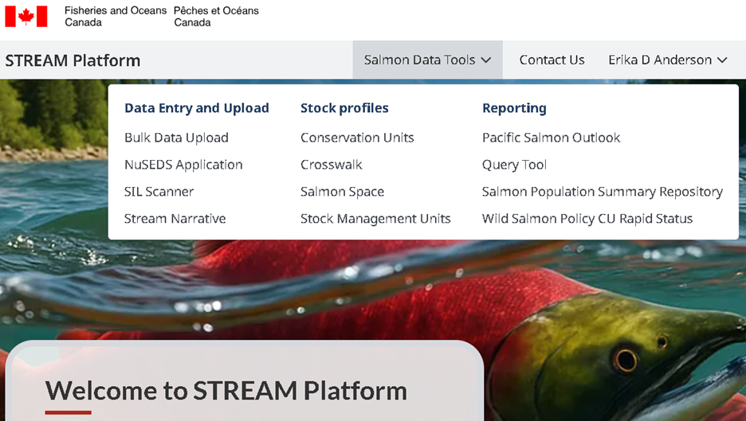

Figure C.1 - Screen capture of the Salmon Tracking Escapement Assessment and Management (STREAM) Platform with the table of contents visible.

#### 2. Salmon Space

[Salmon Space](https://egispi.ent.dfo-mpo.ca/apps/SalmonSpace-Espacesaumon/) is an interactive map that lets you explore salmon information across British Columbia and Yukon. You can search by location or by salmon species to find data such as salmon counts and stock status (Figure 2).

There is strong public demand for access to salmon data to enhance transparency and build trust in departmental decision-making. Salmon Space provides up-to-date salmon counts and status information in an accessible format. By improving data transparency, this application strengthens trust and alignment between internal and external biologists, Indigenous partners, and the broader community of salmon stakeholders and enthusiasts.

The map includes several optional layers, including census sites, conservation units, stock management units, and designatable units, allowing users to view salmon information at different scales. Data is updated weekly from the Fisheries and Oceans regional database, so the public can access recent information with confidence.

Users can download both tabular and spatial data directly from the site, or customize and print map views to support reports, presentations, and research.

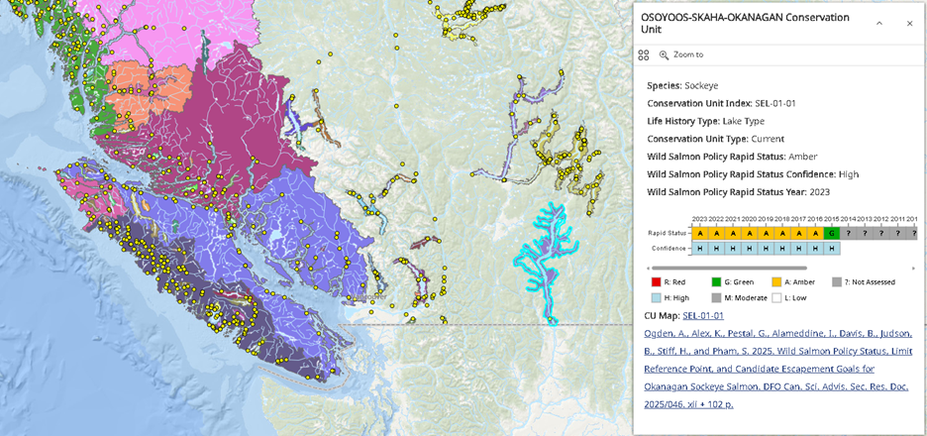

Figure C.2 - Screen capture of Salmon Space showing the Osoyoos-Skaha-Okanagan Sockeye conservation unit (highlighted) with associated information displayed in a pop-up.

#### 3. Specimen Tracking and Analysis Management Platform (STAMP)

The Specimen Tracking and Analysis Management Platform (STAMP) is an integration and tracking system that supports field biologists, laboratories, and analysts by linking information about individual organism specimens across field sampling, tissue handling, and laboratory analysis. STAMP does not collect new data; it connects existing data systems like CREST, KREST and FOS with results data systems like Otomanager and the newly developed Genetics database to ensure that specimen provenance, measurements, and lab results can be reliably tracked and integrated.

Salmon stock assessments and other biological analyses are currently limited by fragmented data systems, inconsistent identifiers, and manual workflows that make it difficult to track tissue samples and link lab results back to individual organisms. STAMP addresses these challenges by providing a standardized unique specimen identifier and shared tracking infrastructure, improving data quality, traceability, and interoperability across projects and systems.

STAMP consists of an integration layer that connects field data systems, laboratory workflows, and results databases, along with tools that support specimen tracking, status reporting, and data linkage. These components enable users to follow specimens from field collection through laboratory processing and to join lab results with organism-level and project-level information.

As STAMP evolves, future development will focus on expanding support to additional lab types, species, and data systems, strengthening data standards and interoperability, and improving tools for querying, reporting, and stewardship. This will enable more efficient operations, reduce manual effort, and support the integrated analyses required by DFO’s modern mandate.

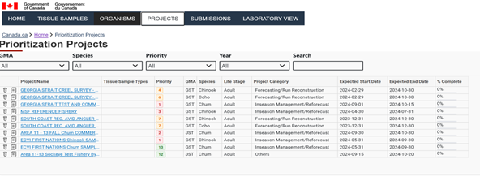

Figure C.3 - Screen capture of STAMP.

#### 4. SILscanner: Stream Inspection Log Digitization Platform

SILscanner is a cloud-based digitization and data recovery platform focused on converting paper Stream Inspection Logs (SILs) into machine-readable data. Stream Inspection Logs or SILs are records of how many salmon of each species were observed and counted during a sampling event on a particular day. SILs remain a significant component of salmon monitoring and assessment operations, and SILscanner supports operational programs by transforming these paper records into accessible digital data.

A large volume of salmon monitoring data continues to be captured on paper field forms, which are later keypunched by DFO staff. This creates delays in data availability, limits data quality control, and requires substantial manual transcription effort. SILscanner addresses this challenge by providing a standardized optical character recognition and form-based data extraction pipeline that recovers structured data directly from Stream Inspection Logs, reducing manual data entry and the risk of transcription errors.

The SILscanner platform consists of a cloud-based optical character recognition (OCR) and form-processing pipeline, secure cloud storage for digitized documents, and a database for indexing extracted data. The system is optimized for form-based data capture from SILs, while also supporting the digitization of handwritten and typewritten archival documents and data extraction from text-based PDFs. Digitized records are indexed and made accessible to analytical and text-mining tools, enabling downstream analysis and integration with other salmon data systems.

SILscanner has been rolled out in the Fraser, West Coast Vancouver Island (WCVI), and North Coast (NC) areas and continuing development to scale to additional areas and form types. Future development will focus on expanding regional coverage, improving data extraction accuracy and validation workflows, and strengthening integration with downstream databases. These enhancements will accelerate data availability, improve data quality, and modernize a critical but currently paper-based component of salmon data capture.

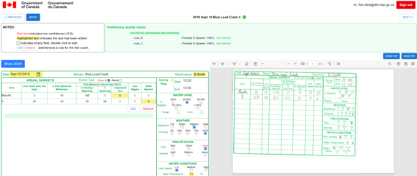

Figure C.4 - Screen capture of SILScanner.

#### 5. DocFlow: AI-Assisted Document Processing for Regulatory and Program Data

DocFlow is an AI-assisted document processing platform designed to transform large collections of unstructured PDF documents into searchable, analyzable, and decision-ready data. It supports programs such as Fish and Fish Habitat Protection by unlocking information embedded in regulatory, monitoring, and authorization documents that are currently difficult and time-consuming to use.

Many critical program datasets, including those stored in systems like Program Activity Tracking for Habitat (PATH), exist primarily as unstructured PDF files with limited metadata. Retrieving information such as project impacts, habitat footprints, mitigation measures, or species at risk often requires manual review of large numbers of documents, taking weeks and producing inconsistent results. DocFlow addresses this challenge by combining optical character recognition, artificial intelligence, and subject-matter-expert guidance to extract structured data from documents in a transparent and reproducible way.

The DocFlow platform consists of a document ingestion and OCR pipeline, AI-based information extraction tools, and an expert-guided interface that allows users to define, validate, and refine how key information is identified within documents. Extracted data are stored in structured formats and linked across related documents using graph-based representations, enabling efficient search, analysis, and structuring across large document collections.

Initially developed as a proof of concept for PATH authorization documents, DocFlow is being scaled to additional document types, programs, and regions, supporting integrative analyses such as cumulative effects assessment, regulatory performance reporting, and long-term data stewardship.

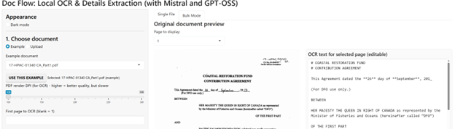

Figure C.5 - Screen capture of DocFlow.

#### 6. DFO Salmon Data Standards

The Government of Canada (GC) Fisheries and Oceans Canada (DFO) Salmon Ontology is a W3C-published semantic schema that provides a common, machine-readable framework for describing Pacific salmon data across DFO. It defines core concepts—such as stocks, surveys, samples, measurements, methods, and results—and their relationships using a hybrid Web Ontology Language (OWL) and Simple Knowledge Organization System (SKOS) approach. The ontology is schema-only by design, meaning it contains no data values, which supports clean versioning, reuse across systems, and interoperability with external platforms.

The ontology’s purpose is to reduce friction in data integration, discovery, and reuse by providing scientists, data stewards, and managers with a shared, well-defined vocabulary. It aligns with international standards including Darwin Core, Basic Formal Ontology (BFO), Information Artifact Ontology (IAO), Sensor, Observation, Sample, and Actuator (SOSA), Provenance Ontology (PROV), and the InteroperAble Descriptions of Observable Property (I-ADOPT) framework. This alignment supports FAIR (Findable, Accessible, Interoperable, Reusable) and CARE principles while enabling future automation such as validation, provenance tracking, and semantic querying without locking DFO into a single system or tool.

#### 7. Salmon Population Summary Database (SPSR)

The Salmon Population Summary Database (SPSR) is a regional repository designed to centralize key salmon population index data—such as spawner abundance, catch, recruitment, exploitation rates, age structure, and hatchery contribution—that underpin routine stock assessments and forecasting. It addresses a major program gap where derived index data are currently scattered across local spreadsheets and bespoke systems, limiting transparency, efficiency, and trust. SPSR is intended to support Fisheries Science Advisory Reports (FSARs) and related assessment work by providing a consistent, FAIR-aligned source of core indices and associated metadata.

The database compiles standardized population indices and reference points at Conservation Unit (CU) and Stock Management Unit (SMU) scales, without replacing authoritative source systems such as NuSEDS, Fishery Operations System (FOS), or coded-wire tag (CWT) databases. It documents methods, assumptions, infilling approaches, and data quality to support reproducibility, succession, and training. SPSR is modeled on established repositories used by the National Oceanic and Atmospheric Administration (NOAA) and is intended for DFO science and assessment staff, with future development focused on expanding coverage, improving interoperability, and supporting strategic reviews of monitoring and assessment frameworks.

#### 8. Open Science Documentation Hub

The Data Stewardship Unit (DSU) is part of the Fishery and Assessment Data Section (FADS) within the Pacific Region Science Branch of Fisheries and Oceans Canada (DFO). The Open Science Documentation Hub provides a public, authoritative reference for data stewardship practices that support salmon science and assessment. It addresses common challenges related to inconsistent data management, limited documentation, and barriers to reproducible analysis across programs.

The hub supports biologists, analysts, and data stewards by documenting practical guidance, standards, and workflows across the full data lifecycle—from planning and collection to analysis and publication. Content is grounded in real biological and management contexts, including stock assessment and monitoring, and is aligned with FAIR data principles and Indigenous data governance considerations such as OCAP®. The site complements internal FADS resources by making core guidance openly accessible.

#### 9. FADS Salmon Data Wiki

The FADS Salmon Data Wiki is an internal, community-maintained reference for DFO Pacific Region Science staff that documents the salmon data landscape across programs, databases, and systems. Its purpose is to support orientation, onboarding, and day-to-day work by providing clear, factual descriptions of datasets, infrastructure, and contacts, without replacing authoritative databases or formal scientific documentation.

The wiki organizes information by major data domains (e.g., fisheries, escapement, genetics, enhancement, habitat) and describes how key systems are accessed and used in biological and management contexts such as stock assessment and fisheries management. It is available to all DFO staff and relies on ongoing contributions to remain current. Future work includes improving consistency across entries, strengthening links to authoritative metadata and open data records, and expanding coverage as systems evolve.

#### 10. Custom Salmon Data GPT

This supports salmon biologists and data stewards by converting messy spreadsheets into standardized Salmon Data Packages (SDPs) that follow a common specification and shared ontology. It streamlines biological and management data workflows by generating consistent metadata, controlled vocabularies, and semantically enriched variable definitions aligned with the DFO Salmon Ontology, Darwin Core, and I-ADOPT measurement patterns. This approach modernizes salmon data management by embedding ontology-based methods and reproducible standards directly into day-to-day data preparation, improving comparability across stock assessment, monitoring, genetics, and fisheries management datasets.

The project is accessed as a Custom GPT in ChatGPT and is intended for DFO scientists, data stewards, and collaborators, with outputs that are openly reusable as CSV-based SDPs. Next steps focus on expanding ontology coverage, refining measurement patterns, and further automating validation through companion tools (e.g., metasalmon). Simple visuals—such as SDP workflow diagrams or ontology relationship graphics—are often included to help users quickly understand how raw data are transformed into standardized, reusable packages.

#### 11. Salmon Data Package (SDP)

The Salmon Data Package (SDP) is a lightweight, frictionless-data-style specification for exchanging salmon datasets between scientists, assessment biologists, and data stewards. It is designed to work with familiar formats such as Excel and CSV while remaining ontology-aware, linking columns and code lists to the DFO Salmon Ontology and related vocabularies. SDP provides a consistent way to describe datasets, tables, variables, and categorical codes without enforcing a single rigid schema.

SDP enables automated validation, reproducible analysis, and interoperability across projects by standardizing metadata and semantics. It supports AI-assisted workflows, integration with R and Python tools (including the metasalmon package), and alignment with standards such as Frictionless Data and Darwin Core. The specification is openly available, versioned, and intended for use by DFO staff and collaborators preparing data for analysis, sharing, publication, or future knowledge-graph integration.

#### 12. Salmon Escapement Estimates Classification Toolkit

The Salmon Escapement Estimates Classification Toolkit is an interactive R Shiny application designed to standardize how salmon escapement estimate types are classified across DFO Stock Assessment groups. It responds to long-standing inconsistencies in how estimate types (Type 1–6) have been applied in NuSEDS, which can affect interpretation of data quality and downstream uses such as Wild Salmon Policy (WSP) rapid status assessments. The toolkit operationalizes updated guidance into a transparent, repeatable decision process.

The application guides users through a three-phase, dichotomous classification key that evaluates enumeration methods, estimation methods, and documentation and accuracy requirements. It provides traceable results, clear downgrade logic, and reference visuals to support consistent application across regions and programs. The tool is publicly accessible via ShinyApps.io for DFO staff and collaborators and is supported by structured YAML logic and reproducible documentation outputs. Future work includes refining guidance based on user feedback, aligning outputs more tightly with NuSEDS tables, and supporting broader integration with assessment workflows and training materials.

#### 13. Salmon Outlook Report Automation

The Salmon Outlook Report project modernizes the annual Salmon Outlook process, which produces categorical and numeric forecasts of salmon abundance by Stock Management Unit and Conservation Unit to support harvest planning. It addresses tight timelines and fragmented workflows by streamlining how Outlook data are collected, processed, and transformed into tables, reports, and presentations used by science and management.

The project uses Survey123 for structured data collection and R-based workflows to automate report and presentation generation. It supports semi-automated slide decks tailored to different audiences and produces technical reports using R Markdown and the csasdown format. The tools are intended for DFO science and assessment staff and are actively under development, with next steps focused on refining data inputs, stabilizing scripts, and improving integration with evolving crosswalks and Outlook processes.

#### 14. Genetics Results Database (GRD)

The Genetics Results Database (GRD) is a governed, centralized data product intended to serve as the authoritative source for Genetic Stock Identification (GSI) and Parentage-Based Tagging (PBT) results across DFO programs. It addresses fragmentation, inconsistent formats, and version conflicts that currently slow reuse and reduce confidence in genetics outputs. The GRD shifts long-term stewardship responsibility away from analytical labs toward a sustainable, FAIR-aligned data product with clear ownership and accountability.

The GRD supports science, assessment, and management by providing traceable, versioned genetics results with standardized metadata, aligned with FAIR and CARE principles and Indigenous data governance. Governance roles are clearly defined across the data lifecycle, with integration planned across regional and enterprise systems such as STAMP, CREST, and FOS. The database is intended for DFO staff, collaborators, and partners, with phased development beginning in 2025 and broader system integration in 2026. Success is measured by adoption, reduced integration effort, and sustained governance.